UNITED STATES

SECURITIES AND EXCHANGE COMMISSION

Washington, D.C. 20549

FORM 10-K

(Mark One)

- ANNUAL REPORT PURSUANT TO SECTION 13 OR 15(d) OF THE SECURITIES EXCHANGE ACT OF 1934

For the Fiscal Year Ended December 28, 2024

or

- TRANSITION REPORT PURSUANT TO SECTION 13 OR 15(d) OF THE SECURITIES EXCHANGE ACT OF 1934
 | For the transition period from ______to ______
 |  | Commission file number: 001-31829
 |  | CARTER’S, INC.
 | (Exact name of registrant as specified in its charter)
Delaware |  |  |  | 13-3912933
(State or other jurisdiction of |  |  |  | (I.R.S. Employer Identification No.)
incorporation or organization)
 |  | Phipps Tower
 | 3438 Peachtree Road NE, Suite 1800
 |  | Atlanta, Georgia 30326
 | (Address of principal executive offices, including zip code)
 | (678) 791-1000
 | (Registrant’s telephone number, including area code)
 | _______________________________________________
Securities registered pursuant to Section 12(b) of the Act:
Title of Each Class |  | Trading Symbol(s) |  | Name of Each Exchange on Which Registered
Common stock, par value $0.01 per share |  | CRI |  | New York Stock Exchange

Securities registered pursuant to section 12(g) of the Act: None

Indicate by check mark if the registrant is a well-known seasoned issuer, as defined in Rule 405 of the Securities Act. Yes ☒ No ☐

Indicate by check mark if the registrant is not required to file reports pursuant to Section 13 or Section 15(d) of the Act. Yes ☐ No ☒

Indicate by check mark whether the registrant (1) has filed all reports required to be filed by Section 13 or 15(d) of the Securities Exchange Act of 1934 during the preceding 12 months (or for such shorter period that the registrant was required to file such reports), and (2) has been subject to such filing requirements for the past 90 days. Yes ☒ No ☐

Indicate by check mark whether the registrant has submitted electronically every Interactive Data File required to be submitted pursuant to Rule 405 of Regulation S-T (§ 232.405 of this chapter) during the preceding 12 months (or for such shorter period that the registrant was required to submit such files). Yes ☒ No ☐

Indicate by check mark whether the registrant is a large accelerated filer, an accelerated filer, a non-accelerated filer, a smaller reporting company, or an emerging growth company. See the definitions of “large accelerated filer,” “accelerated filer,” “smaller reporting company,” and “emerging growth company” in Rule 12b-2 of the Exchange Act.
Large Accelerated Filer ☒ Accelerated Filer ☐

Non-Accelerated Filer ☐ Smaller Reporting Company ☐

Emerging Growth Company ☐

If an emerging growth company, indicate by check mark if the registrant has elected not to use the extended transition period for complying with any new or revised financial accounting standards provided pursuant to Section 13(a) of the Exchange Act. ☐

Indicate by check mark whether the registrant has filed a report on and attestation to its management’s assessment of the effectiveness of its internal control over financial reporting under Section 404(b) of the Sarbanes-Oxley Act (15 U.S.C. 7262(b)) by the registered public accounting firm that prepared or issued its audit report. ☒

If securities are registered pursuant to Section 12(b) of the Act, indicate by check mark whether the financial statements of the registrant included in the filing reflect the correction of an error to previously issued financial statements. ☐

Indicate by check mark whether any of those error corrections are restatements that required a recovery analysis of incentive-based compensation received by any of the registrant’s executive officers during the relevant recovery period pursuant to §240.10D-1(b). ☐

Indicate by check mark whether the registrant is a shell company (as defined in Rule 12b-2 of the Act). Yes ☐ No ☒

The approximate aggregate market value of the voting stock held by non-affiliates of the registrant as of the last business day of the registrant’s most recently completed second fiscal quarter, based upon the closing sale price of the registrant’s common stock on June 29, 2024 as reported on the New York Stock Exchange was $2,173,597,502. For purposes of the foregoing calculation only, which is required by Form 10-K, the registrant has included in the shares owned by affiliates those shares owned by directors and executive officers of the registrant, and such inclusion shall not be construed as an admission that any such person is an affiliate for any purpose.

As of February 18, 2025, there were 36,010,750 shares of the registrant’s common stock outstanding.

DOCUMENTS INCORPORATED BY REFERENCE

Portions of the definitive proxy statement to be filed with the Securities and Exchange Commission pursuant to Regulation 14A relating to the Annual Meeting of shareholders of Carter’s, Inc., expected to be held on May 14, 2025, will be incorporated by reference in Part III of this Form 10-K. Carter’s, Inc. intends to file such proxy statement with the Securities and Exchange Commission not later than 120 days after its fiscal year ended December 28, 2024.

 |  |  |  |  |  |  |  |  |  |  |  |  |  |  |  |  |  |  |  |  |  |  | CARTER’S, INC.
 |  |  |  |  |  |  |  |  |  |  |  |  |  |  |  |  |  |  | INDEX TO ANNUAL REPORT ON FORM 10-K
 |  |  |  |  |  |  |  |  |  |  |  |  |  |  |  |  |  |  | FISCAL YEAR ENDED DECEMBER 28, 2024
 |  |  |  |  |  |  |  |  |  |  |  |  |  |  |  |  |  |  |  |  |  |  |  |  |  |  |  |  |  | Page
 | Part I |  |  |  |  |  |  |  |  |  |  |  |  |  |  |  |  |  |  |  |  |  |  |  |  |  |  |  |  | 1
 |  |  |  |  |  | Item 1 |  |  | Business |  |  |  |  |  |  |  |  |  |  |  |  |  |  |  |  |  |  |  |  | 3
 |  |  |  |  |  | Item 1A |  |  | Risk Factors |  |  |  |  |  |  |  |  |  |  |  |  |  |  |  |  |  |  |  |  |  | 12
 |  |  |  |  |  | Item 1B |  |  | Unresolved Staff Comments |  |  |  |  |  |  |  |  |  |  |  |  |  |  |  |  |  |  |  |  | 28
 |  |  |  |  |  | Item 1C |  |  | Cybersecurity |  |  |  |  |  |  |  |  |  |  |  |  |  |  |  |  |  |  |  |  | 28
 |  |  |  |  |  | Item 2 |  |  | Properties |  |  |  |  |  |  |  |  |  |  |  |  |  |  |  |  |  |  |  |  |  | 30
 |  |  |  |  |  | Item 3 |  |  | Legal Proceedings |  |  |  |  |  |  |  |  |  |  |  |  |  |  |  |  |  |  |  |  |  | 30
 |  |  |  |  |  | Item 4 |  |  | Mine Safety Disclosures |  |  |  |  |  |  |  |  |  |  |  |  |  |  |  |  |  |  |  |  |  | 30
 | Part II |  |  |  |  |  |  |  |  |  |  |  |  |  |  |  |  |  |  |  |  |  |  |  |  |  |  |  |  |  | 31
 |  |  |  |  |  | Item 5 |  |  | Market for Registrant’s Common Equity, Related Stockholder Matters, and Issuer Purchases of Equity Securities |  |  |  |  |  |  |  |  |  |  |  |  |  |  |  |  |  |  |  |  | 31
 |  |  |  |  |  | Item 6 |  |  | [Reserved] |  |  |  |  |  |  |  |  |  |  |  |  |  |  |  |  |  |  |  |  |  | 32
 |  |  |  |  |  | Item 7 |  |  | Management’s Discussion and Analysis of Financial Condition and Results of Operations |  |  |  |  |  |  |  |  |  |  |  |  |  |  |  |  |  |  |  |  |  | 33
 |  |  |  |  |  | Item 7A |  |  | Quantitative and Qualitative Disclosures about Market Risk |  |  |  |  |  |  |  |  |  |  |  |  |  |  |  |  |  |  |  |  | 48
 |  |  |  |  |  | Item 8 |  |  | Financial Statements and Supplementary Data |  |  |  |  |  |  |  |  |  |  |  |  |  |  |  |  |  |  |  |  |  | 50
 |  |  |  |  |  | Item 9 |  |  | Changes in and Disagreements with Accountants on Accounting and Financial Disclosure |  |  |  |  |  |  |  |  |  |  |  |  |  |  |  |  |  |  |  |  |  | 93
 |  |  |  |  |  | Item 9A |  |  | Controls and Procedures |  |  |  |  |  |  |  |  |  |  |  |  |  |  |  |  |  |  |  |  |  | 93
 |  |  |  |  |  | Item 9B |  |  | Other Information |  |  |  |  |  |  |  |  |  |  |  |  |  |  |  |  |  |  |  |  | 93
 |  |  |  |  |  | Item 9C |  |  | Disclosure Regarding Foreign Jurisdictions that Prevent Inspections |  |  |  |  |  |  |  |  |  |  |  |  |  |  |  |  |  |  |  |  | 94
 | Part III |  |  |  |  |  |  |  |  |  |  |  |  |  |  |  |  |  |  |  |  |  |  |  |  |  |  |  |  |  | 95
 |  |  |  |  |  | Item 10 |  |  | Directors and Executive Officers of the Registrant |  |  |  |  |  |  |  |  |  |  |  |  |  |  |  |  |  |  |  |  |  | 95
 |  |  |  |  |  | Item 11 |  |  | Executive Compensation |  |  |  |  |  |  |  |  |  |  |  |  |  |  |  |  |  |  |  |  |  | 95
 |  |  |  |  |  | Item 12 |  |  | Security Ownership of Certain Beneficial Owners and Management and Related Stockholder Matters |  |  |  |  |  |  |  |  |  |  |  |  |  |  |  |  |  |  |  |  | 95
 |  |  |  |  |  | Item 13 |  |  | Certain Relationships and Related Transactions |  |  |  |  |  |  |  |  |  |  |  |  |  |  |  |  |  |  |  |  | 95
 |  |  |  |  |  | Item 14 |  |  | Principal Accountant Fees and Services |  |  |  |  |  |  |  |  |  |  |  |  |  |  |  |  |  |  |  |  | 95
 | Part IV |  |  |  |  |  |  |  |  |  |  |  |  |  |  |  |  |  |  |  |  |  |  |  |  |  |  |  |  |  | 96
 |  |  |  |  |  | Item 15 |  |  | Exhibits and Financial Statement Schedules |  |  |  |  |  |  |  |  |  |  |  |  |  |  |  |  |  |  |  |  | 96
 |  |  |  |  |  | Item 16 |  |  | Form 10-K Summary |  |  |  |  |  |  |  |  |  |  |  |  |  |  |  |  |  |  |  |  | 101
 | SIGNATURES |  |  |  |  |  |  |  |  |  |  |  |  |  |  |  |  |  |  |  |  |  |  |  |  |  |  |  |  | 102

Statements contained in this annual report that are not historical fact and use predictive words such as “estimates”, “outlook”, “guidance”, “expect”, “believe”, “intend”, “designed”, “target”, “plans”, “may”, “will”, “are confident” and similar words are forward-looking statements (as such term is defined in the Private Securities Litigation Reform Act of 1995). These forward-looking statements and related assumptions involve risks and uncertainties that could cause actual results and outcomes to differ materially from any forward-looking statements or views expressed in this press release. These risks and uncertainties include, but are not limited to, those discussed in the subsection entitled “Risk Factors” under Part I, Item 1A, of this Annual Report on 10-K, and otherwise in our reports and filings with the Securities and Exchange Commission, as well as the following factors: changes in global economic and financial conditions, and the resulting impact on consumer confidence and consumer spending, as well as other changes in consumer discretionary spending habits; risks related to public health crises; risks related to consumer tastes and preferences, as well as fashion trends; the failure to protect our intellectual property; the diminished value of our brands, potentially as a result of negative publicity or unsuccessful branding and marketing efforts; delays, product recalls, or loss of revenue due to a failure to meet our quality standards; risks related to uncertainty regarding the future of international trade agreements; increased competition in the marketplace; financial difficulties for one or more of our major customers; identification of locations and negotiation of appropriate lease terms for our retail stores; distinct risks facing our eCommerce business; failure to forecast demand for our products and our failure to manage our inventory; increased margin pressures, including increased cost of materials and labor and our inability to successfully increase prices to offset these increased costs; continued inflationary pressures with respect to labor and raw materials and global supply chain constraints that have, and could continue, to affect freight, transit, and other costs; fluctuations in foreign currency exchange rates; unseasonable or extreme weather conditions; risks associated with corporate responsibility issues; our foreign sourcing arrangements; a relatively small number of vendors supply a significant amount of our products; disruptions in our supply chain, including increased transportation and freight costs; our ability to effectively source and manage inventory; problems with our Braselton, Georgia distribution facility; pending and threatened lawsuits; a breach of our information technology systems and the loss of personal data or a failure to implement new information technology systems successfully; unsuccessful expansion into international markets; failure to comply with various laws and regulations; failure to properly manage strategic initiatives; retention of key individuals; acquisition and integration of other brands and businesses; failure to achieve sales growth plans and profitability objectives to support the carrying value of our intangible assets; our continued ability to meet obligations related to our debt; changes in our tax obligations, including additional customs, duties or tariffs; our continued ability to declare and pay a dividend; volatility in the market price of our common stock; and the cost or effort required for our shareholders to bring certain claims or actions against us, as a result of our designation of the Court of Chancery of the State of Delaware as the sole and exclusive forum for certain types of actions and proceedings. Except for any ongoing obligations to disclose material information as required by federal securities laws, the Company does not undertake any obligation to publicly update or revise any forward-looking statements, whether as a result of new information, future events, or otherwise. The inclusion of any statement in this Annual Report on Form 10-K does not constitute an admission by the Company or any other person that the events or circumstances described in such statement are material.

PART I

Unless the context indicates otherwise, in this filing on Form 10-K, “Carter’s,” the “Company,” “we,” “us,” “its,” and “our” refers to Carter’s, Inc. and its wholly owned subsidiaries.

Our market share data is based on information provided by Circana, LLC (formerly the NPD Group, Inc.). Circana, LLC. (“Circana”) data is based upon Consumer Panel TrackSM (consumer-reported sales) calibrated with selected retailers’ point of sale data for children’s apparel and juvenile products in the United States (“U.S.”) and represents the twelve-month period ended December 2024.

Unless otherwise indicated, references to market share in this Annual Report on Form 10-K are expressed as a percentage of total retail sales of the stated market. Some Circana market share data is presented based on age segments. The baby and young children’s apparel market in which we compete includes apparel products for ages zero to 10 and is divided into the zero to two-year-old baby market, the three- to four-year-old toddler market, and the five- to 10-year-old kids market. Note that Carter’s defines its product offerings by sizes: baby (sizes newborn to 24 months), toddlers (sizes 2T to 5T), and kids (sizes 4-14). In addition, other Circana market share data is presented based on Circana’s definition of the baby and playclothes categories, which is different from Carter’s definitions of these categories.

Certain Circana data cited in prior Annual Reports on Form 10-K were based on an alternate methodology no longer employed by Circana and are not comparable to the current year presentation.

Our trademarks that are referred to in this Annual Report on Form 10-K, including Carter’s, OshKosh B’gosh, OshKosh, Skip Hop, Child of Mine, Just One You, Simple Joys, Little Planet, PurelySoft, and Carter’s Rewards, many of which are registered

1

in the United States and in over 100 other countries and territories, are each the property of one or more subsidiaries of Carter’s, Inc.

The Company’s fiscal year ends on the Saturday in December or January nearest December 31. Every five or six years, our fiscal year includes an additional 53rd week of results. Fiscal 2024 ended on December 28, 2024, fiscal 2023 ended on December 30, 2023, and fiscal 2022 ended on December 31, 2022. All three fiscal years contained 52 calendar weeks.

2

ITEM 1. BUSINESS

Overview

We are the largest branded marketer of young children’s apparel in North America. We own two of the most highly recognized and trusted brand names in the children’s apparel market, Carter’s and OshKosh B’gosh (or “OshKosh”). We also own Skip Hop, a leading young children’s lifestyle brand, Little Planet, a brand focused on organic fabrics and sustainable materials, and exclusive Carter’s brands developed for Amazon, Target, and Walmart.

Established in 1865, our Carter’s brand is recognized and trusted by consumers for high-quality apparel and accessories for children in sizes newborn to 14.

Established in 1895, OshKosh is a well-known brand, trusted by consumers for high-quality apparel and accessories for children in sizes newborn to 14, with a focus on playclothes for toddlers and young children. We acquired OshKosh in 2005.

Established in 2003, the Skip Hop brand rethinks, reenergizes, and reimagines durable necessities to create higher value, superior quality, and award-winning products for parents, babies, and toddlers. We acquired Skip Hop in 2017.

Launched in 2021, the Little Planet brand focuses on sustainable clothing through the sourcing of mostly organic cotton as certified under the Global Organic Textile Standard (“GOTS”), a global textile processing standard for organic fibers. This brand includes a wide assortment of baby and toddler apparel, accessories, and sleepwear.

Additionally, Child of Mine, an exclusive Carter’s brand, is sold at Walmart, Just One You, an exclusive Carter’s brand, is sold at Target, and Simple Joys, an exclusive Carter’s brand, is available on Amazon.

Our mission is to serve the needs of families with young children, with a vision to be the world’s favorite brands in young children’s apparel and related products. We believe our brands are complementary to one another in product offering and aesthetic. Each brand is uniquely positioned in the marketplace and offers great value to families with young children. The baby and young children’s apparel market, ages zero to 10, in the U.S. is approximately $28 billion as of December 2024. In this market, our Carter’s brands, including our exclusive brands, hold the #1 position with approximately 10% market share and our OshKosh brand has less than 1% market share as of December 2024.

Our multichannel global business model, which includes retail stores, eCommerce, and wholesale distribution channels, as well as omni-channel capabilities in the United States and Canada, enables us to reach a broad range of consumers around the world. At the end of fiscal 2024, our channels included 1,057 company-owned retail stores in North America, eCommerce websites, approximately 19,500 wholesale locations in North America, as well as our international wholesale accounts and licensees who operate in over 1,100 locations outside of North America in over 90 countries.

Our three business segments are: U.S. Retail, U.S. Wholesale, and International. These segments are our operating and reporting segments. Our U.S. Retail segment consists of revenue primarily from sales of products in the United States through our retail stores and eCommerce websites. Similarly, our U.S. Wholesale segment consists of revenue primarily from sales in the United States of products to our wholesale customers. Our International segment consists of revenue primarily from sales of products outside the United States, largely through our retail stores and eCommerce websites in Canada and Mexico, and sales to our international wholesale customers and licensees. Additional financial and geographical information about our business segments is contained in Item 8 “Financial Statements and Supplementary Data” and under Note 18, Segment Information, to the consolidated financial statements.

Strategy

We have extensive experience in the young children’s apparel and accessories market and focus on delivering products that satisfy our consumers’ needs. Our growth agenda is centered on three fundamental areas:
- Elevate the style and value of our product offerings — We are focused on driving growth by delivering market-leading style and enhancing our value proposition. In fiscal 2024, informed by consumer demand and insights, we initiated a shift of our U.S. Retail product assortment to increase the sales mix of the “best” (more premium fashion) and the opening price point components of our apparel offering. As a result, both components represented a higher proportion of sales in the second half of fiscal 2024 compared to the first half of fiscal 2024.

The shift to increase the penetration of our “best” product is supported by a house-of-brands strategy that enables us to leverage new, more targeted and differentiated brands like Little Planet, as well as our curated collections from PurelySoft, OshKosh B’gosh, Skip Hop and Carter’s. Over time we plan to develop this strategy further as a way of reaching more of the marketplace, including some customer segments which we do not serve today.

3

Also in fiscal 2024, and enabled by our enhanced pricing capabilities, we made retail price investments to be more competitive in select toddler and kids size playwear categories and during higher-volume market share promotional events, and to support inventory management objectives. Areas of playwear investment included select opening price point categories, which are less differentiated from similar private label products in the marketplace and exhibit higher price elasticity, and additional programs such as collections, fleece, and activewear. Collectively these efforts helped to drive growth in the value component of our U.S. Retail assortment and contributed to an increase in conversion rates (measured as the percentage of store visitors and website traffic that resulted in a purchase) and units per transaction in both stores and eCommerce in the second half of fiscal 2024 compared to the first half of fiscal 2024.

- Improve our marketing capabilities and effectiveness — Our marketing investments are targeted at acquiring new customers, developing stronger relationships with our existing customers, and extending our customers’ tenure with our brands. Recent areas of investment include brand marketing, personalization capabilities, a rebranded and relaunched customer loyalty program, enhanced digital and social media programs, and strengthened consumer-facing technologies such as our mobile app. Collectively these investments contributed to sequential improvement in U.S. Retail comparable sales, growth in new and reactivated customers, and an improved retention rate in the second half of fiscal 2024 compared to the first half of fiscal 2024.

- Leverage our unparalleled multi-channel market presence to extend the reach of our brands — Our global, multichannel business model is unique. No other children’s apparel company in the world has our combined capabilities in the retail store, online and wholesale channels.

We are the largest specialty retailer in North America focused on young children’s apparel, with over 1,000 company-owned stores and dedicated websites in the United States, Canada, and Mexico. Across our retail fleet, we made progress in fiscal 2024 accelerating remodels and introducing new in-store experiences. In fiscal 2024, we opened our first-ever flagship store in Atlanta, Georgia, which includes brand-centric presentations, in-store shops for baby, toddler and kids, and Little Planet, modern digital displays, a gifting station, and community engagement events. We believe learnings from the ongoing innovations at our flagship store will inspire new and remodeled store experiences across our fleet.

In wholesale, we are the largest supplier of young children’s apparel to the largest retailers in North America. We have the most extensive distribution of childrenswear – our brands are sold in more than 19,500 wholesale retail locations in North America and through our wholesale customers’ websites. Our brand reach efforts are enabled by our long-standing wholesale customer partnerships, which are important contributors to our sales and profitability and consumer brand awareness. We plan to continue to prioritize investments in our brand experiences with our wholesale partners, both digitally and in-store. Outside of North America, our global distribution capabilities are further strengthened through our relationships with multi-national retailers and other wholesale partners with over 1,100 points of distribution, and over 150 global websites.

In addition to the fundamental areas above, we intend to pursue improvements to our operating model, which includes improving our product and brand development processes in an effort to be faster, nimbler and able to respond to changing consumer preferences more rapidly. We also plan to continue to pursue opportunities to improve productivity throughout the business and to manage spending prudently.

Our Brands

Carter’s & OshKosh B’gosh

Our Carter’s and OshKosh product offerings include apparel and accessories for babies (sizes newborn to 24 months), toddlers (sizes 2T to 5T), and kids (sizes 4-14).

For our Carter’s brands, our focus is on essential and fashion apparel products for babies and young children, including bodysuits, layette essentials, sleep and play, pants, tops and t-shirts, multi-piece sets, dresses, and sleepwear. We attribute our leading market position to our strong value proposition, brand strength, distinctive design, commitment to quality, and our broad distribution through our company-owned retail stores, websites, and mobile app, as well as our wholesale distribution channel that includes successful and long-standing relationships with leading global and national retailers. Our marketing programs are targeted toward first-time parents, experienced parents, and gift-givers. Our core baby product line provides families with essential products and accessories, including value-focused multi-piece sets. We also have three exclusive Carter’s brands: our Child of Mine brand, which is sold at Walmart, our Just One You brand, which is sold at Target, and our Simple Joys brand, which is available on Amazon.

4

Carter’s is the leading brand in the zero to 10-year-old market in the United States, with particular strength in the zero to two-year-old segment. As of December 2024, our multichannel business model enabled our Carter’s brands to maintain a leading market share of approximately 10% in the zero to 10-year-old market. Our Carter’s brands maintained the leading market position with approximately 21% in the zero to two-year-old baby market and maintained its leading market position with approximately 11% in the three to four-year-old toddler market. Our Carter’s brands also have an approximately 3% market share in the five to ten-year-old kid market.

The focus of the OshKosh brand is high-quality playclothes, including denim jeans, overalls, core bottoms, knit tops, t-shirts, and layering pieces for everyday use, primarily targeted at toddlers and young children. We believe our OshKosh brand has significant brand name recognition, which consumers associate with high-quality, durable, and authentic playclothes for young children. As of December 2024, our OshKosh brand’s market share was less than 1% of the zero to 10-year-old apparel market in the United States.

For both our Carter’s and OshKosh brands, we employ cross-functional teams to develop our product assortments. Team members from merchandising, art, design, sourcing, product development, and planning follow a disciplined development process. We believe this approach, which includes consumer research, value engineering, and rigorous attention to detail, results in compelling consumer product offerings, increases consumer response, and supports efficient and productive operations.

We are focused on strengthening our brands with consumers by differentiating our products through fabric softness, on-trend styling, updated packaging and presentation strategies, and consumer-facing marketing. We also place importance on differentiating our brand experience through in-store fixturing, branding, signage, photography, and advertising across all of our global channels of distribution.

Licensed Products

We license our Carter’s, OshKosh, Child of Mine, Just One You, Simple Joys, and Little Planet brands to various licensed partners in order to expand our product offerings into additional product categories such as footwear, outerwear, accessories (such as hair accessories and jewelry), toys, home décor, cribs and baby furniture, and bedding. These licensed partners develop and sell our branded products through multiple sales channels, while leveraging our brand strength, customer relationships, and designs. Licensed products provide our customers with a range of lifestyle products that complement and expand upon our baby and young children’s apparel offerings. Our license agreements require strict adherence to our quality and compliance standards and provide for a multi-step product approval process. We work in conjunction with our licensing partners in the development of our branded products to aim to ensure consistency across product offerings with our brand vision of high-quality products at market-leading value.

We also partner with other brand owners to further expand our retail apparel product offerings, including a range of licensed sports and character t-shirts, bodysuits, and sleepwear.

Skip Hop

Under our Skip Hop brand, we design, source, and market products that are sold primarily to expectant parents and families with young children. Our Skip Hop brand is best known for diaper bags, kid’s bags, home gear, and products for playtime, mealtime, bath time, and travel, and combines innovative functionality with attractive design. Skip Hop was the #1 brand in diaper bags in 2024.

We believe Skip Hop is a global lifestyle brand. Skip Hop’s core philosophy and positioning revolves around its brand promise — “Must-Haves * Made Better.” This reflects the brand’s goal of creating innovative, smartly designed, and highly functional essentials for parents, babies, and toddlers. The Skip Hop team includes both in-house design and creative teams, each of which is dedicated to meeting that goal. We have made investments to in-store fixturing, branding, and signage, along with digital advertising, to further strengthen the position of the Skip Hop brand. Skip Hop branded products are sold through our retail stores, our eCommerce site, and in the wholesale channel.

Little Planet

Our Little Planet brand launched in 2021 and is a primarily organic and sustainable apparel brand created to serve a growing consumer need for beautiful heirloom-quality baby and toddler products developed using sustainable materials. The assortment of products includes sleepwear, swimwear, outerwear, bedding, accessories, and toys. Little Planet products are sold through our retail stores, our eCommerce site, and in the wholesale channel.

5

Sales Channels

We sell our Carter’s, OshKosh, Skip Hop, and Little Planet branded products through multiple channels, both in the United States and globally.

U.S. Retail

Our U.S. Retail segment includes sales of our products through our U.S. retail stores and eCommerce sites, including through our omni-channel capabilities to allow our customers to experience our brands as a seamless shopping experience in the channel of their choice.

Our U.S. retail stores are generally located in high-traffic open-air shopping centers and malls in or near major cities or in outlet centers that are near densely populated areas. We believe our brand strength, product assortment, shopping experience, and high-quality service have made our retail stores a destination for consumers seeking children’s apparel and accessories.

Each of our stores carries an assortment of Carter’s, OshKosh, and/or Skip Hop branded products, as well as other products, including Little Planet branded products, depending on the store and location. As of the end of fiscal 2024, our stores averaged approximately 5,100 square feet per location. As of the end of fiscal 2024, we operated 804 stores in the United States.

In the fourth quarter of fiscal 2024, we opened our first-ever flagship store in Atlanta, Georgia, which includes brand-centric presentations, in-store shops for baby, toddler and kids, as well as Little Planet, modern digital displays, a gifting station, and community engagement events.

We regularly assess potential new retail store locations and closures of existing stores based on demographic factors, retail adjacencies, competitive factors, population density, growth projections, and performance of existing stores as part of a rigorous real estate portfolio optimization process.

We also sell our products through our U.S. eCommerce websites at www.carters.com, www.oshkosh.com, www.skiphop.com, www.shoplittleplanet.com, and through our mobile app.

We focus on the customer experience through store and eCommerce website design, visual aesthetics, clear product presentation, and exceptional customer service. Our eCommerce websites also feature product recommendations and online-only offerings.

We strive to create a seamless omni-channel experience between our retail stores and our eCommerce websites. Customers can choose to have eCommerce purchases shipped directly to them (same-day shipping available in select markets), to pick-up the purchases in a store (buy-online, pick-up in-store), or through our curbside pick-up services. eCommerce purchases, including from our eCommerce websites and mobile app, may be shipped from one of our distribution facilities or from a retail store (buy-online, deliver-from-store). Store purchases are primarily fulfilled from each store’s inventory, but our in-store buy-online services offer our broadest assortment to be shipped to a customer from one of our distribution facilities or from another retail store. We utilize radio frequency identification (“RFID”) technology in our stores. This technology helps us to improve our management of inventory and allows us to fulfill omni-channel orders more effectively.

U.S. Wholesale

Our U.S. Wholesale segment includes sales of our products to our U.S. wholesale customers.

Our Carter’s brand wholesale customers in the United States include major retailers, such as, in alphabetical order, Costco, JCPenney, Kohl’s, Macy’s, and Sam’s Club. Additionally, our Child of Mine exclusive brand is sold at Walmart, our Just One You exclusive brand is sold at Target, and our Simple Joys exclusive brand is available on Amazon.

Our OshKosh brand wholesale customers in the United States include major retailers, such as, in alphabetical order, Amazon and Target.

Our Skip Hop brand wholesale customers in the United States include major retailers, such as, in alphabetical order, Amazon, Target, and Walmart.

Our Little Planet brand wholesale customers in the United States include major retailers, such as, in alphabetical order, Amazon and Target.

6

We collaborate with our wholesale customers to provide a consistent and high-level of service, and to drive growth through eCommerce, replenishment, product mix, and brand presentation initiatives. We also have frequent meetings with the senior management of key accounts to align on strategic growth plans.

Our two largest wholesale customers accounted for 10.9% and 10.1%, respectively, of consolidated net sales in fiscal 2024.

International

Our International segment includes sales of our products through our retail stores and eCommerce sites in Canada and Mexico. As of the end of fiscal 2024, in Canada we operated 191 retail stores and an eCommerce site at www.cartersoshkosh.ca, and in Mexico we operated 62 retail stores and an eCommerce site at www.carters.com.mx.

Our International segment includes sales of our products to wholesale accounts outside of the United States, including both domestic retailers with international operations and international retailers. In addition, we license our Carter’s and OshKosh brands to international customers that sell our products through branded retail and online stores, as well as to wholesale customers, within their licensed territories. Our International segment includes sales of our products to these licensees, and royalty income based on sales made by certain licensees. As of the end of fiscal 2024 our International channel included wholesale accounts in approximately 19,500 locations in North America and wholesale accounts and licensees who operated in over 1,100 locations outside of North America. As of the end of fiscal 2024, we had approximately 40 international licensees who operated in over 90 countries.

Our Marketing Strategy

For all our brands, our marketing is largely focused on driving brand preference and engagement with first-time and experienced parents, as well as gift-givers. Our goal is to have the most top-of-mind, preferred brands in the young children’s apparel market and to connect with diverse, digitally savvy consumers. As such, our marketing investments are targeted at acquiring new customers, developing stronger relationships with our existing customers, and extending our customers’ tenure with our brands. Included among our marketing investments are our newly developed marketing personalization capabilities, a rebranded and relaunched customer loyalty program, enhanced digital and social media programs, and strengthened consumer-facing technologies such as our mobile app.

We use our customer loyalty program in the United States to drive customer traffic, sales, and brand loyalty. In the second quarter of fiscal 2024, we rebranded and relaunched our loyalty program as Carter’s Rewards with the goals of further deepening our customer loyalty, increasing the frequency of visits, and growing customer lifetime value. This program is integrated across our U.S. retail stores and online businesses. During fiscal 2024, our U.S. retail sales were predominantly made to members of Carter’s Rewards.

Complementing our Carter’s Rewards loyalty program is our Carter’s private label credit card, which provides added benefits for our Carter’s Rewards customers. A third-party financial institution issues the Carter’s credit card to consumers and bears all underwriting and credit risk under the program. Under the credit card program agreement with the third-party financial institution, the Company receives payments for the establishment of new credit accounts, as well as royalties on the usage of the credit card by customers.

Our Global Sourcing Network

We source all of our apparel and other products from a global network of third-party suppliers, primarily located in Asia. We source the remainder of our products primarily through North America, Africa, and Central America. During fiscal 2024, approximately 75% of our product was sourced from Vietnam, Cambodia, Bangladesh, and India, and approximately 60% of the fabric that was used in the manufacture of our products was sourced from China, with the remainder sourced primarily from India, Vietnam, Thailand, and Bangladesh. We do not own any raw materials or manufacturing facilities.

Our sourcing operations are based in Hong Kong in order to facilitate better service and manage the volume of manufacturing in Asia. Our Hong Kong office acts as an agent for substantially all of our sourcing in Asia and monitors production at manufacturers’ facilities to ensure quality control, compliance with our manufacturing specifications and social responsibility standards, as well as timely delivery of finished apparel to our distribution facilities. We also have sourcing offices in Cambodia, Vietnam, China, and Bangladesh to help support these efforts.

Prior to placing production, and on a recurring basis, we conduct assessments of political, social, economic, environmental, trade, labor and intellectual property protection conditions in the countries in which we source our products, and we conduct assessments of our manufacturers and supply chain, as discussed under “—Responsible Sourcing” below. In connection with

7

the manufacture of our products, manufacturers purchase raw materials including fabric and other materials (such as linings, zippers, buttons, and trim) at our direction. We regularly inspect and supervise the manufacture of our products as well as test the products in order to maintain safety and quality control, monitor compliance with our manufacturing specifications and social responsibility standards, and to ensure timely delivery. We also inspect finished products at the manufacturing facilities.

We generally arrange for the production of products on a purchase order basis with completed products manufactured to our design specifications. We assume the risk of loss predominantly on a Freight-On-Board (F.O.B.) basis when goods are delivered to a shipper and are insured against losses arising during shipping.

We have not entered into any long-term contractual arrangements with any contractor or manufacturer. We believe that the production capacity of each foreign manufacturer with which we have developed, or are developing, a relationship is adequate to meet our production requirements for the foreseeable future. We believe that alternative foreign manufacturers are readily available.

We expect all of our suppliers shipping to the United States to adhere to the requirements of the U.S. Customs and Border Protection’s Customs-Trade Partnership Against Terrorism (“C-TPAT”) program, including standards relating to facility security, procedural security, personnel security, cargo security, and the overall protection of the supply chain. In the event a supplier does not comply with our C-TPAT requirements, or if we have determined that the supplier will be unable to correct a deficiency, we may move that supplier’s product through alternative supply chain channels or we may terminate our business relationship with the supplier.

Responsible Sourcing

We continue to seek the best pricing in our sourcing practices, and with that goal in mind, we have adopted a factory on-boarding program that allows us to assess each factory’s compliance with our ethical and social responsibility standards before we place orders for product with that factory. Additionally, we regularly assess the manufacturing facilities we use through periodic on-site facility inspections, including the use of independent auditors to supplement our internal staff. We use audit data and performance results to identify potential improvements, and we integrate this information into our on-going sourcing decisions. Our vendor code of ethics, with which we require our factories to comply, outlines our standards for supplier behavior in creating a fair and safe workplace and covers employment practices, such as wages and benefits, working hours, health and safety, working age, and discriminatory practices, as well as environmental, ethical, and other legal matters. In addition, our social responsibility policy establishes our expectations for our global suppliers and guides our oversight. This policy is derived from the policies, standards, and conventions of the International Labor Organization, and includes a commitment to the Universal Declaration of Human Rights.

Sustainability

We issued our fourth annual Raise the Future Impact Report in fiscal 2024, in which we highlighted our three strategic pillars that guide our long-term corporate responsibility commitments: Product, Planet, and People. In furtherance of these commitments, we discussed our efforts to grow our sustainable product offerings, reduce our carbon footprint, and uplift our workers and communities. At the end of fiscal 2024, we continued our transition to more sustainably grown cotton through the Better Cotton Initiative, with over 50% of our cotton sourced through this program. Additionally, we expanded our use of LENZING™ ECOVERO™, a sustainably produced viscose fiber sourced from responsibly managed forests.

As a result of customer demand, we have increased the sales of and expanded the scope of our Little Planet brand and PurelySoft collection, and we plan to increase the availability of sustainable choices across all our product lines to support the growing demand. We have increased our transparency on our chemicals management process by publishing a Restricted Substances List, designating chemicals that should be minimized or avoided in our apparel and accessories, and are working with our suppliers to minimize or avoid the use of such chemicals in our products. We use the OEKO-TEX® Standard 100 certification label, a well-known certification for textiles tested for harmful substances, which appeared on more than 98% of our baby apparel and sleepwear in fiscal 2024. We have established targets, validated by the Science-Based Target Initiative, to reduce risks associated with our Scope 1 and 2 greenhouse gas emissions.

Our Global Distribution Network

The majority of all finished goods manufactured for us is shipped to our distribution facilities or to designated third-party facilities for final inspection, allocation, and reshipment to customers. The goods are delivered to us and to our customers by independent shippers. We choose the form of shipment based upon needs, costs, and timing considerations.

8

In the United States, we operate three distribution centers in Georgia: an approximately 1.1 million square-foot multichannel facility in Braselton, a 0.5 million square-foot facility in Stockbridge, and a 0.2 million square-foot single-channel facility in Jonesboro. We outsource certain distribution activities to third-party logistics providers located in California and leverage additional third-party providers in Georgia, as needed, primarily for storage seasonally. Our distribution center activities include receiving finished goods from our vendors, inspecting those products, and preparing and shipping them to our wholesale customers, retail stores, and eCommerce customers.

Internationally, we operate directly or outsource our distribution activities to third-party logistics providers in Canada, China, Mexico, and Vietnam to support shipment to the United States, as well as our international wholesale accounts, international licensees, international eCommerce operations, and Canadian and Mexican retail store networks.

Governmental Regulation

We are subject to laws, regulations and standards set by various governmental authorities and standard setting bodies around the world, including in the United States, Canada, and Mexico, including:

- those imposed by the Sarbanes-Oxley Act of 2002, the Dodd-Frank Wall Street Reform and Consumer Protection Act, the Securities and Exchange Commission (“SEC”), and the New York Stock Exchange (“NYSE”);
- the U.S. Foreign Corrupt Practices Act, and similar world-wide anti-bribery laws;

- the tax laws of the United States and other countries;

- health care, employment and labor laws;

- product and consumer safety laws, including those imposed by the U.S. Consumer Product Safety Commission and the Americans with Disabilities Act of 1990;

- data privacy laws, including the European Union General Data Protection Act (“GDPA”), the California Consumer Privacy Act (“CCPA”), and the California Privacy Rights Act (“CPRA”);

- trade, transportation and logistics related laws, including tariffs, quotas, embargoes, and orders issued by Customs and Border Protection and similar agencies in other countries; and

- applicable environmental laws.

The majority of our products are imported into the United States, Canada, and Mexico. These products are subject to various customs laws, which may impose tariffs, as well as quota restrictions. In addition, each of the countries in which our products are sold has laws and regulations covering imports. The United States and other countries in which our products are sold may impose, from time to time, new duties, tariffs, surcharges, or other import controls or restrictions including trade related restrictions on the sourcing and importation of raw materials and finished goods, or adjust presently prevailing duty or tariff rates or levels. We, therefore, actively monitor import restrictions and developments and seek to minimize our potential exposure to import related risks through shifts of production among countries, including consideration of countries with tariff preference and free trade agreements, manufacturers, and geographical diversification of our sources of supply.

Additionally, we are subject to various other federal, state, local and foreign laws and regulations that govern our activities, operations, and products, including data privacy, truth-in-advertising, accessibility, customs, wage and hour laws and regulations, and zoning and occupancy ordinances that regulate retailers generally and govern the promotion and sale of merchandise and the operation of retail stores and eCommerce sites. Noncompliance with these laws and regulations may result in substantial monetary penalties and criminal sanctions.

Competition

The baby and young children’s apparel and accessories market is highly competitive. Competition in our market is generally based on a variety of factors, including comfort and fit, quality, pricing, style, selection, and breadth of distribution. Both national brand and private label manufacturers, as well as specialty apparel brands and retailers, aggressively compete in the baby and young children’s apparel market. Our primary competitors include (in alphabetical order): Gap, Old Navy, and The Children’s Place; Cat & Jack (private label sold exclusively in Target) and Garanimals (sold exclusively in Walmart); and Disney, Nike, Adidas, and Under Armour (national brands). Because of the highly fragmented nature of the industry, we also compete with many small specialty brands and retailers. We believe that the awareness and strength of our brand names, combined with the breadth and value of our product offerings, broad distribution, scale, and operational expertise, position us well against these competitors.

9

Seasonality and Weather

We experience seasonal fluctuations in our sales and profitability due to the timing of certain holidays and key retail shopping periods, which generally have resulted in lower sales and gross profit in the first half of our fiscal year versus the second half of the year. Accordingly, our results of operations during the first half of the year may not be indicative of the results we expect for the full fiscal year. In addition, our business is susceptible to unseasonable weather conditions, which could influence consumer behavior, customer traffic, and shopping habits. For example, extended periods of unseasonably warm temperatures during the winter season or cool temperatures during the summer season could affect the level and timing of demand.

Human Capital Management

As of the end of fiscal 2024, we had approximately 15,350 employees globally. The tables below present the composition and location of our employees:

 | Employee Count |  |  | % of Total
Retail stores |  | 11,932 |  | 77.7 %
Corporate offices |  | 1,866 |  | 12.2 %
Distribution centers |  | 1,552 |  | 10.1 %
Total |  | 15,350 |  | 100.0 %

 |  | Employee Count |  | % of Total
United States |  | 12,170 |  | 79.3 %
Canada |  | 2,205 |  | 14.4 %
Mexico |  | 660 |  | 4.3 %
Other (primarily countries in Asia) |  | 315 |  | 2.1 %
Total |  | 15,350 |  | 100.0 %
Talent and Development
We are guided by our core values:
• | Act with Integrity
• | Exceed Expectations
• | Inspire Innovation
• | Succeed Together
• | Invest in People

We believe that to succeed as a business and to positively impact families and our communities, we must first create and maintain an inclusive, supportive workplace culture that fosters high employee engagement. We believe in developing our employees and offer numerous formal training opportunities as well as ongoing informal on-the-job learning, including:

- mentoring, reverse mentoring, and executive development programs that nurture emerging talent and facilitate knowledge sharing, benefiting employees at all stages of their careers;

- development days, when employees step away from their day-to-day responsibilities for curated professional growth opportunities;

- online courses and formal development programs designed to enhance personal leadership skills, business acumen, and people management skills, as well as specialized development resources for our retail store, distribution center and office employees; and
- each year, we award scholarships to Carter’s employees and children of employees to attend an accredited college or university.

Diversity and Inclusion

We are committed to attracting and retaining multicultural consumers and, through various efforts across our global enterprise, to building a workforce to support our consumer acquisition and retention efforts. Our Diversity & Inclusion (“D&I”) efforts are focused on growing our relevance with all consumers with the support of cross-functional teams leveraging consumer insights to inform our product, marketing, and consumer experience strategies. Our teams are also focused on ensuring fairness across our global enterprise.

10

Health and Safety

We maintain a culture focused on safety with the goal of eliminating workplace incidents, risks and hazards. We have created and implemented processes to help eliminate safety incidents by reducing their frequency and severity, and we review and monitor our performance closely.

Available Information

Our corporate website address is https://corporate.carters.com. On our investor relations website (ir.carters.com), we make available, free of charge, our SEC filings, such as Annual Reports on Form 10-K, Quarterly Reports on Form 10-Q, Current Reports on Form 8-K, proxy statements, director and officer reports on Forms 3, 4, and 5, and any amendments to these reports, as soon as reasonably practicable after we electronically file such material with, or furnish it to, the SEC. We also make available on our website the Carter’s Code of Ethics, the Vendor Code of Ethics, and the CSR Report our corporate governance principles, and the charters for the Compensation, Audit, and Nominating and Corporate Governance Committees of the Board of Directors. The information contained on our website is not included as part of, or incorporated by reference into, this Annual Report on Form 10-K or any other reports we file with or furnish to the SEC. The SEC maintains an internet site, www.sec.gov, containing reports, proxy and information statements, and other information regarding issuers, including us, that file electronically with the SEC.

11

ITEM 1A. RISK FACTORS

Risk Factors Summary

The following is a summary of the principal risks and uncertainties described in more detail in this Annual Report on Form 10-K for the year ended December 28, 2024.

Risks Related to Global and Macroeconomic Conditions

- Our business is sensitive to overall levels of consumer spending, consumer confidence, and consumer sentiment, particularly in the young children’s apparel market.

- Our business could be negatively impacted by political or economic risks that we are exposed to as a part of our global operations.

- Public health crises have and may in the future have a significant adverse effect on our business, financial condition, and results of operations.

Risks Related to Our Brands and Product Value

- The acceptance of our products in the marketplace is affected by consumer tastes and preferences, along with fashion trends.

- We may be unable to protect our intellectual property rights, which could diminish the value of our brands, weaken our competitive position, and adversely affect our reputation and results.

- The value of our brands, and our sales, could be diminished if we are associated with negative publicity, including through actions by our employees, and our vendors, marketing partners, third-party manufacturers, and licensees, over whom we have limited control.
- Our future growth depends significantly on our branding and marketing efforts, and if our marketing efforts are not successful or if we receive negative publicity, the value of our brands, and our sales, could be diminished.
- We may experience delays, product recalls, or loss of revenues or incur additional costs if our products do not meet our quality standards.

Risks Related to Operating a Global Business

- We face risks related to the uncertainty regarding the future of international trade agreements and the United States’ position on international trade.

- We operate in a highly competitive market and the size and resources of some of our competitors may allow them to compete more effectively than we can.

- Financial difficulties for, or the loss of one or more of, our major wholesale customers could result in a material loss of revenues.

- Our retail success is dependent upon identifying locations and negotiating appropriate lease terms for retail stores.

- Our eCommerce business faces distinct risks, and our failure to successfully manage it could have a negative impact on our profitability.

- Profitability and our reputation and relationships could be negatively affected if we do not adequately forecast the demand for our products and, as a result, create significant levels of excess inventory or insufficient levels of inventory.
- Our profitability may decline as a result of lower margins, such as through deflationary pressures on our selling prices and increases in production costs and costs to serve.

- We may not be able to increase prices to fully offset inflationary pressures on costs, such as raw materials, labor, and transportation costs, which may impact our expenses and profitability.

- Our revenues, product costs, and other expenses are subject to foreign economic and currency risks due to our operations outside of the United States.

- Our business could suffer a material adverse effect from unseasonable or extreme weather conditions, or other effects of climate change.

- Environmental, social, and governance matters and any related reporting obligations may adversely impact our business, financial condition and results of operations.

12

Risks Related to our Global Supply Chain and Labor Force

- We source substantially all of our products through foreign-based suppliers and manufacturers. Our dependence on foreign supply sources is subject to risks associated with global sourcing and manufacturing which could result in disruptions to our operations.
- A relatively small number of vendors supply a significant amount of our products, and losing one or more of these vendors could have a material adverse effect on our business.

- Labor or other disruptions along our supply chain may adversely affect our relationships with customers, reputation with consumers, and results of operations.

- Our inability to effectively source and manage inventory could negatively impact our ability to timely deliver our inventory supply and disrupt our business, which may adversely affect our operating results.
- Our Braselton, Georgia distribution facility handles a large portion of our merchandise distribution. If we encounter problems with this facility, our ability to deliver our products to the market could be adversely affected.

Risks Relating to Litigation

- We are and may become subject to various claims and pending or threatened lawsuits, including as a result of investigations or other proceedings related to investigations.

Risks Relating to Cybersecurity, Data Privacy, and Information Technology

- Our systems, and those of our third-party vendors, containing personal information and payment data of our retail store and eCommerce customers, employees, and other third parties could be breached, which could subject us to adverse publicity, costly government enforcement actions or private litigation, and expenses.
- Failure to implement new information technology systems or needed upgrades to our systems, including operational and financial systems, could adversely affect our business.

Risks Relating to Our International Expansion

- We may be unsuccessful in expanding into international markets.

Risks Related to Governmental and Regulatory Changes

- Failure to comply with the various laws and regulations as well as changes in laws and regulations could have an adverse impact on our reputation, financial condition, or results of operations.

Risks Related to Executing Our Strategic Plan

- Our failure to properly manage strategic initiatives in order to achieve our objectives may negatively impact our business.

- Our success is dependent upon retaining key individuals within the organization to execute our strategic plan.

- We may be unable to grow through acquisitions or successfully integrate acquired businesses, and such acquisitions may fail to achieve the financial results we expected.

Risks Related to Financial Reporting, Our Debt, and Taxes

- We may not achieve sales growth plans, profitability objectives, and other assumptions that support the carrying value of our intangible assets.

- We have substantial debt, which could adversely affect our financial health and our ability to obtain financing in the future and to react to changes in our business.

- We may experience fluctuations in our tax obligations and effective tax rate.

General Risks

- Quarterly cash dividends and share repurchases are subject to a number of uncertainties, and may affect the price of our common stock.

- The market price of our common stock may be volatile.

- Our amended and restated bylaws designate the Court of Chancery of the State of Delaware as the sole and exclusive forum for certain types of actions and proceedings that may be initiated by our shareholders, which could limit our

13

shareholders’ ability to obtain a favorable judicial forum for disputes with us or our directors, officers, employees, or agents.

You should carefully consider each of the following risk factors as well as the other information contained in this Annual Report on Form 10-K and our other filings with the SEC in evaluating our business. The risks and uncertainties described below are not the only ones we face. Additional risks and uncertainties not presently known to us or that we currently consider immaterial may also impact our business operations. If any of the following risks actually occur, our operating results may be affected.

Risks Related to Global and Macroeconomic Conditions

Our business is sensitive to overall levels of consumer spending, consumer confidence, and sentiment, particularly in the young children’s apparel market.

Both retail consumer and wholesale customer demand for young children’s apparel and accessories, specifically brand name apparel products, is affected by the overall level of consumer spending, consumer confidence, and sentiment. Overall spending in the market is affected by a number of global and macroeconomic factors, such as overall economic conditions and employment levels, gasoline and utility costs, business conditions, market volatility, bank failures, availability of consumer credit, tax rates, the availability of tax credits, interest rates, inflationary pressures and general uncertainty regarding the overall future political and economic climate, levels of consumer indebtedness, foreign currency exchange rates, weather, and overall levels of consumer confidence. For example, in recent years, the U.S. economy has been negatively impacted by historically high inflation rates, which have negatively impacted and may continue to negatively impact consumer demand. Birth rate fluctuations, which in turn affect the number of customers that are acquired and retained, can have a material impact on consumer spending and our business. Reductions, or lower-than-expected growth, in the level of discretionary or overall consumer spending may have a material adverse effect on our sales and results of operations.

Our business could be negatively impacted by political and economic risks that we are exposed to as a result of our global operations.

We are subject to general political and economic risks in connection with our global operations, including political instability (both in the United States and globally, including the ongoing conflict between Russia and Ukraine and the related economic and retaliatory measures), the ongoing war between Israel and Hamas, the conflict in the Red Sea region, terrorist attacks, and changes in diplomatic and trade relationships, any of which may have a significant adverse effect on our business, financial condition, and results of operations. Economic uncertainty in the United States and abroad has led to growing concerns about the systemic impact of rising energy costs, geopolitical issues, or the availability and cost of credit and higher interest rates, which could further lead to increased market volatility, decreased consumer confidence, and diminished growth expectations in the U.S. economy and abroad. As our customers react to global economic conditions we have seen and may see customers reduce spending on our products and take additional precautionary measures to limit or delay expenditures and preserve capital and liquidity, thereby adversely affecting our customers’ ability or willingness to purchase our products.

Public health crises have and may in the future have a significant adverse effect on our business, financial condition, and results of operations.

We are subject to public health crises which have had, and may in the future have, a significant impact on our operations, cash flow and liquidity. For example, the response to the COVID-19 pandemic negatively affected the global economy, disrupted global supply chains, and created significant disruption in financial and retail markets, including increased unemployment rates and a disruption in consumer demand for baby and children’s clothing and accessories. Uncertainty caused by pandemics, epidemics, or similar public health crises could lead to prolonged economic downturns and reduce or delay demand for our products, in which case our revenues could be significantly impacted. The extent to which a public health crisis impacts our business, results of operations, and financial condition will depend on future developments, which are highly uncertain and cannot be predicted.

Risks Related to Our Brands and Product Value

The acceptance of our products in the marketplace is affected by consumer tastes and preferences, along with fashion trends.

We believe that our continued success depends on our ability to create products that provide a compelling value proposition for our consumers in all of our distribution channels. There can be no assurance that the demand for our products will not decline, or that we will be able to successfully and timely evaluate and adapt our products to changes in consumer tastes and preferences

14

or fashion trends. If demand for our products declines, promotional pricing may be required to sell out-of-season or excess merchandise, and our profitability and results of operations could be adversely affected.

We may be unable to protect our intellectual property rights, which could diminish the value of our brand, weaken our competitive position, and adversely affect our reputation and results.

We currently rely on a combination of trademark, unfair competition, and copyright laws, as well as licensing and vendor arrangements, to establish and protect our intellectual property assets and rights. The steps taken by us or by our licensees and vendors to protect our proprietary rights may not be adequate to prevent either the counterfeit production of our products or the infringement of our trademarks or proprietary rights by others. Despite our efforts, our brands are still susceptible to counterfeiting. Such counterfeiting dilutes our brands and can cause harm to our reputation and business. In addition, intellectual property protection may be unavailable or limited in some foreign countries where laws or law enforcement practices may not protect our proprietary rights and where third parties may have rights to conflicting trademarks, and it may be more difficult for us to successfully challenge the use of our proprietary rights by other parties in those countries. If we fail to protect and maintain our intellectual property rights, the value of our brands could be diminished, and our competitive position may suffer. Further, third parties may assert intellectual property claims against us, particularly as we expand our business geographically or through acquisitions, and any such claim could be expensive and time consuming to defend, regardless of their merit. Successful infringement claims against us could result in significant monetary liability or prevent us from selling some of our products, which could have an adverse effect on our results of operations.

The value of our brands, and our sales, could be diminished if we are associated with negative publicity, including through actions by our employees, and our vendors, marketing partners, third-party manufacturers, and licensees, over whom we have limited control.

Although we maintain policies with our employees, vendors, marketing partners, third-party manufacturers, and licensees that promote ethical business practices, and our employees, agents, and third-party compliance auditors periodically visit and monitor the operations of these entities, we do not control our vendors, third-party manufacturers, or licensees, or their practices. A violation of our vendor policies, licensee agreements, health and safety standards, labor laws, anti-bribery laws, privacy laws or other policies or laws by these employees, vendors, third-party manufacturers, or licensees could damage the image and reputation of our brands and could subject us to liability. As a result, negative publicity regarding us or our brands or products, including licensed products, could adversely affect our reputation and sales. Further, while we take steps to ensure the reputations of our brands are maintained through license and vendor agreements, there can be no guarantee that our brand image will not be negatively affected through its association with products or actions of our licensees, vendors, or third-party manufacturers.

Our future growth depends significantly on our branding and marketing efforts, and if our marketing efforts are not successful or if we receive negative publicity, the value of our brands, and our sales, could be diminished.

We have invested significantly in our brands and believe that maintaining and enhancing our brands’ identities is crucial to our success. Our ability to attract customers depends in large part on the success of marketing efforts and the success of the marketing channels we use to promote our products. Our marketing channels include earned media through press, social media and search engine optimization, as well as paid advertising, such as online affiliations, search engine marketing, digital marketing, social media marketing, influencer marketing, offline partnerships, direct mail, and television advertising. While our goal remains to increase the strength, recognition and trust in our brands by increasing our customer base and expanding our products, if in the future any of our current marketing channels becomes less effective, if we are unable to continue to use any of these channels, if we receive negative publicity or fail to maintain our brands, if the cost of using these channels significantly increases or if we are not successful in generating new channels, we may not be able to attract new customers or increase the activity of our existing members on our platform in a cost-effective manner.

We may experience delays, product recalls, or loss of revenues or incur additional costs if our products do not meet our quality standards.

From time to time, we receive shipments of product from our third-party vendors that fail to conform to our quality standards. A failure in our quality control program may result in diminished inventory levels and product quality, which in turn may result in increased order cancellations and product returns, decreased consumer demand for our products, or product recalls, any of which may have a material adverse effect on our results of operations and financial condition. In addition, products that fail to meet our standards, or other unauthorized products, may be sold by third-parties without our knowledge or consent. This could materially harm our brands and our reputation in the marketplace. Although we have not incurred any material product recalls or delays to date, we have been subject to product recalls and/or delays in the past. We cannot provide any assurances that such events will not occur and impacts therefrom will not be material in the future.

15

Risks Related to Operating a Global Business

We face risks related to the uncertainty regarding the future of international trade agreements and the United States’ position on international trade.

We sell products outside the U.S. through our multichannel global business model, and we source all of our apparel and other products from a global network of third-party suppliers, primarily located in Asia. Certain policies and statements of the first Trump administration that may continue in the second Trump administration have given rise to uncertainty regarding the future of international trade agreements and the United States’ position on international trade. For example, the first Trump administration imposed tariffs on a range of products from China, which led China to also impose tariffs on certain U.S. goods in retaliation. Additionally, actions taken by, and announcements from, the second Trump administration, could result in retaliatory tariffs imposed on U.S. businesses from China and any other countries affected by such tariffs. Moreover, the uncertainty regarding the policies of the second Trump administration with respect to the future of trade partnerships and relations, including the possibility of additional or increased tariffs, may reduce our competitiveness in countries that may be affected by those policies, whether or not the second Trump administration ultimately takes any such actions. If increased or additional tariffs or other restrictions, quotas, embargoes, or safeguards are placed on goods imported into the U.S., or any related counter-measures are taken by other countries, we may have to raise our prices or increase inventory levels, or find new sources of products that we import, and our revenue, gross margins, and results of operations may be materially harmed.

We operate in a highly competitive market and the size and resources of some of our competitors may allow them to compete more effectively than we can.

The global baby and young children’s apparel and accessories market is highly competitive and includes both branded and private label manufacturers. Because of the fragmented nature of the industry, we also compete with many other manufacturers and retailers including in certain instances some of our wholesale accounts. Some of our competitors have greater financial resources and larger customer bases than we have. As a result, these competitors may be able to adapt to changes in customer requirements and preferences more quickly, take advantage of acquisitions and other opportunities more readily, devote greater resources to the marketing and sale of their products, adopt more aggressive pricing strategies than we can, and more successfully utilize developing technology, including data analytics, artificial intelligence, and machine learning.

Financial difficulties for, or the loss of one or more of, our major wholesale customers could result in a material loss of revenues.

A significant amount of our business is with our wholesale customers. For fiscal 2024, we derived approximately 36% of our consolidated net sales from our U.S. Wholesale segment, approximately 35% of our consolidated net sales from our top ten wholesale customers, and approximately 31% of consolidated net sales from our top five wholesale customers, which includes net sales from our exclusive brands sold, in alphabetical order, at Amazon, Target, and Walmart. Our two largest wholesale customers accounted for 10.9% and 10.1%, respectively, of consolidated net sales in fiscal 2024.

As of the end of fiscal 2024, approximately 83% of our gross accounts receivable were from our ten largest wholesale customers, with three of these customers having individual receivable balances in excess of 10% of our total accounts receivable. Furthermore, we do not enter into long-term sales contracts with our major wholesale customers, relying instead on product performance, long-standing relationships, and our position in the marketplace.

As we have experienced in the past, we face the risk that if one or more of these customers significantly decreases their business, does business with us on less favorable terms or terminates their relationship with us as a result of financial difficulties (including bankruptcy or insolvency), competitive forces, consolidation, reorganization, changes in merchandising strategies, or other reasons, then we may have significant levels of excess inventory that we may not be able to place elsewhere, a material decrease in our sales, or material impact on our operating results. In addition, our reserves for estimated credit losses resulting from the inability of our customers to make payments may prove not to be sufficient if any one or more of our customers are unable to meet outstanding obligations to us, which could materially adversely affect our operating results. If the financial condition or credit position of one or more of our customers were to deteriorate, or such customer fails, or is unable to pay the amounts owed to us in a timely manner, this could have a significant adverse impact on our business and results of operations. For instance, the parent company of buybuy BABY, Bed Bath & Beyond, Inc., filed for Chapter 11 bankruptcy in April 2023 and closed all of its 360 stores.

Our retail success is dependent upon identifying locations and negotiating appropriate lease terms for retail stores.

We derive a significant portion of our revenues through our retail stores in leased retail locations across the United States, Canada, and Mexico. Successful operation of a retail store depends, in part, on the overall ability of the retail location to attract a consumer base sufficient to generate profitable store sales volumes. A significant number of our stores are located in malls

16

and other shopping centers, and many of these malls and shopping centers have been experiencing declines in customer traffic. If we are unable to identify new retail locations with consumer traffic sufficient to support a profitable sales level, our retail growth may be limited. Some new stores may be located in areas where we have existing sales channels. Increasing the number of stores in these markets may result in inadvertent diversion of customers and sales from our existing sales channels in the same market, thereby negatively affecting our results of operations. Further, if existing stores do not maintain a sufficient customer base that provides a reasonable sales volume or we are unable to negotiate appropriate lease terms for the retail stores, there could be a material adverse impact on our sales, gross margin, and results of operations. In addition, if consumer shopping preferences transition more from brick-and-mortar stores to online retail experiences, with us or other retailers, any increase we may see in our eCommerce sales may not be sufficient to offset the decreases in sales from our brick-and-mortar stores.

We also must be able to effectively renew our existing store leases on acceptable terms. In addition, from time to time, we may seek to renegotiate existing lease terms or downsize, consolidate, reposition, or close some of our real estate locations, which in most cases requires a modification of an existing store lease. Failure to renew existing store leases, secure adequate new lease terms, or successfully modify existing locations, or failure to effectively manage the profitability of our existing fleet of stores, including the failure to successfully identify and close underperforming stores, could have a material adverse effect on our results of operations.

Additionally, the economic environment may at times make it difficult to determine the fair market rent of real estate properties within the United States and internationally. This could impact the quality of our decisions to exercise lease options and renew expiring leases at negotiated rents. Any adverse effect on the quality of these decisions could impact our ability to retain real estate locations adequate to meet our profit or growth targets or efficiently manage the profitability of our existing fleet of stores and could have a material adverse effect on our results of operations.

Our eCommerce business faces distinct risks, and our failure to successfully manage it could have a negative impact on our profitability.

The successful operation of our eCommerce business as well as our ability to provide a positive shopping experience that will generate consumer demand and drive subsequent visits depends on efficient and uninterrupted operation of our order-taking and fulfillment operations. Risks associated with our eCommerce business in the United States, Canada, and Mexico include:

- the failure of the computer systems, including those of third-party vendors, that operate our eCommerce sites and mobile apps, including, among others, inadequate system capacity, service outages, computer viruses, human error, changes in programming, security breaches, system upgrades or migration of these services to new systems;
- disruptions in telecommunications services or power outages;

- reliance on third parties for computer hardware and software, as well as delivery of merchandise to our customers on-time and without damage;

- limitations of shipping volumes which may be imposed by service providers;

- rapid technology changes;

- the failure to deliver products to customers on-time and within customers’ expectations;

- credit or debit card, or other electronic payment-type, fraud, or disruptions in payment systems;

- the diversion of sales from our physical stores;

- natural disasters or adverse weather conditions;

- changes in applicable federal, state and international regulations;

- liability for online content; and

- consumer privacy concerns and regulation.

Problems in any of these areas could result in a reduction in sales, increased costs and damage to our reputation and brands, which could adversely affect our business and results of operations. In addition, in both fiscal 2024 and fiscal 2023 we experienced a decrease in net sales in our eCommerce channel compared to fiscal 2022. Our eCommerce business may continue to be negatively impacted if we do not successfully integrate our traditional brick-and-mortar shopping experience with our eCommerce experience or if we fail to improve on our eCommerce shopping experience, and any increase we may see in net sales from the growth in brick-and-mortar retail may not be sufficient to offset the decreases in net sales from eCommerce.

17

Profitability and our reputation and relationships could be negatively affected if we do not adequately forecast the demand for our products and, as a result, create significant levels of excess inventory or insufficient levels of inventory.

There can be no assurance that we will be able to successfully anticipate changing consumer preferences and product trends or economic conditions and, as a result, we may not successfully manage inventory levels to meet our future order requirements. If we fail to accurately forecast consumer demand, we may experience excess inventory levels or a shortage of product required to meet the demand. Inventory levels in excess of consumer demand have resulted and may continue to result in inventory write-downs and the sale of excess inventory at discounted prices, which could have an adverse effect on the image and reputation of our brands and negatively impact profitability. On the other hand, if we underestimate demand for our products, our third-party manufacturers may not be able to produce enough products to meet consumer requirements, and this could result in delays in the shipment of products and lost revenues, as well as damage to our reputation and relationships. These risks could have a material adverse effect on our brand image, as well as our results of operations and financial condition.

Our profitability may decline as a result of lower margins, such as through deflationary pressures on our selling prices and increases in production costs and costs to serve.

The global apparel industry is subject to pricing pressure caused by many factors, including intense competition, the promotional retail environment, and changes in consumer demand. The demand for baby and young children’s apparel and accessories in particular may also be subject to other external factors, such as general inflationary pressures, as well as the costs of our products, which are driven in part by the costs of raw materials (including cotton and other commodities), labor, fuel, transportation and duties, any increases in mandatory minimum wages, and the costs to deliver those products to our customers. If external pressures, including increased inflationary pressures on our consumers’ discretionary spending and deflation, cause us to reduce our sales prices and we fail to sufficiently reduce our product costs or operating expenses, or if we are unable to fully optimize prices or pass on increased costs to our customers, our profitability could decline. Additionally, while deflation could positively impact our product costs, it could have an adverse effect on our average selling prices per unit, resulting in lower sales and operating results. This could have a material adverse effect on our results of operations, liquidity, and financial condition.

We may not be able to increase prices to fully offset inflationary pressures on costs, such as raw materials, labor, and transportation costs, which may impact our expenses and profitability.

As a large, branded marketer of apparel for babies and young children, we rely on vendors, distribution resources and transportation providers. In fiscal 2022 and 2023, the costs of raw materials, packaging materials, labor, energy, fuel, transportation, and other inputs necessary for the production and distribution of our products increased significantly. We have recently seen moderation in the costs of raw materials and ocean freight, but cannot predict the impact that increased costs will have on our expenses and profitability.

Our attempts to offset these cost pressures, such as through increases in the selling prices of some of our products, may not be successful. Higher product prices may result in reductions in sales volume, as consumers may choose less expensive options, or forego some purchases altogether, during an economic downturn. To the extent that price increases are not sufficient to offset these increased costs adequately or in a timely manner, and/or if they result in significant decreases in sales volume, our business, financial condition, or operating results may be adversely affected. Conversely, if competitive pressures or other factors prevent us from offsetting increased costs by price increases, our profitability may decline.

Our revenues, product costs, and other expenses are subject to foreign economic and currency risks due to our operations outside of the United States.

We have operations in Canada, Mexico, and Asia, and our vendors, third-party manufacturers, and licensees are located around the world. The value of the U.S. dollar against other foreign currencies has experienced significant volatility in recent years. While our business is primarily conducted in U.S. dollars, we source substantially all of our production from Asia, and we generate significant revenues in Canada. Our international wholesale customers have from time to time and may in the future be negatively impacted by inflation, the stronger U.S. dollar, and global conflicts. Cost increases caused by currency exchange rate fluctuations could make our products less competitive or have a material adverse effect on our profitability. Currency exchange rate fluctuations could also disrupt the businesses of our third-party manufacturers that produce our products by making their purchases of raw materials or products more expensive and more difficult to finance. Additionally, fluctuations in currency exchange rates impact the amount of our reported sales and expenses, which could have a material adverse effect on our financial position, results of operations, and cash flows.

18

Our business could suffer a material adverse effect from unseasonable or extreme weather conditions, or other effects of climate change.

Our business is susceptible to unseasonable weather conditions, which could influence customer demand, consumer traffic, and shopping habits. For example, extended periods of unseasonably warm temperatures during the winter season or cool temperatures during the summer season have in the past and could in the future affect the timing of and reduce or shift demand for our products, and thereby could have an adverse effect on our operating results, financial position, and cash flows. In addition, extreme weather conditions in the areas in which our stores are located could negatively affect our business, operating results, financial position, and cash flows. For example, frequent or unusually heavy or intense snowfall, flooding, hurricanes, heat stress and sea level rise, or other extreme weather conditions over an extended period have caused and could in the future cause our stores to close for a period of time or permanently, and could make it difficult for our customers and employees to travel to our stores or to receive products shipped to them, which in turn could negatively impact our operating results.

In addition, there is concern that climate change could cause significant changes in weather patterns around the globe and an increase in the frequency and severity of natural disasters, which could have a long-term adverse impact on our business and results of operations. These changes may increase the effects described above, and changing weather patterns could result in decreased agricultural productivity in certain regions, which may limit availability and/or increase the cost of certain key materials, such as cotton.

Environmental, social, and governance matters and any related reporting obligations may adversely impact our business, financial condition and results of operations.

U.S. and international regulators, customers, and investors are increasingly focused on corporate environmental, social, and governance (“ESG”) practices and disclosures and may evaluate our business or other practices according to a variety of ESG targets, standards, and expectations. For example, new domestic and international laws and regulations relating to ESG matters have been adopted or are under consideration, including laws and regulations related to disclosure of and risks related to climate-change, extended producer responsibility matters, and sustainability and traceability laws and regulations. These, and additional legislation which may be passed, have caused and may cause us to incur additional costs of compliance due to the need for expanded data collection, analysis, and certification with respect to greenhouse gas emissions and other climate change related risks, as well as other ESG topics, which may be significant.

Although we have announced goals with respect to certain ESG topics, including Scope 1 and 2 greenhouse gas emissions, suppliers with science-based sustainability targets, waste, plastic packaging, and water usage, as well as goals with respect to our products and our people, we may be unable to meet them, or we may revise our goals or targets, or change our priorities or strategies. As a result, we may face adverse regulatory, investor, media, or public scrutiny that may adversely affect our business, results of operations, or financial condition. Furthermore, the criteria by which our ESG practices, including our initiatives and public goals, are assessed may change due to the evolution of the sustainability landscape, which could result in greater expectations of us and may cause us to undertake costly initiatives to satisfy new criteria. If we are unable to respond effectively to these changes to the sustainability landscape, governments, customers, and investors may conclude that our policies and/or actions with respect to ESG matters are inadequate. In addition, the methodologies for reporting and measuring ESG metrics may change and may result in adjustments to previously reported information. If we fail or are perceived to have failed to achieve previously announced public goals or to accurately disclose our progress on such goals or initiatives, our reputation, business, results of operations, and financial condition could be adversely impacted.

Further, risks related to environmental and sustainability policies, laws, technologies, and negative impacts on our reputation, can impact our business in the short-, medium-, and long-term. For example, if global suppliers decide to pass additional costs from current and emerging regulation related to emissions reductions or global carbon tax schemes, we could be impacted by those additional costs. Additionally, increasing consumer awareness of environmental issues has sparked a trend in the industry of offering more sustainable products, allowing customers to make conscious decisions, which could put us at a competitive disadvantage as compared to other companies with respect to some of our product offerings.

19

Risks Related to our Global Supply Chain and Labor Force

We source substantially all of our products through foreign-based suppliers and manufacturers. Our dependence on foreign supply sources is subject to risks associated with global sourcing and manufacturing which could result in disruptions to our operations.

We source substantially all of our products through a network of vendors primarily in Asia, principally coordinated by our Hong Kong sourcing office. Our global supply chain could be negatively affected due to a number of factors, including:

- political instability or other global events resulting in the disruption of operations or trade in or with foreign countries from which we source our products;

- the occurrence of a natural disaster, unusual weather conditions, or a disease epidemic in foreign countries from which we source our products;

- financial instability, including bankruptcy or insolvency, of one or more of our major vendors, including our transportation providers and carriers;

- the imposition of new laws and regulations relating to imports, duties, taxes, and other charges on imports, including those that the U.S. government has implemented and may further implement on imports from China, such as the Uyghur Forced Labor Prevention Act and other sanctions and trade regulations issued by the U.S. government related to forced labor in the Xinjiang Uyghur Autonomous Region of China and other regions which may affect our sourcing operations and the availability of raw materials, including cotton, used by the vendors from which we purchase goods;

- increased costs of raw materials (including cotton and other commodities), labor, fuel, and transportation;

- interruptions in the supply of raw materials, including cotton, fabric, and trim items;

- increases in the cost of labor in our sourcing locations;

- changes in the U.S. customs procedures concerning the importation of apparel products, durable goods and accessories;

- unforeseen delays in customs clearance of any goods;

- disruptions in the global transportation network, such as a port strikes or delays, work stoppages or other labor unrest, capacity withholding, world trade restrictions, acts of terrorism, war, vessel availability due to longer transit times and/or schedule changes or timing of new vessel commissioning, and ocean container availability;
- the application of adverse foreign intellectual property laws;

- the ability of our vendors to secure sufficient credit to finance the manufacturing process, including the acquisition of raw materials;

- potential social compliance concerns resulting from our use of international vendors, third-party manufacturers, and licensees, over whom we have limited control;

- manufacturing delays or unexpected demand for products may require the use of faster, but more expensive, transportation methods, such as air-freight services; and

- other events beyond our control that could interrupt our supply chain and delay receipt of our products into the United States, Canada, and Mexico, as well as the 90 additional countries in which our international partners and international wholesale customers operate.

The occurrence of one or more of these events could result in disruptions to our operations, which in turn could increase our cost of goods sold, decrease our gross profit, and/or impact our ability to deliver products to our customers. For example, in fiscal 2024 we experienced delays with respect to our shipments via ocean vessels due to attacks by a militant group at the entrance to the Red Sea region. These attacks required us to route shipments around the Cape of Good Hope at the southern tip of Africa, which has added an additional seven to ten days of transit time. If these hostilities, or hostilities in other regions of the world, continue or escalate, our business and results of operations could be materially adversely affected.

Also, the United States Treasury Department has placed sanctions on China’s Xinjiang Production and Construction Corporation (“XPCC”) for human rights violations and took other significant steps to address the forced labor concerns in the Xinjiang Uyghur Autonomous Region (the “XUAR”) of China, including withhold release orders issued by U.S. Customs and Border Protection, (“US CBP”). Additionally, on December 23, 2021, the Uyghur Forced Labor Prevention Act (the “UFLPA”) was signed into law, addresses the use of forced labor in China’s Xinjiang Uyghur Autonomous Region (“XUAR”). Among other things, the UFLPA imposes a presumptive ban on the import of goods to the United States that are made, wholly or in part, in the XUAR or by persons that participate in certain programs in the XUAR that entail the use of forced labor. The UFLPA took effect on June 21, 2022 and, along with US CBP withhold release orders, may in turn have an adverse effect on global supply chains, including our own supply chains for cotton and cotton-containing products, and the price of cotton in the

20

marketplace. The XUAR is the source of large amounts of cotton and textiles for the global apparel supply chain. Although we do not knowingly source any products from the XUAR and we have no known involvement with China’s Xinjiang Production and Construction Corporation (“XPCC”) or its affiliates, we could be subject to penalties, fines or sanctions if any of the vendors from which we purchase goods is found or suspected to have dealings, directly or indirectly, with XPCC or entities with which it may be affiliated. Additionally, our products have been and, in the future, could be held or delayed by the US CBP under the withhold release orders, which would cause delays and unexpectedly affect our inventory levels. Even if we were not subject to penalties, fines, or sanctions, if products we source are associated in any way to XPCC or the XUAR, our reputation could be damaged.

A relatively small number of vendors supply a significant amount of our products, and losing one or more of these vendors could have a material adverse effect on our business.

In fiscal 2024, we purchased approximately 62% of our products from ten vendors, with three vendors representing approximately one half of the purchases made from our top ten vendors. Additionally, we estimate that approximately 60% of the fabric that is used in the manufacture of our products is sourced from China. We expect that we will continue to source a significant portion of our products from these vendors. We do not have agreements with our major vendors that would provide us with assurances on a long-term basis as to adequate supply or pricing of our products. If any of our major vendors decide to discontinue or significantly decrease the volume of products they manufacture for us, raise prices on products we purchase from them, or become unable to perform their responsibilities (e.g., if our vendors become insolvent or experience financial difficulties, manufacturing capacity constraints, significant labor disputes, or restrictions imposed by foreign governments) our business, results of operations, and financial condition may be adversely affected.

Labor or other disruptions along our supply chain may adversely affect our relationships with customers, reputation with consumers, and results of operations.

Our business depends on our ability to source and distribute products in a timely manner. Labor disputes at third-party factories where our goods are produced, the shipping ports we use, or within our transportation carriers create significant risks for our business, particularly if these disputes result in work slowdowns, lockouts, strikes, or other disruptions during our peak manufacturing and importing times. For example, we source a significant portion of our products through a single port on the West Coast of the United States. Work slowdowns and stoppages relating to labor agreement negotiations involving the operators of this west coast port and unions have in the past resulted in a significant backlog of cargo containers entering the United States. We, along with other companies, have also shifted a significant amount of our product deliveries to ports of entry on the East Coast of the United States, which have experienced volume increases that created, and may continue to create, delays at these ports that did not exist before we, and others, shifted significant volume to them. The ports of entry to which we deliver on the East Coast may also be subject to labor disputes, work slowdowns, lockouts, strikes, or other disruptions. Further, in the past, the insolvency of a major shipping company has also had an effect on our supply chain. As a result, we have in the past experienced delays in the shipment of our products. In the event that these slow-downs, disruptions or strikes occur in the future in connection with labor agreement negotiations or otherwise, it may have a material adverse effect on our financial position, results of operations, or cash flows.

Our inability to effectively source and manage inventory could negatively impact our ability to timely deliver our inventory supply and disrupt our business, which may adversely affect our operating results.

We source all of our products from a global network of third-party suppliers. If we experience significant increases in demand, or need to replace an existing vendor or shift production to vendors in new countries, there can be no assurance that additional manufacturing capacity will be available when required on terms that are acceptable to us or that any vendor would allocate sufficient capacity to us in order to meet our requirements. In addition, for any new vendors, we may encounter delays in production and added costs as a result of the time it takes to train our vendors in producing our products and adhering to our quality control standards. In the event of a significant disruption in the supply of the fabrics or raw materials (including cotton) used by our vendors in the manufacture of our products, such as an inability to source from a particular vendor or geographic region, our vendors might not be able to locate alternative suppliers of materials of comparable quality at an acceptable price. Any delays, interruption, or increased costs in the manufacture of our products could have a material adverse effect on our operating results or cash flows.

Additionally, the nature of our business requires us to carry a significant amount of inventory, especially prior to the peak holiday selling season when we increase our inventory levels, and to support our retail omni-channel strategies, including our buy on-line and pick-up in store program. Merchandise usually must be ordered well in advance of the season in which it is expected to be sold, and frequently before apparel trends are validated by customer purchases. We must enter into contracts for the purchase and manufacture of merchandise well in advance of the applicable selling season. As a result, we are vulnerable to demand and pricing shifts and to suboptimal selection and timing of merchandise purchases and allocations to our sales

21

channels. In the past, we have not always predicted our customers’ preferences and acceptance levels of our trend items with accuracy. If sales do not meet expectations, too much inventory may cause excessive markdowns and, therefore, lower-than-planned margins, and too little inventory may result in lost sales.

Our Braselton, Georgia distribution facility handles a large portion of our merchandise distribution. If we encounter problems with this facility, our ability to deliver our products to the market could be adversely affected.

We process a large portion of our merchandise distribution for our U.S. stores and our eCommerce operations from our facility in Braselton, Georgia. Our ability to meet consumer expectations, manage inventory, complete sales, and achieve objectives for operating efficiencies depends on proper operation of this facility. If we are not able to distribute merchandise to our stores or customers because we have exceeded our capacity at our distribution facility (such as a high level of demand during peak periods) or because of natural disasters, health issues, accidents, system failures, disruptions, or other events, our sales could decline, which may have a materially adverse effect on our earnings, financial position, and our reputation. Additionally, we have experienced significant competition in hiring employees for this facility, and in order to address this, we have increased wages and implemented other policies in order to retain existing employees and attract additional employees. These wage increases impacted our operating results. We are likely to continue to face challenges in hiring employees for this facility due to increased competition and we may incur additional employee-related costs, when necessary, which would impact our operating results. These staffing difficulties have caused and may in the future cause additional capacity constraints. Additionally, if we are unable to adequately staff this facility to meet demand, or if the cost of such staffing is higher than projected due to competition, mandated wage increases, regulatory changes, or other factors, our operating results may be further harmed.

In addition, we use automated systems that manage the order processing for our eCommerce business. In the event that one of these systems becomes inoperable for any reason, we may be unable to ship orders in a timely manner, and as a result, we could experience a reduction in our direct-to-consumer business, which could negatively impact our sales and profitability.

Risk Relating to Litigation

We are and may become subject to various claims and pending or threatened lawsuits, including as a result of investigations or other proceedings related to investigations.

We are subject to various claims and pending or threatened lawsuits in the course of our business, including claims that our designs infringe on the intellectual property rights of third parties. We are also affected by trends in litigation, including class action litigation brought under various laws, including product liability, consumer protection, employment, and privacy and information security laws. In addition, litigation risks related to claims that technologies we use infringe intellectual property rights of third parties have been amplified by the increase in third parties whose primary business is to assert such claims. When appropriate, reserves are established based on our best estimates of our potential liability. However, we cannot accurately predict the ultimate outcome of any such proceedings due to the inherent uncertainties of litigation. Regardless of the outcome or whether the claims are meritorious, legal and regulatory proceedings may require that management devote substantial time and expense to defend the Company. In the event we are required or decide to pay amounts in connection with any such claims or lawsuits, such amounts could exceed applicable insurance coverage, if any, or contractual rights available to us. As a result, such lawsuits could be significant and have a material adverse impact on our business, results of operations and financial condition. Product safety concerns may also require us to recall selected products at a substantial cost to us, which may lead to a lack of consumer trust and reputational harm to the affected brand. Product safety concerns, or the failure to manage recalls or defects, could also result in governmental fines, product liability litigation, lost sales and increased costs.

Risks Related to Cybersecurity, Data Privacy, and Information Technology

Our systems, and those of our third-party vendors, containing personal information and payment data of our retail store and eCommerce customers, employees, and other third parties could be breached, which could subject us to adverse publicity, costly government enforcement actions or private litigation, and expenses.

We rely on the security of our networks, databases, systems, and processes to protect our proprietary information and information about our customers, employees, and vendors, including customer payment information. We have established physical, electronic, and organizational measures to safeguard and secure our systems to prevent data compromise and rely on commercially available systems, software, tools, and monitoring to provide security for our IT systems and the processing, transmission and storage of digital information. However, our IT systems are vulnerable to damage or interruption from a variety of sources, including physical damage, telecommunications or network failures or interruptions, system malfunction, natural disasters, malicious human acts, terrorism, and war, and we have experienced interruptions in the past. These systems, including our servers, are also vulnerable to physical or electronic break-ins, security breaches from inadvertent or intentional actions by our employees, third-party service providers, contractors, consultants, business partners, and/or other third parties, or from cyber-attacks by malicious third parties (including the deployment of harmful malware, ransomware, denial-of-service

22

attacks, social engineering, and other means to affect service reliability and threaten the confidentiality, integrity, and availability of information). We have outsourced elements of our IT systems, including to cloud-based solution vendors, and use third-party vendors in other aspects of our operations and, as a result, a number of third-party vendors may or could have access to confidential information. Our third-party vendors have experienced service interruptions and cyber-attacks in the past, and we expect they will continue.

Cyber criminals are constantly devising schemes to circumvent information technology security safeguards and other retailers have suffered serious data security breaches. The risk of a security breach or disruption, particularly through cyber-attacks or cyber intrusion, including by computer hackers, foreign governments, and cyber terrorists, has generally increased as the number, intensity, and sophistication of attempted attacks and intrusions from around the world have increased, due in part to cyber-attacks stemming from the Russia-Ukraine conflict. Cybersecurity threat actors are increasingly targeting employees, contractors, service providers, and third-parties through various techniques that involve social engineering and/or misrepresentation. We may not be able to anticipate all types of security threats, and we may not be able to implement preventive measures effective against all such security threats. The techniques used by cyber criminals change frequently, including as a result of emerging technologies, such as artificial intelligence and machine learning, may not be recognized until launched, and can originate from a wide variety of sources, including outside groups such as external service providers, organized crime affiliates, terrorist organizations, or hostile foreign governments or agencies. It is possible that we or our third-party vendors may experience cybersecurity and other breach incidents that remain undetected for an extended period. Even when a security breach is detected, the full extent of the breach may not be determined immediately. The costs to us to mitigate network security issues, bugs, viruses, worms, malicious software programs and security vulnerabilities could be significant and, while we have implemented security measures to protect our IT and data security infrastructure, our efforts to address these issues may not be successful.

If unauthorized parties gain access to our networks or databases, or those of our vendors, they may be able to steal, publish, delete, modify, or block our access to our private and sensitive internal and third-party information, including payment information and personally identifiable information. In such circumstances, we could be held liable to our customers, other parties, or employees as well as be subject to regulatory or other actions for breaching privacy law (including the E.U. GDPA, CCPA, and the CPRA) or failing to adequately protect such information. This could result in costly investigations and litigation exceeding applicable insurance coverage or contractual rights available to us, civil or criminal penalties, operational changes, or other response measures, loss of consumer confidence in our security measures, and negative publicity that could adversely affect our financial condition, results of operations, and reputation. Further, if we are unable to comply with the security standards established by banks and the payment processing industry, we may be subject to fines, restrictions, and expulsion from payment acceptance programs, which could adversely affect our retail operations. In addition, we may be required to incur significant costs to protect against damage caused by these disruptions or security breaches in the future. If our IT systems fail and our redundant systems or disaster recovery plans are not adequate to address such failures, or if our business interruption insurance does not sufficiently compensate us for any losses that we may incur, our revenues and profits could be reduced and the reputation of our brand and our business could be materially and adversely affected.

We are also reliant on the security practices of our third-party service providers, which may be outside of our direct control. The services provided by these third parties have been, and will likely continue to be, subject to the same risk of outages, other failures and security breaches described above. If these third parties fail to adhere to adequate security practices, or experience a breach of their systems, the data of our employees and customers may be improperly accessed, used or disclosed. In addition, our third-party providers may take actions beyond our control that could harm our business, including discontinuing or limiting our access to one or more services, increasing pricing terms, terminating, or seeking to terminate our contractual relationship altogether, or altering how we are able to process data in a way that is unfavorable or costly to us. Although we expect that we could obtain similar services from other third parties, if our arrangements with our current

providers were terminated, we could experience interruptions in our business, as well as delays and additional expenses in arranging for alternative cloud infrastructure services. Any loss or interruption to our systems or the services provided by third parties, and the other risks from cybersecurity threats described above, could adversely affect our business strategy, financial condition, or

results of operations. Although the aggregate impact of cybersecurity breaches has not been material to date, we have been subject to cybersecurity and information security incidents in the past, including within the last three years and including third parties, and expect them to continue as cybersecurity threats evolve in sophistication. We cannot provide any assurances that such events will not occur and impacts therefrom will not be material in the future.

23

Failure to implement new information technology systems or needed upgrades to our systems, including operational and financial systems, could adversely affect our business.

As our business continues to grow in size, complexity, and geographic footprint, we have enhanced and upgraded our information technology infrastructure and we expect there to be a regular need for additional enhancements and upgrades as we continue to grow. Failure to implement new systems or upgrade systems, including operational and financial systems, as needed or complications encountered in implementing new systems or upgrading existing systems could cause disruptions that may adversely affect our business and results of operations. Further, additional investments needed to upgrade and expand our information technology infrastructure may require significant investment of additional resources and capital, which may not always be available or available on favorable terms.

Risks Relating to Our International Expansion

We may be unsuccessful in expanding into international markets.

We cannot be sure that we can successfully complete any planned international expansion or that new international business will be profitable or meet our expectations. We do not have significant experience operating in markets outside of North America. Consumer demand, behavior, tastes, and purchasing trends may differ in international markets and, as a result, sales of our products may not be successful or meet our expectations, or the margins on those sales may not be in line with those we currently anticipate. We may encounter differences in business culture and the legal environment that may make working with commercial partners and hiring and retaining an adequate employee base more challenging. We may also face difficulties integrating foreign business operations with our current operations, including our international supply chain operations. Significant changes in foreign laws or relations, such as political uncertainty and potential trade wars between nations in which we operate, may also hinder our success in new markets. Our entry into new markets may have upfront investment costs that may not be accompanied by sufficient revenues to achieve typical or expected operational and financial performance and such costs may be greater than expected. If our international expansion plans are unsuccessful, our results could be materially adversely affected.

Risks Related to Governmental and Regulatory Changes

Failure to comply with the various laws and regulations as well as changes in laws and regulations could have an adverse impact on our reputation, financial condition, or results of operations.

We are subject to laws, regulations and standards set by various governmental authorities around the world, including in the United States, Canada, and Mexico, including:

- those imposed by the Sarbanes-Oxley Act of 2002, the Dodd-Frank Wall Street Reform and Consumer Protection Act, the SEC, and the NYSE;

- the U.S. Foreign Corrupt Practices Act, and similar world-wide anti-bribery laws;

- health care, employment and labor laws;

- product and consumer safety laws, including those imposed by the U.S. Consumer Product Safety Commission and the Americans with Disabilities Act of 1990;

- data privacy laws, including the E.U. GDPA and the CCPA;

- trade, transportation and logistics related laws, including tariffs and orders issued by Customs and Border Protection; and

- applicable environmental laws.

Our failure to comply with these various laws and regulations could have an adverse impact on our reputation, financial condition, or results of operations. In addition, these laws, regulations, and standards may change from time to time, and the complexity of the regulatory environment in which we operate may increase. Although we undertake to monitor changes in these laws, if these laws change without our knowledge, or are violated by importers, designers, manufacturers, distributors, or agents, we could experience delays in shipments and receipt of goods or be subject to fines or other penalties under the controlling regulations, any of which could negatively affect our business and results of operations. Also, our inability, or that of our vendors, to comply on a timely basis with regulatory requirements could result in product recalls, or significant fines or penalties, which in turn could adversely affect our reputation and sales, and could have an adverse effect on our results of operations. Issues with respect to the compliance of merchandise we sell with these regulations and standards, regardless of our culpability or customer concerns about such issues, could result in damage to our reputation, lost sales, uninsured product liability claims or losses, product recalls, and increased costs.

24

Risks Related to Executing Our Strategic Plan

Our failure to properly manage strategic initiatives in order to achieve our objectives may negatively impact our business.

The implementation of our business strategy periodically involves the execution of complex initiatives, such as investments and acquisitions, which may require that we make significant estimates and assumptions about opportunities and initiatives that we may pursue. These projects could place significant demands on our accounting, financial, information technology, and other systems, and on our business overall, and could require significant investment. We are dependent on our management’s ability to oversee these projects effectively and implement them successfully. If our estimates and assumptions about a project are incorrect, or if we underestimate the resources or time we need to complete a project or fail to implement a project effectively, our business and operating results could be adversely affected.

Given the trend of declining customer traffic in malls and shopping centers, our multichannel business model is an important pillar of our strategic plan. Our multichannel global business model, which includes retail store, eCommerce, and wholesale sales channels, enables us to reach a broad range of consumers around the world. However, to be effective, this strategy has and will continue to require significant investment in cross-functional operations and management focus, along with investment in supporting technologies. Omni-channel retailing is rapidly evolving and we must anticipate and meet changing customer expectations and address new developments and technology investments by our competitors. Our omni-channel retailing strategy includes implementing new technology, software, and processes to be able to fulfill customer orders from any point within our system of stores and distribution centers, which is extremely complex and may not meet customer expectations for timely and accurate deliveries. We have made significant investments in our direct-to-consumer capabilities in recent years, including same-day fulfillment of online purchases and radio frequency identification (RFID) technology, in order to increase the visibility and accuracy of our inventories. If we are unable to attract and retain employees or contract with third-parties having the specialized skills needed to support our multichannel efforts, implement improvements to our customer-facing technology in a timely manner, allow real-time and accurate visibility to product availability when customers are ready to purchase, quickly and efficiently fulfill our customers’ orders using the fulfillment and payment methods they demand, or provide a convenient and consistent experience for our customers regardless of the ultimate sales channel, our ability to compete and our results of operations could be adversely affected. In addition, if our retail eCommerce sites or our other customer-facing technology systems do not appeal to our customers, reliably function as designed, or maintain the privacy of customer data, or if we are unable to consistently meet our brand and delivery promises to our customers, we may experience a loss of customer confidence or lost sales, or be exposed to fraudulent purchases, which could adversely affect our reputation and results of operations.

Additionally, our pricing and other strategies for growing profitability may not achieve their objectives, may adversely affect our business, inventory units sold, results of operations, and cash flows.

A failure to properly execute our plans and business strategies, delays in executing our plans and business strategies, increased costs associated with executing on our plans and business strategies, or failure to identify alternative strategies could have a material adverse effect on our business, financial position, results of operations, and cash flows.

Our success is dependent upon retaining key individuals within the organization to execute our strategic plan.

Our ability to attract and retain qualified executive management, marketing, merchandising, design, sourcing, technology, operations, including distribution center and retail store, and support function staffing is key to our success. We cannot be sure that we will be able to attract, retain, and motivate a sufficient number of qualified personnel in the future, or that the compensation costs of doing so will not adversely affect our operating results. With the recent retirement of our Chief Executive Officer and our ongoing search for a new Chief Executive Officer, we provided retention awards to our executive officers; however, our inability to retain our existing executives or appoint a new Chief Executive Officer could disrupt our business and may adversely affect our results of operations, financial position, and cash flows.

In addition, the expense for retaining our workforce may increase in response to competition, as necessary. Our inability to retain personnel could cause us to experience business disruption due to a loss of historical knowledge and a lack of business continuity and may adversely affect our results of operations, financial position, and cash flows.

We may be unable to grow through acquisitions or successfully integrate acquired businesses, and such acquisitions may fail to achieve the financial results we expected.

From time to time we may acquire other businesses as part of our growth strategy, such as our acquisitions of the Skip Hop brand and our Mexican licensee in fiscal 2017, and we may partially or fully fund future acquisitions by taking on additional debt. We may be unable to continue to grow through acquisitions if we are not able to identify suitable acquisition candidates or

25

acquire them on favorable terms, and potential acquisitions may be abandoned or delayed if necessary financing is not available or regulatory approvals cannot be obtained. For completed acquisitions, we may be unable to successfully integrate businesses we acquire and such acquisitions may fail to achieve the financial results we expected. Integrating completed acquisitions into our existing operations, particularly larger acquisitions, involves numerous risks, including harmonizing divergent technology platforms, diversion of our management attention, failure to retain key personnel and customers, and failure of the acquired business to be financially successful. In addition, we cannot be certain of the extent of any unknown or contingent liabilities of any acquired business, including liabilities for failure to comply with applicable laws, such as those relating to product safety, anti-bribery or anti-corruption. We may incur material liabilities for past activities of acquired businesses. Also, depending on the location of the acquired business, we may be required to comply with laws and regulations that may differ from those of the jurisdictions in which our operations are currently conducted. Our inability to successfully integrate businesses we acquire, or if such businesses do not achieve the financial results we expect, may increase our costs and have a material adverse impact on our financial condition and results of operations.

Risks Related to Financial Reporting, Our Debt, and Taxes

We may not achieve sales growth plans, profitability objectives, and other assumptions that support the carrying value of our intangible assets.

The carrying values of our goodwill and tradename assets are subject to annual impairment reviews as of the last day of each fiscal year or more frequently, if deemed necessary, due to any significant events or changes in circumstances. Estimated future cash flows used in these impairment reviews could be negatively affected if we do not achieve our sales plans and planned profitability objectives. Other assumptions that support the carrying value of these intangible assets, including a deterioration of macroeconomic conditions which would negatively affect the cost of capital and/or discount rates, could also result in impairment of the remaining asset values, which could be material. For example, in fiscal 2024, we recorded a non-cash pre-tax impairment charge of $30.0 million on our OshKosh indefinite-lived tradename asset, reflecting the effect of lower forecasted sales and profitability. Additionally, in fiscal 2022, we recorded a non-cash pre-tax impairment charge of $9.0 million on our Skip Hop indefinite-lived tradename asset, reflecting the effect of increased discount rates and lower forecasted sales and profitability.

We have substantial debt, which could adversely affect our financial health and our ability to obtain financing in the future and to react to changes in our business.

As of the end of fiscal 2024, we had $500.0 million aggregate principal amount of debt outstanding (excluding $4.7 million of outstanding letters of credit), and $845.3 million of undrawn availability under our senior secured revolving credit facility after giving effect to $4.7 million of letters of credit issued under our senior secured revolving credit facility. As a result, our ability to obtain additional financing for working capital, capital expenditures, acquisitions, debt service requirements, or general corporate or other purposes may be limited, and we may be unable to renew or refinance our debt on terms as favorable as our existing debt or at all.

If our liquidity, cash flows, and capital resources are insufficient to fund our debt service obligations and other cash requirements, we could be forced to reduce or delay investments and capital expenditures or to sell assets or operations, seek additional capital, or restructure or refinance our indebtedness. We may not be able to effect any such alternative measures, if necessary, on commercially reasonable terms or at all and, even if successful, such alternative actions may not allow us to meet our scheduled debt service obligations. In the absence of such operating results and resources, we could face substantial liquidity problems and might be required to dispose of material assets or operations to meet our debt service and other obligations.

In addition, both our senior secured revolving credit facility and, in certain circumstances, the indenture that governs the senior notes contain restrictive covenants that, subject to specified exemptions, restrict our ability to incur indebtedness, grant liens, make certain investments (including business acquisitions), pay dividends or distributions on our capital stock, engage in mergers, dispose of assets and use the proceeds from any such dispositions, and raise debt or equity capital to be used to repay other indebtedness when it becomes due. These restrictions may limit our ability to engage in acts that may be in our long-term best interests, and may make it difficult for us to execute our business strategy successfully or effectively compete with companies that are not similarly restricted. In particular, we cannot guarantee that we will have sufficient cash from operations, borrowing capacity under our debt documents, or the ability to raise additional funds in the capital markets to pursue our growth strategies as a result of these restrictions or otherwise. We may also incur future debt obligations that might subject us to additional restrictive covenants that could affect our financial and operational flexibility.

26

We may experience fluctuations in our tax obligations and effective tax rate.

We are subject to income taxes in federal and applicable state and local tax jurisdictions in the United States, Canada, Hong Kong, Mexico, and other foreign jurisdictions. Our taxable income in each jurisdiction is affected by certain transfer pricing arrangements between affiliated entities. Challenges to the arms-length nature of these transfer prices could materially affect our taxable income in a taxing jurisdiction, and therefore affect our income tax expense. We record tax expense based on our estimates of current and future payments, which include reserves for estimates of uncertain tax positions. At any time, many tax years are subject to audit by various taxing jurisdictions. The results of these audits and negotiations with taxing authorities may impact the ultimate settlement of these tax positions. As a result, there could be ongoing variability in our quarterly tax rates as taxable events occur and exposures are re-evaluated. Further, our effective tax rate in any financial statement period may be materially affected by changes in the geographic mix and level of earnings.

During the requisite service period for compensable equity-based compensation awards that we may grant to certain employees, we recognize a deferred income tax benefit on the compensation expense we incur for these awards for all employees, subject to a limitation applicable to our named executive officers. At time of subsequent vesting, exercise, or expiration of an award, the difference between our actual income tax deduction, if any, and the previously accrued income tax benefit is recognized in our income tax expense/benefit during the current period and can consequently raise or lower our effective tax rate for the period. Such differences are largely dependent on changes in the market price for our common stock.

We cannot predict whether quotas, duties, taxes, or other similar restrictions will be imposed by the United States or foreign countries upon the import or export of our products in the future, or what effect any of these actions would have, if any, on our business, financial condition, or results of operations.

Changes in regulatory, geopolitical, social or economic policies, treaties between the United States and other countries, and other factors may have a material adverse effect on our business in the future or may require us to exit a particular market or significantly modify our current business practices. For example, our taxable income may be affected by new laws, rulings, initiatives, and other events, which may affect our business, results of operations, or financial condition in future periods, including:

- the CARES Act, which was enacted in March 2020, and which significantly affects U.S. taxation by providing a retention credit and eases limitations on certain deductions including interest due to potential volatility in 2020 taxable income;
- a 2018 U.S. Supreme Court ruling, under which states may have additional ability to tax entities operating in their state, but lacking physical presence;

- mandatory country by country reporting of revenue, employees and profits, and certain international initiatives (such as the Organisation for Economic Co-operation and Development (OECD)’s Base Erosion and Profit Shifting (BEPS)) that are focused on the equity of international taxation, which may ultimately result in a worldwide minimum tax, or more defined approach around global profit allocation between related companies operating in jurisdictions with disparate income tax rates; and

- tax revenue reductions as a result of the economic impact of the pandemic, which may lead to increases in state tax rates or the expansions of their tax base.

General Risks

Quarterly cash dividends and share repurchases are subject to a number of uncertainties, and may affect the price of our common stock.

Quarterly cash dividends and share repurchases under our share repurchase program have historically been part of our capital allocation strategy. Although we reinstated our share repurchase program in August 2021 and resumed payment of a quarterly dividend in the third quarter of fiscal 2021, in the first quarter of fiscal 2020 we suspended both our quarterly cash dividends and our share repurchase program due to the effects of the COVID-19 pandemic, and we are not required to declare dividends or make any share repurchases under our share repurchase program in the future. Furthermore, the Company paused share repurchases beginning in the third quarter of 2024, but future repurchases may occur from time to time in the open market, in privately negotiated transactions, or otherwise. Decisions with respect to future dividends and share repurchases are subject to the discretion of our Board of Directors and will be based on a variety of factors, including restrictions under our secured revolving credit facility, market conditions, the price of our common stock, the nature and timing of other investment opportunities, changes in our business strategy, the terms of our financing arrangements, our outlook as to the ability to obtain financing at attractive rates, the impact on our credit ratings and the availability of domestic cash. A subsequent reduction or elimination of our cash dividend, or subsequent recommencement and later suspension or elimination of our share repurchase program, could adversely affect the market price of our common stock. Additionally, there can be no assurance that any share

27

repurchases will enhance shareholder value because the market price of our common stock may decline below the levels at which we repurchased shares of common stock, and short-term stock price fluctuations could reduce the program’s effectiveness.

The market price of our common stock may be volatile.

The market price of our common stock may fluctuate substantially. Future announcements concerning us or our competitors’, financial results, quarterly variations in operating results or comparable sales, updates on strategic initiatives, failure to meet analyst or investor expectations, failure of investors or analysts to understand our business strategies or fundamental changes in our business or sector, among other factors, could cause these fluctuations. In addition, stock markets have experienced periods of significant price or volume volatility in recent years. This volatility has had a substantial effect on the market prices of securities of many public companies for reasons frequently unrelated to the operating performance of the specific companies. Stock price volatility may also impact our decisions with respect to future dividends and share repurchases.

Our amended and restated bylaws designate the Court of Chancery of the State of Delaware as the sole and exclusive forum for certain types of actions and proceedings that may be initiated by our shareholders, which could limit our shareholders’ ability to obtain a favorable judicial forum for disputes with us or our directors, officers, employees, or agents.

Our amended and restated bylaws provide that, unless we consent in writing to the selection of an alternative forum, the Court of Chancery of the State of Delaware will, to the fullest extent permitted by applicable law, be the sole and exclusive forum for (i) any derivative action or proceeding brought on our behalf, (ii) any action asserting a claim of breach of a fiduciary duty owed by any of our directors, officers, employees, or agents to us or our shareholders, (iii) any action asserting a claim arising pursuant to any provision of the Delaware General Corporation Law (the “DGCL”), our certificate of incorporation or our bylaws, or (iv) any action asserting a claim against us that is governed by the internal affairs doctrine, in each such case subject to such Court of Chancery having personal jurisdiction over the indispensable parties named as defendants therein. This exclusive forum provision is not intended to apply to actions arising under the Exchange Act or the Securities Act of 1933, as amended. The Court of Chancery of the State of Delaware has held that a Delaware corporation can only use its constitutive documents to bind a plaintiff to a particular forum where the claim involves rights or relationships that were established by or under the DGCL.

Any person or entity purchasing or otherwise acquiring any interest in shares of our capital stock will be deemed to have notice of, and consented to, the forum selection provision of our amended and restated bylaws. The choice of forum provision may limit a shareholder’s ability to bring a claim in a judicial forum that it finds favorable for disputes with us or our directors, officers, employees, or agents, which may discourage such lawsuits against us and such persons. Alternatively, if a court were to find this provision of our amended and restated bylaws inapplicable to, or unenforceable in respect of, one or more of the specified types of actions or proceedings, we may incur additional costs associated with resolving such matters in other jurisdictions, which could adversely affect our business, financial condition, or results of operations.

ITEM 1B. UNRESOLVED STAFF COMMENTS

None.

ITEM 1C. CYBERSECURITY

Risk Management and Strategy

To effectively assess, identify, and manage material risks from cybersecurity threats, the Company maintains a cyber risk management program, which is led by our Chief Information Security Officer and Vice President of Infrastructure Services and Supply Chain Systems (the “CISO”). The CISO reports to the Executive Vice President, Chief Information & Technology Officer (the “CITO”), who in turn reports to the CEO.

The Company has implemented the following processes to assess, identify, and manage material risks from cybersecurity threats:

- Annual audits, by an independent third party, of the Company’s cybersecurity framework under the National Institute for Standards and Technology (“NIST”) cybersecurity framework;

- Penetration tests conducted by a third-party;

- Simulation of attacks on the Company’s systems by third-parties to test the Company’s systems and protections;

- “Table-top” simulation exercises involving the Company’s management and its third-party consultants and advisors to simulate a cyber incident and the Company’s response to that incident, pursuant to the Company’s Incident Response Plan; and

28

- Payment card industry (“PCI”) audits to assess the Company’s processing of credit card transactions pursuant to standards adopted by the PCI.

In addition, to mitigate material risks from cybersecurity threats, the Company has implemented various controls, including, but not limited to, the following:

- Intrusion prevention controls (such as network segmentation and firewalls);

- Access controls (such as identity and access management and multi-factor authentication on critical applications and systems);

- Detection controls (such as endpoint threat detection and response, and logging and monitoring involving the use of a third-party for security information and event management, with reports and alerts provided by the third-party to the CISO’s team); and
- Threat protection controls (such as mandatory cyber-threat training and simulated phishing campaigns with employees, vendor management programs, and vulnerability and patch management).

The Company has integrated its processes for assessing, identifying, and managing material risks from cybersecurity threats into its overall risk management framework, including through coordination with the Company’s internal leader of Enterprise Risk Management, and through quarterly reporting to the Company’s Audit Committee. Cybersecurity threats, including as a result of any previous cybersecurity incidents incurred either by us or third parties, have not materially affected or are reasonably likely to materially affect the Company, including its business strategy, results of operations, or financial condition, except as disclosed in the risk factor titled “Our systems, and those of our third-party vendors, contain personal information and payment data of our retail store and eCommerce customers, and other third parties could be breached, which could subject us to adverse publicity, costly government enforcement actions or private litigation, and expenses” in Part I, Item 1A, “Risk Factors”.

The Company has also implemented processes for overseeing and identifying risks from cybersecurity threats associated with its use of third-party service providers. For example, the Company has implemented the following:

- Vendor onboarding processes including a Privacy Impact Assessment and a Cyber Security and Compliance Questionnaire; and

- Enrollment of each vendor in a third-party risk monitoring tool that alerts the CISO’s team should that vendor’s security posture change.

Governance

The Audit Committee of the Board of Directors oversees risks from cybersecurity threats, including through quarterly reports to the Audit Committee by the Company’s CISO and CIO and, as needed, special reports to the Audit Committee and/or the Chairperson of the Audit Committee. The Audit Committee includes members with technology and cybersecurity experience and certifications, including a Committee member with over 28 years of experience working for Hewlett Packard Enterprise Company and a Committee member with a Computer Emergency Readiness Team (“CERT”) Certificate in Cybersecurity Oversight issued by the CERT Division of the Software Engineering Institute at Carnegie Mellon University and completion of the National Association of Corporate Directors Master Course in Cybersecurity.

Management plays an integral role in assessing and managing the Company’s material risk from cybersecurity risks. The assessment and management of those risks is led by the Company’s CISO, who has over 20 years of experience working in information technology, including over 10 years specifically focused on information security, infrastructure, and strategy, and the Company’s CIO, who has over 30 years of experience in Retail, Consumer Products, Merchandising, and IT, of which 16 years have been in leadership roles, and implemented by the CISO’s team, who are responsible for leading enterprise-wide cybersecurity strategy, policy, standards, architecture, processes and operations. The CISO and CIO lead quarterly meetings of the Company’s Security Executive Steering Committee (the “Steering Committee”), which is composed of the Company’s CFO, General Counsel, and CIO. The Steering Committee drives awareness, ownership and alignment across broad governance and risk stakeholder groups for effective cybersecurity risk management and reporting.

The Company’s management maintains and implements a written Incident Response Plan, which is reviewed and updated on an annual basis and includes an Incident Response Plan Executive Committee consisting of the Company’s CIO, CISO, and General Counsel. In addition, members of the CISO’s and CIO’s teams monitor the Company’s systems and processes and promptly report incidents as required under the Incident Response Plan, including, but not limited to, reporting to the appropriate members of management and, as needed, the Audit Committee.

29

The Incident Response Plan has been developed to align with the four phases for the security handling lifecycle set forth in the National Institute for Standards and Technology Special Publication 800-61: (1) Preparation, (2) Detection & Analysis, (3) Containment Eradication & Recovery, and (4) Post-Incident Activity.

ITEM 2. PROPERTIES

The following is a summary of our principal owned and leased properties as of December 28, 2024.

Our corporate headquarters occupies 209,000 square feet of leased space in a building in Atlanta, Georgia. Our lease for that space expires in July 2035. In addition, we occupy leased space in a building in Mississauga, Ontario, which serves as our regional headquarters for Canada, and we occupy leased space in Hong Kong, which serves as our principal sourcing office in Asia. We also lease other space in Georgia and New York, as well as in Bangladesh, Cambodia, China, Mexico, and Vietnam that, depending on the site, serves as a sourcing, sales, or administrative office. We also own a 224,000 square foot facility in Griffin, Georgia.

Our largest distribution centers, which we lease, are located in Braselton, Georgia, Stockbridge, Georgia, and Jonesboro, Georgia and are 1.1 million, 0.5 million, and 0.2 million square feet, respectively. The distribution centers in Braselton, Georgia and Stockbridge, Georgia support all of our operating segments, and the distribution center in Jonesboro, Georgia supports our U.S. Wholesale segment. We also lease additional space in or use third-party logistics providers in California, Canada, China, Mexico, and Vietnam for warehousing and distribution purposes.

We also operate the following number of leased retail stores: 804 in the United States, 191 in Canada, and 62 in Mexico. Our average remaining lease term for retail store leases in the United States, Canada, and Mexico is approximately 3.4 years, excluding renewal options.

ITEM 3. LEGAL PROCEEDINGS

We are subject to various claims and pending or threatened lawsuits in the normal course of our business. The Company is not currently a party to any legal proceedings that it believes would have a material adverse effect on its financial position, results of operations, or cash flows.

ITEM 4. MINE SAFETY DISCLOSURES

Not applicable.

30

PART II

ITEM 5. MARKET FOR REGISTRANT’S COMMON EQUITY, RELATED STOCKHOLDER MATTERS, AND ISSUER PURCHASES OF EQUITY SECURITIES Common Stock

Our common stock trades on the New York Stock Exchange (NYSE) under the trading symbol CRI. As of February 18, 2025, there were 178 holders of record of our common stock. The vast majority of holders of our common stock are “street name” or beneficial holders, whose shares of record are held by banks, brokers, and other financial institutions.

Open Market Share Repurchases

The following table provides information about shares repurchased during the fourth quarter of fiscal 2024:

 |  | Total number |  |  |  |  |  | Total number of shares |  |  | Approximate
 |  | Total number |  |  |  | Average price paid per |  | purchased as part of |  |  | dollar value of remaining
Period |  | of shares |  |  |  |  |  | publicly announced plans or |  |  | shares that can be purchased
 |  | purchased^{(*)} |  |  |  | share |  | programs |  |  | under the plans or programs
September 29, 2024 through October 26, 2024 |  |  | — | $ |  | — |  | — | $ |  | 598,966,271
October 27, 2024 through November 23, 2024 |  |  | 195 | $ |  | 51.64 |  | — | $ |  | 598,966,271
November 24, 2024 through December 28, 2024 |  |  | — | $ |  | — |  | — | $ |  | 598,966,271
Total |  |  | 195 |  |  |  |  | —

- All the 195 shares purchased represent shares of our common stock surrendered by our employees to satisfy required tax withholding upon the vesting of restricted stock awards between October 27, 2024 and November 23, 2024.

Share Repurchase Program

On February 24, 2022, our Board of Directors authorized share repurchases up to $1.00 billion, inclusive of $301.9 million remaining under previous authorizations. The total aggregate remaining capacity under outstanding repurchase authorizations as of December 28, 2024 was $599.0 million. The share repurchase authorizations have no expiration dates.

We repurchased and retired shares in open market transactions in the following amounts for the fiscal periods indicated:

 |  |  |  |  | Fiscal year ended
 |  | December 28, 2024 |  |  | December 30, 2023 |  |  | December 31, 2022
Number of shares repurchased⁽¹⁾ |  | 736,423 |  |  | 1,446,269 |  |  | 3,747,187
Aggregate cost of shares repurchased (dollars in thousands)⁽²⁾ | $ | 50,526 |  | $ | 100,034 |  | $ | 299,667
Average price per share⁽²⁾ | $ | 68.61 |  | $ | 69.17 |  | $ | 79.97

- Share repurchases were made in compliance with all applicable rules and regulations and in accordance with the share repurchase authorizations described in Item 8, “Financial Statements and Supplementary Data” under Note 11, Common Stock, to the consolidated financial statements.
- The aggregate cost of share repurchases and average price paid per share excludes excise tax on share repurchases imposed as part of the Inflation Reduction Act of 2022.

The Company paused share repurchases during the third quarter of fiscal 2024. Future repurchases may occur from time to time in the open market, in privately negotiated transactions, or otherwise. The timing and amount of any repurchases will be at the discretion of the Company subject to restrictions under the Company’s secured revolving credit facility and considerations given to market conditions, stock price, other investment priorities, excise taxes, and other factors.

Dividends

On February 21, 2025, the Company’s Board of Directors declared a quarterly cash dividend payment of $0.80 per common share, payable on March 28, 2025 to shareholders of record at the close of business on March 10, 2025.

In each quarter of fiscal 2024, the Board of Directors declared, and the Company paid, a cash dividend per common share of $0.80 (for an aggregate cash dividend per common share of $3.20 for fiscal 2024). In fiscal 2023 the Board of Directors declared, and the Company paid, a cash dividend per common share of $0.75 (for an aggregate cash dividend per common

31

share of $3.00 for fiscal 2023). Our Board of Directors will evaluate future dividend declarations based on a number of factors, including restrictions under our secured revolving credit facility, business conditions, our financial performance, and other considerations.

Provisions in our secured revolving credit facility could have the effect of restricting our ability to pay cash dividends on, or make future repurchases of, our common stock, as further described in Item 8, “Financial Statements and Supplementary Data” under Note 10, Long-Term Debt, to the consolidated financial statements.

Recent Sales of Unregistered Securities

None.

ITEM 6. [RESERVED]

32

ITEM 7. MANAGEMENT’S DISCUSSION AND ANALYSIS OF FINANCIAL CONDITION AND RESULTS OF OPERATIONS

The following is a discussion of our results of operations and current financial condition. You should read this discussion in conjunction with our consolidated historical financial statements and notes included elsewhere in this Annual Report on Form 10-K. Our discussion of our results of operations and financial condition contains certain forward-looking statements within the meaning of the federal securities laws relating to our future performance. We based these statements on assumptions that we consider reasonable. Actual results may differ materially from those suggested by our forward-looking statements for various reasons including those discussed under “Risk Factors” in Part I, Item 1A of this Annual Report on Form 10-K. Those risk factors expressly qualify all subsequent oral and written forward-looking statements attributable to us or persons acting on our behalf. Except for any ongoing obligations to disclose material information as required by federal securities laws, we do not have any intention or obligation to update forward-looking statements after we file this Annual Report on Form 10-K.

For a comparison of our results for fiscal year 2023 to our results for fiscal year 2022 and other financial information related to fiscal year 2022, refer to Item 7 “Management’s Discussion and Analysis of Financial Condition and Results of Operations” in our 2023 Annual Report on Form 10-K, filed with the SEC on February 27, 2024.

Fiscal Years

Our fiscal year ends on the Saturday in December or January nearest December 31. Every five or six years, our fiscal year includes an additional 53rd week of results. Fiscal 2024 ended on December 28, 2024, fiscal 2023 ended on December 30, 2023, and fiscal 2022 ended on December 31, 2022. All three fiscal years contained 52 calendar weeks.

Our Business

We are the largest branded marketer of young children’s apparel in North America. We own two of the most highly recognized and trusted brand names in the children’s apparel market, Carter’s and OshKosh B’gosh (or “OshKosh”). We also own Skip Hop, a leading young children’s lifestyle brand, Little Planet, a brand focused on organic fabrics and sustainable materials and exclusive Carter’s brands developed for Amazon, Target, and Walmart.

Our multichannel global business model, which includes retail stores, eCommerce, and wholesale distribution channels, as well as omni-channel capabilities in the United States and Canada, enables us to reach a broad range of consumers around the world. At the end of fiscal 2024, our channels included 1,057 company-owned retail stores in North America, eCommerce websites, approximately 19,500 wholesale locations in North America, as well as our international wholesale accounts and licensees who operate in over 1,100 locations outside of North America in over 90 countries.

Segments

Our three business segments are: U.S. Retail, U.S. Wholesale, and International. These segments are our operating and reporting segments. Our U.S. Retail segment consists of revenue primarily from sales of products in the United States through our retail stores and eCommerce websites. Similarly, our U.S. Wholesale segment consists of revenue primarily from sales in the United States of products to our wholesale customers. Our International segment consists of revenue primarily from sales of products outside the United States, largely through our retail stores and eCommerce websites in Canada and Mexico, and sales to our international wholesale customers and licensees. Additional financial and geographical information about our business segments is contained in Item 8 “Financial Statements and Supplementary Data” and under Note 18, Segment Information, to the consolidated financial statements.

In fiscal 2024, the Company changed its measure of segment profitability to segment operating income. Segment operating income includes net sales, royalty income, and related cost of goods sold and selling, general, and administrative expenses attributable to each segment. Segment operating income excludes unallocated corporate expenses as well as specific charges that are not directly attributable to segment operations, including restructuring costs and impairment charges related to goodwill and indefinite-lived intangible assets, which were included in our previous measure of segment profitability. This change has no impact on our consolidated operating income. Management believes this updated presentation more accurately reflects how the business is managed and provides better insight into segment performance. Prior period segment operating income for the fiscal year ended December 30, 2023 has been recast to conform to the current presentation.

Gross Profit and Gross Margin

Gross profit is calculated as consolidated net sales less cost of goods sold. Gross margin is calculated as gross profit divided by consolidated net sales. Cost of goods sold includes expenses related to the merchandising, design, and procurement of product, including inbound freight, purchasing, receiving, and inspection costs. Also included in costs of goods sold are the costs of

33

shipping eCommerce product to end consumers. Retail store occupancy costs, distribution expenses, and generally all other expenses other than interest and income taxes are included in Selling, general, and administrative (“SG&A”) expenses. Distribution expenses that are included in SG&A primarily consist of payments to third-party shippers and handling costs to process product through our distribution facilities, including eCommerce fulfillment costs, and delivery to our wholesale customers and to our retail stores. Our gross profit and gross margin may not be comparable to other entities that define their metrics differently.

Comparable Sales Metrics

We present comparable sales metrics because we consider them an important supplemental measure of our U.S. Retail and International performance, and the Company uses such information to assess the performance of the U.S. Retail and International segments. Additionally, we believe they are frequently used by securities analysts, investors, and other interested parties in the evaluation of our business.

Our comparable sales metrics include sales for all stores and eCommerce sites that were open and operated by us during the comparable fiscal period, including stand-alone format stores that converted to multi-branded format stores and certain remodeled or relocated stores. A store or site becomes comparable following 13 consecutive full fiscal months of operations. If a store relocates within the same center with no business interruption or material change in square footage, the sales of such store will continue to be included in the comparable store metrics. If a store relocates to another center more than five miles away, or there is a material change in square footage, such store is treated as a new store. Stores that are closed during the relevant fiscal period are included in the comparable store sales metrics up to the last full fiscal month of operations.

The method of calculating sales metrics varies across the retail industry. As a result, our comparable sales metrics may not be comparable to those of other retailers.

Known or Anticipated Trends

Macroeconomic Factors and Consumer Demand

Macroeconomic factors, including persistent inflationary pressures on families with young children, elevated interest rates, increased consumer debt levels, decreased savings rates, and geopolitical unrest continue to create a complex and challenging retail environment. These macroeconomic factors have had and may continue to have a negative impact on consumer sentiment and consumer demand for our products. In part due to these macroeconomic factors, our business has experienced a shift in consumer demand from the retail channel to the mass channel. As consumers face financial pressures, U.S. Wholesale has benefited from consumers choosing the ease of one-stop shopping available through mass channel retailers. Additionally, we have observed increased promotional activity across the retail industry, which may negatively impact our financial results, including revenue and operating margins in the future.

We have taken actions to mitigate the impact of decreased consumer demand, including strengthening our product offerings through a focus on style and value, increasing our mix of opening price and premium price offerings, including through our Little Planet brand and our PurelySoft collection, optimizing our fleet of retail stores, improving our marketing effectiveness to drive traffic, including through the relaunch of our loyalty program in the second quarter of fiscal 2024, and investing in our exclusive wholesale brands, our international omnichannel capabilities, and the talent in our organization.

Additionally, in the second half of fiscal 2024, we made a strategic investment of approximately $65.0 million to strengthen the value proposition of our direct-to-consumer product offerings and drive improvements in customer acquisition, customer retention, and brand awareness. This investment included $55.0 million allocated toward pricing to enhance competitiveness in opening price point categories and to increase clearance velocity on prior season goods. This investment also included $10.0 million allocated toward brand marketing. We believe these investments, combined with enhancements to the in-store and online shopping experience, contributed to an improvement in U.S. Retail comparable sales, conversion rates (measured as the percentage of store visitors and website traffic that resulted in a purchase), transaction count, units sold, units per transaction, and new customer acquisition in the second half of fiscal 2024 compared to the first half of fiscal 2024. We expect for our strategic investments in pricing to continue through the first half of fiscal 2025.

Supply Chain

The disruption of container shipping traffic through the Red Sea affected transit times and shipping costs for product sourced from our Asia manufacturers beginning in fiscal 2024. The adverse impact of the disruptions in the region, including additional transportation fees to re-route these shipments, were approximately $6.5 million in fiscal 2024. While we do not believe we will incur any material additional transportation costs related to the Red Sea conflict in fiscal 2025, if these hostilities continue or escalate, our business and results of operations could be materially adversely affected.

34

Additionally, as a result of capacity shortages with some of our carriers in Asia, we incurred approximately $5.2 million in additional transportation costs in fiscal 2024, primarily attributable to surcharges on shipments and higher spot market rates associated with the use of non-contractual carriers.

Despite these additional costs, our inbound freight input costs for fiscal 2024 were favorable to those incurred in fiscal 2023 by approximately 20%. We anticipate an increase in ocean freight rates when our ocean freight contracts renew in the second quarter of fiscal 2025. This increase is largely driven by ongoing capacity shortages related to Red Sea diversions by the majority of cargo carriers whom have not resumed accessing the canal for most U.S. bound routes.

Recent Developments

Trade Policy

Recent developments in U.S. trade policy have introduced uncertainty regarding the future of global trade relations. Following the inauguration of the second Trump administration, there have been numerous announcements made and actions taken related to tariff increases and other trade restrictions regarding imports into the U.S. Given that we source all of our apparel and other products from a global network of third-party suppliers—primarily located in Asia—any new or increased tariffs, quotas, embargoes, or other trade barriers could impact our supply chain and cost structure. Additionally, retaliatory measures by affected countries, could further disrupt our operations or reduce our competitiveness in international markets. We continue to monitor these changing tariffs and trade restrictions. If new tariffs or trade restrictions are imposed, we may need to adjust our pricing, increase inventory levels, or seek alternative suppliers, any of which could materially affect our revenue, gross margins, and overall financial performance.

Executive Leadership Transition

On January 3, 2025, subsequent to the fiscal year ended December 28, 2024, Michael D. Casey retired as Chief Executive Officer and Chairman of the Board of the Company. Mr. Casey’s retirement was not the result of any disagreement with the Company on matters related to operations, policies, or practices. To ensure a smooth leadership transition, Mr. Casey will continue to serve in an advisory capacity through February 28, 2025.

Effective January 5, 2025, Richard F. Westenberger, then serving as Senior Executive Vice President, Chief Financial Officer and Chief Operating Officer, was appointed as Interim Chief Executive Officer. Mr. Westenberger will maintain his existing responsibilities in addition to serving as our interim Chief Executive Officer while the Board of Directors continues the process of identifying a permanent Chief Executive Officer.

Business Strategies and Outlook

We believe that our growth in the years ahead will be driven by our three key strategic priorities: elevating the style and value of our product offerings, improving our marketing capabilities and effectiveness, and leveraging our multichannel market presence to extend the reach of our brands.

In U.S. Retail, we expect our growth will be driven by improvement in product assortment to highlight both our value-oriented opening price product and our premium fashion assortment, investments in marketing which are intended to drive traffic, improve unaided awareness and increase new customer acquisition, and investments in store remodels that improve customer experience and retention.

In U.S. Wholesale, we continue to expect growth to be driven by our exclusive Carter’s brands. Our wholesale channel has benefited from increased traffic to mass channel retailers as consumers have sought the convenience of one-stop shopping for items such as groceries, other consumer packaged goods, and apparel.

In international markets, we expect our growth will be driven through our Canadian retail stores, new store openings in Mexico, investments in marketing to improve traffic, expansion through our wholesale partner in Brazil, and growth with other wholesale customers.

Fiscal Year 2024 Financial Highlights

Unless otherwise stated, comparisons are to fiscal 2023.

- Consolidated net sales decreased $101.5 million, or 3.4%, to $2.84 billion, driven by decreased U.S. Retail and International sales.

- Consolidated gross profit decreased $30.8 million, or 2.2%, to $1.37 billion, driven by decreased net sales. Consolidated gross margin increased 60 bps to 48.0%, driven by lower average cost per unit sold, customer mix, and

35

decreased sales to low-margin off-price wholesale channel customers, partially offset by decreased average selling prices per unit driven by investments in pricing.

- Consolidated SG&A expenses increased $5.7 million, or 0.5%, to $1.10 billion. SG&A as a percentage of consolidated net sales (“SG&A rate”) increased 160 bps to 38.7%, due to factors that include fixed cost deleverage on decreased sales and investments in brand marketing and retail stores. We remain committed to effectively managing our variable costs while strategically investing to drive business growth. These investments include strengthening our relationship with consumers through more effective marketing, and elevating our brand experience in collaboration with our wholesale partners, and enhancing the customer experience in our retail stores.

- Consolidated operating income decreased $68.7 million, or 21.2%, to $254.7 million, and adjusted operating income, a non-GAAP financial measure, decreased $41.3 million, or 12.6%, to $286.6 million. Operating margin decreased 200 bps to 9.0%, primarily due to the factors discussed in detail below, including the recognition of a $30.0 million non-cash pre-tax impairment charge related to the OshKosh tradename in fiscal 2024.

- Consolidated net income decreased $47.0 million, or 20.2%, to $185.5 million primarily due to the factors discussed in detail below, including a $6.9 million court-approved settlement in fiscal 2023 that did not reoccur in fiscal 2024 and a non-cash partial pension settlement charge of $0.9 million, partially offset by a decrease in our income tax provision of $24.4 million, an increase in interest income of $6.3 million, and a decrease in interest expense of $2.6 million.

- Diluted net income per common share decreased $1.12, or 18.0%, to $5.12, and adjusted diluted net income per common share decreased $0.38, or 6.1%, to $5.81.

- Inventories decreased $34.8 million, or 6.5%, to $502.3 million, due to decreased days of supply and lower average unit costs.

- We have continued to invest in the optimization of our fleet of U.S. Retail stores, including through opening new stores, remodeling existing locations, and enhancing the in-store shopping experience. In fiscal 2024, we opened 41 stores and closed 29 stores in the United States. We are projecting approximately 30 new store openings and 19 store closures in fiscal 2025, with a greater number of net store openings in future years.

- As a result of our strong financial position and available liquidity, we returned $166.7 million to our shareholders, comprised of $116.2 million in cash dividends and $50.5 million in share repurchases.

36

RESULTS OF OPERATIONS

2024 FISCAL YEAR ENDED DECEMBER 28, 2024 COMPARED TO 2023 FISCAL YEAR ENDED DECEMBER 30, 2023

The following table summarizes our results of operations:

 |  | Fiscal year ended
(dollars in thousands, except per share data) |  | December 28, 2024 |  |  | December 30, 2023 |  |  | $ Change |  | % / bps Change
Consolidated net sales | $ | 2,844,102 |  | $ | 2,945,594 |  | $ | (101,492) |  | (3.4)%
Cost of goods sold |  | 1,478,936 |  |  | 1,549,659 |  |  | (70,723) |  | (4.6)%
Gross profit |  | 1,365,166 |  |  | 1,395,935 |  |  | (30,769) |  | (2.2)%
Gross profit as % of consolidated net sales |  | 48.0 % |  |  | 47.4 % |  |  |  |  | 60 bps
Royalty income, net |  | 19,251 |  |  | 21,410 |  |  | (2,159) |  | (10.1)%
Royalty income as % of consolidated net sales |  | 0.7 % |  |  | 0.7 % |  |  |  |  | 0 bps
Selling, general, and administrative expenses |  | 1,099,689 |  |  | 1,093,940 |  |  | 5,749 |  | 0.5 %
SG&A expenses as % of consolidated net sales |  | 38.7 % |  |  | 37.1 % |  |  |  |  | 160 bps
Intangible asset impairment |  | 30,000 |  |  | — |  |  | nm |  | nm
Operating income |  | 254,728 |  |  | 323,405 |  |  | (68,677) |  | (21.2)%
Operating income as % of consolidated net sales |  | 9.0 % |  |  | 11.0 % |  |  |  |  | (200) bps
Interest expense |  | 31,331 |  |  | 33,973 |  |  | (2,642) |  | (7.8)%
Interest income |  | (11,039) |  |  | (4,776) |  |  | (6,263) |  | 131.1 %
Other expense (income), net |  | 3,627 |  |  | (8,034) |  |  | 11,661 |  | nm
Income before income taxes |  | 230,809 |  |  | 302,242 |  |  | (71,433) |  | (23.6)%
Income tax provision |  | 45,300 |  |  | 69,742 |  |  | (24,442) |  | (35.0)%
Effective tax rate^{(*)} |  | 19.6 % |  |  | 23.1 % |  |  |  |  | (350) bps
Net income | $ | 185,509 |  | $ | 232,500 |  | $ | (46,990) |  | (20.2)%
Basic net income per common share | $ | 5.12 |  | $ | 6.24 |  | $ | (1.12) |  | (18.0)%
Diluted net income per common share | $ | 5.12 |  | $ | 6.24 |  | $ | (1.12) |  | (18.0)%
Dividend declared and paid per common share | $ | 3.20 |  | $ | 3.00 |  | $ | 0.20 |  | 6.7 %

- Effective tax rate is calculated by dividing the provision for income taxes by income before income taxes.

Note: Results may not be additive due to rounding. Percentage changes considered not meaningful denoted with “nm”.

Consolidated Net Sales

Consolidated net sales decreased $101.5 million, or 3.4%, to $2.84 billion. The decrease in net sales was driven by lower traffic and demand in our U.S. Retail businesses, decreased sales of our Carter’s brand to wholesale customers, decreased sales to off-price wholesale channel customers as a result of our lower excess inventory levels, decreased demand in our International businesses, and decreased average selling prices per unit. These decreases were partially offset by increased sales of our exclusive Carter’s brands and growth from our retail stores in Mexico. Average selling prices per unit decreased by a mid-single digit percentage, driven by investments in pricing. Units sold increased by a low-single digit percentage, driven by higher volumes sold of our exclusive Carter’s brands. Changes in foreign currency exchange rates used for translation in fiscal 2024 had an unfavorable effect on our consolidated net sales of $7.4 million.

Gross Profit and Gross Margin

Consolidated gross profit decreased $30.8 million, or 2.2%, to $1.37 billion and consolidated gross margin increased 60 bps to 48.0%. The decrease in consolidated gross profit was driven by decreased net sales. The increase in consolidated gross margin was driven by lower average cost per unit sold, customer mix, and decreased sales to low-margin off-price wholesale channel customers. Average cost per unit sold decreased by a mid-single digit percentage, driven by lower ocean freight rates and product input costs, partially offset by increased freight surcharges and costs to re-route our product around the Red Sea. These factors were partially offset by a benefit in excess inventory provisions in fiscal 2023 that did not reoccur in fiscal 2024, decreased average selling prices per unit driven by investments in pricing, and an increase in the mix of U.S. Wholesale net

37

sales. In fiscal 2025, we expect product input costs to increase by a low-single digit percentage and inbound transportation rates, including ocean freight rates, to increase by a high-single digit percentage.

Royalty Income

We have licensing agreements with domestic and international licensees that grant licensees the right to access certain trademarks in return for royalty payments or licensing fees. Royalty income decreased $2.2 million, or 10.1%, to $19.3 million, driven by decreased wholesale customer demand.

Selling, General, and Administrative Expenses

Consolidated SG&A expenses increased $5.7 million, or 0.5%, to $1.10 billion in fiscal 2024 and SG&A rate increased 160 bps to 38.7%. The increase in SG&A rate was driven by fixed cost deleverage on decreased sales, investments in our retail stores and brand marketing, and increased charitable donations, partially offset by decreased performance-based compensation expense, decreased organizational restructuring costs, and decreased consulting costs. Performance-based compensation expense as a percentage of net sales decreased 60 bps due to lower-than-planned financial performance in fiscal 2024.

Intangible Asset Impairment

Due to decreased actual and projected sales and profitability, the Company performed a quantitative impairment test on the goodwill ascribed to each of the Company’s reporting units and on the value of its indefinite-lived intangible tradename assets as of December 28, 2024. Based upon the results of the impairment test, we recognized a non-cash pre-tax impairment charge of $30.0 million in the fourth quarter of fiscal 2024 related to our OshKosh indefinite-lived tradename asset.

Operating Income

Consolidated operating income decreased $68.7 million, or 21.2%, to $254.7 million, and consolidated operating margin decreased 200 bps to 9.0%, due to the factors discussed above.

Interest Expense

Consolidated interest expense decreased $2.6 million, or 7.8%, to $31.3 million due to a decrease in weighted-average borrowings. Weighted-average borrowings were $500.0 million at an effective interest rate of 6.23%, compared to weighted-average borrowings for fiscal 2023 of $545.5 million at an effective interest rate of 6.22%. The decrease in weighted-average borrowings was attributable to decreased borrowings under our secured revolving credit facility.

Interest Income

Consolidated interest income increased $6.3 million to $11.0 million due to increased cash balances during the period.

Other Expense (Income), Net

Consolidated other expense (income), net increased $11.7 million to $3.6 million in fiscal 2024 due to a $6.9 million court-approved settlement in fiscal 2023 that did not reoccur in fiscal 2024, a non-cash partial pension settlement charge of $0.9 million, and unfavorable changes in foreign currency exchange rates, primarily between the U.S. dollar and the Canadian dollar and the Mexican peso.

Income Taxes

Our consolidated income tax provision decreased $24.4 million, or 35.0%, to $45.3 million, and the effective tax rate decreased 350 bps to 19.6%. The decreased effective tax rate relates to a lower proportion of income generated in the United States, where the tax rate is higher relative to some of our international jurisdictions, compared to fiscal 2023.

Net Income

Consolidated net income decreased $47.0 million, or 20.2%, to $185.5 million, due to the factors previously discussed.

38

Results by Segment - Fiscal Year 2024 compared to Fiscal Year 2023

The following table summarizes net sales by segment and segment operating income for the fiscal years ended December 28, 2024 and December 30, 2023:

 |  |  |  | Fiscal year ended
(dollars in thousands) |  | December 28, 2024 |  | % of consolidated net |  |  | December 30, 2023 |  | % of consolidated net |  |  | $ Change |  | % Change
(dollars in thousands) |  |  |  | sales |  |  |  |  | sales |  |  | $ Change |  | % Change
Net sales:
U.S. Retail | $ | 1,417,108 |  | 49.8 % |  | $ | 1,501,780 |  | 51.0 % |  | $ | (84,672) | (5.6)%
U.S. Wholesale |  | 1,021,396 |  | 35.9 % |  |  | 1,014,584 |  | 34.4 % |  |  | 6,812 | 0.7 %
International |  | 405,598 |  | 14.3 % |  |  | 429,230 |  | 14.6 % |  |  | (23,632) | (5.5)%
Consolidated net sales | $ | 2,844,102 |  | 100.0 % |  | $ | 2,945,594 |  | 100.0 % |  | $ | (101,492) | (3.4)%

Segment operating income⁽¹⁾: |  |  |  | Segment operating |  |  |  |  | Segment operating
Segment operating income⁽¹⁾: |  |  |  | margin |  |  |  |  | margin
U.S. Retail | $ | 132,926 |  | 9.4 % |  | $ | 190,642 |  | 12.7 % |  | $ | (57,716) | (30.3)%
U.S. Wholesale |  | 216,980 | 21.2 % |  |  |  | 198,945 |  | 19.6 % |  |  | 18,035 | 9.1 %
International |  | 38,970 |  | 9.6 % |  |  | 45,131 |  | 10.5 % |  |  | (6,161) | (13.7)%
Total segment | $ | 388,876 | 13.7 % |  |  | $ | 434,718 |  | 14.8 % |  | $ | (45,842) | (10.5)%
operating income | $ | 388,876 |  |  |  | $ | 434,718 |  | 14.8 % |  | $ | (45,842) | (10.5)%
Items not included in segment operating income: |  |  |  | Consolidated operating |  |  |  |  | Consolidated operating
Items not included in segment operating income: |  |  |  | margin |  |  |  |  | margin
Unallocated corporate expenses |  | (102,326) |  | n/a |  |  | (106,901) |  | n/a |  |  | (4,575) | (4.3)%
Intangible asset impairment |  | (30,000) |  | n/a |  |  | — |  | n/a |  |  | n/a | n/a
Organizational restructuring⁽²⁾ |  | (1,822) |  | n/a |  |  | (4,412) |  | n/a |  |  | n/a | n/a
Consolidated operating income | $ | 254,728 | 9.0 % |  |  | $ | 323,405 |  | 11.0 % |  | $ | (68,677) | (21.2)%

- Segment operating income for the fiscal year ended December 30, 2023 has been recast to conform to the current presentation.

- Relates to organizational restructuring for the fiscal year ended December 28, 2024 and organizational restructuring and related corporate office lease amendment actions for the fiscal year ended December 30, 2023. Organizational restructuring charges are reflected within Selling, general, and administrative expenses in our consolidated statement of operations.

U.S. Retail

U.S. Retail segment net sales decreased $84.7 million, or 5.6%, to $1.42 billion. The decrease in net sales was driven by lower traffic in our eCommerce channels and in our retail stores, as well as decreased average selling prices per unit. Traffic and demand decreased, in part due to ongoing macroeconomic headwinds negatively impacting families with young children including inflationary pressures, elevated interest rates, increased consumer debt levels, decreased savings rates, and geopolitical unrest. Average selling prices per unit decreased by a mid-single digit percentage due to investments in our pricing and an increased mix of clearance sales. Units sold decreased by a low-single digit percentage.

These factors were partially offset by sales contribution of our new retail stores. Additionally, U.S. Retail saw an improved trend in demand in the second half of fiscal 2024, compared to the first half of fiscal 2024, which we believe reflects the positive impact of our investments in pricing and brand marketing, as well as our enhancements to the in-store and online shopping experience. However, if these macroeconomic headwinds persist, the effects may continue to negatively impact our financial results in fiscal 2025.

Comparable net sales, including retail stores and eCommerce, decreased 6.9%, driven by the factors mentioned above. As of December 28, 2024, we operated 804 retail stores in the U.S. compared to 792 in fiscal 2023.

U.S. Retail segment operating income decreased $57.7 million, or 30.3%, to $132.9 million, due to a decrease in gross profit of $50.0 million and an increase in SG&A expenses of $6.6 million. Segment operating margin decreased 330 bps to 9.4%, primarily driven by a 340 bps increase in SG&A rate. Gross margin was comparable to fiscal 2023 due to decreased average

39

cost per unit sold and a benefit recorded in fiscal 2024 related to prior period freight expense, which was offset by our investments in pricing in the second half of fiscal 2024. Average cost per unit sold decreased by a mid-single digit percentage, due to decreased inbound freight rates and product input costs. The increase in the SG&A rate was driven by fixed cost deleverage on decreased net sales, investments in our retail stores and brand marketing, increased retail store rents and employee compensation costs, and increased transportation costs, partially offset by decreased performance-based compensation expense.

U.S. Wholesale

U.S. Wholesale segment net sales increased $6.8 million, or 0.7%, to $1.02 billion, driven by growth in our exclusive Carter’s brands and our Little Planet brand, offsetting lower seasonal demand for our Carter’s brands, decreased sales to low-margin off-price wholesale channel customers as a result of our lower excess inventory levels, and decreased average selling prices per unit. We believe we are well positioned to benefit from consumer demand trends in the mass channel as a result of our strong relationships and exclusive brands with Amazon, Target, and Walmart. Average selling prices per unit decreased by a mid-single digit percentage due to investments in our pricing, while units sold increased by a mid-single digit percentage.

U.S. Wholesale segment operating income increased $18.0 million, or 9.1%, to $217.0 million, due to an increase of gross profit of $19.2 million, partially offset by an increase in SG&A expenses of $0.6 million. Segment operating margin increased 160 bps to 21.2%, driven by a 170 bps increase in gross margin, partially offset by a 10 bps increase in SG&A rate. The increase in gross margin was due to decreased average cost per unit, partially offset by a benefit in excess inventory provisions in fiscal 2023 that did not reoccur in fiscal 2024 and decreased average selling prices per unit mentioned above. Average cost per unit sold decreased by a high-single digit percentage due to decreased ocean freight rates and product input costs. The increase in the SG&A rate was driven by investments in brand marketing, partially offset by decreased performance-based compensation expense and transportation costs.

International

International segment net sales decreased $23.6 million, or 5.5%, to $405.6 million, driven by decreased net sales in Canada, decreased demand from our international wholesale partners in the Middle East and Europe, decreased average selling prices per unit, and a strengthening of the U.S. dollar against other foreign currencies, partially offset by growth in our retail stores in Mexico.

Demand in Canada was negatively affected by ongoing macroeconomic headwinds negatively impacting families with young children, including inflationary pressures, elevated interest rates, and higher unemployment. However, we believe that our investments in pricing and demand for colder weather outfitting contributed to an improved trend in demand in the second half of fiscal 2024 compared to the first half of fiscal 2024.

Changes in foreign currency exchange rates, primarily between the U.S. dollar and the Canadian dollar and the U.S. dollar and the Mexican peso, used for translation in fiscal 2024 had an unfavorable effect on International segment net sales of $7.4 million. Average selling prices per unit decreased by a low-single digit percentage driven by our investment in pricing. Units sold decreased by a low-single digit percentage.

Canadian comparable net sales, including retail stores and eCommerce, decreased 2.7%, driven by decreased traffic in our eCommerce channel and in our retail stores, in part due to macroeconomic headwinds. As of December 28, 2024, we operated 191 retail stores in Canada, compared to 188 at the end of fiscal 2023. As of December 28, 2024, we operated 62 retail stores in Mexico, compared to 54 in fiscal 2023.

International segment operating income decreased $6.2 million, or 13.7%, to $39.0 million, driven by an increase in SG&A expenses of $5.8 million. Segment operating margin decreased 90 bps to 9.6%, driven by a 360 bps increase in SG&A rate, partially offset by a 270 bps increase in gross margin. The increase in gross margin was due to decreased average cost per unit sold, partially offset by decreased selling prices per unit. Average cost per unit sold decreased by a high-single digit percentage due to decreased ocean freight rates and product input costs. The increase in the SG&A rate was due to fixed cost deleverage on decreased sales, investments in our retail stores in Mexico, and increased retail store employee compensation costs, partially offset by decreased performance-based compensation expense.

Unallocated Corporate Expenses

Unallocated corporate expenses include corporate overhead expenses that are not directly attributable to one of our business segments and include unallocated accounting, finance, legal, human resources, and information technology expenses,

40

occupancy costs for our corporate headquarters, and other benefit and compensation programs, including performance-based compensation.

Unallocated corporate expenses decreased $4.6 million, or 4.3%, to $102.3 million in fiscal 2024. Unallocated corporate expenses, as a percentage of consolidated net sales, was 3.6%, which was comparable to fiscal 2023. The decrease in consulting costs and performance-based compensation expense was offset by fixed cost deleverage on decreased sales, increased charitable donations, and increased brand management costs.

RECONCILIATION OF NON-GAAP FINANCIAL MEASURES TO GAAP MEASURES

We have provided non-GAAP adjusted operating income, income taxes, net income, and diluted net income per common share measures, which exclude certain items presented below. We believe that this information provides a meaningful comparison of our results and affords investors a view of what management considers to be our core performance, and we also, from time to time, use some of these non-GAAP measures, such as adjusted operating income, as performance metrics in awards under our annual and long-term incentive compensation plans. These measures are not in accordance with, or an alternative to, generally accepted accounting principles in the U.S. (GAAP). The most comparable GAAP measures are operating income, income tax provision, net income, and diluted net income per common share, respectively. Adjusted operating income, income taxes, net income, and diluted net income per common share should not be considered in isolation or as a substitute for analysis of our results as reported in accordance with GAAP. Other companies may calculate adjusted operating income, income taxes, net income, and diluted net income per common share differently than we do, limiting the usefulness of the measure for comparisons with other companies.

 |  |  |  |  |  |  |  |  |  |  |  |  | Fiscal year ended
 |  |  |  | December 28, 2024 |  |  |  |  |  |  |  |  |  |  |  |  |  |  | December 30, 2023
(In millions, except earnings |  | Operating |  |  |  |  |  |  |  |  |  |  | Diluted Net |  |  |  | Operating |  |  |  |  |  |  |  |  |  |  | Diluted Net
(In millions, except earnings |  | Operating |  | % Net Sales |  | Income Taxes |  |  |  | Net Income |  |  | Income per |  |  |  | Operating |  | % Net Sales |  | Income Taxes |  |  |  | Net Income |  |  | Income per
per share) |  | Income |  |  |  |  |  |  |  |  |  | Common Share |  |  |  |  | Income |  |  |  |  |  |  |  |  |  | Common Share
As reported (GAAP) | $ | 254.7 |  | 9.0 % |  | $ | 45.3 |  | $ | 185.5 |  | $ | 5.12 |  |  | $ | 323.4 |  | 11.0 % |  | $ | 69.7 |  | $ | 232.5 |  | $ | 6.24
Organizational restructuring⁽¹⁾ |  | 1.8 |  |  |  |  | 0.2 |  |  | 1.6 |  |  | 0.04 |  |  |  | 4.4 |  |  |  |  | 1.0 |  |  | 3.4 |  |  | 0.09
Intangible asset impairment⁽²⁾ |  | 30.0 |  |  |  |  | 7.2 |  |  | 22.8 |  |  | 0.63 |  |  |  | — |  |  |  |  | — |  |  | — |  |  | —
Partial pension plan |  | — |  |  |  |  | 0.2 |  |  | 0.7 |  |  | 0.02 |  |  |  | — |  |  |  |  | — |  |  | — |  |  | —
settlement⁽³⁾ |  | — |  |  |  |  | 0.2 |  |  | 0.7 |  |  | 0.02 |  |  |  | — |  |  |  |  |  |  |  |  |  |  | —
Legal settlement⁽⁴⁾ |  | — |  |  |  |  | — |  |  | — |  |  | — |  |  |  | — |  |  |  |  | (1.7) |  |  | (5.3) |  |  | (0.14)
As adjusted | $ | 286.6 | 10.1 % |  |  | $ | 52.9 |  | $ | 210.7 |  | $ | 5.81 |  |  | $ | 327.8 | 11.1 % |  |  | $ | 69.1 |  | $ | 230.6 |  | $ | 6.19

- Related to charges for organizational restructuring in the fiscal year ended December 28, 2024 and organizational restructuring and related corporate office lease amendment actions in the fiscal year ended December 30, 2023.

- Related to a non-cash impairment charge on the OshKosh indefinite-lived tradename asset in the fiscal year ended December 28, 2024.

- Related to a non-cash partial pension settlement charge in the fiscal year ended December 28, 2024.

- In fiscal 2023, a pre-tax adjustment of $6.9 million ($5.3 million net of tax, or $0.14 per diluted share) was made related to a gain on a court-approved settlement in December 2023.

Note: Results may not be additive due to rounding.

LIQUIDITY AND CAPITAL RESOURCES

Our ongoing cash needs are primarily for working capital (consisting primarily of inventory), capital expenditures, employee compensation, interest on debt, the return of capital to our shareholders, and other general corporate purposes. We expect that our primary sources of liquidity will be cash and cash equivalents on hand, cash flow from operations, and available borrowing capacity under our secured revolving credit facility. We believe that our sources of liquidity are sufficient to meet our cash requirements for at least the next twelve months. However, these sources of liquidity may be affected by events described in the “Forward-Looking Statements” section, in our risk factors, as discussed under the heading “Risk Factors” in Part I, Item 1A of this Annual Report on Form 10-K, and in other reports filed with the Securities and Exchange Commission from time to time.

41

As discussed under the heading “Known or Anticipated Trends” in Part II, Item 7 of this Annual Report on Form 10-K, macroeconomic factors have had a negative impact on consumer sentiment and consumer demand for our products. Continued pressure on consumer sentiment in fiscal 2025 may have an adverse impact on financial results in fiscal 2025. We cannot predict the timing and amount of such impact.

As of December 28, 2024, we had $412.9 million of cash and cash equivalents held at major financial institutions, including $75.3 million held at financial institutions located outside of the United States. We maintain cash deposits with major financial institutions that exceed the insurance coverage limits provided by the Federal Deposit Insurance Corporation in the United States and by similar insurers for deposits located outside the United States. To mitigate this risk, we utilize a policy of allocating cash deposits among major financial institutions that have been evaluated by us and third-party rating agencies as having acceptable risk profiles.

Balance Sheet

Net accounts receivable at December 28, 2024 were $194.8 million compared to $183.8 million at December 30, 2023. The increase of $11.1 million, or 6.0%, primarily reflects the timing of wholesale customer shipments and payments.

Inventories at December 28, 2024 were $502.3 million compared to $537.1 million at December 30, 2023. The decrease of $34.8 million, or 6.5%, was due to decreased days of supply and lower average unit costs. We are currently experiencing stable inventory levels, inventory transit times, and flow of seasonal product in line with our historical experience.

Operating lease assets at December 28, 2024 were $577.1 million compared to $528.4 million at December 30, 2023. The increase of $48.7 million, or 9.2% in operating lease assets was driven by the renewal of a contract with a third-party logistics provider in California for warehousing and distribution purposes and investments in our retail store fleet.

Accounts payable at December 28, 2024 were $248.2 million compared to $242.1 million at December 30, 2023. The increase of $6.1 million, or 2.5%, is driven by the timing of payments for purchases of inventory.

Cash Flow

Net Cash Provided by Operating Activities

Net cash provided by operating activities decreased $230.3 million, or 43.5%, to $298.8 million. Our cash flow provided by operating activities is driven by net income and changes in our net working capital. The decrease in operating cash flow was driven by smaller reductions in inventory balances due to the sell through of a large portion of prior season inventory in fiscal 2023 and decreased net income.

Net Cash Used in Investing Activities

Net cash used in investing activities decreased $3.7 million, or 6.2%, to $56.2 million. This decrease in net cash used in investing activities is driven by decreased capital expenditures. Capital expenditures in fiscal 2024 were primarily related to U.S. and international retail store openings and remodels and investments in our distribution facilities. We plan to invest approximately $65 million in capital expenditures in fiscal 2025, which primarily relates to U.S. and international retail store openings and remodels, investments in our distribution facilities, and strategic information technology initiatives.

Net Cash Used in Financing Activities

Net cash used in financing activities decreased $157.8 million, or 47.4%, to $174.8 million. This change in cash flow used in financing activities was primarily driven by decreased common stock share repurchases and by payments on our secured revolving credit facility in fiscal 2023 that did not reoccur in fiscal 2024.

Share Repurchases

On February 24, 2022, our Board of Directors authorized share repurchases up to $1.00 billion, inclusive of $301.9 million remaining under previous authorizations. The total remaining capacity under outstanding repurchase authorizations as of December 28, 2024 was approximately $599.0 million, based on settled repurchase transactions. The share repurchase authorizations have no expiration dates.

In fiscal 2024, we repurchased and retired 736,423 shares in open market transactions for $50.5 million, at an average price of $68.61 per share. In fiscal 2023, we repurchased and retired 1,446,269 shares in open market transactions for $100.0 million, at an average price of $69.17 per share.

42

The Company paused share repurchases during the third quarter of fiscal 2024. Future repurchases may occur from time to time in the open market, in privately negotiated transactions, or otherwise. The timing and amount of any repurchases will be at the discretion of the Company subject to restrictions under the Company’s secured revolving credit facility and considerations given to market conditions, stock price, other investment priorities, excise taxes, and other factors.

Dividends

On February 21, 2025, the Company’s Board of Directors declared a quarterly cash dividend payment of $0.80 per common share, payable on March 28, 2025 to shareholders of record at the close of business on March 10, 2025.

In each quarter of fiscal 2024, the Board of Directors declared, and the Company paid, a cash dividend per common share of $0.80 (for an aggregate cash dividend per common share of $3.20 for fiscal 2024). In fiscal 2023, the Board of Directors declared, and the Company paid, a cash dividend per common share of $0.75 (for an aggregate cash dividend per common share of $3.00 for fiscal 2023). Our Board of Directors will evaluate future dividend declarations based on a number of factors, including restrictions under our secured revolving credit facility, business conditions, our financial performance, and other considerations.

Provisions in our secured revolving credit facility could have the effect of restricting our ability to pay cash dividends on, or make future repurchases of, our common stock, as further described in Item 8, “Financial Statements and Supplementary Data” under Note 10, Long-Term Debt, to the consolidated financial statements.

Financing Activities

Secured Revolving Credit Facility

As of December 28, 2024, we had no outstanding borrowings under our secured revolving credit facility, exclusive of $4.7 million of outstanding letters of credit. As of December 30, 2023, we had no outstanding borrowings under our secured revolving credit facility, exclusive of $4.4 million of outstanding letters of credit. As of December 28, 2024 and December 30, 2023, there was $845.3 million and $845.6 million available for future borrowing, respectively. Any outstanding borrowings under our secured revolving credit facility are classified as non-current liabilities on our consolidated balance sheets due to contractual repayment terms under the credit facility. However, these repayment terms also allow us to repay some or all of the outstanding borrowings at any time.

Terms of the Secured Revolving Credit Facility

Our secured revolving credit facility provides for an aggregate credit line of $850 million which includes a $750 million U.S. dollar facility and a $100 million multicurrency facility. The credit facility matures in April 2027. The facility contains covenants that restrict the Company’s ability to, among other things: (i) create or incur liens, debt, guarantees or other investments, (ii) engage in mergers and consolidations, (iii) pay dividends or other distributions to, and redemptions and repurchases from, equity holders, (iv) prepay, redeem or repurchase subordinated or junior debt, (v) amend organizational documents, and (vi) engage in certain transactions with affiliates.

Our secured revolving credit facility provides for a leverage-based pricing grid which determines an interest rate for borrowings, calculated as the applicable floating benchmark rate plus a credit spread adjustment, if any, plus an amount ranging from 1.125% to 1.625% based on leverage. As of December 28, 2024, the borrowing rate for an adjusted term Secured Overnight Financing Rate (“SOFR”) loan would have been 5.58%, which includes a leverage-based adjustment of 1.125%.

There were no borrowings in fiscal 2024. Weighted-average borrowings were $45.6 million for fiscal 2023.

As of December 28, 2024, the Company was in compliance with the financial and other covenants under the secured revolving credit facility.

Senior Notes

As of December 28, 2024, TWCC had $500.0 million principal amount of senior notes outstanding, bearing interest at a rate of 5.625% per annum, and maturing on March 15, 2027. On our consolidated balance sheet, the $500.0 million of outstanding senior notes as of December 28, 2024 is reported net of $1.9 million of unamortized issuance-related debt costs, and the $500.0 million of outstanding senior notes as of December 30, 2023 is reported net of $2.6 million of unamortized issuance-related debt costs. TWCC may redeem all or part of the senior notes at a redemption price of 100% of the principal amount of the senior notes, plus accrued and unpaid interest.

43

The senior notes mentioned above are unsecured and are fully and unconditionally guaranteed by Carter’s, Inc. and certain domestic subsidiaries of TWCC. The guarantor subsidiaries are 100% owned directly or indirectly by Carter’s, Inc. and all guarantees are joint, several and unconditional.

The indentures governing the senior notes provides that upon the occurrence of specific kinds of changes of control, unless a redemption notice with respect to all the outstanding senior notes has previously or concurrently been mailed or delivered, we will be required to make an offer to purchase the senior notes at 101% of their principal amount, plus accrued and unpaid interest to (but excluding) the date of purchase.

The indentures governing the senior notes include a number of covenants, that, among other things and subject to certain exceptions, restrict TWCC’s ability and the ability of certain of its subsidiaries to: (a) incur certain types of indebtedness that is secured by a lien; (b) enter into certain sale and leaseback transactions; and (c) consolidate or merge with or into, or sell substantially all of the issuer’s assets to, another person, under certain circumstances. Terms of the notes contain customary affirmative covenants and provide for events of default which, if certain of them occur, would permit the trustee or the holders of at least 25.0% in principal amount of the then total outstanding senior notes to declare all amounts owning under the notes to be due and payable. Carter’s, Inc. is not subject to these covenants.

Contractual Obligations and Commitments

We enter into contractual obligations and commitments in the ordinary course of business that may require future cash payments. Such obligations include: 1) debt repayments and letters of credit (as described in Item 8, “Financial Statements and Supplementary Data” under Note 10, Long-Term Debt, to the consolidated financial statements), 2) operating lease liabilities (as described in Item 8, “Financial Statements and Supplementary Data” under Note 5, Leases, to the consolidated financial statements) and 3) liabilities related to employee benefit plans (as described in Item 8, “Financial Statements and Supplementary Data” under Note 17, Employee Benefit Plans, to the consolidated financial statements).

In addition, we have commitments to purchase inventory in the normal course of business, which are cancellable (with or without penalty, depending on the stage of production) and span a period of one year or less. As of December 28, 2024, our estimate for commitments to purchase inventory was between $450 million and $550 million.

We are unable to reasonably predict future reserves for income taxes, as these are contingent on the ultimate amount or timing of settlement.

Liquidity Outlook

Based on our current outlook, we believe that cash and cash equivalents on hand, cash flow generated from operations, and available borrowing capacity under our secured revolving credit facility will be adequate to meet our working capital needs and capital expenditure requirements for our longer-term strategic plans, although no assurance can be given in this regard.

Seasonality

We experience seasonal fluctuations in our sales and profitability due to the timing of certain holidays and key retail shopping periods, which generally has resulted in lower sales and gross profit in the first half of our fiscal year versus the second half of the fiscal year. Accordingly, our results of operations during the first half of the year may not be indicative of the results we expect for the full year.

CRITICAL ACCOUNTING POLICIES AND ESTIMATES

Our discussion and analysis of our financial condition and results of operations are based upon our consolidated financial statements, which have been prepared in accordance with accounting principles generally accepted in the United States of America. The preparation of these financial statements requires us to make estimates and judgments that affect the reported amounts of assets, liabilities, revenues, expenses, and related disclosure of contingent assets and liabilities. We base our estimates on historical experience and on various other assumptions that we believe are reasonable under the circumstances, the results of which form the basis for making judgments about the carrying values of assets and liabilities that are not readily apparent from other sources. Actual results may differ from these estimates under different assumptions or conditions.

Our significant accounting policies are described in our accompanying consolidated financial statements. The following discussion addresses our critical accounting policies and estimates, which are those policies that require management’s most difficult and subjective judgments, often as a result of the need to make estimates about the effect of matters that are inherently uncertain.

44

Revenue Recognition and Accounts Receivable Allowance

Our revenues, which are reported as Net sales, consist of sales to customers, net of returns, discounts, chargebacks, and cooperative advertising. We recognize revenue when (or as) the performance obligation is satisfied. Generally, the performance obligation is satisfied when we transfer control of the goods to the customer.

Our retail store revenues, also reported as Net sales, are recognized at the point of sale. Retail sales through our online channels are recognized at time of delivery to the customer. Revenue from omni-channel sales, including buy-online and pick-up in-store, buy-online, ship-to-store, and buy-online, deliver-from-store, are recognized when the product has been picked up by the customer at the store or when the product is physically delivered to the customer. We recognize retail sales returns at the time of transaction by recording adjustments to both revenue and cost of goods sold. Additionally, we maintain an asset, representing the goods we expect to receive from the customer, and a liability for estimated sales returns. There are no accounts receivable associated with our retail customers.

Our accounts receivable reserves for wholesale customers include an allowance for expected credit losses and an allowance for chargebacks. The allowance for expected credit losses includes estimated losses resulting from the inability of our customers to make payments. If the financial condition of a customer were to deteriorate, resulting in an impairment of its ability to make payments, an additional allowance could be required. Our credit and collections department reviews all past due balances regularly. Account balances are charged off against the allowance when it is probable that the receivable will not be recovered. The allowance for chargebacks is based on historical experience and includes estimated losses resulting from pricing adjustments, short shipments, handling charges, returns, and freight. Provisions for the allowance for expected credit losses are reflected in Selling, general and administrative expenses on our consolidated statement of operations and provisions for chargebacks are reflected as a reduction in Net sales on our consolidated statement of operations.

Cooperative advertising arrangements reimburse customers for marketing activities for certain of our products. For arrangements in which the Company receives a distinct good or service, we record these reimbursements under cooperative advertising arrangements with certain of our major wholesale customers at fair value. Fair value is determined based upon, among other factors, comparable market analysis for similar advertisements when fair value is determinable. We have included the fair value of these arrangements of $0.9 million for fiscal 2024 and $0.6 million for fiscal 2022 as a component of SG&A expenses on the Company’s consolidated statements of operations, rather than as a reduction of Net sales. There were no amounts for cooperative advertising arrangements recorded as a component of SG&A expenses for fiscal 2023. Amounts determined to be in excess of the fair value of these arrangements are recorded as a reduction of net sales. For arrangements in which the Company does not receive a distinct good or service, we record these reimbursements as a reduction of net sales. The majority of the Company’s digital cooperative advertising arrangements are recorded as a reduction of net sales as there was no distinct good or service received by the Company.

Except in very limited circumstances, we do not allow our wholesale customers to return goods to us.

Inventory

Our inventories, which consist primarily of finished goods, are stated approximately at the lower of cost (first-in, first-out basis for wholesale inventory and average cost for retail inventories) or net realizable value. Obsolete, damaged, and excess inventory is carried at net realizable value by establishing reserves after assessing historical recovery rates, current market conditions, and future marketing and sales plans. Rebates, discounts and other cash consideration received from a vendor related to inventory purchases are reflected as reductions in the cost of the related inventory item and are therefore reflected in Cost of goods sold when the related inventory item is sold.

The Company also has minimum inventory purchase commitments, including fabric commitments, with our suppliers which secure a portion of our raw material needs for future seasons. In the event anticipated market sales prices are lower than these committed costs or customer orders are canceled, the Company records an estimated liability reserve for these adverse inventory and fabric purchase commitments. Increases to this reserve are reflected in Costs of goods sold on our consolidated statement of operations.

Impairment of Goodwill and Other Indefinite-Lived Intangible Assets

The carrying values of the goodwill and indefinite-lived tradename assets are subject to annual impairment reviews which are performed as of the last day of each fiscal year. Additionally, a review for potential impairment is performed whenever significant events or changes in circumstances indicate that the carrying value of the assets may not be recoverable. The impairment models included in our analysis utilize significant estimates and assumptions to determine asset fair values. A

45

deterioration of macroeconomic factors may negatively impact these estimates and assumptions and result in future impairment charges.

Goodwill

The Company performs impairment tests of its goodwill at the reporting unit level. Qualitative and quantitative methods are used to assess for impairment, including the use of discounted cash flows (“income approach”) and relevant data from guideline public companies (“market approach”).

Under a qualitative assessment, we estimate if it is “more likely than not” that the fair value of the reporting unit is less than its carrying value. Qualitative factors may include but are not limited to: macroeconomic conditions; industry and market considerations; cost factors that may have a negative effect on earnings; overall financial performance; and other relevant entity-specific events. If the results of a qualitative test determine that it is “more likely than not” that the fair value of a reporting unit is less than its carrying value, then a goodwill impairment test using quantitative assessments must be performed. If it is determined that it is not “more likely than not” that the fair value of the reporting unit is less than its carrying value, then no further testing is required.

Under a quantitative assessment for goodwill, we compare the fair value of a reporting unit to its carrying value, including goodwill. We use a 50% weighting of the income approach and a 50% weighting of the market approach to determine the fair value of a reporting unit. The assumptions used in these approaches include revenue growth and profitability, terminal growth rates, discount rates, market multiples, and an implied control premium. Discount rates are dependent upon interest rates and the cost of capital at a point in time. These assumptions are consistent with those we believe hypothetical marketplace participants would use. An impairment is recorded for any excess carrying value above the fair value of the reporting unit, not to exceed the carrying value of goodwill.

In fiscal 2024, the Company performed a quantitative impairment test on the goodwill ascribed to each of the Company’s reporting units and on the value of its indefinite-lived intangible tradename assets as of December 28, 2024. Based upon this assessment, there were no impairments on the value of goodwill.

As of December 28, 2024, goodwill allocated to the Canada reporting unit was $36.8 million. The most recent assessment indicated that the fair value of assets for the Canada reporting unit exceeded its carrying value by approximately 13%. Sensitivity tests on the Canada reporting unit showed that a 100 basis point increase in the discount rate or a 100 basis point decrease in the long-term revenue growth rate would not change the conclusion and would not result in an impairment charge. However, a 100 basis point decrease in the revenue growth rates would indicate an goodwill impairment charge of approximately $7 million of the Canada reporting unit. Although the Company determined that no impairment exists for the Canada reporting unit, goodwill ascribed to the Canada reporting unit could be at risk for impairment should macroeconomic factors, including declining consumer sentiment, continue to adversely affect the Company’s financial results.

Indefinite-Lived Intangible Assets

A tradename is considered impaired if the estimated fair value of the tradename is less than the carrying amount. Impairment reviews for an indefinite-lived tradename can be conducted using qualitative analysis, and if necessary, by a quantitative impairment test. If a tradename is considered impaired, we recognize a loss equal to the difference between the carrying amount and the estimated fair value of the tradename. The process of estimating the fair value of a tradename incorporates the relief-from-royalty valuation method, which requires us to make assumptions and to apply judgment, including forecasting revenue growth and profitability and selecting the appropriate terminal growth rate, discount rate, and royalty rate.

As discussed above, the Company performed quantitative impairment assessments on the value of the Company’s indefinite-lived intangible tradename assets as of December 28, 2024. Based on these assessments, a non-cash pre-tax impairment charge of $30.0 million was recorded during the fourth quarter of fiscal 2024 on our indefinite-lived OshKosh tradename asset to write-down the carrying value to $40.0 million. This impairment charge was the result of decreased actual and projected sales and profitability for our OshKosh brand. Sensitivity tests on the OshKosh indefinite-lived tradename asset showed that a 100 basis point increase in the discount rate, a 500 basis point decrease in the revenue growth rate, or a 50 basis point decrease in the royalty rate would result in further impairment charges of approximately $5 million, $10 million, and $20 million, respectively.

Impairment of Other Long-Lived Assets

We review other long-lived assets, including right of use (“ROU”) lease assets, property, plant, and equipment, definite-lived tradename assets, and customer relationship assets, for impairment whenever events or changes in circumstances indicate that the carrying amount of such an asset may not be recoverable. To determine whether there has been a permanent impairment on

46

such assets, a recoverability test is performed by comparing anticipated undiscounted future cash flows from the use and eventual disposition of the asset or asset group to the carrying value of the asset. If the undiscounted cash flows are less than the related carrying value of the other long-lived asset, they are written down to their fair value. The process of estimating the fair value requires us to make assumptions and to apply judgment including forecasting revenue growth and profitability, utilizing external market participant assumptions, including estimated market rents, and selecting the appropriate discount rate. Long-lived assets that meet the definition of held for sale will be valued at the lower of carrying amount or fair value, less costs to sell.

We review all stores leases that have been opened for greater than 14 months for impairment on at least an annual basis, or sooner if circumstances so dictate. In determining undiscounted future cash flows for the recoverability test of store leases, we take various factors into account, including the continued market acceptance of our current products, the development of new products, changes in merchandising strategy, retail store cost controls, store traffic, competition, and the effects of macroeconomic factors such as consumer spending. In determining the fair value of store leases, we utilize external market participant assumptions, including market rents per square foot and market rent growth rates.

A deterioration of macroeconomic factors may not only negatively impact the estimated future cash flows used in our cash flow models but may also negatively impact other assumptions used in our analysis, including, but not limited to, the estimated discount rates. Changes in these estimates and assumptions may have a significant impact on our assessment of fair value and result in future impairment charges.

Accrued Expenses

Accrued expenses for workers’ compensation, incentive compensation, health insurance, 401(k), and other outstanding obligations are assessed based on actual commitments, statistical trends, and/or estimates based on projections and current expectations, and these estimates are updated periodically as additional information becomes available.

Loss Contingencies

We record accruals for various contingencies including legal exposures as they arise in the normal course of business. We determine whether to disclose and accrue for loss contingencies based on an assessment of whether the risk of loss is remote, reasonably possible, or probable and whether the loss can be reasonably estimated. Our assessment is developed in consultation with our internal and external counsel and other advisers and is based on an analysis of possible outcomes under various strategies. Loss contingency assumptions involve judgments that are inherently subjective and can involve matters that are in litigation, which, by their nature are unpredictable. We believe that our assessment of the probability of loss contingencies is reasonable.

Accounting For Income Taxes

As part of the process of preparing the accompanying consolidated financial statements, we are required to estimate our actual current tax exposure (state, federal, and foreign). We assess our income tax positions and record tax benefits for all years subject to examination based upon management’s evaluation of the facts, circumstances, and information available at the reporting dates. We recognize the tax benefit from an uncertain tax position only if it is more likely than not that the tax position will be sustained on examination by the taxing authorities, based on the technical merits of the position. If it is more likely than not that a tax position would not be sustained, then no tax benefit would be recognized. Where applicable, associated interest related to unrecognized tax benefits is recognized as a component of interest expense and associated penalties related to unrecognized tax benefits are recognized as a component of income tax expense.

We also assess permanent and temporary differences resulting from differing basis and treatment of items for tax and accounting purposes, such as the carrying value of intangibles, deductibility of expenses, depreciation of property, plant, and equipment, stock-based compensation expense, and valuation of inventories. Temporary differences result in deferred tax assets and liabilities, which are included within our consolidated balance sheets. We must then assess the likelihood that our deferred tax assets will be recovered from future taxable income. Actual results could differ from this assessment if sufficient taxable income is not generated in future periods. To the extent we determine the need to establish a valuation allowance or increase such allowance in a period, we must include an expense within the tax provision in the accompanying consolidated statements of operations.

Based on our results for fiscal 2024, a hypothetical 1% increase in our effective tax rate would have resulted in an increase in our income tax expense of $2.3 million.

47

Employee Benefit Plans

We sponsor a frozen defined benefit pension plan and other unfunded post-retirement plans. The defined benefit pension and post-retirement plans require an actuarial valuation to determine plan obligations and related periodic costs. Plan valuations require economic assumptions, including expected rates of return on plan assets, discount rates to value plan obligations and employee demographic assumptions including mortality rates. Plan valuations based on the actuarial assumptions used may differ materially from actual results due to changing market and economic conditions. Actual results that differ from the plan valuations are reflected as deferred gains and losses in Accumulated other comprehensive income (loss) within shareholder’s equity. Deferred gains and losses that exceed 10% of the greater of the plan’s projected benefit obligations or market value of assets are amortized to earnings over the average remaining life of inactive plan participants.

Any future obligation under our pension plan not funded from returns on plan assets is expected to be funded from cash flows from operations.

The most significant assumption used to determine the Company’s projected benefit obligation under its defined benefit plans is the discount rate. For further details on rates and assumptions, see Item 8, “Financial Statements and Supplementary Data” under Note 17, Employee Benefit Plans, to the consolidated financial statements.

Stock-Based Compensation Arrangements

We recognize the cost resulting from all stock-based compensation arrangements in the financial statements at grant date fair value. The fair value of stock awards (other than market-based restricted stock awards) is determined based on the quoted closing price of our common stock on the date of grant. Our market-based awards are subject to vesting conditions based on the performance of the Company’s total shareholder return (“TSR”) relative to the TSR of a select group of peer companies over the three-year period. The fair value of market-based restricted stock awards is determined based on a Monte-Carlo simulation valuation model, which requires the use of subjective assumptions including the expected volatility of our stock price, the expected volatility of the peer group’s stock prices, the correlation of our stock price and those of the peer group, the risk-free interest rate, and the expected dividend yield. The fair value of stock options is determined based on the Black-Scholes option pricing model, which requires the use of subjective assumptions. There have been no issuances of stock options since 2018, and there are no unrecognized compensation costs remaining on outstanding stock options.

Subjective assumptions also include a forfeiture rate assumption for all restricted stock awards and an estimate for the probability that the performance criteria will be achieved for performance-based restricted stock awards. We estimate forfeitures of restricted stock awards based on historical experience and expected future activity. We account for performance-based awards over the vesting term of the awards that are expected to vest based on whether it is probable that the performance criteria will be achieved. We reassess the probability of vesting at each reporting period for awards with performance criteria and adjust stock-based compensation expense based on the probability assessments.

Changes in the subjective assumptions can materially affect the estimate of fair value of stock-based compensation and, consequently, the related amount recognized in the accompanying consolidated statements of operations.

During the requisite service period, we recognize a deferred income tax benefit for the expense recognized for U.S. GAAP. At time of subsequent vesting, exercise, forfeiture, or expiration of an award, the difference between our actual income tax deduction, if any, and the previously accrued income tax benefit is recognized in our income tax expense/benefit during the current period.

ITEM 7A. QUANTITATIVE AND QUALITATIVE DISCLOSURES ABOUT MARKET RISK Currency and Interest Rate Risks

In the operation of our business, we have market risk exposures including those related to foreign currency risk and interest rates. These risks, and our strategies to manage our exposure to them, are discussed below.

Currency Risk

We contract to purchase product from third parties, primarily in Asia. While these contracts are stated in U.S. dollars, there can be no assurance that the cost for the future production of our products will not be affected by exchange rate fluctuations between the U.S. dollar and the local currencies of these contracted manufacturers. Due to the number of currencies involved, we cannot quantify the potential impact that future currency fluctuations may have on our results of operations in future periods.

The financial statements of our foreign subsidiaries that are denominated in functional currencies other than the U.S. dollar are translated into U.S. dollars using period-end exchange rates for assets and liabilities and weighted-average exchange rates for

48

revenues and expenses. The resulting translation adjustments are recorded as a component of Accumulated other comprehensive income (loss).

Our foreign subsidiaries typically record sales denominated in currencies other than the U.S. dollar, which are then translated into U.S. dollars using weighted-average exchange rates. The changes in foreign currency exchange rates used for translation in fiscal 2024 had a $7.4 million unfavorable effect on our consolidated net sales.

Fluctuations in exchange rates between the U.S. dollar and other currencies may affect our results of operations, financial position, and cash flows. Transactions by our foreign subsidiaries may be denominated in a currency other than the entity's functional currency. Foreign currency transaction gains and losses also include the impact of intercompany loans with foreign subsidiaries that are marked to market. In our consolidated statement of operations, these gains and losses are recorded within Other (income) expense, net. Foreign currency transaction gains and losses related to intercompany loans with foreign subsidiaries that are of a long-term nature are accounted for as translation adjustments and are included in Accumulated other comprehensive income (loss).

Interest Rate Risk

Our operating results are subject to risk from interest rate fluctuations on our secured revolving credit facility, which carries variable interest rates. As of December 28, 2024, there were no variable rate borrowings outstanding under the secured revolving credit facility. As a result, the impact of a hypothetical 100 bps increase in the effective interest rate would not result in a material amount of additional interest expense over a 12-month period.

Other Risks

We enter into various purchase order commitments with our suppliers. We can cancel these arrangements, although in some instances, we may be subject to a termination charge reflecting a percentage of work performed prior to cancellation.

49

ITEM 8. FINANCIAL STATEMENTS AND SUPPLEMENTARY DATA

CARTER’S, INC.

INDEX TO CONSOLIDATED FINANCIAL STATEMENTS

 |  |  |  |  |  |  |  | Page
Report of Independent Registered Public Accounting Firm (PCAOB 238 ID ) |  |  |  |  |  |  |  | 51
Consolidated Balance Sheets at December 28, 2024 and December 30, 2023 |  |  |  |  |  |  |  | 54
Consolidated Statements of Operations for the fiscal years ended December 28, 2024, December 30, 2023, and December 31, 2022 |  |  |  |  |  |  |  | 55
Consolidated Statements of Comprehensive Income for the fiscal years ended December 28, 2024, December 30, 2023, and December 31, 2022 |  |  |  |  |  |  |  | 56
Consolidated Statements of Cash Flows for the fiscal years ended December 28, 2024, December 30, 2023, and December 31, 2022 |  |  |  |  |  |  |  | 57
Consolidated Statements of Changes in Shareholders' Equity for the fiscal years ended December 28, 2024, December 30, 2023, and December |  |  |  |  |  |  |  | 58
31, 2022
Notes to Consolidated Financial Statements |  |  |  |  |  |  |  | 59

50

Report of Independent Registered Public Accounting Firm

To the Board of Directors and Shareholders of Carter’s, Inc.

Opinions on the Financial Statements and Internal Control over Financial Reporting

We have audited the accompanying consolidated balance sheets of Carter’s, Inc. and its subsidiaries (the “Company”) as of December 28, 2024 and December 30, 2023, and the related consolidated statements of operations, of comprehensive income, of changes in shareholders’ equity and of cash flows for each of the three years in the period ended December 28, 2024, including the related notes (collectively referred to as the “consolidated financial statements”). We also have audited the Company’s internal control over financial reporting as of December 28, 2024, based on criteria established in Internal Control - Integrated Framework (2013) issued by the Committee of Sponsoring Organizations of the Treadway Commission (COSO).

In our opinion, the consolidated financial statements referred to above present fairly, in all material respects, the financial position of the Company as of December 28, 2024 and December 30, 2023, and the results of its operations and its cash flows for each of the three years in the period ended December 28, 2024 in conformity with accounting principles generally accepted in the United States of America. Also in our opinion, the Company maintained, in all material respects, effective internal control over financial reporting as of December 28, 2024, based on criteria established in Internal Control - Integrated Framework (2013) issued by the COSO.

Basis for Opinions

The Company’s management is responsible for these consolidated financial statements, for maintaining effective internal control over financial reporting, and for its assessment of the effectiveness of internal control over financial reporting, included in Management’s Report on Internal Control over Financial Reporting appearing under Item 9A. Our responsibility is to express opinions on the Company’s consolidated financial statements and on the Company’s internal control over financial reporting based on our audits. We are a public accounting firm registered with the Public Company Accounting Oversight Board (United States) (PCAOB) and are required to be independent with respect to the Company in accordance with the U.S. federal securities laws and the applicable rules and regulations of the Securities and Exchange Commission and the PCAOB.

We conducted our audits in accordance with the standards of the PCAOB. Those standards require that we plan and perform the audits to obtain reasonable assurance about whether the consolidated financial statements are free of material misstatement, whether due to error or fraud, and whether effective internal control over financial reporting was maintained in all material respects.

Our audits of the consolidated financial statements included performing procedures to assess the risks of material misstatement of the consolidated financial statements, whether due to error or fraud, and performing procedures that respond to those risks. Such procedures included examining, on a test basis, evidence regarding the amounts and disclosures in the consolidated financial statements. Our audits also included evaluating the accounting principles used and significant estimates made by management, as well as evaluating the overall presentation of the consolidated financial statements. Our audit of internal control over financial reporting included obtaining an understanding of internal control over financial reporting, assessing the risk that a material weakness exists, and testing and evaluating the design and operating effectiveness of internal control based on the assessed risk. Our audits also included performing such other procedures as we considered necessary in the circumstances. We believe that our audits provide a reasonable basis for our opinions.

Definition and Limitations of Internal Control over Financial Reporting

A company’s internal control over financial reporting is a process designed to provide reasonable assurance regarding the reliability of financial reporting and the preparation of financial statements for external purposes in accordance with generally accepted accounting principles. A company’s internal control over financial reporting includes those policies and procedures that (i) pertain to the maintenance of records that, in reasonable detail, accurately and fairly reflect the transactions and dispositions of the assets of the company; (ii) provide reasonable assurance that transactions are recorded as necessary to permit preparation of financial statements in accordance with generally accepted accounting principles, and that receipts and expenditures of the company are being made only in accordance with authorizations of management and directors of the company; and (iii) provide reasonable assurance regarding prevention or timely detection of unauthorized acquisition, use, or disposition of the company’s assets that could have a material effect on the financial statements.

Because of its inherent limitations, internal control over financial reporting may not prevent or detect misstatements. Also, projections of any evaluation of effectiveness to future periods are subject to the risk that controls may become inadequate because of changes in conditions, or that the degree of compliance with the policies or procedures may deteriorate.

51

Critical Audit Matters

The critical audit matters communicated below are matters arising from the current period audit of the consolidated financial statements that were communicated or required to be communicated to the audit committee and that (i) relate to accounts or disclosures that are material to the consolidated financial statements and (ii) involved our especially challenging, subjective, or complex judgments. The communication of critical audit matters does not alter in any way our opinion on the consolidated financial statements, taken as a whole, and we are not, by communicating the critical audit matters below, providing separate opinions on the critical audit matters or on the accounts or disclosures to which they relate.

Revenue Recognition - U.S. Wholesale

As described in Notes 2 and 3 to the consolidated financial statements, the Company’s U.S. wholesale revenue was $1.02 billion for the year ended December 28, 2024. The Company relies on shipping terms to determine when performance obligations are satisfied. The Company recognizes the revenue once control passes to the customer. When goods are shipped to wholesale customers “FOB Shipping Point,” control of the goods is transferred to the customer at the time of shipment. When goods are shipped to wholesale customers “FOB Destination,” control of the goods is transferred to the customer when the goods reach the customer. The transaction price is the amount of consideration the Company expects to receive under the arrangement. The Company is required to estimate variable consideration (if any) and to factor that estimation into the determination of the transaction price. The Company may offer sales incentives to wholesale and retail customers, including discounts.

The principal consideration for our determination that performing procedures relating to U.S. wholesale revenue recognition is a critical audit matter is a high degree of auditor effort in performing procedures related to the Company’s U.S. wholesale revenue recognition.

Addressing the matter involved performing procedures and evaluating audit evidence in connection with forming our overall opinion on the consolidated financial statements. These procedures included testing the effectiveness of controls relating to the revenue recognition process, including controls over the recording of U.S. wholesale revenue at the transaction price once control passes to the customer. These procedures also included, among others (i) testing U.S. wholesale revenue transactions by evaluating the issuance and settlement of invoices and credit memos, tracing transactions not settled to a detailed listing of accounts receivable, and testing the completeness and accuracy of data provided by management; (ii) testing, on a sample basis, sales incentive transactions by obtaining and inspecting source documents, including support for the nature of the incentive, amount, and agreement with the customer; and (iii) testing, on a sample basis, outstanding customer invoice balances as of December 28, 2024 by obtaining and inspecting source documents, such as invoices, proof of shipment or delivery, and subsequent payment receipts.

Indefinite-Lived Intangible Asset Impairment Assessment - OshKosh Tradename

As described in Notes 2 and 6 to the consolidated financial statements, the Company’s consolidated indefinite-lived tradename balance was $266.2 million as of December 28, 2024, of which $40.0 million related to the OshKosh tradename. The carrying values of indefinite-lived tradename assets are subject to annual impairment reviews as of the last day of each fiscal year. Between annual assessments, impairment reviews may also be triggered by any significant events or changes in circumstances affecting the business. As disclosed by management, a tradename is considered impaired if the estimated fair value of the tradename is less than the carrying amount. The process of estimating the fair value of a tradename incorporates the relief-from-royalty valuation method, which requires management to make assumptions and to apply judgment, including forecasting revenue growth and profitability and selecting the appropriate terminal growth rate, discount rate, and royalty rate. Based on the indefinite-lived tradename asset impairment assessments, a non-cash pre-tax impairment charge of $30.0 million was recorded during the fourth quarter of fiscal 2024 on the Oshkosh tradename.

The principal considerations for our determination that performing procedures relating to the indefinite-lived intangible asset impairment assessment of the OshKosh tradename is a critical audit matter are (i) the significant judgment by management when developing the fair value estimate of the OshKosh tradename; (ii) a high degree of auditor judgment, subjectivity, and effort in performing procedures and evaluating management’s significant assumptions related to revenue growth, terminal growth rate, discount rate, and royalty rate; and (iii) the audit effort involved the use of professionals with specialized skill and knowledge.

Addressing the matter involved performing procedures and evaluating audit evidence in connection with forming our overall opinion on the consolidated financial statements. These procedures included testing the effectiveness of controls relating to management’s indefinite- lived tradename impairment assessment, including controls over the valuation of the OshKosh tradename. These procedures also included, among others (i) testing management’s process for developing the fair value

52

estimate of the OshKosh tradename; (ii) evaluating the appropriateness of the relief-from-royalty valuation method; (iii) testing the completeness and accuracy of underlying data used in the relief-from-royalty valuation method; and (iv) evaluating the reasonableness of significant assumptions used by management related to revenue growth, terminal growth rate, discount rate, and royalty rate. Evaluating management’s assumption related to revenue growth involved evaluating whether the assumption used by management was reasonable considering (i) the current and past performance of the OshKosh brand; (ii) the consistency with external market and industry data; and (iii) whether the assumption was consistent with evidence obtained in other areas of the audit. Professionals with specialized skill and knowledge were used to assist in evaluating (i) the appropriateness of the relief-from-royalty valuation method and (ii) the reasonableness of the terminal growth rate, discount rate, and royalty rate assumptions.

Goodwill Impairment Assessment – Canada Reporting Unit

As described in Notes 2 and 6 to the consolidated financial statements, the Company’s consolidated goodwill balance was $206.9 million as of December 28, 2024, and as disclosed by management, the goodwill allocated to the Canada reporting unit was $36.8 million. The carrying values of goodwill are subject to annual impairment reviews as of the last day of each fiscal year. Between annual assessments, impairment reviews may be triggered by any significant events or changes in circumstances affecting the business. An impairment is recorded for any excess carrying value above the fair value of the reporting unit, not to exceed the carrying value of goodwill. Management uses qualitative and quantitative methods to assess for impairment, including the use of discounted cash flows (“income approach”) and relevant data from guideline public companies (“market approach”). The Company uses a 50% weighting of the income approach and a 50% weighting of the market approach to determine the fair value of a reporting unit. The assumptions used in these approaches include revenue growth and profitability, terminal growth rates, discount rates, market multiples and an implied control premium.

The principal considerations for our determination that performing procedures relating to the goodwill impairment assessment of the Canada reporting unit is a critical audit matter are (i) the significant judgment by management when developing the fair value estimate of the Canada reporting unit; (ii) a high degree of auditor judgment, subjectivity, and effort in performing procedures and evaluating management’s significant assumptions related to revenue growth and profitability, terminal growth rate, discount rate, market multiples, and implied control premium; and (iii) the audit effort involved the use of professionals with specialized skill and knowledge.

Addressing the matter involved performing procedures and evaluating audit evidence in connection with forming our overall opinion on the consolidated financial statements. These procedures included testing the effectiveness of controls relating to management’s goodwill impairment assessment, including controls over the valuation of the Canada reporting unit. These procedures also included, among others (i) testing management’s process for developing the fair value estimate of the Canada reporting unit; (ii) evaluating the appropriateness of the income and market approaches;
- testing the completeness and accuracy of underlying data used in the income and market approaches; and (iv) evaluating the reasonableness of significant assumptions used by management

related to revenue growth and profitability, terminal growth rate, discount rate, market multiples, and implied control premium. Evaluating management’s assumptions related to revenue growth and profitability involved evaluating whether the assumptions used by management were reasonable considering (i) the current and past performance of the Canada reporting unit; (ii) the consistency with external market and industry data; and (iii) whether the assumptions were consistent with evidence obtained in other areas of the audit. Professionals with specialized skill and knowledge were used to assist in evaluating (i) the appropriateness of the income and market approaches and (ii) the reasonableness of the terminal growth rate, discount rate, market multiples, and implied control premium assumptions.

/s/ PricewaterhouseCoopers LLP

Atlanta, Georgia

February 25, 2025

We have served as the Company’s auditor since at least 1968. We have not been able to determine the specific year we began serving as auditor of the Company.

53

CARTER’S, INC.

CONSOLIDATED BALANCE SHEETS

(dollars in thousands, except for share data)

 |  | December 28, 2024 |  |  | December 30, 2023
ASSETS
Current assets:
Cash and cash equivalents | $ | 412,926 |  | $ | 351,213
Accounts receivable, net of allowance for credit losses of $5,663 and $4,754, respectively |  | 194,834 |  |  | 183,774
Finished goods inventories |  | 502,332 |  |  | 537,125
Prepaid expenses and other current assets |  | 32,580 |  |  | 29,131
Total current assets |  | 1,142,672 |  |  | 1,101,243
Property, plant, and equipment, net |  | 180,956 |  |  | 183,111
Operating lease assets |  | 577,133 |  |  | 528,407
Tradenames, net |  | 268,008 |  |  | 298,186
Goodwill |  | 206,875 |  |  | 210,537
Customer relationships, net |  | 23,543 |  |  | 27,238
Other assets |  | 33,980 |  |  | 29,891
Total assets | $ | 2,433,167 |  | $ | 2,378,613
LIABILITIES AND SHAREHOLDERS’ EQUITY
Current liabilities:
Accounts payable | $ | 248,200 |  | $ | 242,149
Current operating lease liabilities |  | 130,564 |  |  | 135,369
Other current liabilities |  | 130,052 |  |  | 134,344
Total current liabilities |  | 508,816 |  |  | 511,862
Long-term debt, net |  | 498,127 |  |  | 497,354
Deferred income taxes |  | 38,210 |  |  | 41,470
Long-term operating lease liabilities |  | 501,503 |  |  | 448,810
Other long-term liabilities |  | 31,949 |  |  | 33,867
Total liabilities | $ | 1,578,605 |  | $ | 1,533,363
Commitments and contingencies - Note 19
Shareholders’ equity:
Preferred stock; par value $0.01 per share; 100,000 shares authorized; none issued or outstanding | $ | — |  | $ | —
Common stock, voting; par value $0.01 per share; 150,000,000 shares authorized; 36,041,995 and 36,551,221 shares issued and outstanding, |  | 360 |  |  | 366
respectively |  | 360 |  |  | 366
Additional paid-in capital |  | 3,856 |  |  | —
Accumulated other comprehensive loss |  | (43,678) |  |  | (23,915)
Retained earnings |  | 894,024 |  |  | 868,799
Total shareholders’ equity |  | 854,562 |  |  | 845,250
Total liabilities and shareholders’ equity | $ | 2,433,167 |  | $ | 2,378,613

See accompanying notes to the consolidated financial statements.

54

CARTER’S, INC.

CONSOLIDATED STATEMENTS OF OPERATIONS

(dollars in thousands, except per share data)

 |  |  |  |  | Fiscal year ended
 |  | December 28, 2024 |  |  | December 30, 2023 |  |  | December 31, 2022
Net sales | $ | 2,844,102 |  | $ | 2,945,594 |  | $ | 3,212,733
Cost of goods sold |  | 1,478,936 |  |  | 1,549,659 |  |  | 1,740,375
Gross profit |  | 1,365,166 |  |  | 1,395,935 |  |  | 1,472,358
Royalty income, net |  | 19,251 |  |  | 21,410 |  |  | 25,820
Selling, general, and administrative expenses |  | 1,099,689 |  |  | 1,093,940 |  |  | 1,110,007
Intangible asset impairment |  | 30,000 |  |  | — |  |  | 9,000
Operating income |  | 254,728 |  |  | 323,405 |  |  | 379,171
Interest expense |  | 31,331 |  |  | 33,973 |  |  | 42,781
Interest income |  | (11,039) |  |  | (4,776) |  |  | (1,261)
Other expense (income), net |  | 3,627 |  |  | (8,034) |  |  | 975
Loss on extinguishment of debt |  | — |  |  | — |  |  | 19,940
Income before income taxes |  | 230,809 |  |  | 302,242 |  |  | 316,736
Income tax provision |  | 45,300 |  |  | 69,742 |  |  | 66,698
Net income | $ | 185,509 |  | $ | 232,500 |  | $ | 250,038
Basic net income per common share | $ | 5.12 |  | $ | 6.24 |  | $ | 6.34
Diluted net income per common share | $ | 5.12 |  | $ | 6.24 |  | $ | 6.34
Dividend declared and paid per common share | $ | 3.20 |  | $ | 3.00 |  | $ | 3.00

See accompanying notes to the consolidated financial statements.

55

CARTER’S, INC.

CONSOLIDATED STATEMENTS OF COMPREHENSIVE INCOME

(dollars in thousands)

 |  |  |  |  | Fiscal year ended
 |  | December 28, 2024 |  |  | December 30, 2023 |  |  | December 31, 2022
Net income | $ | 185,509 |  | $ | 232,500 |  | $ | 250,038
Other comprehensive income:
Partial pension settlement charge, net of tax of $(224) for fiscal 2024 |  | 725 |  |  | — |  |  | —
Unrealized gain on OshKosh defined benefit plan, net of tax of $(396), $(50), and $(540) for the fiscal |  | 1,275 |  |  | 160 |  |  | 1,739
years 2024, 2023, and 2022, respectively |  | 1,275 |  |  | 160 |  |  | 1,739
Unrealized (loss) gain on Carter’s post-retirement benefit obligation, net of tax of $80, $100, and $(100) |  | (274) |  |  | (330) |  |  | 344
for fiscal years 2024, 2023, and 2022, respectively |  | (274) |  |  | (330) |  |  | 344
Foreign currency translation adjustments |  | (21,489) |  |  | 10,593 |  |  | (7,524)
Total other comprehensive (loss) income |  | (19,763) |  |  | 10,423 |  |  | (5,441)
Comprehensive income | $ | 165,746 |  | $ | 242,923 |  | $ | 244,597

See accompanying notes to the consolidated financial statements.

56

CARTER’S, INC.

CONSOLIDATED STATEMENTS OF CASH FLOWS

(dollars in thousands)

 |  |  |  |  | Fiscal year ended
 |  | December 28, 2024 |  |  | December 30, 2023 |  |  | December 31, 2022
Cash flows from operating activities:
Net income | $ | 185,509 |  | $ | 232,500 |  | $ | 250,038
Adjustments to reconcile net income to net cash provided by operating activities:
Depreciation of property, plant, and equipment |  | 54,233 |  |  | 60,407 |  |  | 61,543
Amortization of intangible assets |  | 3,693 |  |  | 3,732 |  |  | 3,733
(Recoveries of) provisions for excess and obsolete inventory, net |  | (348) |  |  | (10,439) |  |  | 5,039
Intangible asset impairment |  | 30,000 |  |  | — |  |  | 9,000
Gain on partial termination of corporate lease |  | — |  |  | (4,366) |  |  | —
Other asset impairments and loss on disposal of property, plant and equipment, net of recoveries |  | 865 |  |  | 3,078 |  |  | 372
Amortization of debt issuance costs |  | 1,630 |  |  | 1,586 |  |  | 1,950
Stock-based compensation expense |  | 17,841 |  |  | 19,463 |  |  | 21,879
Unrealized foreign currency exchange loss (gain), net |  | 380 |  |  | (207) |  |  | (78)
Provisions for doubtful accounts receivable from customers |  | 1,086 |  |  | 471 |  |  | 75
Loss on extinguishment of debt |  | — |  |  | — |  |  | 19,940
Unrealized (gain) loss on investments |  | (2,214) |  |  | (2,237) |  |  | 2,475
Partial pension plan settlement |  | 949 |  |  | — |  |  | —
Deferred income tax benefit |  | (6,422) |  |  | (600) |  |  | (740)
Other |  | — |  |  | — |  |  | 919
Effect of changes in operating assets and liabilities:
Accounts receivable |  | (13,743) |  |  | 15,453 |  |  | 32,683
Finished goods inventories |  | 26,131 |  |  | 222,920 |  |  | (106,763)
Prepaid expenses and other assets |  | (2,962) |  |  | 4,317 |  |  | 14,897
Accounts payable and other liabilities |  | 2,159 |  |  | (16,946) |  |  | (228,601)
Net cash provided by operating activities | $ | 298,787 |  | $ | 529,132 |  | $ | 88,361
Cash flows from investing activities:
Capital expenditures | $ | (56,165) |  | $ | (59,860) |  | $ | (40,364)
Net cash used in investing activities | $ | (56,165) |  | $ | (59,860) |  | $ | (40,364)
Cash flows from financing activities:
Payment of senior notes due 2025 | $ | — |  | $ | — |  | $ | (500,000)
Premiums paid to extinguish debt |  | — |  |  | — |  |  | (15,678)
Payments of debt issuance costs |  | — |  |  | — |  |  | (2,420)
Borrowings under secured revolving credit facility |  | — |  |  | 70,000 |  |  | 240,000
Payments on secured revolving credit facility |  | — |  |  | (190,000) |  |  | (120,000)
Repurchases of common stock |  | (50,526) |  |  | (100,034) |  |  | (299,667)
Dividends paid |  | (116,178) |  |  | (112,005) |  |  | (118,113)
Withholdings from vesting of restricted stock |  | (7,579) |  |  | (5,024) |  |  | (6,930)
Proceeds from exercise of stock options |  | 367 |  |  | 4,418 |  |  | 4,457
Other |  | (900) |  |  | — |  |  | (919)
Net cash used in financing activities | $ | (174,816) |  | $ | (332,645) |  | $ | (819,270)
Net effect of exchange rate changes on cash and cash equivalents |  | (6,093) |  |  | 2,838 |  |  | (1,273)
Net increase (decrease) in cash and cash equivalents | $ | 61,713 |  | $ | 139,465 |  | $ | (772,546)
Cash and cash equivalents, beginning of fiscal year |  | 351,213 |  |  | 211,748 |  |  | 984,294
Cash and cash equivalents, end of fiscal year | $ | 412,926 |  | $ | 351,213 |  | $ | 211,748

See accompanying notes to the consolidated financial statements.

57

CARTER’S, INC.

CONSOLIDATED STATEMENTS OF CHANGES IN SHAREHOLDERS’ EQUITY

(dollars in thousands)

 |  |  |  |  |  |  |  |  |  | Accumulated other
 |  |  |  |  |  |  | Additional |  |  | comprehensive |  |  |  |  |  | Total
 |  |  | Common |  |  |  | paid-in |  |  | (loss) |  |  | Retained |  |  | shareholders’
 | Common stock - shares |  | stock - $ |  |  |  | capital |  |  | income |  |  | earnings |  |  | equity
Balance at January 1, 2022 | 41,148,870 |  | $ | 411 |  | $ | — |  | $ | (28,897) |  | $ | 978,672 |  | $ | 950,186
Exercise of stock options | 76,550 |  |  | — |  |  | 4,457 |  |  | — |  |  | — |  |  | 4,457
Withholdings from vesting of restricted stock | (74,307) |  |  | — |  |  | (6,930) |  |  | — |  |  | — |  |  | (6,930)
Restricted stock activity | 288,206 |  |  | 3 |  |  | (3) |  |  | — |  |  | — |  |  | —
Stock-based compensation expense | — |  |  | — |  |  | 21,879 |  |  | — |  |  | — |  |  | 21,879
Repurchases of common stock | (3,747,187) |  |  | (37) |  |  | (19,403) |  |  | — |  |  | (280,227) |  |  | (299,667)
Cash dividends declared and paid of $3.00 per common | — |  |  | — |  |  | — |  |  | — |  |  | (118,113) |  |  | (118,113)
share |  |  |  |  |  |  |  |  |  |  |  |  | (118,113) |  |  | (118,113)
Comprehensive income | — |  |  | — |  |  | — |  |  | (5,441) |  |  | 250,038 |  |  | 244,597
Balance at December 31, 2022 | 37,692,132 |  | $ | 377 |  | $ | — |  | $ | (34,338) |  | $ | 830,370 |  | $ | 796,409
Exercise of stock options | 64,700 |  |  | 1 |  |  | 4,417 |  |  | — |  |  | — |  |  | 4,418
Withholdings from vesting of restricted stock | (64,952) |  |  | (1) |  |  | (4,652) |  |  | — |  |  | (371) |  |  | (5,024)
Restricted stock activity | 305,610 |  |  | 3 |  |  | (3) |  |  | — |  |  | — |  |  | —
Stock-based compensation expense | — |  |  | — |  |  | 19,463 |  |  | — |  |  | — |  |  | 19,463
Repurchases of common stock | (1,446,269) |  |  | (14) |  |  | (18,325) |  |  | — |  |  | (81,695) |  |  | (100,034)
Cash dividends declared and paid of $3.00 per common | — |  |  | — |  |  | — |  |  | — |  |  | (112,005) |  |  | (112,005)
share |  |  |  |  |  |  |  |  |  |  |  |  | (112,005) |  |  | (112,005)
Comprehensive income | — |  |  | — |  |  | — |  |  | 10,423 |  |  | 232,500 |  |  | 242,923
Other | — |  |  | — |  |  | (900) |  |  | — |  |  | — |  |  | (900)
Balance at December 30, 2023 | 36,551,221 |  | $ | 366 |  | $ | — |  | $ | (23,915) |  | $ | 868,799 |  | $ | 845,250
Exercise of stock options | 4,408 |  |  | — |  |  | 367 |  |  | — |  |  | — |  |  | 367
Withholdings from vesting of restricted stock | (94,143) |  |  | (1) |  |  | (5,735) |  |  | — |  |  | (1,843) |  |  | (7,579)
Restricted stock activity | 316,932 |  |  | 3 |  |  | (3) |  |  | — |  |  | — |  |  | —
Stock-based compensation expense | — |  |  | — |  |  | 17,841 |  |  | — |  |  | — |  |  | 17,841
Repurchases of common stock | (736,423) |  |  | (8) |  |  | (8,255) |  |  | — |  |  | (42,263) |  |  | (50,526)
Cash dividends declared and paid of $3.20 per common | — |  |  | — |  |  | — |  |  | — |  |  | (116,178) |  |  | (116,178)
share |  |  |  |  |  |  |  |  |  |  |  |  | (116,178) |  |  | (116,178)
Comprehensive income | — |  |  | — |  |  | — |  |  | (19,763) |  |  | 185,509 |  |  | 165,746
Other | — |  |  | — |  |  | (359) |  |  | — |  |  | — |  |  | (359)
Balance at December 28, 2024 | 36,041,995 |  | $ | 360 |  | $ | 3,856 |  | $ | (43,678) |  | $ | 894,024 |  | $ | 854,562

See accompanying notes to the consolidated financial statements.

58

CARTER’S, INC.

NOTES TO CONSOLIDATED FINANCIAL STATEMENTS

NOTE 1 – THE COMPANY

Carter’s, Inc. and its wholly owned subsidiaries (collectively, the “Company”) design, source, and market branded childrenswear and related products under the Carter’s, OshKosh B’gosh (or “OshKosh”), Skip Hop, Child of Mine, Just One You, Simple Joys, Little Planet, and other brands. The Company’s products are sourced through contractual arrangements with manufacturers worldwide for wholesale distribution to leading department stores, national chains, and specialty retailers domestically and internationally and for sale in the Company’s retail stores and on its eCommerce sites that market its brand name merchandise and other licensed products manufactured by other companies.

NOTE 2 – SUMMARY OF SIGNIFICANT ACCOUNTING POLICIES

Basis of Presentation

Principles of Consolidation

The accompanying consolidated financial statements include the accounts of Carter’s, Inc. and its wholly owned subsidiaries. All intercompany transactions and balances have been eliminated in consolidation.

Fiscal Year

The Company’s fiscal year ends on the Saturday in December or January nearest December 31. Every five or six years, our fiscal year includes an additional 53rd week of results. Fiscal 2024 ended on December 28, 2024, fiscal 2023 ended on December 30, 2023, and fiscal 2022 ended on December 31, 2022. All three fiscal years contained 52 calendar weeks.

Use of Estimates in the Preparation of the Consolidated Financial Statements

The preparation of these consolidated financial statements in conformity with accounting principles generally accepted in the United States (“U.S. GAAP”) requires management to make estimates and assumptions that affect the reported amounts of assets and liabilities and disclosures of contingent assets and liabilities at the date of the financial statements, and the reported amounts of revenues and expenses during the reporting period. Actual results could differ from those estimates.

Foreign Currency Translation and Transactions

Translation Adjustments

The functional currency of substantially all of the Company’s foreign operations is the local currency in each foreign country. Assets and liabilities are translated into U.S. dollars using the current exchange rates in effect at the balance sheet date, while revenues and expenses are translated at the average exchange rates for the period. The resulting translation adjustments are recorded as a component of Accumulated other comprehensive income (loss) within the accompanying consolidated balance sheets.

Transaction Adjustments

The Company also recognizes gains and losses on transactions that are denominated in a currency other than the respective entity’s functional currency. Foreign currency transaction gains and losses also include the impact of intercompany loans with foreign subsidiaries. Foreign currency transaction gains and losses are recognized in earnings, as a separate component of Other expense (income), net, within the consolidated statements of operations. Foreign currency transaction gains and losses related to intercompany loans with foreign subsidiaries that are of a long-term nature are accounted for as translation adjustments and are included in Accumulated other comprehensive income (loss) within the accompanying consolidated balance sheets.

Cash and Cash Equivalents

The Company considers all highly liquid investments that have original maturities of three months or less to be cash equivalents. Cash and cash equivalents consist of deposit accounts and cash management funds invested in U.S. government instruments. These investments are stated at cost, which approximates fair value. Cash equivalents also include amounts due from third-party financial institutions for credit and debit card transactions; these amounts typically settle in less than five days. Money market funds held in a rabbi trust that are being used as investments to satisfy the Company’s obligations under its deferred compensation plans are treated as investments and recorded in Other assets on the accompanying consolidated balance sheets.

59

CARTER’S, INC.

NOTES TO CONSOLIDATED FINANCIAL STATEMENTS (Continued)

Concentration of Cash Deposits Risk

As of December 28, 2024, the Company had $412.9 million of cash and cash equivalents in major financial institutions, including $75.3 million in financial institutions located outside of the U.S. The Company maintains cash deposits with major financial institutions that exceed the insurance coverage limits provided by the Federal Deposit Insurance Corporation in the U.S. and by similar insurers for deposits located outside the U.S. To mitigate this risk, the Company utilizes a policy of allocating cash deposits among major financial institutions that have been evaluated by the Company and third-party rating agencies as having acceptable risk profiles.

Accounts Receivable

Concentration of Credit Risk

In fiscal 2024, our two largest wholesale customers accounted for 10.9% and 10.1% ,respectively, of the Company’s consolidated net sales. No other customer accounted for 10% or more of the Company’s consolidated net sales in fiscal 2024. In fiscal 2023, our largest wholesale customer accounted for 10.4% of the Company’s consolidated net sales. No other customer accounted for 10% or more of the Company’s consolidated net sales in fiscal 2023. In fiscal 2022, no customer accounted for 10% or more of the Company’s consolidated net sales.

At December 28, 2024, three wholesale customers each had individual receivable balances in excess of 10% of gross accounts receivable, and the total receivable balances due from these three wholesale customers in the aggregate equaled approximately 64% of total gross trade receivables outstanding. At December 30, 2023, three wholesale customers each had individual receivable balances in excess of 10% of gross accounts receivable, and the total receivable balances due from these three wholesale customers in the aggregate equaled approximately 56% of total gross trade receivables outstanding.

Valuation Accounts for Wholesale Accounts Receivable

Accounts Receivable Reserves

The Company’s accounts receivable reserves for wholesale customers include an allowance for expected credit losses and an allowance for chargebacks. The allowance for expected credit losses includes estimated losses resulting from the inability of our customers to make payments. If the financial condition of a customer were to deteriorate, resulting in an impairment of its ability to make payments, an additional allowance could be required. Past due balances over 90 days are reviewed individually for collectability. The Company’s credit and collections department reviews all other balances regularly. Account balances are charged off against the allowance when it is probable that the receivable will not be recovered. The allowance for chargebacks is based on historical experience and includes estimated losses resulting from pricing adjustments, short shipments, handling charges, returns, and freight. Provisions for the allowance for expected credit losses are reflected in Selling, general, and administrative (“SG&A”) expenses on the consolidated statement of operations and provisions for chargebacks are reflected as a reduction in Net sales on the consolidated statement of operations.

Sales Returns Reserves

Except in very limited instances, the Company does not allow its wholesale customers to return goods to the Company.

Inventories

Inventories, which consist primarily of finished goods, are stated approximately at the lower of cost (using first-in, first-out basis for wholesale inventory and average cost for retail inventory) or net realizable value. Costs of finished goods inventories include all costs incurred to bring inventory to its current condition, including inbound freight, duties, and other costs. Obsolete, damaged, and excess inventory is carried at net realizable value by establishing reserves after assessing method of cost determination, historical recovery rates, current market conditions, and future marketing and sales plans. Rebates, discounts, and other cash consideration received from a vendor related to inventory purchases are reflected as reductions in the cost of the related inventory item and are therefore reflected in cost of sales when the related inventory item is sold.

Leases

The Company has operating leases for retail stores, distribution centers, corporate offices, data centers, and certain equipment.

Financial Presentation

The Company determines if an arrangement is a lease at its inception. Operating leases are included in Operating lease assets, Current operating lease liabilities, and Long-term operating lease liabilities in our consolidated balance sheets.

60

CARTER’S, INC.

NOTES TO CONSOLIDATED FINANCIAL STATEMENTS (Continued)

Right of use (“ROU”) assets represent our right to use an underlying asset for the lease term, and lease liabilities represent our obligation to make lease payments arising from the lease. Operating lease ROU assets and liabilities are recognized at commencement date based on the present value of lease payments over the lease term. Our lease terms may include options to extend or terminate the lease when it is reasonably certain that we will exercise that option.

The operating lease ROU asset also includes initial direct costs and excludes lease incentives. Lease expense is recognized on a straight-line basis over the lease term.

Certain of our lease agreements include variable rental payments based on a percentage of retail sales over contractual levels and others include variable rental payments adjusted periodically for inflation. Our lease agreements do not contain any material residual value guarantees or material restrictive covenants.

Policy Elections

Portfolio approach - In general, the Company accounts for the underlying leased asset and applies a discount rate at the lease level. However, there are certain non-real estate leases for which the Company utilizes the portfolio method by aggregating similar leased assets based on the underlying lease term.

Non-lease component - The Company has lease agreements with lease and non-lease components. The Company has elected a policy to account for lease and non-lease components as a single component for all asset classes.

Short-term lease - Leases with an initial term of 12 months or less are not recorded on the balance sheets.

Discount rate - As the rate implicit in the majority of the Company’s leases is not readily determinable, the Company uses the incremental borrowing rate based on the information available at commencement date, including the lease term and currency, in determining the present value of lease payments.

Renewal options - The Company evaluates the inclusion of renewal options on a lease by lease basis. In general, for leased retail real estate, the Company does not include renewal options in the underlying lease term.

Property, Plant, and Equipment

Property, plant, and equipment are stated at cost, less accumulated depreciation and amortization. When fixed assets are sold or otherwise disposed of, the accounts are relieved of the original cost of the assets and the related accumulated depreciation or amortization and any resulting gain or loss is credited or charged to income. For financial reporting purposes, depreciation and amortization are computed on the straight-line method over the estimated useful lives of the assets as follows: buildings and improvements from 15 to 26 years, retail store fixtures, equipment, and computers from 3 to 10 years. Leasehold improvements and fixed assets purchased under capital leases are amortized over the lesser of the asset life or the related lease term.

Internal-Use Software

The Company purchases software licenses from external vendors and also develops software internally using Company employees and consultants. Software license costs, as well as development-stage costs for internally-developed software, are capitalized within Property, plant, and equipment, net on the consolidated balance sheets. All other costs, including preliminary project costs and post-implementation costs for internally-developed software, are expensed as incurred. Capitalized software is depreciated or amortized on the straight-line method over its estimated useful lives, from 3 to 10 years.

If a software application does not include a purchased license for the software, such as a cloud-based software application, the arrangement is accounted for as a service contract. Implementation costs incurred in the development stage of such software applications are capitalized and reported in Prepaid expenses and other current assets on the consolidated balances sheets. All other costs, including preliminary project costs and post-implementation costs for these software applications, are expensed as incurred. Any capitalized costs are amortized over the term of the hosting arrangement, and the expense is presented in the same line item within the consolidated statements of operations as the expense for the service contract’s fees.

Goodwill and Other Indefinite-Lived Intangible Assets

Annual Impairment Reviews

The carrying values of the goodwill and indefinite-lived tradename assets are subject to annual impairment reviews, which are performed as of the last day of each fiscal year. Additionally, a review for potential impairment is performed whenever significant events or changes in circumstances indicate that the carrying value of the assets may not be recoverable. These impairment reviews are performed in accordance with ASC 350, “Intangibles--Goodwill and Other” (“ASC 350”). Significant

61

CARTER’S, INC.

NOTES TO CONSOLIDATED FINANCIAL STATEMENTS (Continued)

assumptions in the impairment models include estimates of revenue growth and profitability, terminal growth rates, discount rates, market multiples, an implied control premium, and, in the case of tradenames, royalty rates. Discount rates are dependent upon interest rates and the cost of capital at a point in time.

Goodwill

The Company performs impairment tests of its goodwill at the reporting unit level. Qualitative and quantitative methods are used to assess for impairment, including the use of discounted cash flows (“income approach”) and relevant data from guideline public companies (“market approach”).

Under a qualitative assessment, the Company determines if it is “more likely than not” that the fair value of the reporting unit is less than its carrying value. Qualitative factors may include but are not limited to: macroeconomic conditions, industry and market considerations, cost factors that may have a negative effect on earnings, overall financial performance, and other relevant entity-specific events. If the Company determines that it is “more likely than not” that the fair value of the reporting unit is less than its carrying value, then a goodwill impairment test using quantitative assessments must be performed. If it is determined that it is “not more likely than not” that the fair value of the reporting unit is less than its carrying value, then no further testing is required and the Company documents the relevant qualitative factors that support the strength in the fair value.

Under a quantitative assessment for goodwill, the Company compares the fair value of a reporting unit to its carrying value, including goodwill. The Company uses a 50% weighting of the income approach and a 50% weighting of the market approach to determine the fair value of a reporting unit. The assumptions used in these approaches include revenue growth and profitability, terminal growth rates, discount rates, market multiples and an implied control premium. These assumptions are consistent with those of hypothetical marketplace participants. An impairment is recorded for any excess carrying value above the fair value of the reporting unit, not to exceed the carrying value of goodwill.

In fiscal 2024, the Company performed a quantitative impairment test on the goodwill ascribed to each of the Company’s reporting units and on the value of its indefinite-lived intangible tradename assets as of December 28, 2024. Based upon this assessment, there were no impairments to the value of goodwill.

Indefinite-Lived Intangible Assets

For indefinite-lived tradenames, the Company may utilize a qualitative assessment, as described above, to determine whether the fair value of an indefinite-lived asset is less than its carrying value. If a quantitative assessment is necessary, the Company determines fair value using the relief-from-royalty valuation method, which examines the hypothetical cost savings that accrue as a result of not having to license the tradename from another owner. The relief-from-royalty valuation method involves two steps: (1) estimation of reasonable royalty rates for the tradename assets and (2) the application of these royalty rates to a forecasted net revenue stream and discounting the resulting cash flows to determine a fair value. If the carrying amount exceeds the fair value of the tradename, an impairment charge is recognized in the amount of the excess.

As discussed above, the Company performed quantitative impairment assessments on the value of the Company’s indefinite-lived intangible tradename assets as of December 28, 2024. Based on these assessments, a non-cash pre-tax impairment charge of $30.0 million was recorded during the fourth quarter of fiscal 2024 on our indefinite-lived OshKosh tradename asset to write-down the carrying value to $40.0 million. This impairment charge was the result of decreased actual and projected sales and profitability for our OshKosh brand.

Impairment of Other Long-Lived Assets

The Company reviews other long-lived assets, including ROU lease assets, property, plant, and equipment, definite-lived tradename assets, and customer relationship assets, for impairment whenever events or changes in circumstances indicate that the carrying amount of such an asset may not be recoverable. To determine whether there has been a permanent impairment on such assets, a recoverability test is performed by comparing anticipated undiscounted future cash flows from the use and eventual disposition of the asset or asset group to the carrying value of the asset. If the undiscounted cash flows are less than the related carrying value of the other long-lived asset, they are written down to their fair value. The process of estimating the fair value requires us to make assumptions and to apply judgment including forecasting revenue growth and profitability, utilizing external market participant assumptions, including estimated market rents, and selecting the appropriate discount rate. Long-lived assets that meet the definition of held for sale will be valued at the lower of carrying amount or fair value, less costs to sell.

62

CARTER’S, INC.

NOTES TO CONSOLIDATED FINANCIAL STATEMENTS (Continued)

Deferred Debt Issuance Costs

Debt issuance costs associated with the Company’s secured revolving credit facility and senior notes are deferred and amortized to interest expense over the term of the related debt using the effective interest method. Debt issuance costs associated with Company’s senior notes are presented on the Company’s consolidated balance sheet as a direct reduction in the carrying value of the associated debt liability. Fees paid to lenders by the Company to obtain its secured revolving credit facility are included within Other assets on the Company’s consolidated balance sheets and classified as either current or non-current based on the expiration date of the credit facility.

Fair Value Measurements

The fair value framework requires the Company to categorize certain assets and liabilities into three levels, based upon the assumptions used to price those assets or liabilities. The three levels are defined as follows:

Level 1: Quoted prices in active markets for identical assets or liabilities.

Level 2: Quoted prices for similar assets and liabilities in active markets or inputs that are observable.

Level 3: Unobservable inputs reflecting management’s own assumptions about the inputs used in pricing the asset or liability.

The Company measures its pension assets, deferred compensation plan investment assets, and any unsettled foreign currency forward contracts at fair value. The Company’s cash and cash equivalents, accounts receivable, and accounts payable are short-term in nature. As such, their carrying value approximates fair value.

The carrying values of the Company’s outstanding borrowings are not required to be remeasured and adjusted to the then-current fair values at the end of each reporting period. Instead, the fair values of the Company’s outstanding borrowings are disclosed at the end of each reporting period in Note 14, Fair Value Measurements, to the consolidated financial statements. Had the Company been required to remeasure and adjust the carrying values of its outstanding borrowings to fair value at the end of each reporting period, such fair value measurements would have been disclosed as a Level 2 liability in the fair value hierarchy.

Revenue Recognition

In accordance with ASC 606, “Revenue from Contracts with Customers”, the Company uses the five-step model to recognize revenue:

- Identify the contract with the customer;

- Identity the performance obligation(s);

- Determine the transaction price;

- Allocate the transaction price to each performance obligation if multiple obligations exist; and

- Recognize the revenue when (or as) the performance obligations are satisfied.

Performance Obligations

The Company identifies each distinct performance obligation to transfer goods (or bundle of goods). Revenue transactions associated with the sale of products to customers through wholesale and international channels and to retail customers that are not members of the Carter’s Rewards loyalty program comprise of a single performance obligation. Revenue transactions associated with the sale of products to retail customers that are members of the Carter’s Rewards loyalty program comprise of two performance obligations: the transfer of control of the goods to the customer and the option for members to earn loyalty points that accumulate towards earning reward certificates. Other than inbound and outbound freight and shipping arrangements, the Company does not use third parties to satisfy its performance obligations in revenue arrangements with customers.

When Performance Obligations Are Satisfied

Wholesale Revenues - The Company has a single performance obligation in its wholesale arrangements, including replenishment orders. The Company typically satisfies its performance obligation when it transfers control of the goods to the customer upon shipment. However, in certain arrangements where the Company retains the risk of loss during shipment, satisfaction of the performance obligation occurs when the goods reach the customer. To ensure proper timing of revenue recognition, the Company defers the recognition of revenue for shipments that originated at the end of the reporting period in which the Company retains the risk of loss during shipment. “Pack and hold” inventories are not yet associated with any

63

CARTER’S, INC.

NOTES TO CONSOLIDATED FINANCIAL STATEMENTS (Continued)

purchase order or purchase commitment. Therefore, these inventories are treated consistently with the rest of our wholesale inventory, and no deferral of revenue has been recognized.

Retail Revenues - For transactions in stores, the Company satisfies its performance obligation at point of sale when the customer takes possession of the goods and tenders payment. For purchases made through the Company’s eCommerce channel, revenue is recognized when the goods are physically delivered to the customer or picked up in store. To ensure proper timing of revenue recognition, the Company defers the recognition of revenue for eCommerce channel shipments that originated at the end of the reporting period.

Loyalty Program - U.S. retail customers can earn loyalty points that accumulate towards earning reward certificates that are redeemable for a specified amount off of future purchases. Loyalty points expire six months from the day they were earned, and reward certificates expire 45 days after issuance. Points and reward certificates earned by retail customers under Carter’s Rewards, the Company’s loyalty program, represent a separate performance obligation. For transactions where a customer earns loyalty points, the Company allocates revenue between the goods sold and the loyalty points expected to be earned towards a reward certificate based upon the relative standalone selling price. The revenue that is deferred is recorded within Other current liabilities on the Company’s consolidated balance sheets and then recognized as revenue upon redemption of the reward certificate. Loyalty program breakage is recognized as revenue based on the customer redemption pattern.

Gift Cards - Customer purchases of gift cards are not recognized as revenue until the gift card is redeemed. The revenue that is deferred is recorded within Other current liabilities on the Company’s consolidated balance sheets. Gifts cards do not have an expiration date however, gift card breakage is recognized as revenue based upon the historical customer redemption pattern.

Credit Card Revenues - The Company’s private label credit card is issued to customers for use exclusively at the Company’s U.S. stores and U.S. eCommerce sites. Credit is extended to such customers by a third-party financial institution without recourse to the Company. The Company’s performance obligations under the private label credit card agreement include providing program marketing and intellectual property to the third-party financial institution in support of the private label credit card program, as well as operating a loyalty program. The upfront bonus paid to the Company is recognized as revenue on a straight-line basis over the term of the agreement. Usage-based royalties are primarily recognized as revenue in the period of usage and an amount is recognized on a point-in-time basis as redemptions under the loyalty program occur. Revenue associated with the establishment of new credit accounts is recognized in the period the activity occurred. Revenues related to the Company’s private label credit card program are recorded as Net sales on the Company’s consolidated statement of operations.

Royalty Revenues - The Company has a single performance obligation in its licensing agreements with domestic and international licensees: to grant licensees the right to access certain trademarks in return for royalty payments or licensing fees. The Company satisfies its performance obligations with licensees over time as customers have the right to use the intellectual property over the contract period. Royalty revenues are included within Royalty income, net on the Company’s consolidated statements of operations.

Significant Payment Terms

Retail customers tender a form of payment, such as cash or a credit/debit card, at point of sale. For wholesale customers and licensees, payment is due based on established terms, which is generally sixty days or less from date of shipment.

Returns and Refunds

The Company establishes return provisions for retail customers in the period the sales occur. Return provisions are calculated based on historical return data and are recorded within Other current liabilities on the Company’s consolidated balance sheets. Except in very limited instances, the Company does not allow its wholesale customers to return goods to the Company.

64

CARTER’S, INC.

NOTES TO CONSOLIDATED FINANCIAL STATEMENTS (Continued)

Significant Judgments

Sale of Goods - The Company relies on shipping terms to determine when performance obligations are satisfied. The Company recognizes the revenue once control passes to the customer. When goods are shipped to wholesale customers “FOB Shipping Point,” control of the goods is transferred to the customer at the time of shipment. When goods are shipped to wholesale customers “FOB Destination,” control of the goods is transferred to the customer when the goods reach the customer. For most retail transactions in stores, no significant judgments are involved since revenue is recognized at the point of sale when tender is exchanged and the customer receives the goods. For retail transactions made through the Company’s eCommerce channel, revenue is recognized when the goods are physically delivered to the customer. The Company recognizes revenue from omni-channel sales, including buy-online and pick-up in-store, buy-online, ship-to-store, and buy-online, deliver-from-store, when the product has been picked up by the customer at the store or when the product is physically delivered to the customer.

Royalty Revenues - The Company transfers the right-to-use benefit to the licensee for the contract term and therefore the Company satisfies its performance obligation over time. Revenue recognized for each reporting period is based on the greater of: 1) the royalties owed on actual net sales by the licensee and 2) a minimum royalty guarantee, if applicable.

Transaction Price - The transaction price is the amount of consideration the Company expects to receive under the arrangement. The Company is required to estimate variable consideration (if any) and to factor that estimation into the determination of the transaction price. The Company may offer sales incentives to wholesale and retail customers, including discounts. Additionally, the Company recognizes an allowance for chargebacks for wholesale customers that is based on historical experience and includes estimated losses resulting from pricing adjustments, short shipments, handling charges, returns, and freight. For retail transactions, the Company has significant experience with return patterns and relies on this experience to estimate expected returns when determining the transaction price.

Standalone Selling Prices - For arrangements that contain multiple performance obligations, including sales through our Carter’s Rewards loyalty program, the Company allocates the transaction price to each performance obligation on a relative standalone selling price basis.

Costs Incurred to Obtain a Contract - Incremental costs to obtain contracts are not material to the Company.

Policy Elections

In addition to those previously disclosed, the Company has made the following accounting policy elections and practical expedients:

- Portfolio Approach - The Company uses the portfolio approach when multiple contracts or performance obligations are involved in the determination of revenue recognition. This approach is primarily used to estimate the redemption of loyalty points, loyalty point breakage, and gift card breakage.

- Taxes - The Company excludes from the transaction price any taxes collected from customers that are remitted to taxing authorities.

- Shipping and Handling Charges - Charges that are incurred before and after the customer obtains control of goods are deemed to be fulfillment costs and are included in Cost of goods sold when the related revenues are recognized.

- Time Value of Money - The Company’s payment terms are less than one year from the transfer of goods. Therefore, the Company does not adjust promised amounts of consideration for the effects of the time value of money.

- Disclosure of Remaining Performance Obligations - The Company does not disclose the aggregate amount of the transaction price allocated to remaining performance obligations for contracts that are one year or less in term.

Cooperative advertising arrangements reimburse customers for marketing activities for certain of our products. The Company records these reimbursements under cooperative advertising arrangements with certain of its major wholesale customers at fair value. Fair value is determined based upon, among other factors, comparable market analysis for similar advertisements. The Company has included the fair value of these arrangements of $0.9 million and $0.6 million for fiscal 2024 and fiscal 2022 as a component of SG&A expenses on the Company’s consolidated statements of operations, rather than as a reduction of Net sales. There were no amounts for cooperative advertising arrangements recorded as a component of SG&A expenses for fiscal 2023. Amounts determined to be in excess of the fair value of these arrangements are recorded as a reduction of Net sales. For arrangements in which the Company does not receive a distinct good or service, we record these reimbursements as a reduction of net sales. The majority of the Company’s digital cooperative advertising arrangements are recorded as a reduction of net sales as there was no distinct good or service received by the Company.

65

CARTER’S, INC.

NOTES TO CONSOLIDATED FINANCIAL STATEMENTS (Continued)

Costs of Goods Sold and Selling, General and Administrative Expenses

In addition to the cost of product, cost of goods sold include changes to our inventory reserve and expenses related to the merchandising, design, and procurement of product, including inbound freight costs, purchasing and receiving costs, and inspection costs. Also included in costs of goods sold are the costs of shipping eCommerce product to end consumers. For omni-channel transactions, costs of goods sold include the costs of shipping product to end customers or to retail stores.

Retail store occupancy costs, distribution expenses, and generally all expenses other than interest and income taxes are included in SG&A expenses. Distribution expenses that are included in SG&A primarily consist of payments to third-party shippers and handling costs to process product through our distribution facilities, including eCommerce fulfillment costs, and delivery to our wholesale customers and to our retail stores. Distribution expenses included in SG&A totaled $176.9 million, $183.4 million, and $216.2 million for fiscal years 2024, 2023, and 2022, respectively.

Gross Profit

Gross profit is calculated as consolidated net sales less cost of goods sold. Gross margin is calculated as gross profit divided by consolidated net sales. Our gross profit and gross margin may not be comparable to other entities that define their metrics differently.

Income from Royalties and License Fees

We license our Carter’s, OshKosh, Child of Mine, Just One You, Simple Joys, and Little Planet brands to various license partners in order to expand our product offerings into footwear, outerwear, accessories (such as hair accessories and jewelry), toys, home décor, cribs and baby furniture, and bedding. These royalties are recorded as earned, based upon the sales of licensed products by licensees and reported as royalty income on the Company’s consolidated statements of operations.

Advertising Expenses

Advertising production costs and costs associated with communicating advertising that has been produced are expensed when the advertising event takes place. Certain other advertising costs where it is uncertain when the expected benefits would occur are expensed in the period incurred. Advertising expenses were $84.1 million, $74.1 million, and $96.0 million for fiscal years 2024, 2023, and 2022, respectively, and are included in SG&A expenses on the Company’s consolidated statement of operations. Deferred advertising costs for advertisements that have not yet occurred or for advertising services that have not yet been received were $2.1 million and $1.2 million at December 28, 2024 and December 30, 2023, respectively, and are included in Prepaid expenses and other current assets on the Company’s consolidated balance sheets.

Stock-Based Compensation Arrangements

The Company recognizes the cost resulting from all stock-based compensation arrangements in the financial statements at grant date fair value. Stock-based compensation expense is recognized over the requisite service period, net of estimated forfeitures. Subjective assumptions include a forfeiture rate assumption for all restricted stock awards and an estimate for the probability that the performance criteria will be achieved for performance awards. We estimate forfeitures of restricted stock awards based on historical experience and expected future activity.

Changes in the subjective assumptions can materially affect the estimate of fair value of stock-based compensation and consequently, the related amount recognized in the accompanying consolidated statements of operations.

During the requisite service period, the Company also recognizes a deferred income tax benefit for the expense recognized for U.S. GAAP. At time of subsequent vesting, exercise, forfeiture, or expiration of an award, the difference between the Company’s actual income tax deduction, if any, and the previously accrued income tax benefit is recognized in income tax expense/benefit during the current period.

Stock Options

The fair value of stock options is determined based on the Black-Scholes option pricing model, which requires the use of subjective assumptions. There has been no issuances of stock options since 2018, and there are no unrecognized compensation costs remaining related to stock options.

Time-Based Restricted Stock Awards

The fair value of time-based restricted stock awards is determined based on the quoted closing price of the Company’s common stock on the date of grant and is recognized as compensation expense over the vesting term of the awards, net of estimated forfeitures.

66

CARTER’S, INC.

NOTES TO CONSOLIDATED FINANCIAL STATEMENTS (Continued)

Performance-Based Restricted Stock Awards

The Company accounts for its performance-based restricted stock awards based on the quoted closing price of the Company’s common stock on the date of grant and records stock-based compensation expense over the vesting term of the awards based on the probability that the performance criteria will be achieved, net of estimated forfeitures. The Company reassesses the probability of vesting at each reporting period and adjusts stock-based compensation expense based on its probability assessment.

Market-Based Restricted Stock Awards

The Company accounts for its market-based restricted stock awards, which are tied to the Company’s relative total shareholder return (“TSR”), using a grant-date fair value determined through a Monte Carlo simulation model. This valuation method considers the potential range of TSR outcomes relative to a defined peer group over the performance period and uses subjective assumptions, including the expected volatility of the Company’s stock price for the period, risk-free interest rate, and expected dividend yield. The resulting fair value of the award is fixed at the grant date and is not subsequently adjusted for changes in the Company’s TSR or the likelihood of achieving the market condition. Stock-based compensation expense is recognized on a straight-line basis over the vesting term of the awards, net of estimated forfeitures, regardless of whether the market condition is ultimately achieved.

Stock Awards

The fair value of stock granted to non-management board members is determined based on the quoted closing price of the Company’s common stock on the date of grant. The Company records the stock-based compensation expense immediately as there are no vesting terms.

Income Taxes

The accompanying consolidated financial statements reflect current and deferred tax provisions, in accordance with ASC 740, Income Taxes. The deferred tax provision is determined under the liability method. Deferred tax assets and liabilities are recognized based on differences between the book and tax basis of assets and liabilities using presently enacted tax rates. Deferred tax assets are a component of non-current Other assets in the Company’s consolidated balance sheet. Valuation allowances are established when it is “more likely than not” that a deferred tax asset will not be recovered. The provision for income taxes is the sum of the amount of income taxes paid or payable for the year as determined by applying the provisions of enacted tax laws to the taxable income for that year, the net change during the year in deferred tax assets and liabilities, and the net change during the year in any valuation allowances.

The Company assesses its income tax positions and records tax benefits for all years subject to examination based upon management’s evaluation of the facts, circumstances, and information available at the reporting dates. A company may recognize the tax benefit from an uncertain tax position only if it is more likely than not that the tax position will be sustained on examination by the taxing authorities, based on the technical merits of the position. If it is more likely than not that a tax position would not be sustained, then no tax benefit would be recognized. Where applicable, associated interest and penalties are also recorded. Interest is recorded as a component of Interest expense and penalties, if any, are recorded within the provision for incomes taxes in the consolidated statements of operations and are classified on the consolidated balance sheets with the related liability for uncertain tax contingency liabilities.

Supplemental Cash Flow Information

Interest paid in cash was $29.5 million, $32.3 million, and $41.2 million for fiscal years 2024, 2023, and 2022, respectively. Income taxes paid in cash was $51.3 million, $76.5 million, and $64.0 million for fiscal years 2024, 2023, and 2022, respectively.

Additions to property, plant and equipment of $3.4 million, $1.6 million, and $10.1 million were excluded from capital expenditures on the Company’s consolidated statements of cash flows for fiscal years 2024, 2023, and 2022, respectively, as these amounts were accrued and unpaid at the end of each respective fiscal year.

Earnings Per Share

The Company calculates basic and diluted net income per common share under the two-class method for unvested share-based payment awards that contain participating rights to dividends or dividend equivalents (whether paid or unpaid).

Basic net income per share is calculated by dividing net income for the period by the weighted-average common shares outstanding for the period. Diluted net income per share includes the effect of dilutive instruments (primarily stock options) and

67

CARTER’S, INC.

NOTES TO CONSOLIDATED FINANCIAL STATEMENTS (Continued)

uses the average share price for the period in determining the number of shares that are to be added to the weighted-average number of shares outstanding.

Open Market Repurchases of Common Stock

Shares of the Company’s common stock that are repurchased by the Company through open market transactions are retired. Through the end of fiscal 2024, all such open market repurchases have been at prices that exceeded the par value of the repurchased common stock, and the amounts of the purchase prices that exceeded par value were charged to additional paid-in capital or to retained earnings if the balance in additional paid-in capital was not sufficient.

The Inflation Reduction Act of 2022 imposed a nondeductible 1% excise tax on the net value of certain share repurchases made after December 31, 2022. Beginning in fiscal 2023, the Company reflected the applicable excise tax in Additional paid-in capital on the Company’s consolidated balance sheets as part of the cost basis of the shares repurchased. The corresponding liability for the excise tax payable is recorded in Other current liabilities on the Company’s consolidated balance sheets.

Employee Benefit Plans

The Company has several defined benefit plans. Various actuarial methods and assumptions are used in determining net pension and post-retirement costs and obligations. Key assumptions include the discount rate used to determine the present value of future benefits and the expected long-term rate of return on plan assets. The over-funded or under-funded status of the defined benefit plans is recorded as an asset or liability on the consolidated balance sheet. Any service costs that arise during the period are presented in the same statement line item as other employee compensation on the consolidated statement of operations. All other components of current period costs related to defined benefit plans, such as prior service costs and actuarial gains and losses, are presented in Other (income) expense, net on the consolidated statement of operations. The actuarial gains or losses that arise during the period are recognized as a component of comprehensive income or loss, net of tax. These costs or income are then subsequently recognized as components of net periodic benefit cost in the consolidated statements of operations. Under the provisions of ASU No. 2015-04, Practical Expedient for the Measurement Date of an Employer’s Defined Benefit Obligation and Plan Assets, the Company is permitted to use December 31 of each year, as opposed to the Company’s last day of each fiscal year, as an alternate measurement date for its defined benefit plans.

During the second quarter of fiscal 2024, the Company announced the offering of a single-sum payment option to certain participants in the frozen OshKosh B’Gosh, Inc. Pension Plan (the “pension plan”), which commenced on June 1, 2024 and closed on July 15, 2024. In the third quarter of fiscal 2024, the pension plan paid $6.9 million from pension plan assets to electing participants, thereby reducing its pension benefit obligations. The transaction had no cash impact on the Company but did result in a non-cash pre-tax partial pension settlement charge of $0.9 million, which is included in Other expense (income), net on the Company’s consolidated statement of operations.

Additionally, the Board of Directors authorized the termination of the pension plan, with an effective date of November 30, 2024. The Company may be required to make a contribution to fully fund the plan for termination prior to the purchase of a group annuity contract to transfer its remaining liabilities under the pension plan. The contribution amount will depend upon the nature and timing of participant settlements and prevailing market conditions. The Company expects to recognize a non-cash charge upon settlement of the pension plan’s obligations in the second half of fiscal 2025. The Company has the right to change the effective date of the termination date or revoke the decision to terminate, but it has no current intent to do so.

Facility Closure and Severance Costs

The Company records severance costs when the appropriate notifications have been made to affected employees or when the decision is made, if the one-time benefits are contractual. When employees are required to work for a period before termination, the severance costs are recognized over the required service period. For operating leases, lease termination costs are recognized at fair value at the date the Company ceases to use the leased property. Useful lives assigned to fixed assets at the facility to be closed are revised based on the specifics of the exit plan, resulting in accelerated depreciation expense.

Seasonality

The Company experiences seasonal fluctuations in its sales and profitability due to the timing of certain holidays and key retail shopping periods, typically resulting in lower sales and gross profit in the first half of its fiscal year. Accordingly, the Company’s results of operations during the first half of the year may not be indicative of the results for the full year.

68

CARTER’S, INC.

NOTES TO CONSOLIDATED FINANCIAL STATEMENTS (Continued)

Recent Accounting Pronouncements

Adopted in Fiscal 2024

Segment Reporting - Improvements to Reportable Segment Disclosures (ASU 2023-07)

In November 2023, the FASB issued ASU No. 2023-07, Segment Reporting - Improvements to Reportable Segment Disclosures. This new guidance is designed to improve the disclosures about a public entity’s reportable segments and address requests from investors for more detailed information about a reportable segment’s expenses in an interim and annual basis. ASU 2023-07 is effective for fiscal years beginning after December 15, 2023, and interim periods within fiscal years beginning after December 15, 2024. Public entities must adopt the changes to the segment reporting guidance on a retrospective basis. The Company adopted ASU 2023-07 in fiscal 2024. The effect of the adoption of ASU 2023-07 was not material to the Company’s consolidated financial statements.

Supplier Finance Programs (ASU 2022-04)

In September 2022, the FASB issued Accounting Standards Update No. 2022-04, Liabilities - Supplier Finance Programs (Subtopic 405-50): Disclosure of Supplier Finance Program Obligations (“ASU 2022-04”). This new guidance is designed to enhance transparency around supplier finance programs by requiring new disclosures that would allow a user of the financial statements to understand the program’s nature, activity during the period, changes from period to period, and potential magnitude. ASU 2022-04 is effective for fiscal years beginning after December 15, 2022, including interim periods within those fiscal years, except for the disclosure of the rollforward of annual activity, which is effective for fiscal years beginning after December 15, 2023. The Company adopted the annual disclosure requirements, except for the rollforward of annual activity, in fiscal 2023. The Company adopted the rollforward of annual activity requirement in fiscal 2024. The effect of the adoption of ASU 2022-04 was not material to the Company’s consolidated financial statements.

To Be Adopted After Fiscal 2024

Income Taxes - Improvements to Income Tax Disclosures (ASU 2023-09)

In December 2023, the FASB issued ASU No. 2023-09, Income Taxes - Improvements to Income Tax Disclosures. This new guidance requires consistent categories and greater disaggregation of information in the rate reconciliation and greater disaggregation of income taxes paid by jurisdiction. ASU 2023-09 is effective for fiscal years beginning after December 15, 2024. Early adoption is permitted. The Company is currently evaluating the impact of this amendment on its consolidated financial statements but does not expect the effect of the adoption of ASU 2023-09 to be material.

Disaggregation of Income Statement Expenses (ASU 2024-03)

In November 2024, the FASB issued ASU No. 2024-03, Disaggregation of Income Statement Expenses. This new guidance is intended to increase transparency and comparability of financial statements by requiring disclosure of significant expense components for certain expenses on the face of the consolidated statement of operations. The ASU is effective for fiscal years beginning after December 15, 2026 and for interim periods within fiscal years beginning after December 15, 2027, with early adoption permitted. The Company is currently evaluating the impact that this standard will on its consolidated financial statements but does not expect the effect of the adoption of ASU 2024-03 to be material.

NOTE 3 - REVENUE RECOGNITION

The Company’s revenues are earned from contracts or arrangements with retail and wholesale customers and licensees. Contracts include written agreements, as well as arrangements that are implied by customary practices or law.

69

CARTER’S, INC.

NOTES TO CONSOLIDATED FINANCIAL STATEMENTS (Continued)

Disaggregation of Revenue

The Company sells its products directly to consumers (“direct-to-consumer”) and to other retail companies and partners that subsequently sell the products directly to their own retail customers. The Company also earns royalties from certain of its licensees. Disaggregated revenues from these sources for the fiscal years presented were as follows:

(dollars in thousands)

Direct-to-consumer

Wholesale channel

Royalty income, net

(dollars in thousands)

Direct-to-consumer

Wholesale channel

Royalty income, net

(dollars in thousands)

Direct-to-consumer

Wholesale channel

Royalty income, net

Fiscal year ended December 28, 2024

 | U.S. Retail |  |  |  |  | U.S. Wholesale |  |  |  | International |  |  |  | Total
$ |  | 1,417,108 |  |  | $ |  | — |  | $ | 268,409 |  |  | $ | 1,685,517
 |  |  | — |  |  | 1,021,396 |  |  |  | 137,189 |  |  |  | 1,158,585
$ | 1,417,108 |  |  |  | $ | 1,021,396 |  |  | $ | 405,598 |  |  | $ | 2,844,102
$ | 5,365 |  |  |  | $ | 11,072 |  |  | $ | 2,814 |  |  | $ | 19,251

Fiscal year ended December 30, 2023

 | U.S. Retail |  |  |  | U.S. Wholesale |  |  |  |  | International |  |  |  | Total
$ | 1,501,780 |  |  | $ |  |  | — |  | $ | 268,596 |  |  | $ | 1,770,376
 |  | — |  |  | 1,014,584 |  |  |  |  | 160,634 |  |  |  | 1,175,218
$ | 1,501,780 |  |  | $ | 1,014,584 |  |  |  | $ | 429,230 |  |  | $ | 2,945,594
$ | 6,549 |  |  | $ | 11,660 |  |  |  | $ | 3,201 |  |  | $ | 21,410

Fiscal year ended December 31, 2022

 | U.S. Retail |  |  |  | U.S. Wholesale |  |  |  |  | International |  |  |  | Total
$ | 1,680,159 |  |  | $ |  |  | — |  | $ | 279,903 |  |  | $ | 1,960,062
 |  | — |  |  | 1,080,471 |  |  |  |  | 172,200 |  |  |  | 1,252,671
$ | 1,680,159 |  |  | $ | 1,080,471 |  |  |  | $ | 452,103 |  |  | $ | 3,212,733
$ | 8,815 |  |  | $ | 12,915 |  |  |  | $ | 4,090 |  |  | $ | 25,820

Accounts Receivable from Customers and Licensees

The components of Accounts receivable, net, were as follows:

(dollars in thousands) |  | December 28, 2024 |  |  | December 30, 2023
Trade receivables from wholesale customers, net | $ | 187,715 |  | $ | 172,106
Royalties receivable, net |  | 3,728 |  |  | 4,753
Other receivables⁽¹⁾ |  | 13,444 |  |  | 20,032
Total receivables | $ | 204,887 |  | $ | 196,891
Less: Wholesale accounts receivable reserves⁽²⁾⁽³⁾ |  | (10,053) |  |  | (13,117)
Accounts receivable, net | $ | 194,834 |  | $ | 183,774

- Includes tax, payroll, gift card and other receivables. The balance for the fiscal period ended December 30, 2023 includes a receivable for a $6.9 million court approved settlement in December 2023 related to payment card interchange fees. This payment was received in the first quarter of fiscal 2024.

- Includes allowance for chargebacks of $4.4 million and $8.4 million for the periods ended December 28, 2024 and December 30, 2023, respectively.

- Includes allowance for credit losses of $5.7 million and $4.8 million for the periods ended December 28, 2024 and December 30, 2023, respectively.

70

CARTER’S, INC.

NOTES TO CONSOLIDATED FINANCIAL STATEMENTS (Continued)

Information regarding Wholesale accounts receivable reserves is as follows:

(dollars in thousands)

Balance at January 1, 2022

Additional provisions

Charges to reserve

Balance at December 31, 2022

Additional provisions
Charges to reserve

Balance at December 30, 2023

Additional provisions

Charges to reserve

Balance at December 28, 2024

Wholesale accounts receivable
reserves

$ | 18,695
 | 9,280
 | (11,527)
$ | 16,448
 | 5,220
 | (8,551)
$ | 13,117
 | 2,836
 | (5,900)
$ | 10,053

Contract Assets and Liabilities

The Company’s contract assets are not material.

Contract Liabilities

The Company recognizes a contract liability when it has received consideration from a customer and has a future obligation to transfer goods to the customer. Total contract liabilities consisted of the following amounts:

(dollars in thousands) |  | December 28, 2024 |  |  | December 30, 2023
Contract liabilities - current:
Unredeemed gift cards | $ | 25,043 |  | $ | 25,162
Unredeemed customer loyalty rewards |  | 2,552 |  |  | 3,355
Carter’s credit card - upfront bonus⁽¹⁾ |  | 714 |  |  | 714
Total contract liabilities - current⁽²⁾ | $ | 28,309 |  | $ | 29,231
Contract liabilities - non-current⁽³⁾ | $ | — |  | $ | 714
Total contract liabilities | $ | 28,309 |  | $ | 29,945

- The Company received an upfront signing bonus from a third-party financial institution, which will be recognized as revenue on a straight-line basis over the term of the agreement. This amount reflects the current portion of this bonus to be recognized as revenue over the next twelve months.

- Included within Other current liabilities on the Company’s consolidated balance sheet.

- This amount reflects the non-current portion of the Carter’s credit card upfront bonus and is included within Other long-term liabilities on the Company’s consolidated balance sheet.

Composition of Contract Liabilities

Unredeemed gift cards - the Company is obligated to transfer goods in the future to customers who have purchased gift cards. Periodic changes in the gift card contract liability result from the purchase of gift cards, the redemption of gift cards by customers and the recognition of estimated breakage revenue for those gift card balances that are not expected to be redeemed. Although gift cards do not have an expiration date, the Company classifies all outstanding gift card balances as current liabilities, as they are redeemable on demand by the valid card holder. The majority of the Company’s gift cards are redeemed within one year of issuance. During fiscal 2024 and fiscal 2023, the Company recognized revenue of $10.5 million and $9.4 million related to the gift card liability balance that existed at December 30, 2023 and December 31, 2022, respectively.

Unredeemed loyalty rewards - points and reward certificates earned by customers under the Company’s loyalty program represent obligations of the Company to transfer goods to the customer upon redemption. Periodic changes in the loyalty program contract liability result from new rewards earned, reward certificate redemptions and expirations. The earning and redemption cycles for our loyalty program are under one year in duration.

Carter’s credit card - upfront bonus - the Company received an upfront bonus from a third-party financial institution, which will be recognized as revenue on a straight-line basis over the term of the agreement.

71

CARTER’S, INC.

NOTES TO CONSOLIDATED FINANCIAL STATEMENTS (Continued)

NOTE 4 – PROPERTY, PLANT, AND EQUIPMENT

Property, plant, and equipment, net consists of the following:

(dollars in thousands) |  | December 28, 2024 |  |  | December 30, 2023
Land, building, and leasehold improvements | $ | 375,173 |  | $ | 357,029
Fixtures, equipment, and computer hardware |  | 301,732 |  |  | 302,747
Computer software^{(*)} |  | 98,563 |  |  | 129,685
Construction in progress |  | 8,158 |  |  | 9,557
 |  | 783,626 |  |  | 799,018
Accumulated depreciation and amortization |  | (602,670) |  |  | (615,907)
Total | $ | 180,956 |  | $ | 183,111

- Decrease related to the derecognition of fully depreciated computer software assets that were no longer in service.

Depreciation and amortization expense related to property, plant, and equipment was $54.2 million, $60.4 million, and $61.5 million for fiscal years 2024, 2023, and 2022, respectively. NOTE 5 - LEASES
The Company has operating leases for retail stores, distribution centers, corporate offices, data centers, and certain equipment. The Company’s leases generally have initial terms ranging from 3 years to 10 years, some of which may include options to extend the leases for up to 5 years, and some of which may include options to early terminate the lease.

As of the periods presented, the Company’s finance leases were not material to the consolidated balance sheets, consolidated statements of operations, or statement of cash flows.

The following components of lease expense are included in Selling, general, and administrative expenses on the Company’s consolidated statements of operations for the fiscal periods indicated:

 |  |  |  |  | Fiscal year ended
(dollars in thousands) |  | December 28, 2024 |  |  | December 30, 2023 |  |  | December 31, 2022
Operating lease cost | $ | 177,034 |  | $ | 171,072 |  | $ | 160,210
Variable lease cost^{(*)} |  | 57,992 |  |  | 56,089 |  |  | 66,400
Net lease cost | $ | 235,026 |  | $ | 227,161 |  | $ | 226,610

- Includes short-term leases, which are not material, and any operating lease impairment charges.

Supplemental balance sheet information related to leases was as follows:

 | December 28, 2024 |  | December 30, 2023
Weighted average remaining operating lease term (years) | 5.9 |  | 5.8
Weighted average discount rate for operating leases | 5.0% |  | 4.63%

Cash paid for amounts included in the measurement of operating lease liabilities in fiscal 2024 and fiscal 2023 was $175.0 million and $177.8 million, respectively.

Operating lease assets obtained in exchange for operating lease liabilities in fiscal 2024 and fiscal 2023 were $196.3 million and $184.6 million, respectively. Operating lease assets obtained primarily consist of new or modified leases.

72

CARTER’S, INC.
NOTES TO CONSOLIDATED FINANCIAL STATEMENTS (Continued)
As of December 28, 2024, the maturities of lease liabilities were as follows:
(dollars in thousands) |  | Operating leases
2025 | $ | 151,728
2026 |  | 146,911
2027 |  | 115,942
2028 |  | 93,103
2029 |  | 69,325
After 2029 |  | 167,329
Total lease payments | $ | 744,338
Less: Interest |  | (112,271)
Present value of lease liabilities^{(*)} | $ | 632,067

- As the rate implicit in the majority of the Company’s leases is not readily determinable, the Company uses the incremental borrowing rate based on the information available at commencement date, including the lease term and currency, to determine the present value of lease payments.

As of December 28, 2024, the minimum rental commitments for additional operating lease contracts, primarily for retail stores, that have not yet commenced are $24.7 million. These operating leases will commence in fiscal year 2025 and fiscal year 2026 with lease terms of 7 years to 10 years.

NOTE 6 – GOODWILL AND OTHER INTANGIBLE ASSETS

The balances and changes in the carrying amount of Goodwill attributable to each segment were as follows:

(dollars in thousands) |  | U.S. Retail |  |  | U.S. Wholesale |  |  | International |  |  | Total
Balance at December 31, 2022^{(*)} | $ | 83,934 |  | $ | 74,454 |  | $ | 50,945 |  | $ | 209,333
Foreign currency impact |  | — |  |  | — |  |  | 1,204 |  |  | 1,204
Balance at December 30, 2023 | $ | 83,934 |  | $ | 74,454 |  | $ | 52,149 |  | $ | 210,537
Foreign currency impact
Foreign currency impact |  | — |  |  | — |  |  | (3,662) |  |  | (3,662)
Balance at December 28, 2024 | $ | 83,934 |  | $ | 74,454 |  | $ | 48,487 |  | $ | 206,875

- Goodwill attributable to the International segment is net of accumulated impairment losses of $17.7 million.

A summary of the carrying value of the Company’s intangible assets were as follows:

 |  |  |  |  |  |  | December 28, 2024 |  |  |  |  |  |  |  |  |  | December 30, 2023
(dollars in thousands) | Weighted-average |  |  | Gross amount |  |  | Accumulated |  |  | Net amount |  |  |  | Gross amount |  |  | Accumulated |  |  | Net amount
(dollars in thousands) | useful life |  |  |  |  |  | amortization |  |  |  |  |  |  |  |  |  | amortization |  |  | Net amount
Carter’s tradename | Indefinite |  | $ | 220,233 |  | $ | — |  | $ | 220,233 |  |  | $ | 220,233 |  | $ | — |  | $ | 220,233
OshKosh tradename⁽¹⁾ | Indefinite |  |  | 40,000 |  |  | — |  |  | 40,000 |  |  |  | 70,000 |  |  | — |  |  | 70,000
Skip Hop tradename | Indefinite |  |  | 6,000 |  |  | — |  |  | 6,000 |  |  |  | 6,000 |  |  | — |  |  | 6,000
Finite-life tradenames⁽²⁾ | 5 - 20 years |  |  | 3,911 |  |  | 2,136 |  |  | 1,775 |  |  |  | 3,911 |  |  | 1,958 |  |  | 1,953
Total tradenames, net |  |  | $ | 270,144 |  | $ | 2,136 |  | $ | 268,008 |  |  | $ | 300,144 |  | $ | 1,958 |  | $ | 298,186
Skip Hop customer relationships | 15 years |  | $ | 47,300 |  | $ | 24,540 |  | $ | 22,760 |  |  | $ | 47,300 |  | $ | 21,363 |  | $ | 25,937
Carter’s Mexico customer relationships | 10 years |  |  | 3,145 |  |  | 2,362 |  |  | 783 |  |  |  | 3,324 |  |  | 2,023 |  |  | 1,301
Total customer relationships, net |  |  | $ | 50,445 |  | $ | 26,902 |  | $ | 23,543 |  |  | $ | 50,624 |  | $ | 23,386 |  | $ | 27,238

- A non-cash pre-tax impairment charge of $30.0 million on the OshKosh indefinite-lived tradename asset was recorded during fiscal 2024.

- Relates to the acquisition of rights to the Carter’s brand in Chile in December 2014 and the acquisition of the Skip Hop brand in February 2017.

The carrying values of goodwill and indefinite-lived tradename assets are subject to annual impairment reviews as of the last day of each fiscal year. Between annual assessments, impairment reviews may also be triggered by any significant events or changes in circumstances affecting our business. These impairment reviews are performed in accordance with ASC 350, “Intangibles--Goodwill and Other” (“ASC 350”).

73

CARTER’S, INC.

NOTES TO CONSOLIDATED FINANCIAL STATEMENTS (Continued)

In fiscal 2024, the Company performed a quantitative impairment test on the goodwill ascribed to each of the Company’s reporting units and on the value of its indefinite-lived intangible tradename assets as of December 28, 2024.

The goodwill impairment assessment for each reporting unit was performed in accordance with ASC 350 and compares the carrying value of each reporting unit to its fair value. Consistent with prior practice, the Company uses a 50% weighting of the income approach and a 50% weighting of the market approach to determine the fair value of a reporting unit. Based upon this assessment, there were no impairments on the value of goodwill.

The indefinite-lived tradename asset assessments were performed in accordance with ASC 350 and were determined using a discounted cash flow analysis which examined the hypothetical cost savings that accrue as a result of not having to license the tradename from another owner. Based on these assessments, a non-cash pre-tax impairment charge of $30.0 million was recorded during the fourth quarter of fiscal 2024 on our indefinite-lived OshKosh tradename asset to write-down the carrying value to $40.0 million. This impairment charge was the result of decreased actual and projected sales and profitability for our OshKosh brand.

In fiscal 2022, a non-cash pre-tax impairment charge of $9.0 million was recorded during the fourth quarter of fiscal 2022 on our indefinite-lived Skip Hop tradename asset to write-down the carrying value to $6.0 million. This impairment charge was due to increased discount rates, decreased actual and projected sales and profitability, and the announcement of the substantial doubt of a Skip Hop wholesale customer’s ability to continue to operate as a going concern.

Changes in the carrying values between comparative periods for goodwill related to the International segment were due to fluctuations in the foreign currency exchange rates primarily between the Canadian and U.S. dollar that were used in the remeasurement process for preparing the Company’s consolidated financial statements. The changes in the carrying value of customer relationships for Carter’s Mexico, including the related accumulated amortization, that were not attributable to amortization expense was also impacted by foreign currency exchange rate fluctuations.

Amortization expense for intangible assets subject to amortization was $3.7 million for each of fiscal years 2024, 2023, and 2022. Amortization expense is included in SG&A expenses on the Company’s consolidated statements of operations.

The estimated amortization expense for the next five fiscal years is as follows:

(dollars in thousands) |  | Amortization expense
2025 | $ | 3,657
2026 | $ | 3,657
2027 | $ | 3,531
2028 | $ | 3,354
2029 | $ | 3,354

NOTE 7 – PREPAID EXPENSES AND OTHER CURRENT ASSETS

Prepaid expenses and other current assets at the end of any comparable period, were as follows:

(dollars in thousands) |  | December 28, 2024 |  |  | December 30, 2023
Prepaid information technology-related contracts^{(*)} |  | 14,953 |  |  | 11,504
Prepaid income taxes |  | 4,398 |  |  | 2,563
Other |  | 13,229 |  |  | 15,064
Prepaid expenses and other current assets | $ | 32,580 |  | $ | 29,131

- Primarily related to cloud computing arrangements and software maintenance contracts.

74

CARTER’S, INC.

NOTES TO CONSOLIDATED FINANCIAL STATEMENTS (Continued)

NOTE 8 – OTHER CURRENT LIABILITIES

Other current liabilities at the end of any comparable period, were as follows:

(dollars in thousands) |  | December 28, 2024 |  |  | December 30, 2023
Unredeemed gift cards | $ | 25,043 |  | $ | 25,162
Accrued employee benefits |  | 20,824 |  |  | 17,928
Accrued taxes |  | 14,455 |  |  | 12,909
Income taxes payable |  | 13,820 |  |  | 12,697
Accrued salaries and wages |  | 12,345 |  |  | 12,458
Accrued bonuses and incentive compensation^{(*)} |  | 2,757 |  |  | 20,817
Other |  | 40,808 |  |  | 32,373
Other current liabilities | $ | 130,052 |  | $ | 134,344

- Decrease primarily related to lower than forecasted financial performance in fiscal 2024.

NOTE 9 – SUPPLY CHAIN FINANCE PROGRAM

We have established a voluntary supply chain finance (“SCF”) program through participating financial institutions. This SCF program enables participating suppliers to accelerate payments for receivables due from the Company by selling them directly to the participating financial institutions at their discretion. As of December 28, 2024, the SCF program has a $70.0 million revolving capacity. We are not a party to the agreements between the participating financial institutions and the suppliers in connection with the SCF program. Payment terms for most of our suppliers are 60 days, regardless of participation in the SCF program. The Company does not provide any guarantees under the SCF program.

The Company’s liability related to amounts payable to the participating financial institution for suppliers who voluntarily participate in the SCF program are included in Accounts payable on our consolidated balance sheets. As of December 28, 2024 and December 30, 2023, amounts under the SCF program included in Accounts payable were $19.0 million and $14.8 million, respectively. Payments made in connection with the SCF program, like payments of other accounts payable, are reflected as a reduction to our operating cash flow.

The rollforward of the Company’s liability related to amounts payable to the participating financial institution, including new additions, settlements and the ending balance is as follows:

(dollars in thousands)

Outstanding, December 30, 2023

Invoices confirmed during the year

Confirmed invoices paid during the year

Outstanding, December 28, 2024

Amounts payable under SCF program
$ | 14,792
 | 148,343
 | (144,092)
$ | 19,043

NOTE 10 – LONG-TERM DEBT

Long-term debt consisted of the following:

(dollars in thousands) |  | December 28, 2024 |  |  | December 30, 2023
$500 million, 5.625% Senior Notes due 2027 | $ | 500,000 |  | $ | 500,000
Less: unamortized debt issuance-related costs |  | (1,873) |  |  | (2,646)
Senior notes, net | $ | 498,127 |  | $ | 497,354
Secured revolving credit facility |  | — |  |  | —
Total long-term debt, net | $ | 498,127 |  | $ | 497,354

Secured Revolving Credit Facility

As of December 28, 2024, the Company had no outstanding borrowings under its secured revolving credit facility, exclusive of $4.7 million of outstanding letters of credit. As of December 30, 2023, the Company had no outstanding borrowings under its secured revolving credit facility, exclusive of $4.4 million of outstanding letters of credit. As of December 28, 2024 and December 30, 2023, there was $845.3 million and $845.6 million available for future borrowing, respectively. All outstanding

75

CARTER’S, INC.

NOTES TO CONSOLIDATED FINANCIAL STATEMENTS (Continued)

borrowings under the Company’s secured revolving credit facility are classified as non-current liabilities on the Company’s consolidated balance sheets due to contractual repayment terms under the credit facility.

Terms of the Secured Revolving Credit Facility

The Company’s secured revolving credit facility provides for an aggregate credit line of $850.0 million which includes a $750.0 million U.S. dollar facility and a $100.0 million multicurrency facility. The credit facility matures in April 2027. The facility contains covenants that restrict the Company’s ability to, among other things: (i) create or incur liens, debt, guarantees or other investments, (ii) engage in mergers and consolidations, (iii) pay dividends or other distributions to, and redemptions and repurchases from, equity holders, (iv) prepay, redeem or repurchase subordinated or junior debt, (v) amend organizational documents, and (vi) engage in certain transactions with affiliates.

The Company’s secured revolving credit facility provides for a leverage-based pricing grid which determines an interest rate for borrowings, calculated as the applicable floating benchmark rate plus a credit spread adjustment, if any, plus an amount ranging from 1.125% to 1.625%, based on leverage. As of December 28, 2024, the borrowing rate for an adjusted term Secured Overnight Financing Rate (“SOFR”) loan would have been 5.58%, which includes a leverage-based adjustment of 1.125%.

As of December 28, 2024, the Company was in compliance with its financial and other covenants under the secured revolving credit facility.

Senior Notes

2022 Redemption of Senior Notes due 2025

On April 4, 2022, the Company, through its wholly-owned subsidiary, TWCC redeemed $500 million principal amount of senior notes, bearing interest at a rate of 5.500% per annum, and originally maturing on May 15, 2025. Pursuant to the optional redemption provisions described in the indenture dated as of May 11, 2020, TWCC paid the outstanding principal plus accrued interest and an applicable premium as defined in the indenture. This debt redemption resulted in a loss on extinguishment of debt of $19.9 million, primarily consisting of $15.7 million of the applicable premium and $4.3 million related to the write-off of unamortized debt issuance costs.

Senior Notes due 2027

On March 14, 2019, TWCC issued $500 million principal amount of senior notes at par, bearing interest at a rate of 5.625% per annum, and maturing on March 15, 2027. TWCC may redeem all or part of the senior notes at a redemption price of 100% of the principal amount of the senior notes, plus accrued and unpaid interest.

The senior notes mentioned above are unsecured and are fully and unconditionally guaranteed by Carter’s, Inc. and certain domestic subsidiaries of TWCC. The guarantor subsidiaries are 100% owned directly or indirectly by Carter’s, Inc. and all guarantees are joint, several and unconditional.

The indenture governing the senior notes provides that upon the occurrence of specific kinds of changes of control, unless a redemption notice with respect to all the outstanding senior notes has previously or concurrently been mailed or delivered, TWCC will be required to make an offer to purchase the senior notes at 101% of their principal amount, plus accrued and unpaid interest to (but excluding) the date of purchase.

The indenture governing the senior notes includes a number of covenants, that, among other things and subject to certain exceptions, restrict TWCC’s ability and the ability of certain of its subsidiaries to: (a) incur certain types of indebtedness that is secured by a lien; (b) enter into certain sale and leaseback transactions; and (c) consolidate or merge with or into, or sell substantially all of the issuer’s assets to, another person, under certain circumstances. Terms of the notes contain customary affirmative covenants and provide for events of default which, if certain of them occur, would permit the trustee or the holders of at least 25.0% in principal amount of the then total outstanding senior notes to declare all amounts owning under the notes to be due and payable. Carter’s, Inc. is not subject to these covenants.

76

CARTER’S, INC.

NOTES TO CONSOLIDATED FINANCIAL STATEMENTS (Continued)

NOTE 11 – COMMON STOCK

Open Market Share Repurchases

The Company repurchased and retired shares in open market transactions in the following amounts for the fiscal periods indicated:

 |  |  |  |  | Fiscal year ended
 |  | December 28, 2024 |  |  | December 30, 2023 |  |  | December 31, 2022
Number of shares repurchased⁽¹⁾ |  | 736,423 |  |  | 1,446,269 |  |  | 3,747,187
Aggregate cost of shares repurchased (dollars in thousands)⁽²⁾ | $ | 50,526 |  | $ | 100,034 |  | $ | 299,667
Average price per share⁽²⁾ | $ | 68.61 |  | $ | 69.17 |  | $ | 79.97

- Share repurchases were made in compliance with all applicable rules and regulations and in accordance with the share repurchase authorizations.

- The aggregate cost of share repurchases and average price paid per share excludes excise tax on share repurchases imposed as part of the Inflation Reduction Act of 2022.

On February 24, 2022, the Company’s Board of Directors authorized share repurchases up to $1.00 billion, inclusive of $301.9 million remaining under previous authorizations. The total remaining capacity under outstanding repurchase authorizations as of December 28, 2024 was $599.0 million, based on settled repurchase transactions. The share repurchase authorizations have no expiration dates.

Future repurchases may occur from time to time in the open market, in privately negotiated transactions, or otherwise. The timing and amount of any repurchases will be at the discretion of the Company subject to restrictions under the Company’s secured revolving credit facility, market conditions, stock price, other investment priorities, excise taxes, and other factors.

Dividends

On February 21, 2025, the Company’s Board of Directors declared a quarterly cash dividend payment of $0.80 per common share, payable on March 28, 2025 to shareholders of record at the close of business on March 10, 2025.

In each quarter of fiscal 2024, the Board of Directors declared, and the Company paid, a cash dividend per common share of $0.80 (for an aggregate cash dividend per common share of $3.20 for fiscal 2024). In fiscal 2023 the Board of Directors declared, and the Company paid, a cash dividend per common share of $0.75 (for an aggregate cash dividend per common share of $3.00 for fiscal 2023). Additionally, in each quarter of fiscal 2022, the Board of Directors declared and the Company paid, a cash dividend per common share of $0.75 (for an aggregate cash dividend per common share of $3.00 for fiscal 2022).

Our Board of Directors will evaluate future dividend declarations based on a number of factors, including restrictions under the Company’s revolving credit facility, business conditions, the Company’s financial performance, and other considerations.

Provisions in the Company’s secured revolving credit facility could have the effect of restricting the Company’s ability to pay cash dividends on, or make future repurchases of its common stock, as further described in Note 10, Long-Term Debt, to the consolidated financial statements.

NOTE 12 – STOCK-BASED COMPENSATION

Under the Company’s Amended and Restated Equity Incentive Plan (the “Plan”), the Compensation Committee of the Board of Directors may award incentive stock options, stock appreciation rights, restricted stock (including time-based awards, performance-based awards, and market-based awards), unrestricted stock, stock deliverable on a deferred basis (including restricted stock units).

As of December 28, 2024, the maximum number of shares of stock available under the Plan was 18,778,392, and there were 1,805,675 remaining shares available for grant under the Plan. The Plan makes a provision for the treatment of awards upon termination of service or in the case of a merger or similar corporate transaction. Participation in the Plan is limited to members of the Company’s Board of Directors, executive officers and other key employees.

The limit on shares available under the Plan, the individual limits, and other award terms are subject to adjustment to reflect stock splits or stock dividends, combinations, and certain other events. All stock options issued under the Plan expire no later than ten years from the date of grant. The Company believes that the current level of authorized shares is sufficient to satisfy future grants for the foreseeable future.

77

CARTER’S, INC.

NOTES TO CONSOLIDATED FINANCIAL STATEMENTS (Continued)

The Company recorded stock-based compensation cost as follows:

 |  |  |  |  | Fiscal year ended
(dollars in thousands) |  | December 28, 2024 |  |  | December 30, 2023 |  |  | December 31, 2022
Stock options | $ | — |  | $ | — |  | $ | 189
Restricted stock:
Time-based awards |  | 16,388 |  |  | 17,243 |  |  | 17,893
Performance-based awards^{(*)} |  | (935) |  |  | 670 |  |  | 2,091
Market-based awards |  | 788 |  |  | — |  |  | —
Stock awards |  | 1,600 |  |  | 1,550 |  |  | 1,706
Total | $ | 17,841 |  | $ | 19,463 |  | $ | 21,879

- Decrease in fiscal 2024 and fiscal 2023 relates to the downward revision of estimates for the achievement of performance targets related to certain performance-based grants. During fiscal 2024, the revision of performance target estimates resulted in a reversal of previously recognized stock-based compensation expense for outstanding performance-based awards.

As of December 28, 2024, and December 30, 2023, there was no unrecognized compensation costs remaining related to stock options.

Stock Options

Stock options vest in equal annual installments over a four-year period. The Company issues new shares to satisfy stock option exercises. There were no stock options granted in fiscal 2024, 2023, and 2022.

Changes in the Company’s stock options for the fiscal year ended December 28, 2024 were as follows:

 |  | Weighted- average exercise |  | Weighted-average |  | Aggregate intrinsic value
 | Number of shares |  |  | remaining contractual
 | Number of shares | price |  | terms (years) |  |  | (in thousands)
Outstanding, December 30, 2023 | 446,831 | $ | 96.20
Granted^{(*)} | — | $ | —
Exercised | (4,408) | $ | 83.32
Forfeited | — | $ | —
Expired | (53,397) | $ | 95.26
Outstanding, December 28, 2024 | 389,026 | $ | 96.47 | 1.96 |  | $ | —
Vested and expected to vest, December 28, 2024 | 389,026 | $ | 96.47 | 1.96 |  | $ | —
Exercisable, December 28, 2024 | 389,026 | $ | 96.47 | 1.96 |  | $ | —

- The Company did not grant any stock options in fiscal 2024.

The intrinsic value of stock options exercised during the fiscal years ended December 28, 2024, December 30, 2023, and December 31, 2022 was $0.1 million, $0.3 million, and $1.4 million, respectively.

Restricted Stock Awards

Restricted stock awards issued under the Plan vest based upon: 1) continued service (time-based) 2) a combination of continued service and performance targets (performance-based) or 3) a combination of continued service and the Company’s relative total shareholder return (market-based).

78

CARTER’S, INC.

NOTES TO CONSOLIDATED FINANCIAL STATEMENTS (Continued)

The following table summarizes activity related to all restricted stock awards during the fiscal year ended December 28, 2024:

 | Restricted |  |  |  | Weighted-average grant date fair
 | stock |  |  |  | Weighted-average grant date fair
 | awards |  |  |  | value per award
Outstanding, December 30, 2023 |  | 755,289 |  | $ | 84.63
Granted |  | 372,933 | $ |  | 80.32
Vested |  | (254,244) | $ |  | 89.57
Forfeited |  | (51,327) | $ |  | 82.04
Outstanding, December 28, 2024 |  | 822,651 | $ |  | 81.31

During fiscal 2023, a total of 184,803 shares of restricted stock vested with a weighted-average fair value of $91.84 per share. During fiscal 2022, a total of 205,120 shares of restricted stock vested with a weighted-average fair value of $95.54 per share.

At December 28, 2024, there was $30.8 million of unrecognized compensation cost (net of estimated forfeitures) related to all restricted stock awards which is expected to be recognized over a weighted-average period of approximately 2.5 years.

Time-based Restricted Stock Awards

Fiscal year |  | Number of awards granted |  |  | Weighted-average grant date fair value
 |  |  |  |  | per award
2022 |  | 230,625 |  | $ | 90.06
2023 |  | 272,509 |  | $ | 73.80
2024 |  | 266,539 |  | $ | 77.00

Time-based restricted stock awards vest in equal annual installments or cliff vest after a three-year or four-year period. During fiscal years 2024, 2023, and 2022, a total of 254,244 shares, 184,803 shares, and 162,508 shares, respectively, of time-based restricted stock vested with a weighted-average fair value of $89.57 per share, $91.84 per share, and $97.29 per share, respectively. At December 28, 2024, there was $26.4 million of unrecognized compensation cost (net of estimated forfeitures) related to time-based restricted stock which is expected to be recognized over a weighted-average period of approximately 2.5 years.

Performance-based Restricted Stock Awards

Fiscal year |  | Number of awards granted |  |  | Weighted-average grant date fair value
 |  |  |  |  | per award
2022 |  | 89,760 |  | $ | 91.12
2023 |  | 112,284 |  | $ | 74.06
2024 |  | 55,089 |  | $ | 81.95

Performance-based restricted stock awards cliff vest after a three-year period, subject to the achievement of the performance target. During the fiscal years 2024 and 2023, no performance shares vested. During fiscal 2022, 42,612 performance shares vested. As of December 28, 2024, a total of 237,697 performance shares were unvested with a weighted-average fair value of $81.38 per share. As of December 28, 2024, there was $2.3 million unrecognized compensation cost (net of estimated forfeitures) related to the unvested performance-based restricted stock awards based which is expected to be recognized over a weighted-average period of approximately 1.9 years. The Company recognizes compensation cost ratably over the applicable performance periods based on the estimated probability of achievement of its performance targets at the end of each period.

Market-based Restricted Stock Awards

Fiscal year |  | Number of awards granted |  | Weighted-average grant date fair value per
 |  |  |  |  | award
2024 |  | 28,375 |  | $ | 117.28

The market-based restricted stock awards cliff vest after a three-year period, subject to the performance of the Company’s TSR relative to the TSR of a select group of peer companies over the three-year period. A Monte-Carlo simulation was utilized to determine the grant-date fair value of the market-based restricted stock awards, using the following assumptions: beginning

79

CARTER’S, INC.

NOTES TO CONSOLIDATED FINANCIAL STATEMENTS (Continued)

TSR price of $73.60, grant date share price of $81.95, simulation term of 3 years, expected volatility of 32.9%, and risk-free interest rate of 4.5%.

As of December 28, 2024, a total of 28,375 market-based restricted shares were unvested with a weighted-average fair value of $117.28 per share. As of December 28, 2024, there was $2.2 million unrecognized compensation cost (net of estimated forfeitures) related to the unvested market-based restricted stock awards based which is expected to be recognized over a weighted-average period of approximately 2.2 years.

Stock Awards

Included in restricted stock awards are grants to non-management members of the Company’s Board of Directors. At issuance, these awards were fully vested and issued as shares of the Company’s common stock. The Company records the stock-based compensation expense immediately as there are no vesting terms. During fiscal years 2024, 2023, and 2022, such awards were as follows:

Fiscal year |  | Number of shares issued |  |  | Weighted-average grant date fair value
 |  |  |  |  | per share
2022 |  | 21,725 |  | $ | 78.51
2023 |  | 23,850 |  | $ | 65.01
2024 |  | 22,930 |  | $ | 69.78

The Company received no proceeds from the issuance of these shares.

NOTE 13 – ACCUMULATED OTHER COMPREHENSIVE (LOSS) INCOME

The components of Accumulated other comprehensive (loss) income consisted of the following:

 |  | Pension liability |  |  | Post-retirement liability |  |  | Cumulative translation |  |  | Accumulated other
(dollars in thousands) |  |  |  |  |  |  |  |  |  |  | comprehensive (loss)
(dollars in thousands) |  | adjustments^{(*)} |  |  | adjustments |  |  | adjustments |  |  | income
Balance at January 1, 2022 | $ | (8,920) |  | $ | 1,325 |  | $ | (21,302) |  | $ | (28,897)
Fiscal year 2022 change |  | 1,739 |  |  | 344 |  |  | (7,524) |  |  | (5,441)
Balance at December 31, 2022 |  | (7,181) |  |  | 1,669 |  |  | (28,826) |  |  | (34,338)
Fiscal year 2023 change |  | 160 |  |  | (330) |  |  | 10,593 |  |  | 10,423
Balance at December 30, 2023 |  | (7,021) |  |  | 1,339 |  |  | (18,233) |  |  | (23,915)
Fiscal year 2024 change |  | 2,000 |  |  | (274) |  |  | (21,489) |  |  | (19,763)
Balance at December 28, 2024 | $ | (5,021) |  | $ | 1,065 |  | $ | (39,722) |  | $ | (43,678)

- Includes reclassification adjustments for deferred losses on pension obligations of $0.7 million (net of income taxes of $0.2 million) related to the partial settlement of the pension plan in fiscal 2024.

As of December 28, 2024 and December 30, 2023, the cumulative tax effect on the pension liability adjustments were $1.6 million and $2.2 million, respectively. As of December 28, 2024 and December 30, 2023, the cumulative tax effect on the post-retirement liability adjustments were $0.3 million and $0.4 million, respectively.

For the fiscal years ended December 28, 2024 and December 30, 2023, amounts reclassified from Accumulated other comprehensive loss to the consolidated statements of operations consisted of the partial settlement of the pension plan in fiscal 2024 and the amortization of actuarial gains and losses related to the Company’s defined benefit pension plan and defined benefit post-retirement plans. The partial pension settlement charge was recorded in Other expense (income), net on the Company’s consolidated statement of operations. The amortization of actuarial gains and losses amounts are included in the net periodic cost or benefit recognized for these plans during the respective fiscal year. For additional information, see Note 17, Employee Benefit Plans, to the consolidated financial statements.

NOTE 14 – FAIR VALUE MEASUREMENTS

Investments

The Company invests comparable amounts in marketable securities, principally equity-based mutual funds, to approximate the participant’s investment return on employee deferrals of compensation. All of the marketable securities are included in Other assets on the accompanying consolidated balance sheets, and their aggregate fair values were $19.5 million and $17.3 million at the end of fiscal 2024 and fiscal 2023, respectively. These investments are classified as Level 1 within the fair value hierarchy.

80

CARTER’S, INC.

NOTES TO CONSOLIDATED FINANCIAL STATEMENTS (Continued)

The change in the aggregate fair values of marketable securities is due to the net activity of gains and losses and any contributions and distributions during the period. Gains on the investments in marketable securities were $2.2 million for fiscal 2024 and fiscal 2023. These amounts are included in Other expense (income), net on the Company’s consolidated statement of operations.

The fair value of the Company’s pension plan assets at December 28, 2024 and December 30, 2023, by asset category, are disclosed in Note 17, Employee Benefits Plans, to the consolidated financial statements.

Borrowings

As of December 28, 2024, the Company had no outstanding borrowings under its secured revolving credit facility.

The fair value of the Company’s senior notes was $494.4 million and $493.7 million at December 28, 2024 and December 30, 2023, respectively. The fair value of these senior notes with a notional value and carrying value (gross of debt issuance costs) of $500.0 million was estimated using a quoted price as provided in the secondary market, which considers the Company’s credit risk and market related conditions, and is therefore within Level 2 of the fair value hierarchy.

Goodwill, Intangible, and Other Long-Lived Assets

Some assets are not measured at fair value on a recurring basis but are subject to fair value adjustments only in certain circumstances. These assets can include goodwill, indefinite-lived intangible assets, and other long-lived assets that have been reduced to fair value when impaired. Assets that are written down to fair value when impaired are not subsequently adjusted to fair value unless further impairment occurs.

In fiscal 2024, the Company performed a quantitative impairment test on the goodwill ascribed to each of the Company’s reporting units and on the value of its indefinite-lived intangible tradename assets as of December 28, 2024.

The goodwill impairment assessment for each reporting unit was performed in accordance with ASC 350 and compares the carrying value of each reporting unit to its fair value. Consistent with prior practice, the Company uses a 50% weighting of the income approach and a 50% weighting of the market approach to determine the fair value of a reporting unit. Based upon this assessment, there were no impairments on the value of goodwill.

The indefinite-lived tradename asset assessments were performed in accordance with ASC 350 and were determined using a discounted cash flow analysis which examined the hypothetical cost savings that accrue as a result of not having to license the tradename from another owner. Based on these assessments, a non-cash pre-tax impairment charge of $30.0 million was recorded during the fourth quarter of fiscal 2024 on our indefinite-lived OshKosh tradename asset to write-down the carrying value to $40.0 million. This impairment charge was the result of decreased actual and projected sales and profitability for our OshKosh brand.

NOTE 15 – INCOME TAXES

Provision for Income Taxes

The provision for income taxes consisted of the following:

 |  |  |  |  |  |  |  | Fiscal year ended
 | (dollars in thousands) |  |  |  | December 28, 2024 |  |  | December 30, 2023 |  |  | December 31, 2022
 | Current tax provision:
 | Federal |  |  | $ | 33,397 |  | $ | 47,643 |  | $ | 43,569
 | State |  |  |  | 7,422 |  |  | 8,943 |  |  | 8,307
 | Foreign |  |  |  | 10,903 |  |  | 13,756 |  |  | 15,562
 | Total current provision |  |  | $ | 51,722 |  | $ | 70,342 |  | $ | 67,438
 | Deferred tax (benefit) provision:
 | Federal |  |  | $ | (3,965) |  | $ | (148) |  | $ | (1,484)
 | State |  |  |  | (25) |  |  | (512) |  |  | 425
 | Foreign |  |  |  | (2,432) |  |  | 60 |  |  | 319
 | Total deferred benefit |  |  |  | (6,422) |  |  | (600) |  |  | (740)
 | Total provision |  |  | $ | 45,300 |  | $ | 69,742 |  | $ | 66,698

81

CARTER’S, INC.

NOTES TO CONSOLIDATED FINANCIAL STATEMENTS (Continued)

The foreign portion of the tax position substantially relates to the Company’s international operations in Canada, Hong Kong and Mexico, in addition to foreign tax withholdings related to the Company’s foreign royalty income.

The Company plans to repatriate undistributed earnings from Hong Kong and has provided for deferred income taxes related to these earnings. Since the current U.S. tax regime taxes foreign earnings in the year earned, taxes associated with repatriation are not material. Deferred income taxes have not been provided for undistributed foreign earnings from Canada or Mexico, or any additional outside basis difference inherent in all foreign entities, as these amounts continue to be indefinitely reinvested in foreign operations. Total undistributed earnings from the Company’s subsidiaries in Canada and Mexico amounted to $101.3 million. Unrecognized deferred tax liability related to undistributed earnings from the Company’s subsidiaries in Canada and Mexico is estimated to be approximately $4.8 million, based on applicable withholding taxes, levels of foreign income previously taxed in the U.S. and applicable foreign tax credit limitations. The company accounts for the additional U.S. income tax on its foreign earnings under Global Intangible Low-Taxed Income (“GILTI”) as a period expense in the period in which additional tax is due.

The components of income before income taxes were as follows:

 |  |  |  |  | Fiscal year ended
(dollars in thousands) |  | December 28, 2024 |  |  | December 30, 2023 |  |  | December 31, 2022
Domestic | $ | 167,741 |  | $ | 240,627 |  | $ | 227,929
Foreign |  | 63,068 |  |  | 61,615 |  |  | 88,807
Total | $ | 230,809 |  | $ | 302,242 |  | $ | 316,736

Effective Rate Reconciliation

The difference between the Company’s effective income tax rate and the federal statutory tax rate is reconciled below:

Fiscal year ended

 | December 28, 2024 |  |  | December 30, 2023 |  |  | December 31, 2022
Statutory federal income tax rate |  | 21.0 % |  |  | 21.0 % |  | 21.0 %
State income taxes, net of federal income tax benefit |  | 2.9 % |  |  | 3.0 % |  | 2.8 %
Impact of foreign operations |  | (3.4)% |  |  | (0.8)% |  | (2.0)%
Settlement of uncertain tax positions |  | (0.5)% |  |  | (0.6)% |  | (0.7)%
Benefit from stock-based compensation |  | — % |  |  | — % |  | (0.1)%
Other |  | (0.4)% |  |  | 0.5 % |  | 0.1 %
Total |  | 19.6 % |  |  | 23.1 % |  | 21.1 %

The Company and its subsidiaries file a consolidated United States federal income tax return, as well as separate and combined income tax returns in numerous state and foreign jurisdictions. In most cases, the Company is no longer subject to U.S. tax authority examinations for years prior to fiscal 2021.

82

CARTER’S, INC.

NOTES TO CONSOLIDATED FINANCIAL STATEMENTS (Continued)

Deferred Taxes

The following table reflects the Company’s calculation of the components of deferred tax assets and liabilities as of December 28, 2024 and December 30, 2023.

 | (dollars in thousands) |  |  |  | December 28, 2024 |  |  | December 30, 2023
 | Deferred tax assets: |  |  |  | Assets (Liabilities)
 | Accounts receivable allowance |  |  | $ | 4,321 |  | $ | 5,263
 | Inventory |  |  |  | 12,408 |  |  | 14,271
 | Accrued liabilities |  |  |  | 8,810 |  |  | 11,208
 | Equity-based compensation |  |  |  | 3,886 |  |  | 3,511
 | Deferred employee benefits |  |  |  | 3,062 |  |  | 3,397
 | Leasing liabilities |  |  |  | 128,904 |  |  | 105,756
 | Other |  |  |  | 5,078 |  |  | 4,771
 | Total deferred tax assets |  |  |  | 166,469 |  |  | 148,177
 | Deferred tax liabilities:
 | Depreciation |  |  |  | (19,060) |  |  | (19,654)
 | Leasing assets |  |  |  | (115,419) |  |  | (93,943)
 | Tradename and licensing agreements |  |  |  | (63,144) |  |  | (71,361)
 | Other |  |  |  | (2,712) |  |  | (2,516)
 | Total deferred tax liabilities |  |  |  | (200,335) |  |  | (187,474)
 | Net deferred tax liability |  |  | $ | (33,866) |  | $ | (39,297)

Amounts recognized in the consolidated balance sheets:

(dollars in thousands) |  | December 28, 2024 |  |  | December 30, 2023
 |  | Assets (Liabilities)
Deferred tax assets | $ | 4,344 |  | $ | 2,173
Deferred tax liabilities |  | (38,210) |  |  | (41,470)
Net deferred tax liability | $ | (33,866) |  | $ | (39,297)

Uncertain Tax Positions

The following is a reconciliation of the beginning and ending amount of unrecognized tax benefits:

(dollars in thousands)
Balance at January 1, 2022 | $ | 8,856
Additions based on tax positions related to fiscal 2022 |  | 1,040
Reductions for prior year tax positions |  | —
Reductions for lapse of statute of limitations |  | (2,803)
Balance at December 31, 2022 | $ | 7,093
Additions based on tax positions related to fiscal 2023 |  | 1,545
Reductions for prior year tax positions |  | —
Reductions for lapse of statute of limitations |  | (2,373)
Balance at December 30, 2023 | $ | 6,265
Additions based on tax positions related to fiscal 2024 |  | 1,500
Reductions for prior year tax positions |  | —
Reductions for lapse of statute of limitations |  | (1,255)
Balance at December 28, 2024 | $ | 6,510

As of December 28, 2024, the Company had gross unrecognized tax benefits of $6.5 million, of which $5.7 million, if ultimately recognized, will affect the Company’s effective tax rate in the period settled. The Company has recorded tax

83

CARTER’S, INC.

NOTES TO CONSOLIDATED FINANCIAL STATEMENTS (Continued)

positions for which the ultimate deductibility is more likely than not, but for which there is uncertainty about the timing of such deductions. Because of deferred tax accounting, changes in the timing of these deductions would not affect the annual effective tax rate but would accelerate the payment of cash to the taxing authorities.

Included in the reserves for unrecognized tax benefits are $1.5 million of reserves for which the statute of limitations is expected to expire within the next fiscal year. If these tax benefits are ultimately recognized, such recognition, net of federal income taxes, may affect the annual effective tax rate for fiscal 2025 and the effective tax rate in the quarter in which the benefits are recognized.

The Company recognizes interest related to unrecognized tax benefits as a component of interest expense and penalties related to unrecognized tax benefits as a component of income tax

expense. During fiscal 2024, fiscal 2023, and fiscal 2022, expense recorded on uncertain tax positions was not material. The Company had accrued interest on uncertain tax positions of $1.6 million and $1.5 million as of December 28, 2024 and December 30, 2023, respectively.

NOTE 16 – EARNINGS PER SHARE

The following is a reconciliation of basic common shares outstanding to diluted common and common equivalent shares outstanding:

 |  |  |  |  |  |  | Fiscal year ended
 |  |  |  | December 28, 2024 |  |  | December 30, 2023 |  |  | December 31, 2022
Weighted-average number of common and common equivalent shares outstanding:
Basic number of common shares outstanding |  |  |  | 35,524,378 |  |  | 36,589,922 |  |  | 38,822,737
Dilutive effect of equity awards |  |  |  | 1,238 |  |  | 3,344 |  |  | 27,908
Diluted number of common and common equivalent shares outstanding |  |  |  | 35,525,616 |  |  | 36,593,266 |  |  | 38,850,645
Earnings per share:
(dollars in thousands, except per share data)
Basic net income per common share:
Net income |  |  | $ | 185,509 |  | $ | 232,500 |  | $ | 250,038
Income allocated to participating securities |  |  |  | (3,679) |  |  | (4,285) |  |  | (3,714)
Net income available to common shareholders |  |  | $ | 181,830 |  | $ | 228,215 |  | $ | 246,324
Basic net income per common share |  |  | $ | 5.12 |  | $ | 6.24 |  | $ | 6.34
Diluted net income per common share:
Net income |  |  | $ | 185,509 |  | $ | 232,500 |  | $ | 250,038
Income allocated to participating securities |  |  |  | (3,679) |  |  | (4,285) |  |  | (3,712)
Net income available to common shareholders |  |  | $ | 181,830 |  | $ | 228,215 |  | $ | 246,326
Diluted net income per common share |  |  | $ | 5.12 |  | $ | 6.24 |  | $ | 6.34
Anti-dilutive shares excluded from dilutive earnings per share calculations ^{(*)} |  |  |  | 422,865 |  |  | 477,373 |  |  | 526,618

- The volume of antidilutive shares is, in part, due to the related unamortized compensation costs.

The Company grants shares of its common stock in the form of restricted stock awards to certain key employees under the Company’s Amended and Restated Equity Incentive Plan (see Note 12, Stock-based Compensation, to the consolidated financial statements). Prior to vesting of the restricted stock awards, the grant recipients are entitled to receive non-forfeitable cash dividends if the Company declares and pays dividends on the Company’s common stock. Accordingly, unvested shares of the Company’s restricted stock awards are deemed to be participating securities for purposes of computing diluted earnings per share (EPS), and therefore the Company’s diluted EPS represents the lower of the amounts calculated under the treasury stock method or the two-class method of calculating diluted EPS.

84

CARTER’S, INC.

NOTES TO CONSOLIDATED FINANCIAL STATEMENTS (Continued)

NOTE 17 – EMPLOYEE BENEFIT PLANS

The Company maintains defined contribution plans, a deferred compensation plan, and two defined benefit plans. The two defined benefit plans include the OshKosh B’Gosh pension plan and a post-retirement life and medical plan.

OshKosh B’Gosh Pension Plan

Partial Termination

During the second quarter of fiscal 2024, the Company announced the offering of a single-sum payment option to certain participants in the frozen OshKosh B’Gosh, Inc. Pension Plan (the “pension plan”), which commenced on June 1, 2024 and closed on July 15, 2024. In August 2024, the pension plan paid $6.9 million from pension plan assets to electing participants, thereby reducing its pension benefit obligations. The transaction had no cash impact on the Company but did result in a non-cash pre-tax partial pension settlement charge of $0.9 million, which is included in Other expense (income), net on the Company’s consolidated statement of operations.

Additionally, the Board of Directors authorized the termination of the pension plan, with an effective date of November 30, 2024. The Company may be required to make a contribution to fully fund the plan for termination prior to the purchase of a group annuity contract to transfer its remaining liabilities under the pension plan. The contribution amount will depend upon the nature and timing of participant settlements and prevailing market conditions. The Company expects to recognize a non-cash charge upon settlement of the pension plan’s obligations in the second half of fiscal 2025. The Company has the right to change the effective date of the termination date or revoke the decision to terminate, but it has no current intent to do so.

Funded Status

The retirement benefits under the pension plan were frozen as of December 31, 2005. A reconciliation of changes in the projected pension benefit obligation and plan assets is as follows:

 |  | Fiscal year ended
(dollars in thousands) |  | December 28, 2024 |  |  | December 30, 2023
Change in projected benefit obligation:
Projected benefit obligation at beginning of year | $ | 54,785 |  | $ | 53,847
Interest cost |  | 2,401 |  |  | 2,617
Actuarial (gain) loss |  | (4,202) |  |  | 1,376
Benefits paid |  | (3,021) |  |  | (3,055)
Effect of settlement |  | (6,886) |  |  | —
Projected benefit obligation at end of year | $ | 43,077 |  | $ | 54,785
Change in plan assets:
Fair value of plan assets at beginning of year | $ | 55,959 |  | $ | 55,245
Actual return on plan assets |  | (503) |  |  | 3,769
Benefits paid |  | (3,021) |  |  | (3,055)
Effect of settlement |  | (6,886) |  |  | —
Fair value of plan assets at end of year | $ | 45,549 |  | $ | 55,959
Funded status | $ | 2,472 |  | $ | 1,174

The accumulated benefit obligation is equal to the projected benefit obligation as of December 28, 2024 and December 30, 2023 because the plan is frozen. The Company does not expect to make any contributions to the pension plan during fiscal 2025 as the plan’s funding exceeds the minimum funding requirements.

The actuarial gain in fiscal 2024 was primarily attributable to increased discount rates and the removal of participants electing to receive a single-sum payment from the pension plan. The actuarial loss in fiscal 2023 was primarily attributable to decreased discount rates. The funded status asset is included in Other assets in the Company’s consolidated balance sheet.

85

CARTER’S, INC.

NOTES TO CONSOLIDATED FINANCIAL STATEMENTS (Continued)

Net Periodic Pension Cost and Changes Recognized in Other Comprehensive Income

The components of net periodic pension cost recognized in the statement of operations and changes recognized in other comprehensive income were as follows:

 |  |  |  |  | Fiscal year ended
(dollars in thousands) |  | December 28, 2024 |  |  | December 30, 2023 |  |  | December 31, 2022
Recognized in the statement of operations:
Interest cost | $ | 2,401 |  | $ | 2,617 |  | $ | 1,909
Expected return on plan assets |  | (2,176) |  |  | (2,372) |  |  | (3,432)
Amortization of net loss^{(*)} |  | 148 |  |  | 189 |  |  | 217
Partial pension plan settlement charge^{(*)} |  | 949 |  |  | — |  |  | —
Net periodic pension cost (benefit) | $ | 1,322 |  | $ | 434 |  | $ | (1,306)
Changes recognized in other comprehensive income:
Net gain arising during the fiscal year | $ | (1,523) |  | $ | (21) |  | $ | (2,062)
Amortization of net loss^{(*)} |  | (148) |  |  | (189) |  |  | (217)
Partial pension plan settlement charge^{(*)} |  | (949) |  |  | — |  |  | —
Total changes recognized in other comprehensive income | $ | (2,620) |  | $ | (210) |  | $ | (2,279)
Total net periodic pension cost (benefit) and changes recognized in other comprehensive income | $ | (1,298) |  | $ | 224 |  | $ | (3,585)

- Represents pre-tax amounts reclassified from accumulated other comprehensive loss.

Assumptions

The actuarial assumptions used in determining the benefit obligation and net periodic pension cost for our pension plan is presented in the following table:

 | Benefit obligation |  |  | 2024 |  | 2023
 | Discount rate |  |  | 5.50% |  | 4.75%
 | Net periodic pension cost |  |  | 2024 |  | 2023 | 2022
 | Discount rate |  |  | 4.75% |  | 5.00% |  | 2.75%
 | Expected long-term rate of return on plan assets |  |  | 4.75% |  | 5.00% | 5.50%

The discount rates used at December 28, 2024, December 30, 2023, and December 31, 2022 were determined with consideration given to the FTSE Pension Liability Index and the Bloomberg US Aggregate AA Bond Index, adjusted for the timing of expected plan distributions. The Company believes these indexes reflect a risk-free rate consistent with a portfolio of high quality debt instruments with maturities that are comparable to the timing of the expected payments under the plan. The expected long-term rate of return assumption is equal to the assumed discount rate. Refer to “Plan Assets” below in Note 17, Employee Benefit Plans for further discussion.

The increased discount rate assumption at December 28, 2024 resulted in an decrease in the amount of the pension plan’s projected benefit obligation of approximately $3.1 million. A 0.25% change in the assumed discount rate as of December 28, 2024 would result in an increase or decrease in the amount of the pension plan's projected benefit obligation of approximately $1.0 million.

86

CARTER’S, INC.
NOTES TO CONSOLIDATED FINANCIAL STATEMENTS (Continued)
The Company currently expects benefit payments for its defined benefit pension plan as follows for the next ten fiscal years:
(dollars in thousands)
2025 | $ | 3,300
2026 | $ | 3,300
2027 | $ | 3,460
2028 | $ | 3,420
2029 | $ | 3,420
2030-2034 | $ | 17,120

Plan Assets

The Company conducts periodic asset-liability studies for our defined benefit pension plan to develop a policy glide path which adjusts the asset allocation with funded status. During fiscal 2022, the plan became fully funded, and the Company allocated its investments to fixed income securities as a result. These fixed income securities include funds holding corporate bonds of companies from diverse industries and U.S. Treasuries. The expected long-term rate of return on plan assets is 5.50%.

The fair value of the Company’s pension plan assets at December 28, 2024 and December 30, 2023, by asset category, were as follows:

 | (dollars in thousands) |  |  |  |  | December 28, 2024 |  |  |  |  |  |  |  |  |  | December 30, 2023
 | Asset category |  | Total |  |  |  | Level 1 |  | Level 2 |  |  |  | Total |  |  |  | Level 1 |  |  | Level 2
 | Fixed income securities:
 | Corporate bonds^{(*)} |  | $ | 45,549 |  | $ | 45,549 |  | $ | — |  |  | $ | 55,959 |  | $ | 55,959 |  | $ | —

- This category invests in both U.S. Treasuries and corporate debt from U.S. issuers from diverse industries.

Post-retirement Life and Medical Plan

Under a defined benefit plan frozen in 1991, the Company offers a comprehensive post-retirement medical plan to current and certain future retirees and their spouses. The Company also offers life insurance to current and certain future retirees. Employee contributions are required as a condition of participation for both medical benefits and life insurance and the Company’s liabilities are net of these expected employee contributions.

Accumulated Post-Retirement Benefit Obligation

The following is a reconciliation of the accumulated post-retirement benefit obligation (“APBO”) under this plan:

 |  | Fiscal year ended
(dollars in thousands) |  | December 28, 2024 |  |  | December 30, 2023
APBO at beginning of fiscal year | $ | 1,637 |  | $ | 1,745
Service cost |  | 7 |  |  | 6
Interest cost |  | 73 |  |  | 78
Actuarial (gain) loss |  | (51) |  |  | 3
Benefits paid |  | (172) |  |  | (195)
APBO at end of fiscal year | $ | 1,494 |  | $ | 1,637

Approximately $1.3 million and $1.4 million of the APBO at the end of fiscal 2024 and 2023, respectively, were classified as Other long term liabilities in the Company’s consolidated balance sheets.

87

CARTER’S, INC.

NOTES TO CONSOLIDATED FINANCIAL STATEMENTS (Continued)

Net Periodic Post-Retirement Benefit Cost and Changes Recognized in Other Comprehensive Income

The components of net periodic post-retirement benefit cost recognized in the statement of operations and changes recognized in other comprehensive income were as follows:

 |  |  |  |  |  |  |  |  | Fiscal year ended
 | (dollars in thousands) |  |  |  | December 28, 2024 |  |  |  | December 30, 2023 |  |  |  |  |  | December 31, 2022
 | Recognized in the statement of operations:
 | Service cost |  |  | $ | 7 |  |  | $ | 6 |  |  |  | $ | 14
 | Interest cost |  |  |  | 73 |  |  |  | 78 |  |  |  |  | 63
 | Amortization of net gain^{(*)} |  |  |  | (405) |  |  |  | (428) |  |  |  |  | (320)
 | Net periodic post-retirement benefit (income) cost |  |  | $ | (325) |  |  | $ | (344) |  |  |  | $ | (243)
 | Changes recognized in other comprehensive income:
 | Net (gain) loss arising during the fiscal year |  |  | $ | (51) |  |  | $ | 3 |  |  |  | $ | (763)
 | Amortization of net gain^{(*)} |  |  |  | 405 |  |  |  | 428 |  |  |  |  | 320
 | Total changes recognized in other comprehensive income |  |  | $ | 354 |  |  | $ | 431 |  |  |  | $ | (443)
 | Total net periodic post-retirement benefit cost (income) and changes recognized in other |  |  | $ | 29 |  |  | $ | 87 |  |  |  | $ | (686)
 | comprehensive income |  |  | $ |  |  |  | $ |  |  |  |  | $
(*) Represents pre-tax amounts reclassified from accumulated other comprehensive loss.
Assumptions
The actuarial computations utilized the following assumptions, using year-end measurement dates:
 | Post-retirement benefit obligation |  |  |  | 2024 |  |  |  | 2023
 | Discount rate |  |  |  |  | 5.25% |  |  |  |  | 4.75%
 | Net periodic post-retirement benefit cost |  |  |  | 2024 |  |  |  | 2023 |  |  |  |  | 2022
 | Discount rate |  |  |  |  | 4.75% |  |  |  |  | 4.75% |  |  |  | 2.50%

The discount rates used at December 28, 2024, December 30, 2023, and December 31, 2022, were determined with primary consideration given to the FTSE Pension Discount Curve and Liability Index adjusted for the timing of expected plan distributions. The Company believes this index reflects a risk-free rate with maturities that are comparable to the timing of the expected payments under the plan.

The effects on the Company’s plan of all future increases in health care costs are borne primarily by employees; accordingly, increasing medical costs are not expected to have any material effect on the Company’s future financial results.

The Company’s contribution for these post-retirement benefit obligations was $0.2 million for fiscal years 2024, 2023, and 2022. The Company expects that its contribution and benefit payments for post-retirement benefit obligations will be approximately $0.2 million for fiscal years 2025, 2026, 2027, 2028, and 2029. For the five years subsequent to fiscal 2029, the aggregate contributions and benefit payments for post-retirement benefit obligations is expected to be approximately $0.6 million. The Company does not pre-fund this plan and as a result there are no plan assets.

Deferred Compensation Plan

The Company maintains a deferred compensation plan allowing voluntary salary and incentive compensation deferrals for qualifying employees as permitted by the Internal Revenue Code. Participant deferrals earn investment returns based on a select number of investment options, including equity, debt, and real estate mutual funds. Deferred compensation plan liabilities are recognized in Other long term liabilities on the Company’s consolidated balance sheets. Changes in the balance, excluding those related to contributions or payments, are included in Other expense (income), net on the Company’s consolidated statement of operations. The Company invests comparable amounts in marketable securities to approximate the participant’s return on selected investment options.

88

CARTER’S, INC.

NOTES TO CONSOLIDATED FINANCIAL STATEMENTS (Continued)

Defined Contribution Plan

The Company also sponsors defined contribution savings plans in the United States and Canada. The U.S. plan covers employees who are at least 21 years of age and have completed one calendar month of service and, if part-time, work a minimum of one thousand hours of service within the one-year period following the commencement of employment or during any subsequent calendar year. The plan provides for a discretionary employer match of employee contributions. The Company’s expense for the U.S. defined contribution savings plan totaled $8.6 million, $8.1 million, and $8.2 million for the fiscal years ended December 28, 2024, December 30, 2023, and December 31, 2022, respectively.

NOTE 18 – SEGMENT INFORMATION

The Company reports segment information based upon a “management approach.” The management approach refers to the internal reporting that is used by management for making operating decisions and assessing the performance of the Company’s reportable segments.

The Company has identified three operating and reportable segments: U.S. Retail, U.S. Wholesale, and International. The U.S. Retail segment consists of revenue primarily from sales of products in the United States through our retail stores and eCommerce websites. Similarly, the U.S. Wholesale segment consists of revenue primarily from sales in the United States of products to our wholesale partners. The International segment consists of revenue primarily from sales of products outside the United States, largely through our retail stores and eCommerce websites in Canada and Mexico, and sales to our international wholesale customers and licensees. The Company sells similar products in each of its three segments.

The Company’s chief operating decision maker is the Chief Executive Officer. The chief operating decision maker evaluates the operating performance of the segments based upon each segment’s net sales and segment operating income. Segment operating income includes net sales, royalty income, and related cost of goods sold and selling, general, and administrative expenses attributable to each segment. Segment operating income excludes unallocated corporate expenses as well as specific charges that are not directly attributable to segment operations, including restructuring costs and impairment charges related to goodwill and indefinite-lived intangible assets.

In fiscal 2024, the Company changed its measure of segment profitability to segment operating income, which excludes the charges mentioned above, and which were included in our previous measure of segment profitability, to better align with management’s assessment of segment performance and to provide better insights into segment performance. Prior period segment operating income for the fiscal years ended December 30, 2023 and December 31, 2022 has been recast to conform to the current presentation.

The chief operating decision maker uses both net sales and segment operating income for each segment predominantly in the annual budget and quarterly forecasting process. On a quarterly basis, the chief operating decision maker considers budget-to-actual variances and a comparison of segment results for evaluating performance of each segment and making decisions about the allocation of operating and capital resources to each segment. The Company does not evaluate performance or allocate resources based on segment asset data, and therefore total segments assets are not presented.

Segment operating income include the direct costs of each segment and all other costs are allocated based upon detailed estimates and analysis of actual time and expenses incurred to support the operations of each segment or units produced or sourced to support each segment’s revenue. Certain costs, including incentive compensation for certain employees, and various other general corporate costs that are not specifically allocable to segments, are included in unallocated corporate expenses below. Intersegment sales are treated as a transfer of inventory and are not included in segment results for management reporting. The accounting policies of the segments are the same as those described in Note 2, Summary of Significant Accounting Policies, to the consolidated financial statements.

89

CARTER’S, INC.

NOTES TO CONSOLIDATED FINANCIAL STATEMENTS (Continued)

Segment Performance

The tables below present certain segment information for our reportable segments for the periods indicated:

 |  |  |  |  | Fiscal year ended December 28, 2024
(dollars in thousands) |  | U.S. Retail |  |  | U.S. Wholesale |  | International |  |  |  | Total
Net sales | $ | 1,417,108 |  | $ | 1,021,396 |  | $ | 405,598 |  | $ | 2,844,102
Cost of goods sold⁽¹⁾ |  | 567,435 |  |  | 705,550 |  |  | 205,951 |  |  | 1,478,936
Selling expenses⁽²⁾ |  | 489,481 |  |  | 9,591 |  |  | 103,566 |  |  | 602,638
Distribution expenses⁽³⁾ |  | 89,368 |  |  | 62,875 |  |  | 24,607 |  |  | 176,850
Other segment items⁽⁴⁾ |  | 137,898 |  |  | 26,400 |  |  | 32,504 |  |  | 196,802
Segment operating income | $ | 132,926 |  | $ | 216,980 |  | $ | 38,970 |  | $ | 388,876

- Refer to Note 2, Summary of Significant Accounting Policies for additional information on the components of Cost of goods sold.

- Selling expenses include the costs of operating our retail stores and eCommerce channels, as well as wholesale sales management costs.

- Distribution expenses include payments to third-party shippers and handling costs to process product through our distribution facilities, including eCommerce fulfillment costs, and delivery to our wholesale customers and to our retail stores.

- Other segment items include royalty income and overhead costs that are attributable to our reportable segments and include allocated accounting, finance, human resources, and information technology expenses, occupancy costs, and other benefit and compensation programs, including performance-based compensation.

 |  |  |  |  | Fiscal year ended December 30, 2023
(dollars in thousands) |  | U.S. Retail |  |  | U.S. Wholesale |  | International |  |  |  | Total
Net sales | $ | 1,501,780 |  | $ | 1,014,584 |  | $ | 429,230 |  | $ | 2,945,594
Cost of goods sold |  | 602,152 |  |  | 717,936 |  |  | 229,571 |  |  | 1,549,659
Selling expenses |  | 506,709 |  |  | 8,363 |  |  | 95,155 |  |  | 610,227
Distribution expenses |  | 95,354 |  |  | 63,188 |  |  | 24,903 |  |  | 183,445
Other segment items |  | 106,923 |  |  | 26,152 |  |  | 34,470 |  |  | 167,545
Segment operating income | $ | 190,642 |  | $ | 198,945 |  | $ | 45,131 |  | $ | 434,718

 |  |  |  |  | Fiscal year ended December 31, 2022
(dollars in thousands) |  | U.S. Retail |  |  | U.S. Wholesale |  | International |  |  |  | Total
Net sales | $ | 1,680,159 |  | $ | 1,080,471 |  | $ | 452,103 |  | $ | 3,212,733
Cost of goods sold |  | 689,543 |  |  | 800,974 |  |  | 249,858 |  |  | 1,740,375
Selling expenses |  | 521,516 |  |  | 9,402 |  |  | 89,452 |  |  | 620,370
Distribution expenses |  | 113,455 |  |  | 78,079 |  |  | 24,653 |  |  | 216,187
Other segment items |  | 102,788 |  |  | 24,777 |  |  | 28,462 |  |  | 156,027
Segment operating income | $ | 252,857 |  | $ | 167,239 |  | $ | 59,678 |  | $ | 479,774

90

CARTER’S, INC.

NOTES TO CONSOLIDATED FINANCIAL STATEMENTS (Continued)

The table below presents a reconciliation of reportable segment operating income to Income before income taxes:

 |  |  |  |  | Fiscal year ended
 |  | December 28, 2024 |  |  | December 30, 2023 |  |  | December 31, 2022
Total segment operating income | $ | 388,876 |  | $ | 434,718 |  | $ | 479,774
Items not included in segment operating income:
Unallocated corporate expenses⁽¹⁾ |  | (102,326) |  |  | (106,901) |  |  | (91,603)
Organizational restructuring⁽²⁾ |  | (1,822) |  |  | (4,412) |  |  | —
OshKosh tradename impairment charge |  | (30,000) |  |  | — |  |  | —
Skip Hop tradename impairment charge |  | — |  |  | — |  |  | (9,000)
Consolidated operating income | $ | 254,728 |  | $ | 323,405 |  | $ | 379,171
Interest expense |  | 31,331 |  |  | 33,973 |  |  | 42,781
Interest income |  | (11,039) |  |  | (4,776) |  |  | (1,261)
Other expense (income), net |  | 3,627 |  |  | (8,034) |  |  | 975
Loss on extinguishment of debt |  | — |  |  | — |  |  | 19,940
Income before income taxes | $ | 230,809 |  | $ | 302,242 |  | $ | 316,736

- Unallocated corporate expenses include corporate overhead expenses that are not directly attributable to one of our reportable segments and include unallocated accounting, finance, legal, human resources, and information technology expenses, occupancy costs for our corporate headquarters, and other benefit and compensation programs, including performance-based compensation.

- Related to charges for corporate organizational restructuring in the fiscal year ended December 28, 2024 and organizational restructuring and related corporate office lease amendment actions in the fiscal year ended December 30, 2023.

Additional Data by Segment

The tables below present additional information for our reportable segments for the periods presented:

Depreciation and amortization expense

 |  |  |  |  | Fiscal year ended
 |  | December 28, 2024 |  |  | December 30, 2023 |  |  | December 31, 2022
U.S. Wholesale | $ | 8,749 |  | $ | 10,958 |  | $ | 13,415
U.S. Retail |  | 35,562 |  |  | 38,710 |  |  | 39,975
International |  | 11,413 |  |  | 11,758 |  |  | 11,695
Unallocated corporate |  | 2,202 |  |  | 2,713 |  |  | 191
Total |  | 57,926 |  |  | 64,139 |  |  | 65,276

Inventory

 |  |  |  | December 28, 2024 |  |  | December 30, 2023
 | Inventory:
 | U.S. Wholesale^{(*)} |  | $ | 374,610 |  | $ | 381,146
 | U.S. Retail |  |  | 59,868 |  |  | 73,366
 | International |  |  | 67,854 |  |  | 82,613
 | Total inventory |  | $ | 502,332 |  | $ | 537,125
 | All other assets |  |  | 1,930,835 |  |  | 1,841,488
 | Total assets |  | $ | 2,433,167 |  | $ | 2,378,613

- U.S. Wholesale inventories also include inventory produced and warehoused for the U.S. Retail segment.

91

CARTER’S, INC.

NOTES TO CONSOLIDATED FINANCIAL STATEMENTS (Continued)

Net Sales

The table below represents consolidated net sales by product:

 |  |  |  |  | Fiscal year ended
(dollars in thousands) |  | December 28, 2024 |  |  | December 30, 2023 |  |  | December 31, 2022
Baby | $ | 1,139,129 |  | $ | 1,098,304 |  | $ | 1,103,023
Playclothes |  | 948,602 |  |  | 992,726 |  |  | 1,125,352
Sleepwear |  | 373,373 |  |  | 411,678 |  |  | 492,152
Other^{(*)} |  | 382,998 |  |  | 442,886 |  |  | 492,206
Total net sales | $ | 2,844,102 |  | $ | 2,945,594 |  | $ | 3,212,733

- Other product offerings include bedding, outerwear, swimwear, shoes, socks, diaper bags, gift sets, toys, and hair accessories.

Geographical Data

Revenue

The Company’s international sales principally represent sales to customers in Canada. Such sales were 61.3%, 61.5%, and 64.0% of total international net sales in fiscal 2024, 2023, and 2022, respectively.

Long-Lived Assets

The following represents Property, plant, and equipment, net, and Operating lease assets by geographic area:

(dollars in thousands) |  | December 28, 2024 |  |  | December 30, 2023
United States | $ | 614,751 |  | $ | 582,049
International |  | 143,338 |  |  | 129,469
Total | $ | 758,089 |  | $ | 711,518

Long-lived assets in the international segment primarily relate to Canada. Long-lived assets in Canada were 53.8% and 51.0% of total international long-lived assets as of December 28, 2024 and December 30, 2023, respectively.

Major Customers

Our two largest U.S. wholesale customers accounted for 10.9% and 10.1%, respectively, of consolidated net sales in fiscal 2024. Our largest U.S. wholesale customer accounted for 10.4% of consolidated net sales in fiscal 2023. Sales to these customers did not exceed 10% in fiscal 2022.

NOTE 19 – COMMITMENTS AND CONTINGENCIES

The Company is subject to various claims and pending or threatened lawsuits in the normal course of business. The Company is not currently a party to any legal proceedings that it believes would have a material adverse effect on its financial position, results of operations, or cash flows.

The Company’s contractual obligations and commitments include obligations associated with leases, the secured revolving credit agreement, senior notes, and employee benefit plans.

92

ITEM 9. CHANGES IN AND DISAGREEMENTS WITH ACCOUNTANTS ON ACCOUNTING AND FINANCIAL DISCLOSURE Not applicable.

ITEM 9A. CONTROLS AND PROCEDURES

Evaluation of Disclosure Controls and Procedures

Our principal executive officer and principal financial officer has evaluated the effectiveness of the design and operation of our disclosure controls and procedures (as defined under Rules 13a-15(e) and 15d-15(e) promulgated under the Securities Exchange Act of 1934, as amended (the “Exchange Act”) as of the end of the period covered by this report. Based upon that evaluation, our principal executive officer and principal financial officer has concluded that our disclosure controls and procedures are effective as of December 28, 2024.

Management’s Report on Internal Control over Financial Reporting

Our management is responsible for establishing and maintaining adequate internal control over financial reporting, as such term is defined in Exchange Act Rule 13a-15(f). Our internal control over financial reporting is a process designed by, or under the supervision of, the person serving as our principal executive officer and principal financial officer, to provide reasonable assurance regarding the reliability of financial reporting and the preparation of financial statements for external purposes in accordance with generally accepted accounting principles. Internal control over financial reporting includes those policies and procedures that:

- pertain to the maintenance of records that, in reasonable detail, accurately and fairly reflect the transactions and dispositions of the assets of the Company;

- provide reasonable assurance that transactions are recorded as necessary to permit preparation of financial statements in accordance with generally accepted accounting principles, and that receipts and expenditures of the Company are being made only in accordance with authorizations of management and directors of the Company; and

- provide reasonable assurance regarding prevention or timely detection of unauthorized acquisition, use or disposition of the Company’s assets that could have a material effect on the financial statements.

Because of its inherent limitations, internal control over financial reporting may not prevent or detect misstatements. Also, projections of any evaluation of effectiveness to future periods are subject to the risk that controls may become inadequate because of changes in conditions, or that the degree of compliance with the policies or procedures may deteriorate.

Management, including the person serving as our principal executive officer and principal financial officer, assessed the effectiveness of the Company’s internal control over financial reporting as of December 28, 2024. In making this assessment, management used the criteria set forth by the Committee of Sponsoring Organizations of the Treadway Commission (“COSO”) in the 2013 Internal Control-Integrated Framework. Based on this assessment, management has concluded that the Company’s internal control over financial reporting was effective as of December 28, 2024.

The effectiveness of Carter’s, Inc. and its subsidiaries’ internal control over financial reporting as of December 28, 2024 has been audited by PricewaterhouseCoopers LLP, the independent registered public accounting firm that audited the financial statements included in this Annual Report on Form 10-K. PricewaterhouseCoopers LLP has issued an attestation report on Carter’s, Inc.’s internal control over financial reporting containing the required disclosures, which appears herein.

Changes in Internal Control over Financial Reporting

There were no changes in the Company’s internal control over financial reporting during the fourth quarter of fiscal 2024 that have materially affected, or are reasonably likely to materially affect, the Company’s internal control over financial reporting.

ITEM 9B. OTHER INFORMATION

Securities Trading Plans of Directors and Executive Officers

During the fiscal quarter ended December 28, 2024, none of the Company’s directors or officers, as defined in Section 16 of the Exchange Act, adopted, modified, or terminated any contract, instruction or written plan for the purchase or sale of Company securities that was intended to satisfy the affirmative defense conditions of Rule 10b5-1(c) or any “non-Rule 10b5-1 trading arrangement” as defined under Item 408(a) of Regulation S-K.

93

Retirement Agreement with Former Chairman, Chief Executive Officer & President

In its Current Report on Form 8-K filed with the SEC on January 7, 2025, the Company announced that Michael D. Casey had provided notice to the Board of Directors (the “Board”) of the Company of his decision to retire from his position as Chief Executive Officer & President of the Company and as Chairman of the Board, effective immediately, and that Mr. Casey would be serving in an advisory capacity through February 28, 2025 to support the transition (the “Transition Period”). During the Transition Period, Mr. Casey will continue to receive his salary and benefits he had immediately prior to his notice to the Board, and will remain eligible to receive a bonus pursuant to the Company’s Amended and Restated Annual Incentive Compensation Plan with respect to the services provided in 2024, but will not be eligible for a bonus payment in relation to 2025.

In connection with the pending completion of the Transition Period, the Company and Mr. Casey have entered into a Retirement Agreement and Release dated February 20, 2025 (the “Retirement Agreement”). Subject to the terms and conditions of the Retirement Agreement, Mr. Casey will be entitled to accelerated vesting of his outstanding unvested restricted stock awards and pro-rated vesting of his performance share awards issued in 2023 and 2024 (subject to the attainment of the performance metrics under those awards). The foregoing description of the Retirement Agreement is not complete and is subject to and qualified in its entirety by the complete text of the Retirement Agreement, which is filed herewith as an Exhibit.

ITEM 9C. DISCLOSURE REGARDING FOREIGN JURISDICTIONS THAT PREVENT INSPECTIONS Not applicable.

94

PART III

ITEM 10. DIRECTORS, EXECUTIVE OFFICERS AND CORPORATE GOVERNANCE

The information called for by Item 10 is incorporated herein by reference from the sections titled “DELINQUENT SECTION 16 REPORTS” and “AUDIT COMMITTEE REPORT’’ in the definitive proxy statement relating to the Annual Meeting of Shareholders of Carter’s, Inc. expected to be held on May 14, 2025. We intend to file such definitive proxy statement with the SEC pursuant to Regulation 14A within 120 days after the end of the fiscal year covered by this Annual Report on Form 10-K.

We have adopted an insider trading policy governing the purchase and sale of our securities by our directors, officers, and employees, and by the Company. We believe this policy is reasonably designed to promote compliance with insider trading laws, rules, and regulations and listing standards applicable to the Company. A copy of our insider trading policy is filed as Exhibit 19.1 to this Form 10-K.

ITEM 11. EXECUTIVE COMPENSATION

The information called for by Item 11 is incorporated herein by reference from the sections titled “COMPENSATION OF DIRECTORS” and “COMPENSATION DISCUSSION AND ANALYSIS” in the definitive proxy statement referenced above in Item 10.

ITEM 12. SECURITY OWNERSHIP OF CERTAIN BENEFICIAL OWNERS AND MANAGEMENT AND RELATED STOCKHOLDER MATTERS Equity Compensation Plan Information

The following table provides information about our equity compensation plan as of our most recent fiscal year end:

 |  |  |  |  |  |  |  | Number of securities remaining
 |  |  | Number of securities to be issued |  | Weighted-average exercise price |  |  | available for future issuance under
 |  |  | Number of securities to be issued |  |  |  |  | equity compensation plans
 | Plan Category |  | upon exercise of outstanding |  | of outstanding options, warrants, |  |  | (excluding securities reflected in
 |  |  | options, warrants, and rights |  |  | and rights |  | first column)
 | Equity compensation plans approved by security holders^{(*)} |  | 389,026 |  | $ | 96.47 |  | 1,805,675
 | Equity compensation plans not approved by security holders |  | — |  |  | — |  | —
 | Total |  | 389,026 | $ |  | 96.47 | 1,805,675

- Represents stock options that are outstanding or that are available for future issuance pursuant to the Carter’s, Inc. Amended and Restated Equity Incentive Plan.

Additional information called for by Item 12 is incorporated herein by reference from the section titled “SECURITIES OWNERSHIP OF CERTAIN BENEFICIAL OWNERS, DIRECTORS, AND EXECUTIVE OFFICERS” in the definitive proxy statement referenced above in Item 10.

ITEM 13. CERTAIN RELATIONSHIPS AND RELATED TRANSACTIONS, AND DIRECTOR INDEPENDENCE

The information called for by Item 14 is incorporated by reference from the sections titled “DIRECTOR INDEPENDENCE” and “TRANSACTIONS WITH RELATED PERSONS, PROMOTERS, AND CERTAIN CONTROL PERSONS” in the definitive proxy statement referenced above in Item 10.

ITEM 14. PRINCIPAL ACCOUNTANT FEES AND SERVICES

The information called for by Item 14 is incorporated by reference from the section titled “PROPOSAL NUMBER THREE: RATIFICATION OF INDEPENDENT REGISTERED PUBLIC ACCOUNTING FIRM” in the definitive proxy statement referenced above in Item 10.

95

 |  |  |  |  | PART IV
ITEM 15. EXHIBITS AND FINANCIAL STATEMENT SCHEDULES
 | (A) |  |  |  |  |  |  |  |  |  | Page
1. |  | Financial Statements filed as part of this report |  |  |  |  |  |  |  |  |  | 50
 |  | Report of Independent Registered Public Accounting Firm |  |  |  |  |  |  |  |  |  |  | 51
 |  | Consolidated Balance Sheets at December 28, 2024 and December 30, 2023 |  |  |  |  |  |  |  |  | 54
 |  | Consolidated Statements of Operations for the fiscal years ended December 28, 2024, December 30, 2023, and December 31, 2022 |  |  |  |  |  |  |  |  |  |  | 55
 |  | Consolidated Statements of Comprehensive Income for the fiscal years ended December 28, 2024, December 30, 2023, and December 31, 2022 |  |  |  |  |  |  |  |  |  |  | 56
 |  | Consolidated Statements of Cash Flows for the fiscal years ended December 28, 2024, December 30, 2023, and December 31, 2022 |  |  |  |  |  |  |  |  |  |  | 57
 |  | Consolidated Statements of Changes in Shareholders' Equity for the fiscal years ended December 28, 2024, December 30, 2023, and December 31, 2022 |  |  |  |  |  |  |  |  |  |  | 58
 |  | Notes to Consolidated Financial Statements |  |  |  |  |  |  |  |  |  |  | 59

- Financial Statement Schedules: None

  - Exhibits:

Exhibit |  |  |  |  |  |  |  |  |  |  |  |  |  |  | Incorporated by Reference
 |  |  | Exhibit Description |  |  |  |  |  |  |  |  |  | Form |  | Exhibit Number |  | Filing Date |  | Filed Herewith
Number
3.1 |  |  | Amended and Restated Certificate of Incorporation of Carter’s, Inc. |  |  |  |  |  |  |  |  |  | 8-K |  | 3.1 |  | May 23, 2017
3.2 |  |  | Amended and Restated By-Laws of Carter’s, Inc. |  |  |  |  |  |  |  |  |  | 8-K |  | 3.1 |  | August 18, 2023
4.1 |  |  | Specimen Certificate of Common Stock |  |  |  |  |  |  |  |  |  | S-1/A |  | 4.1 |  | October 10, 2003
4.2 |  |  | Indenture, dated March 14, 2019, by and among The William Carter Company, |  |  |  |  |  |  |  |  |  | 8-K |  | 4.1 |  | March 14, 2019
 |  |  | certain guarantors from time to time party thereto and Wells Fargo Bank,
 |  |  | National Association, as Trustee
4.2.1 |  |  | Form of 5.625% Senior Notes due 2027 (included in Exhibit 4.2). |  |  |  |  |  |  |  |  |  | 8-K |  | 4.1 |  | March 14, 2019
4.3 |  |  | Description of Securities |  |  |  |  |  |  |  |  |  | 10-K |  | 4.3 |  | February 24, 2020

96

Exhibit |  |  |  |  |  |  |  |  |  |  |  |  |  |  |  |  |  |  |  |  |  |  |  |  |  |  |  |  |  |  |  |  | Incorporated by Reference
 |  |  | Exhibit Description |  |  |  |  |  |  |  |  |  |  |  |  |  |  |  |  |  |  |  |  |  |  |  |  |  |  |  | Form |  | Exhibit Number |  | Filing Date |  | Filed Herewith
Number
10.1 |  |  | Fourth Amended and Restated Credit Agreement, dated as of August 25, 2017, |  |  |  |  |  |  |  |  |  |  |  |  |  |  |  |  |  |  |  |  |  |  |  |  |  |  |  | 8-K |  | 10.1 |  | August 31, 2017
 |  |  | by and among The William Carter Company, as U.S. Borrower, The Genuine
 |  |  | Canadian Corp., as Canadian Borrower, Carter’s Holdings B.V., as Dutch
 |  |  | Borrower, JPMorgan Chase Bank, N.A., as Administrative Agent, U.S. Dollar
 |  |  | Facility Swing Line Lender, U.S. Dollar Facility L/C Issuer and Collateral
 |  |  | Agent, JPMorgan Chase Bank, N.A., Toronto Branch, as Canadian Agent, |  |  |  |  |  |  |  |  | a
 |  |  | Multicurrency Facility Swing Line Lender and a Multicurrency Facility L/C
 |  |  | Issuer, J.P. Morgan Europe Limited, as European Agent, JPMorgan Chase Bank,
 |  |  | N.A., London Branch, as a Multicurrency Facility Swing Line Lender and a
 |  |  | Multicurrency Facility L/C Issuer, Bank of America, N.A. and Bank of
 |  |  | Montreal, as Co-Syndication Agents, JPMorgan Chase Bank, N.A., Merrill
 |  |  | Lynch, Pierce, Fenner & Smith Incorporated and BMO Capital Markets Corp.,
 |  |  | as Joint Lead Arrangers and Bookrunners, Branch Banking & Trust Company,
 |  |  | HSBC Securities (USA) Inc., Royal Bank of Canada, SunTrust Bank, U.S. Bank
 |  |  | National Association and Wells Fargo Bank, National Association, as Co-
 |  |  | Documentation Agents and certain other lenders party thereto
10.1.1 |  |  | Amendment No. 1, dated as of September 21, 2018, to the Fourth Amended and |  |  |  |  |  |  |  |  |  |  |  |  |  |  |  |  |  |  |  |  |  |  |  |  |  |  |  | 8-K |  | 10.1 |  | September 26, 2018
 |  |  | Restated Credit Agreement dated as of August 25, 2017, by and among The
 |  |  | William Carter Company, as U.S. Borrower, The Genuine Canadian Corp., |  |  |  |  |  |  |  |  |  |  |  |  |  |  | as
 |  |  | Canadian Borrower, Carter’s Holdings B.V., as Dutch Borrower, JPMorgan
 |  |  | Chase Bank, N.A., as Administrative Agent, Collateral Agent, U.S. Dollar
 |  |  | Facility Swing Line Lender and U.S. Dollar Facility L/C Issuer, JPMorgan
 |  |  | Chase Bank, N.A., Toronto Branch, as Canadian Agent, a Multicurrency
 |  |  | Facility Swing Line Lender and a Multicurrency Facility L/C Issuer, J.P.
 |  |  | Morgan Europe Limited, as European Agent, JPMorgan Chase Bank, N.A.,
 |  |  | London Branch, as a Multicurrency Facility Swing Line Lender and a
 |  |  | Multicurrency Facility L/C Issuer, each lender from time to time party |  |  | thereto
 |  |  | and the other parties party thereto
10.1.2 |  |  | Amendment No. 2, dated as of May 4, 2020, to the Fourth Amended and |  |  |  |  |  |  |  |  |  |  |  |  |  |  |  |  |  |  |  |  |  |  |  |  |  |  |  | 10-Q |  | 10.1 |  | July 24, 2020
 |  |  | Restated Credit Agreement dated as of August 25, 2017, by and among |  |  |  |  |  |  | The
William Carter Company, as U.S. Borrower, The Genuine Canadian Corp., as
Canadian Borrower, Carter's Holdings B.V., as Dutch Borrower, JPMorgan
Chase Bank, N.A., as Administrative Agent, Collateral Agent, U.S. Dollar
Facility Swing Line Lender and U.S. Dollar Facility L/C Issuer, JPMorgan
Chase Bank, N.A., Toronto Branch, as Canadian Agent, a Multicurrency
Facility Swing Line Lender and a Multicurrency Facility L/C Issuer, J.P.
Morgan Europe Limited, as European Agent, JPMorgan Chase Bank, N.A.,
London Branch, as a Multicurrency Facility Swing Line Lender and a
Multicurrency Facility L/C Issuer, each lender from time to time party thereto
and the other parties party thereto

97

Exhibit |  |  | Exhibit Description
Number
10.1.3 |  |  | Amendment No. 3, dated as of April 21, 2021, to the Fourth Amended and
 |  |  | Restated Credit Agreement dated as of August 25, 2017, by and among The
 |  |  | William Carter Company, as U.S. Borrower, The Genuine Canadian Corp., |  |  |  |  |  |  |  |  |  |  |  |  |  |  | as
 |  |  | Canadian Borrower, Carter's Holdings B.V., as Dutch Borrower, JPMorgan
 |  |  | Chase Bank, N.A., as Administrative Agent, Collateral Agent, U.S. Dollar
 |  |  | Facility Swing Line Lender and U.S. Dollar Facility L/C Issuer, JPMorgan
 |  |  | Chase Bank, N.A., Toronto Branch, as Canadian Agent, a Multicurrency
 |  |  | Facility Swing Line Lender and a Multicurrency Facility L/C Issuer, JPMorgan
 |  |  | Chase Bank, N.A., as European Agent, JPMorgan Chase Bank, N.A., London
 |  |  | Branch, as a Multicurrency Facility Swing Line Lender and a Multicurrency
 |  |  | Facility L/C Issuer, each lender from time to time party thereto and the other
 |  |  | parties party thereto
10.1.4 |  |  | Amendment No. 4 to Fourth Amended and Restated Credit Agreement and
 |  |  | Second Amendment to Amended and Restated Security Agreement, dated |  |  |  |  |  |  |  |  |  |  |  | as of
 |  |  | April 11, 2022 (this “Amendment No. 4”), relating to (i) the Fourth Amended
 |  |  | and Restated Credit Agreement dated as of August 25, 2017, among The
 |  |  | William Carter Company, a Massachusetts corporation (the “U.S. Borrower”),
 |  |  | The Genuine Canadian Corp., an Ontario corporation (the “Canadian
 |  |  | Borrower”), Carter’s Holdings B.V., having its official seat (statutaire |  |  |  |  | zetel) in
 |  |  | Amsterdam, the Netherlands, registered with the Dutch trade register under
 |  |  | number 63530201 (“Dutch Borrower” and, together with the U.S. Borrower |  |  |  |  |  |  |  |  |  |  |  |  |  |  |  |  |  | and
 |  |  | the Canadian Borrower, the “Borrowers”), each lender from time to time party
 |  |  | thereto (collectively, the “Lenders” and individually, a “Lender”), JPMorgan
 |  |  | Chase Bank, N.A., as Administrative Agent (in such capacity, the
 |  |  | “Administrative Agent”), Collateral Agent (in such capacity, the |  | “Collateral
 |  |  | Agent”), U.S. Dollar Facility Swing Line Lender and U.S. Dollar Facility L/C
 |  |  | Issuer, JPMorgan Chase Bank, N.A., Toronto Branch, as Canadian Agent, a
 |  |  | Multicurrency Facility Swing Line Lender and a Multicurrency Facility L/C
 |  |  | Issuer, J.P. Morgan SE, as European Agent, JPMorgan Chase Bank, N.A.,
 |  |  | London Branch, as a Multicurrency Facility Swing Line Lender and a
 |  |  | Multicurrency Facility L/C Issuer and the other parties party thereto

98

 | Incorporated by Reference
Form | Exhibit Number |  | Filing Date |  | Filed Herewith
8-K | 10.1 |  | April 26, 2021

8-K 10.1 April 14, 2022

Exhibit |  |  | Exhibit Description
Number
10.1.5 |  |  | Amendment No. 5 to Fourth Amended and Restated Credit Agreement, dated
 |  |  | as of June 24, 2024 (this “Amendment No. 5”), relating to the Fourth
 |  |  | Amended and Restated Credit Agreement dated as of August 25, 2017, among
 |  |  | The William Carter Company, a Massachusetts corporation (the “U.S.
 |  |  | Borrower”), The Genuine Canadian Corp., an Ontario corporation (the
 |  |  | “Canadian Borrower” and, together with the U.S. Borrower, the “Borrowers”),
 |  |  | each lender from time to time party thereto (collectively, the “Lenders” and
 |  |  | individually, a “Lender”), JPMorgan Chase Bank, N.A., as Administrative
 |  |  | Agent (in such capacity, the “Administrative Agent”), Collateral Agent, U.S.
 |  |  | Dollar Facility Swing Line Lender and U.S. Dollar Facility L/C Issuer,
 |  |  | JPMorgan Chase Bank, N.A., Toronto Branch, as Canadian Agent (in |  |  |  |  |  |  |  |  |  |  |  | such
 |  |  | capacity, the “Canadian Agent”), a Multicurrency Facility Swing Line Lender
 |  |  | and a Multicurrency Facility L/C Issuer, J.P. Morgan SE, as European Agent,
 |  |  | JPMorgan Chase Bank, N.A., London Branch, as a Multicurrency Facility
 |  |  | Swing Line Lender and a Multicurrency Facility L/C Issuer and the other
 |  |  | parties party thereto
10.2 * |  |  | Form of Severance Agreement entered into from time to time between The
 |  |  | William Carter Company and executive officers
10.3 * |  |  | Amended and Restated Equity Incentive Plan (Effective May 17, 2018)
10.4 * |  |  | Amended and Restated Equity Incentive Plan (Effective February 15, 2024)
10.5 * |  |  | Amended and Restated Annual Incentive Compensation Plan
10.6 * |  |  | The William Carter Company Severance Plan, amended and restated effective
 |  |  | January 1, 2020
10.7 * |  |  | The William Carter Company Deferred Compensation Plan, dated as of
 |  |  | November 10, 2010
10.8 * |  |  | Form of Restricted Stock Award Agreement (Time Vesting) (2023 Awards)
10.9 * |  |  | Form of Performance-Based Restricted Stock Agreement (2023 Awards)
10.10 * |  |  | Consulting Agreement, effective March 1, 2024, between The William Carter
 |  |  | Company and Brian J. Lynch
10.11 * |  |  | Form of Restricted Stock Award Agreement (2024 Awards)
10.12 * |  |  | Form of rTSR Performance-Based Restricted Stock Award Agreement (2024
 |  |  | Awards)
10.13 * |  |  | Form of Company Performance-Based Restricted Stock Award Agreement
 |  |  | (2024 Awards)

 |  | Incorporated by Reference
Form |  | Exhibit Number |  | Filing Date |  | Filed Herewith
10-Q |  | 10.1 |  | July 26, 2014

10-Q | 10.2 | October 29, 2015
DEF 14A | Appendix B | April 4, 2018
8-K | 10.1 | February 16, 2024
DEF 14A | Appendix C | March 31, 2016
10-K | 10.5 | February 24, 2020
10-K | 10.20 | March 2, 2011
10-Q | 10.1 | April 28, 2023
10-Q | 10.2 | April 28, 2023
10-K | 10.10 | February 27, 2024
10-Q | 10.1 | April 26, 2024
10-Q | 10.2 | April 26, 2024
10-Q | 10.3 | April 26, 2024

99

Exhibit |  |  |  |  |  |  |  |  |  |  |  |  |  |  |  |  |  |  |  |  |  |  |  |  |  |  |  |  |  |  |  |  |  | Incorporated by Reference
 |  |  | Exhibit Description |  |  |  |  |  |  |  |  |  |  |  |  |  |  |  |  |  |  |  |  |  |  |  |  |  |  |  |  | Form |  | Exhibit Number |  | Filing Date |  | Filed Herewith
Number
10.14 |  |  | Lease Agreement dated March 29, 2012, between The William Carter |  |  |  |  |  |  |  |  |  |  |  |  |  |  |  |  |  |  |  |  |  |  |  |  |  |  |  |  | 10-Q |  | 10.21 |  | April 27, 2012
 |  |  | Company and Duke Secured Financing 2009-1 ALZ, LLC (Braselton
 |  |  | Distribution Center)
10.15 |  |  | First Amendment to Lease Agreement dated December 4, 2013, between The |  |  |  |  |  |  |  |  |  |  |  |  |  |  |  |  |  |  |  |  |  |  |  |  |  |  |  |  | 10-K |  | 10.12 |  | February 27, 2024
 |  |  | William Carter Company and Duke Secured Financing 2009-1 ALZ, LLC
 |  |  | (Braselton Distribution Center)
10.16 |  |  | Second Amendment to Lease Agreement dated December 17, 2014, between |  |  |  |  |  |  |  |  |  |  |  |  |  |  |  |  |  |  |  |  |  |  |  |  |  |  |  |  | 10-K |  | 10.13 |  | February 27, 2024
 |  |  | The William Carter Company and Duke Secured Financing 2009-1 ALZ, LLC
 |  |  | (Braselton Distribution Center)
10.17 |  |  | Lease Agreement dated December 14, 2012, between The William Carter |  |  |  |  |  |  |  |  |  |  |  |  |  |  |  |  |  |  |  |  |  |  |  |  |  |  |  |  | 8-K |  | 10.1 |  | December 14, 2012
 |  |  | Company and Phipps Tower Associates, LLC
10.18 |  |  | First Amendment to Lease Agreement dated February 28, 2013, between The |  |  |  |  |  |  |  |  |  |  |  |  |  |  |  |  |  |  |  |  |  |  |  |  |  |  |  |  | 10-K |  | 10.15 |  | February 27, 2024
 |  |  | William Carter Company and Phipps Tower Associates, LLC
10.19 |  |  | Second Amendment to Lease Agreement dated June 17, 2013, between The |  |  |  |  |  |  |  |  |  |  |  |  |  |  |  |  |  |  |  |  |  |  |  |  |  |  |  |  | 10-Q |  | 10.19 |  | October 24, 2013
 |  |  | William Carter Company and Phipps Tower Associates, LLC
10.20 |  |  | Third Amendment to Lease Agreement dated August 31, 2016, between The |  |  |  |  |  |  |  |  |  |  |  |  |  |  |  |  |  |  |  |  |  |  |  |  |  |  |  |  | 10-K |  | 10.17 |  | February 27, 2024
 |  |  | William Carter Company and John Hancock Life Insurance Company
 |  |  | (U.S.A.)
10.21 |  |  | Fourth Amendment to Lease Agreement dated December 1, 2021, between |  |  |  |  |  |  |  |  |  |  |  |  |  |  |  |  |  |  |  |  |  |  |  |  |  |  |  |  | 10-K |  | 10.18 |  | February 27, 2024
 |  |  | The William Carter Company and Hancock S-REIT ATL Phipps LLC
10.22 |  |  | Fifth Amendment to Lease Agreement dated February 9, 2023, between The |  |  |  |  |  |  |  |  |  |  |  |  |  |  |  |  |  |  |  |  |  |  |  |  |  |  |  |  | 10-K |  | 10.19 |  | February 27, 2024
 |  |  | William Carter Company and Hancock S-REIT ATL Phipps LLC
10.23 * |  |  | Retirement Agreement and Release dated February 20, 2025, between The |  |  |  |  |  |  |  |  |  |  |  |  |  |  |  |  |  |  |  |  |  |  |  |  |  |  |  |  |  |  |  |  |  |  | x
 |  |  | William Carter Company and Michael D. Casey
19.1 *** |  |  | Carter’s, Inc. Insider Trading Policy |  |  |  |  |  |  |  |  |  |  |  |  |  |  |  |  |  |  |  |  |  |  |  |  |  |  |  |  |  |  |  |  |  |  | x
21 |  |  | Subsidiaries of Carter’s, Inc. |  |  |  |  |  |  |  |  |  |  |  |  |  |  |  |  |  |  |  |  |  |  |  |  |  |  |  |  |  |  |  |  |  |  | x
23 |  |  | Consent of Independent Registered Public Accounting Firm. |  |  |  |  |  |  |  |  |  |  |  |  |  |  |  |  |  |  |  |  |  |  |  |  |  |  |  |  |  |  |  |  |  |  | x
31.1 |  |  | Rule 13a-15(e)/15d-15(e) and 13a-15(f)/15d-15(f) Certification. |  |  |  |  |  |  |  |  |  |  |  |  |  |  |  |  |  |  |  |  |  |  |  |  |  |  |  |  |  |  |  |  |  |  | x
32 * * |  |  | Section 1350 Certification. |  |  |  |  |  |  |  |  |  |  |  |  |  |  |  |  |  |  |  |  |  |  |  |  |  |  |  |  |  |  |  |  |  |  | x
97.1 |  |  | Carter’s, Inc. Clawback Policy Adopted on August 4, 2023 |  |  |  |  |  |  |  |  |  |  |  |  |  |  |  |  |  |  |  |  |  |  |  |  |  |  |  |  | 10-K |  | 97.1 |  | February 27, 2024

100

Exhibit |  |  |  |  |  | Incorporated by Reference
 |  | Exhibit Description |  | Form |  | Exhibit Number |  | Filing Date |  | Filed Herewith
Number
101.INS |  | XBRL Instance Document - the instant document does not appear in the |  |  |  |  |  |  |  | x
 |  | Interactive Data File because its XBRL tags are embedded within the Inline
 |  | XBRL document
101.SCH |  | XBRL Taxonomy Extension Schema Document |  |  |  |  |  |  |  | x
101.CAL |  | XBRL Taxonomy Extension Calculation Linkbase Document |  |  |  |  |  |  |  | x
101.DEF |  | XBRL Taxonomy Extension Definition Linkbase Document |  |  |  |  |  |  |  | x
101.LAB |  | XBRL Taxonomy Extension Label Linkbase Document |  |  |  |  |  |  |  | x
101.PRE |  | XBRL Taxonomy Extension Presentation Linkbase Document |  |  |  |  |  |  |  | x
 |  | The cover page from this Current Report on Form 10-K formatted as Inline |  |  |  |  |  |  |  | x
  - XBRL

* Indicates a management contract or compensatory plan.

- Furnished herewith as an Exhibit.

- Certain portions of this exhibit are confidential and have been omitted pursuant to Item 601(b)(10) of Regulation S-K. The Company agrees to supplementally furnish to the Securities and Exchange Commission a copy of such omissions upon request.

ITEM 16. FORM 10-K SUMMARY

Omitted at registrant’s option.

101

SIGNATURES

Pursuant to the requirements of Section 13 or 15(d) of the Securities Exchange Act of 1934, the Registrant has duly caused this report to be signed on its behalf by the undersigned, thereunto duly authorized.

CARTER’S, INC.

/s/ RICHARD F. WESTENBERGER

Richard F. Westenberger

Interim Chief Executive Officer,
Senior Executive Vice President,
Chief Financial Officer & Chief Operating Officer

Date: February 25, 2025

Pursuant to the requirements of the Securities Exchange Act of 1934, this report has been signed below by the following persons on behalf of the Registrant and in the capacities and on the dates indicated.

 |  | Name |  |  | Title |  | Date
 |  |  |  |  | Interim Chief Executive Officer,
 |  |  |  |  | Senior Executive Vice President,
 | /s/ RICHARD F. WESTENBERGER |  |  |  | Chief Financial Officer & Chief Operating Officer |  | February 25, 2025
 | Richard F. Westenberger |  |  |  | (Principal Executive Officer &
 |  |  |  |  | Principal Financial & Accounting Officer)
 | /s/ WILLIAM J. MONTGORIS |  |  |  | Non-Executive Chairman and Director |  | February 25, 2025
 | William J. Montgoris
 | /s/ ROCHESTER (ROCK) ANDERSON, JR. |  |  |  | Director |  | February 25, 2025
 | Rochester (Rock) Anderson, Jr.
 | /s/ JEFFREY H. BLACK |  |  |  | Director |  | February 25, 2025
 | Jeffrey H. Black
 | /s/ HALI BORENSTEIN |  |  |  | Director |  | February 25, 2025
 | Hali Borenstein
 | /s/ LUIS A. BORGEN |  |  |  | Director |  | February 25, 2025
 | Luis A. Borgen
 |  |  |  | 102

/s/ JEVIN S. EAGLE | Director | February 25, 2025
Jevin S. Eagle
/s/ MARK P. HIPP | Director | February 25, 2025
Mark P. Hipp
/s/ STACEY S. RAUCH | Director | February 25, 2025
Stacey S. Rauch
/s/ GRETCHEN W. SCHAR | Director | February 25, 2025
Gretchen W. Schar
/s/ STEPHANIE P. STAHL | Director | February 25, 2025
Stephanie P. Stahl

103

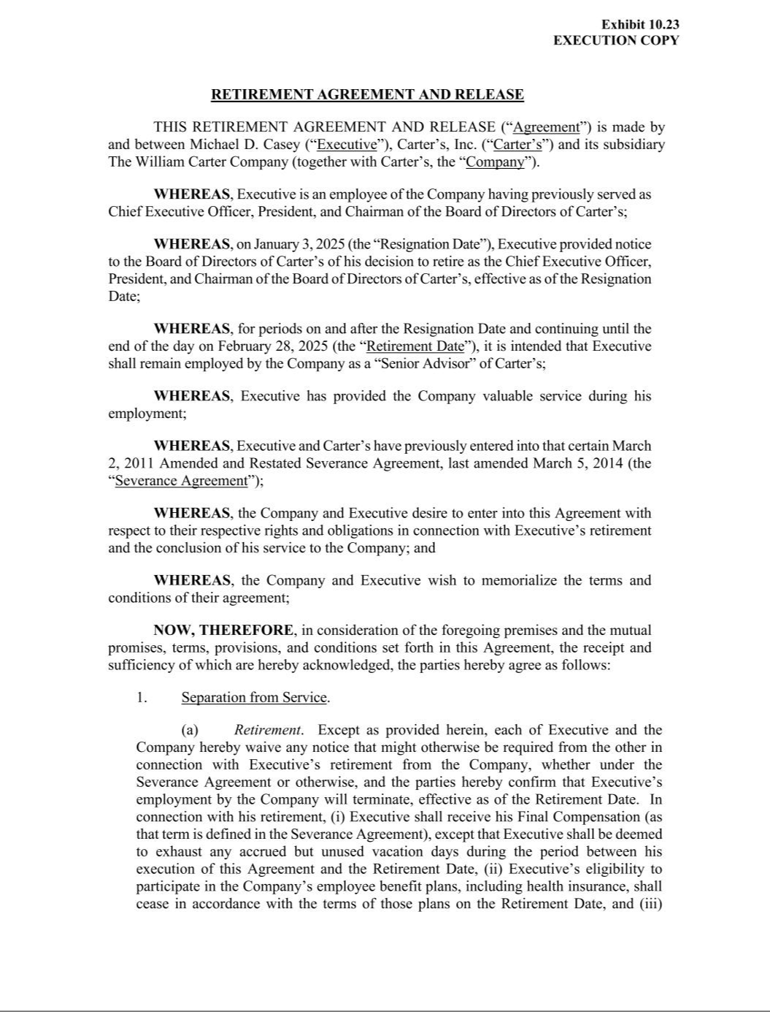

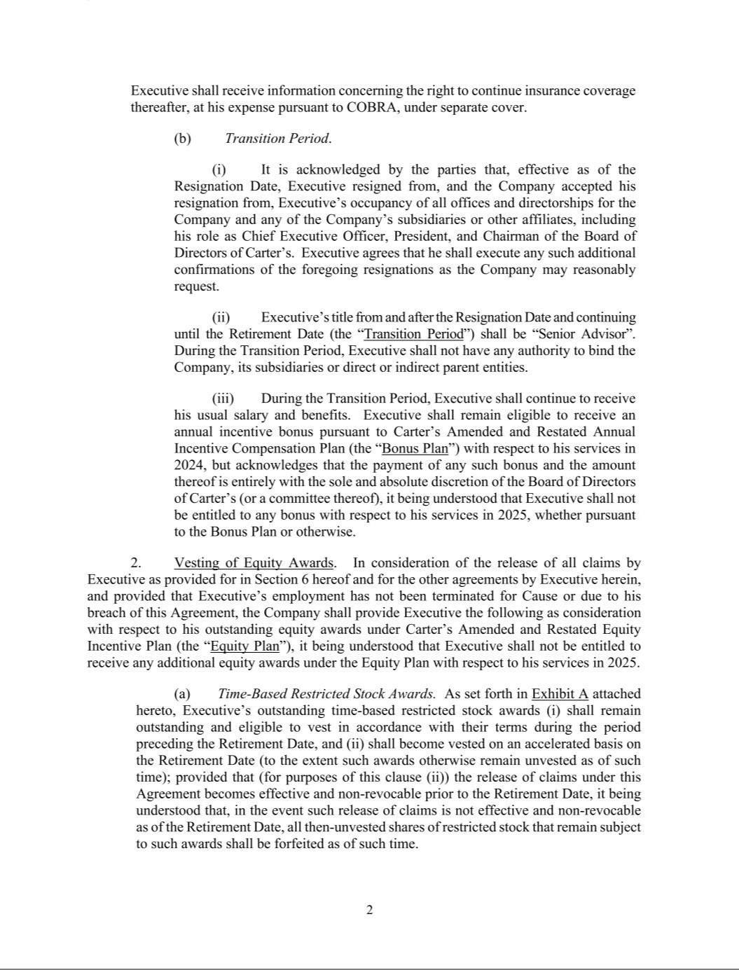

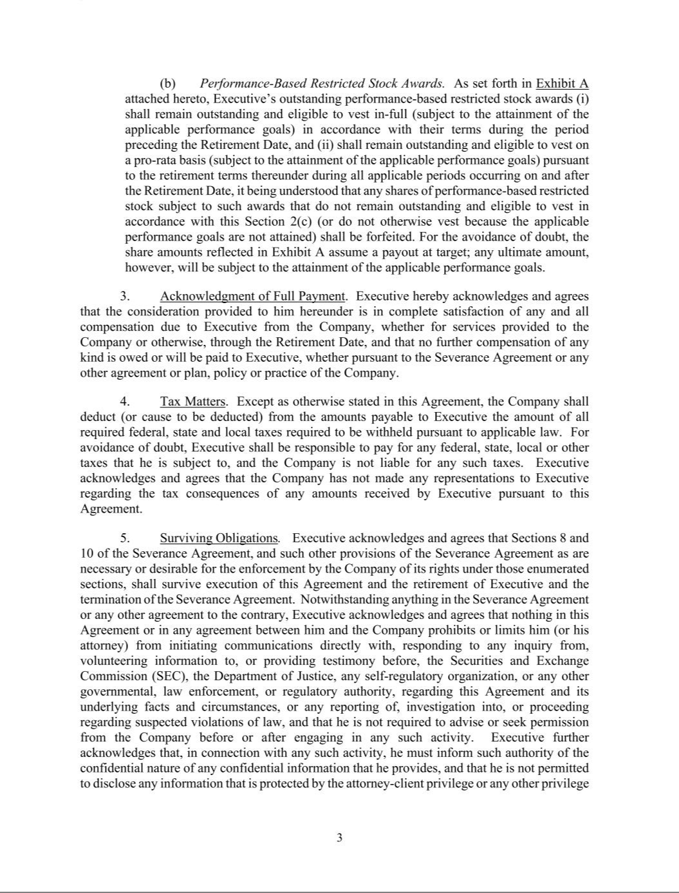

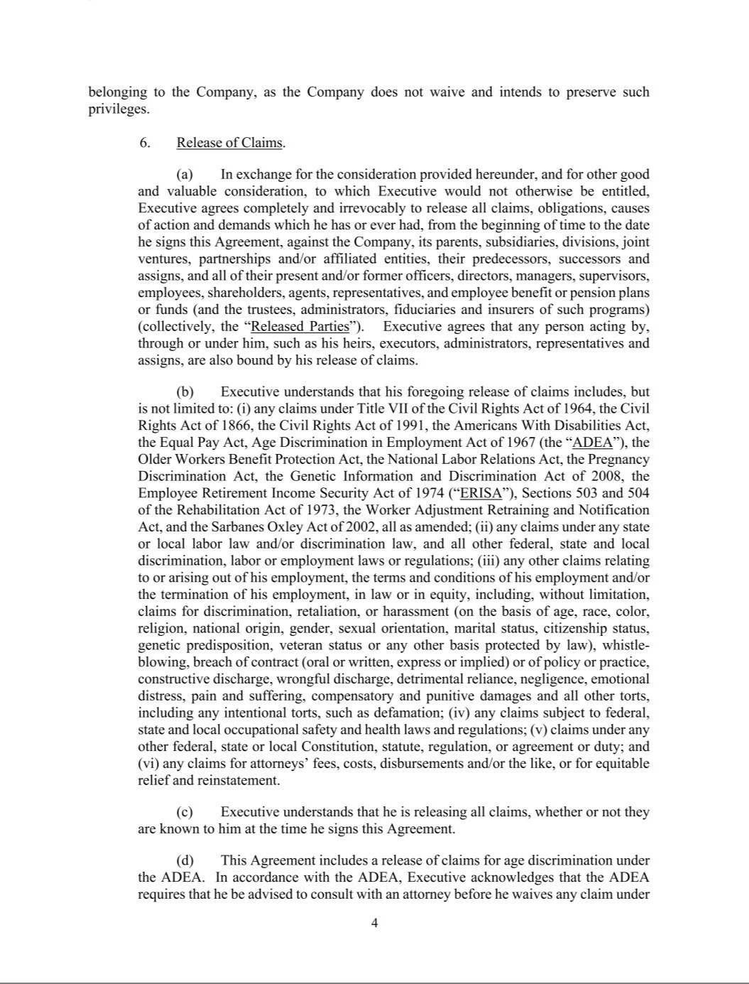

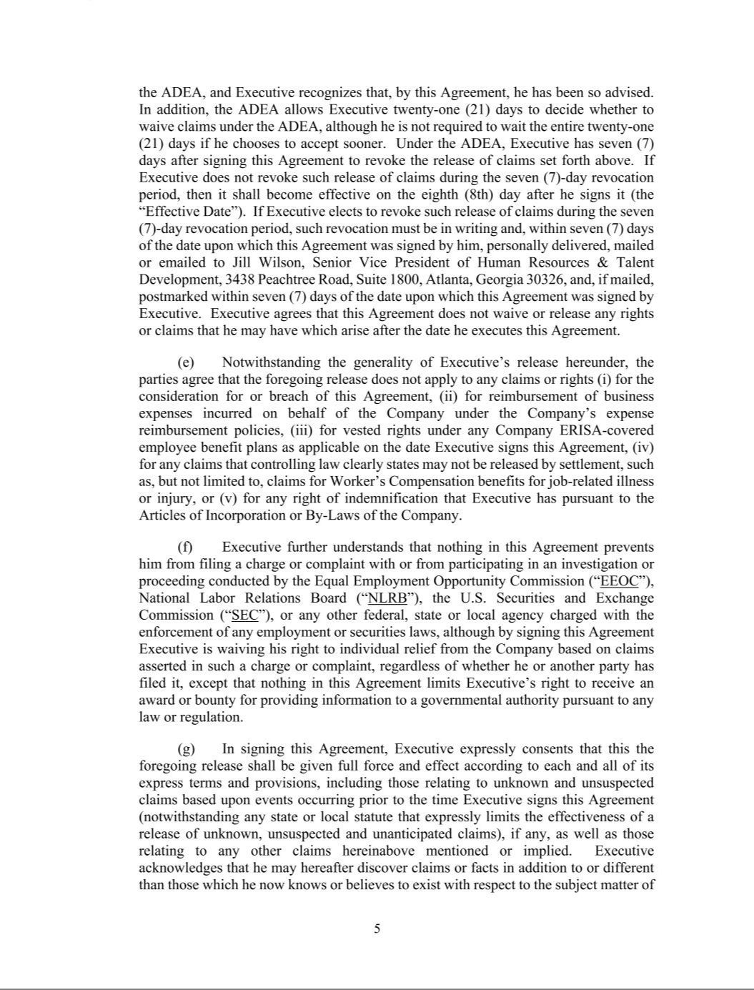

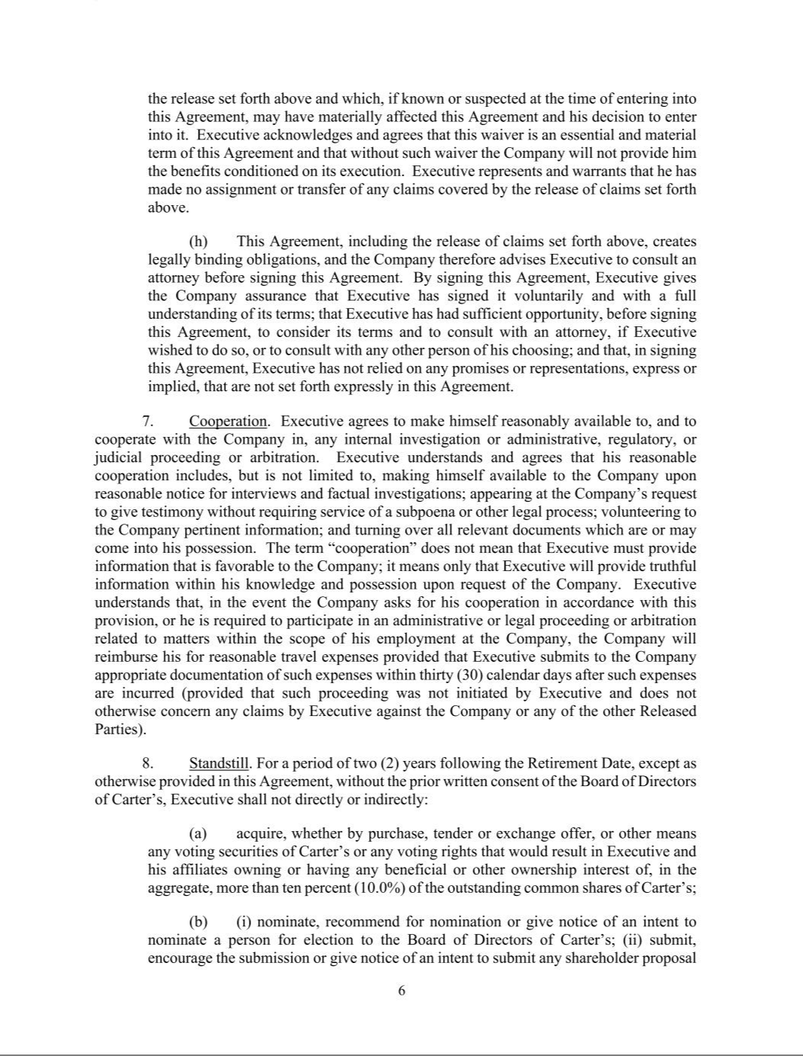

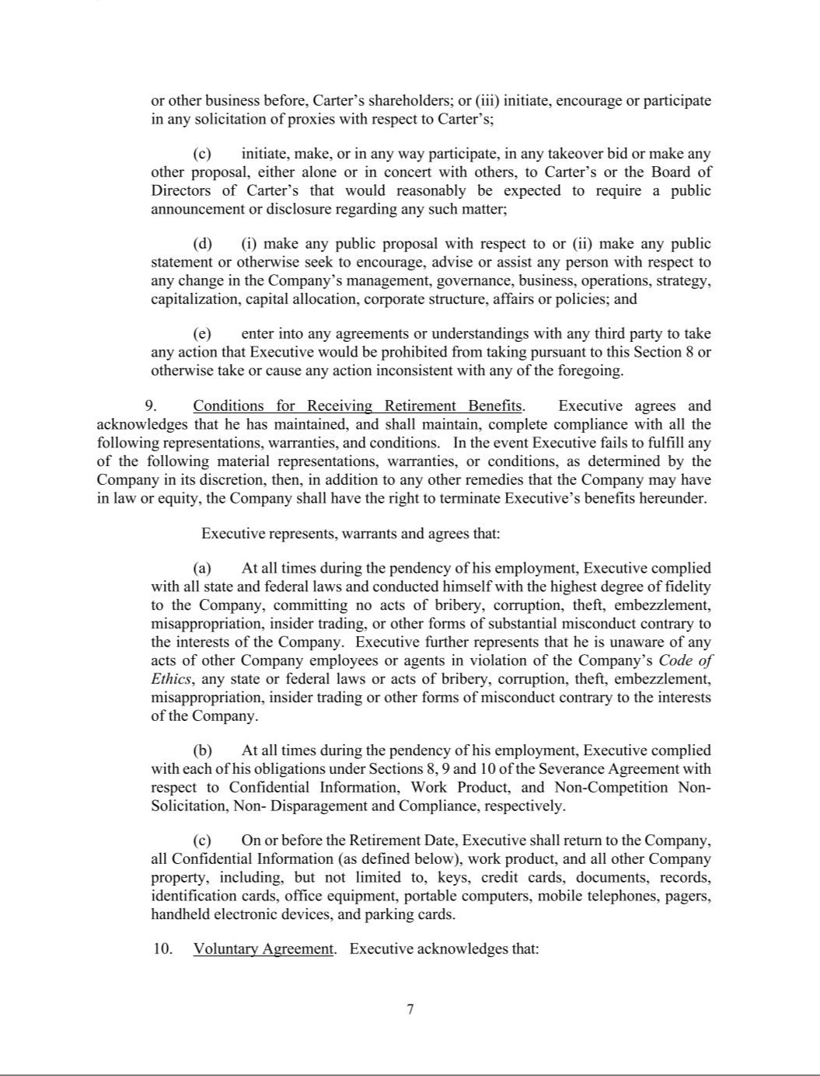

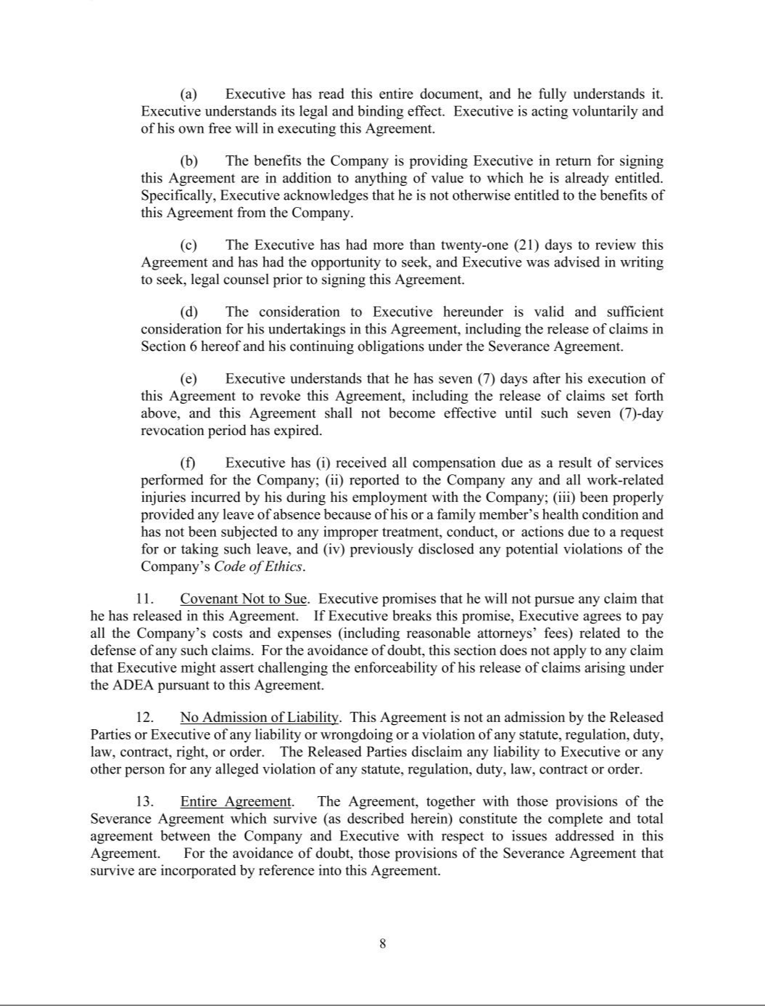

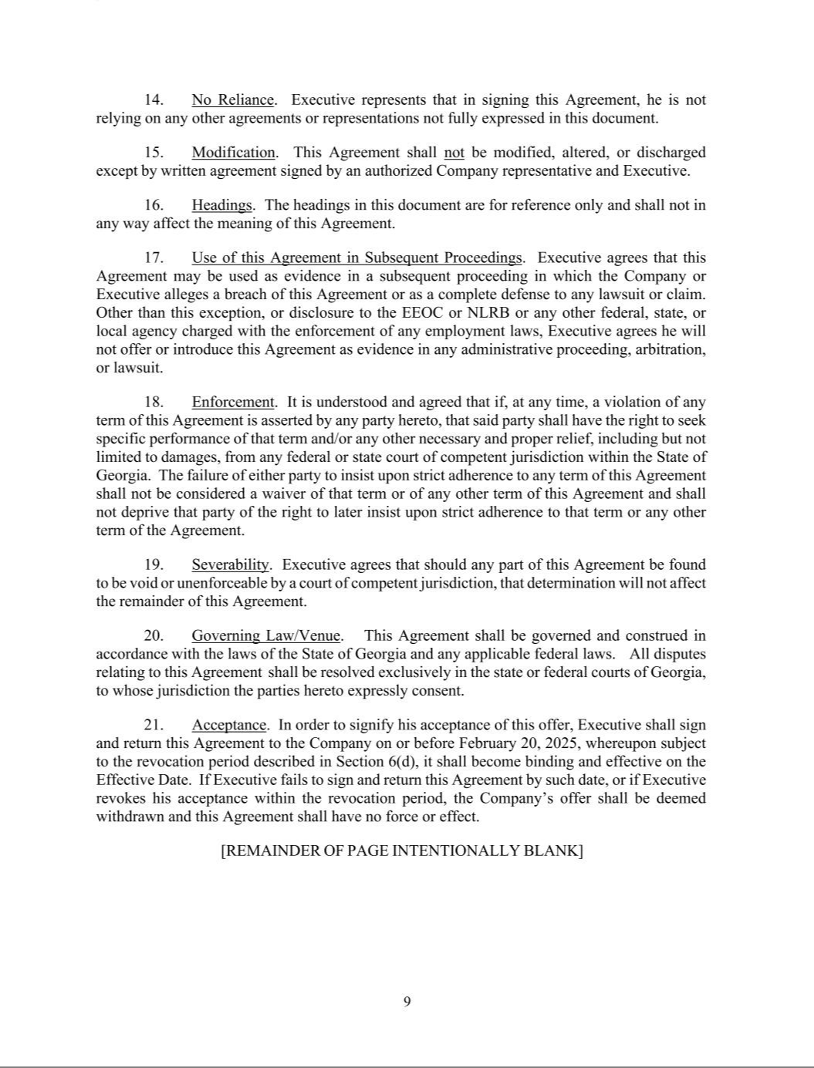

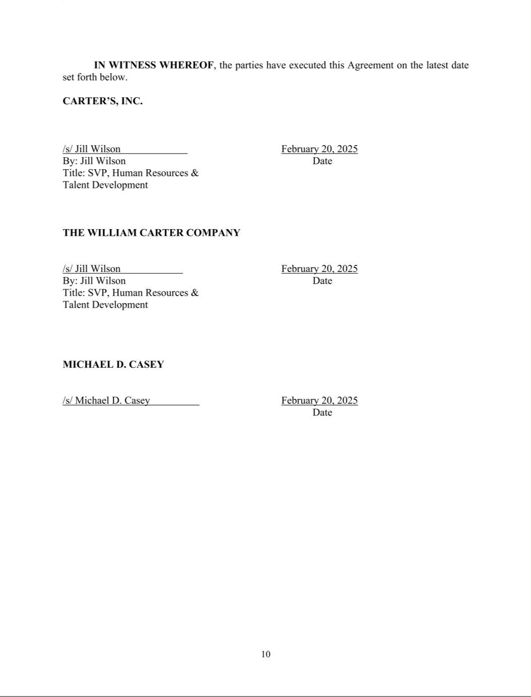

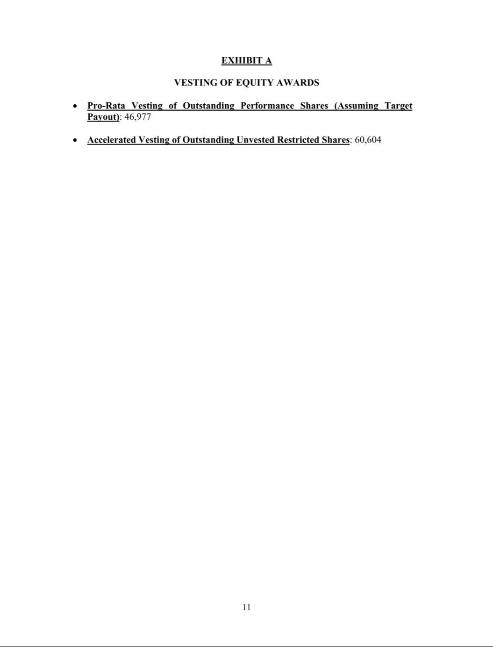

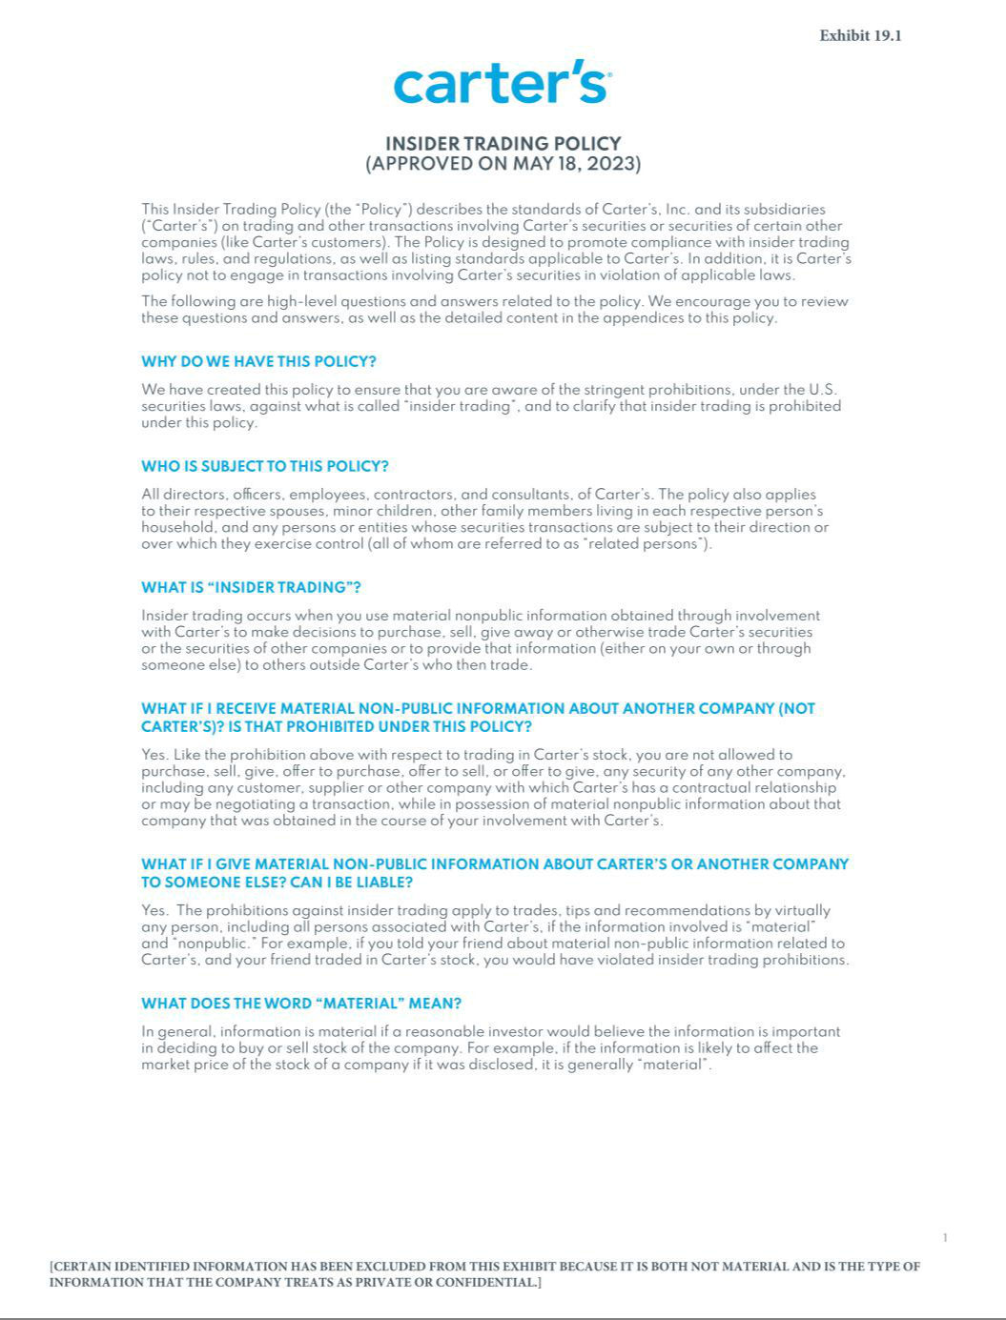

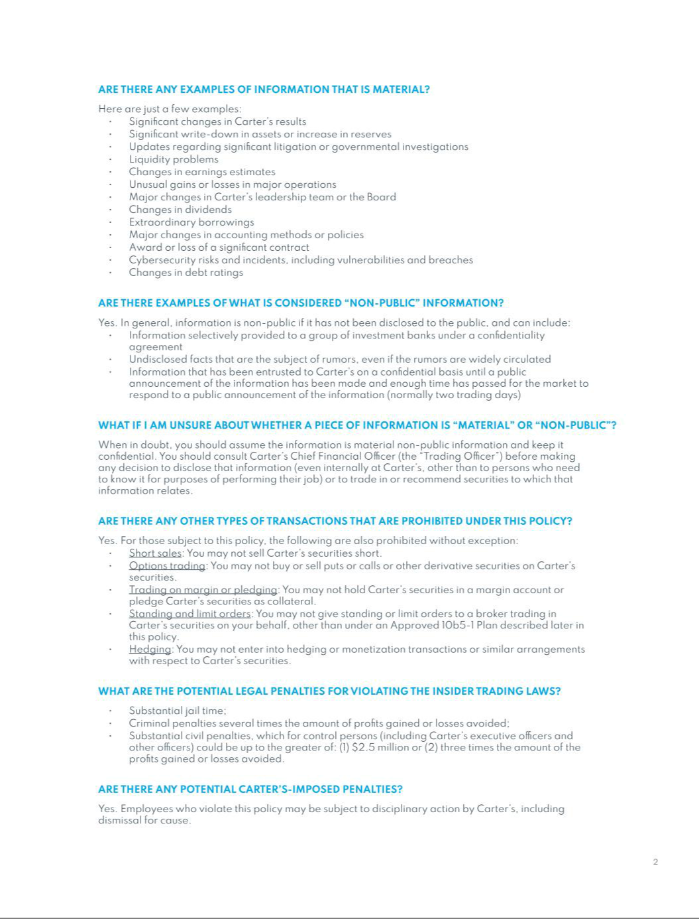

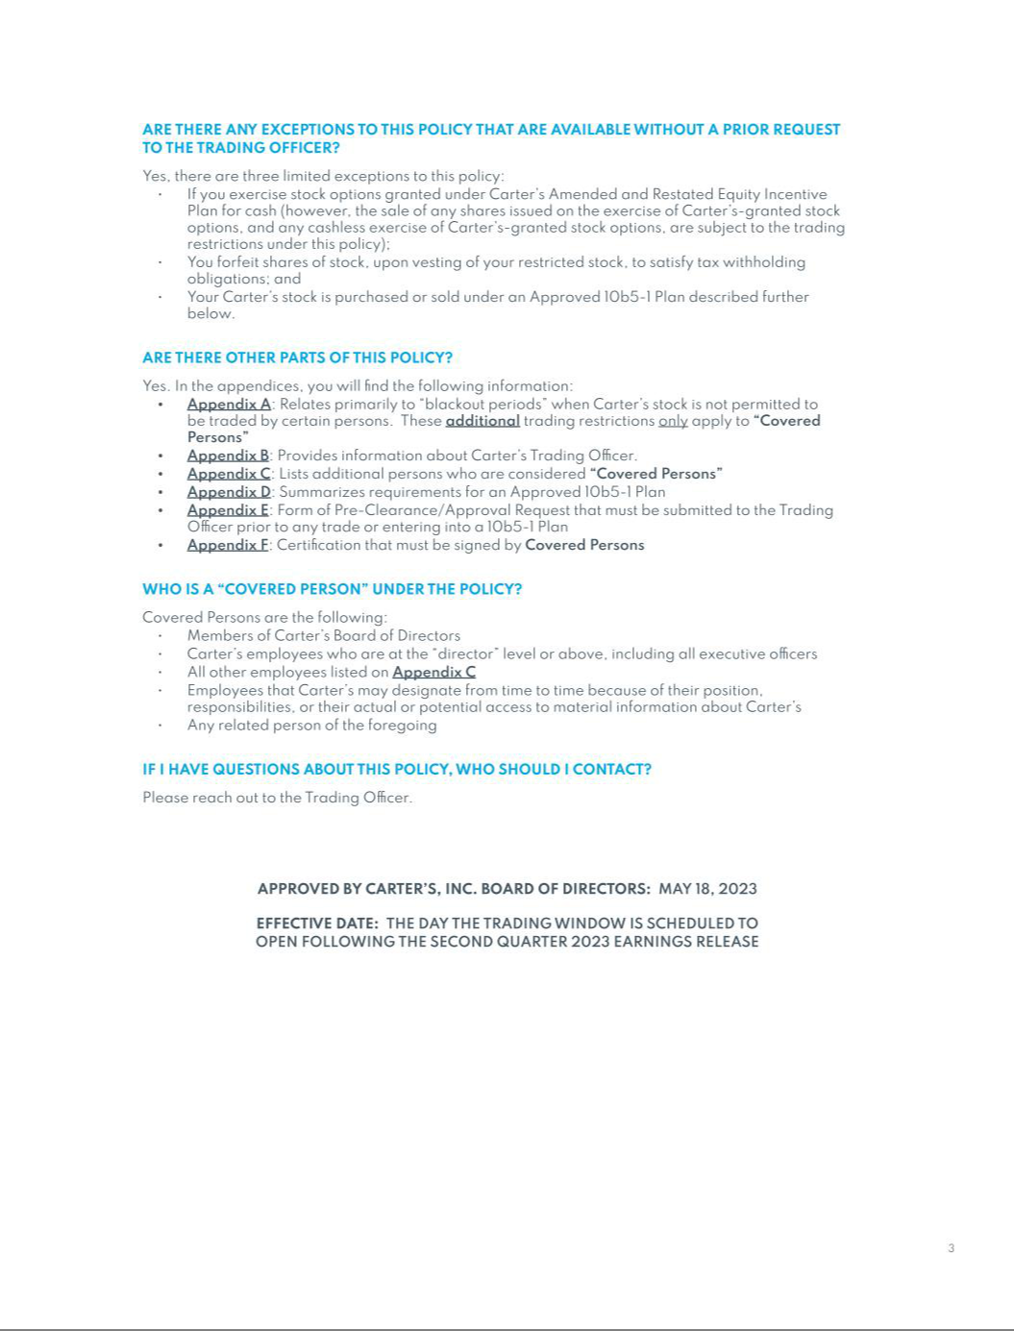

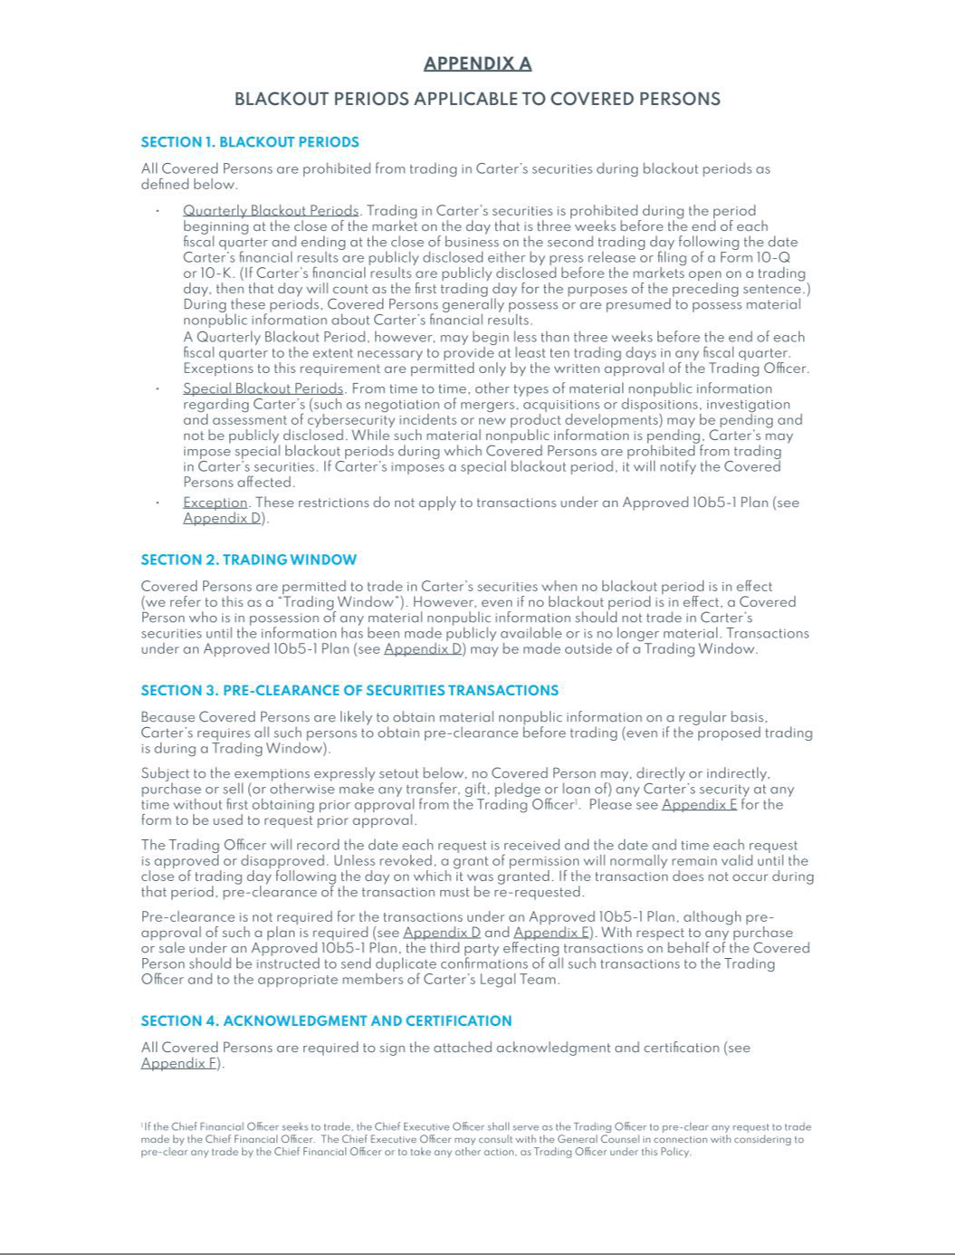

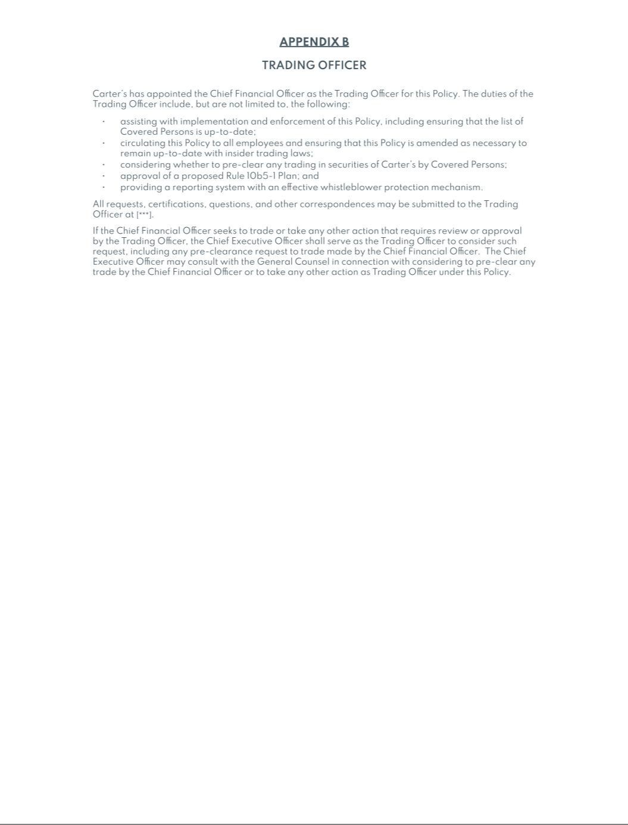

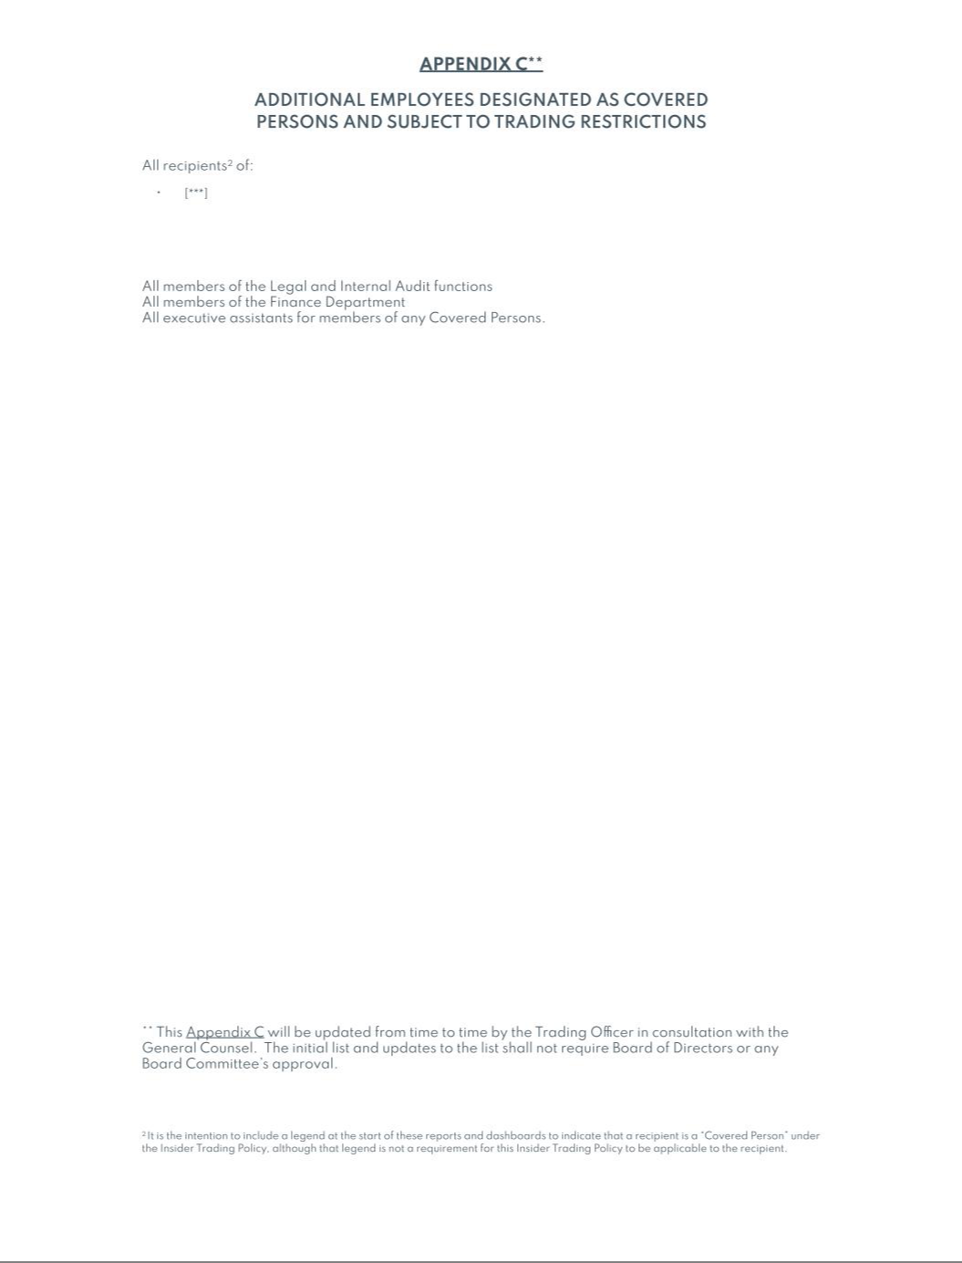

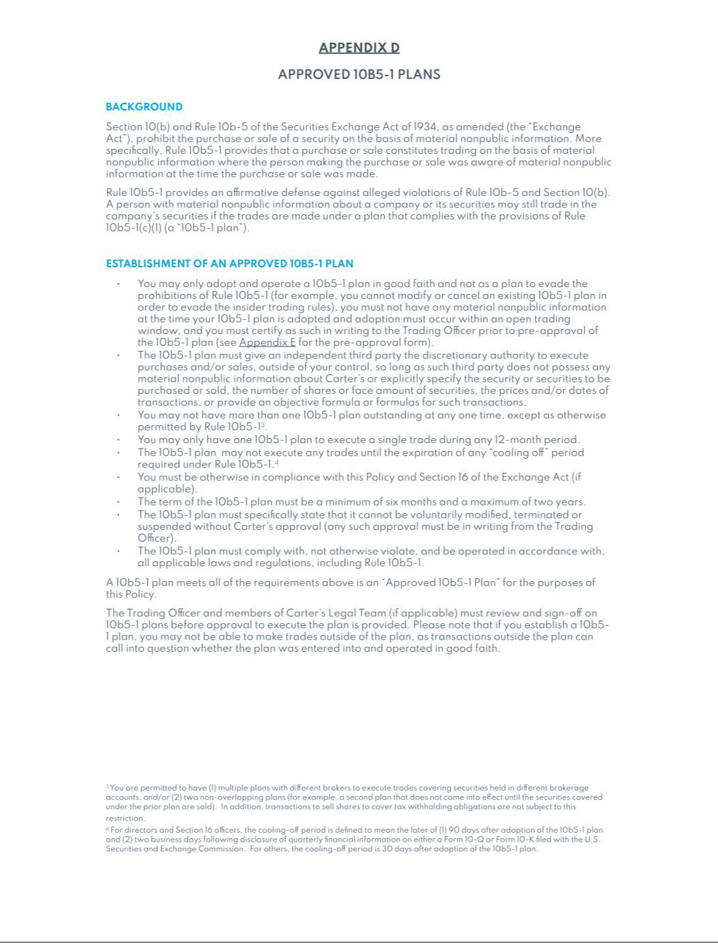

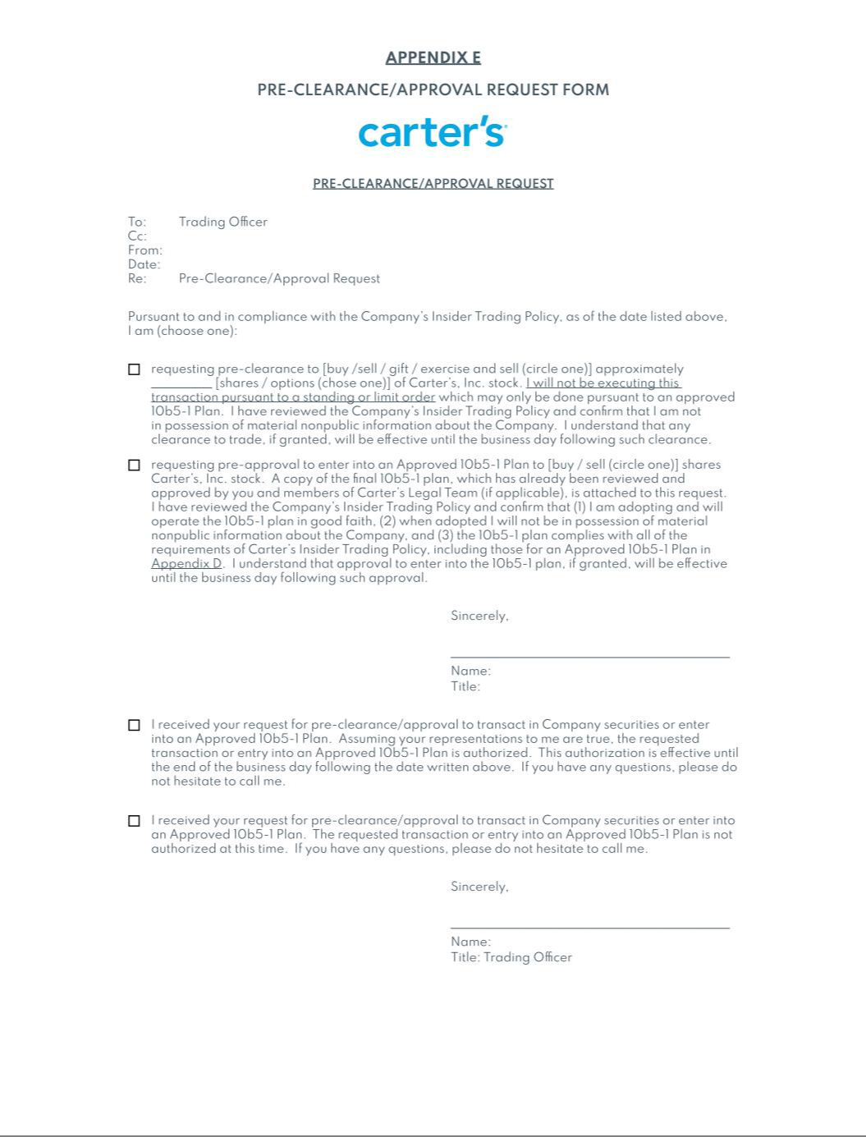

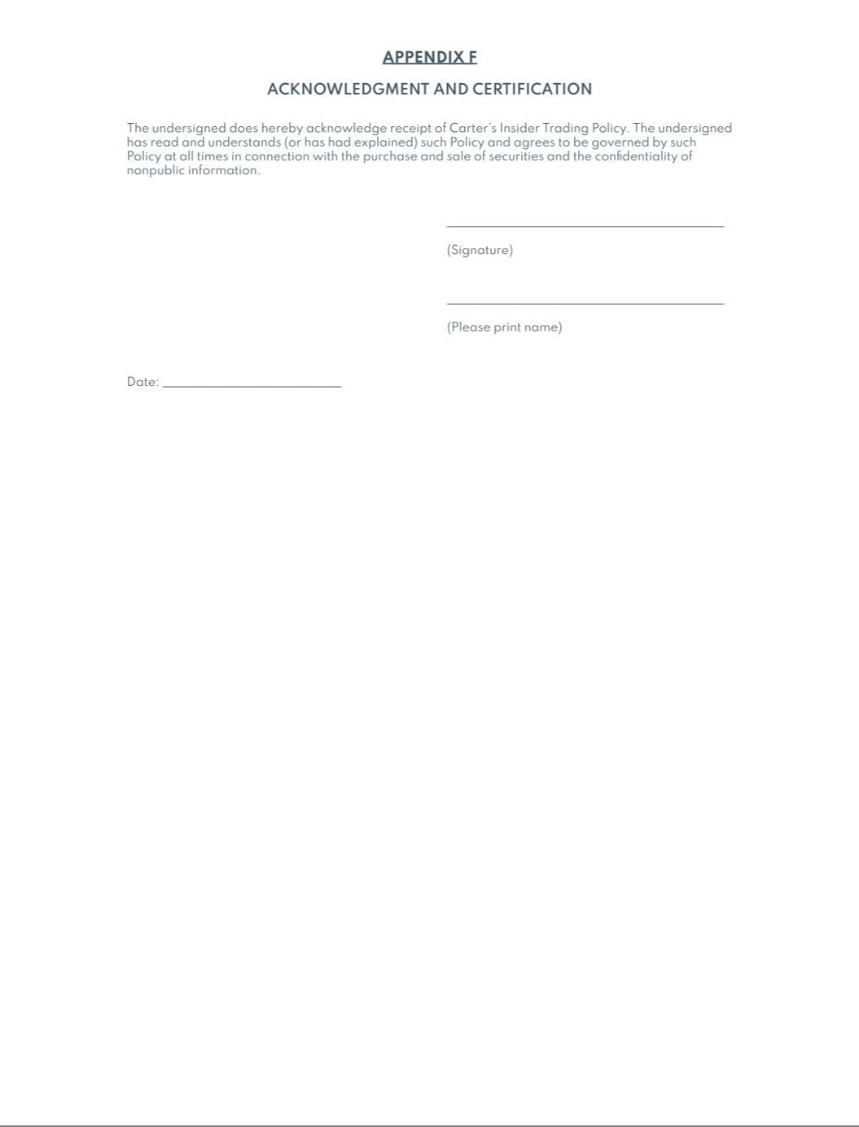

Exhibit 21

Subsidiaries of Carter's, Inc.

The William Carter Company is incorporated in Massachusetts

OshKosh B'Gosh, Inc. is incorporated in Delaware

Carter's Retail, Inc. is incorporated in Delaware

TWCC Product Development and Sales, Inc. is incorporated in Delaware

Carter's Giftcard Company, Inc. is incorporated in Florida

Skip Hop Holdings, Inc. is incorporated in Delaware

Skip Hop, Inc. is incorporated in New York

The Genuine Canadian Corp. is incorporated in Ontario, Canada

Carter's Global Sourcing Limited is formed in Hong Kong

Skip Hop (Shenzhen) Trading Company Limited is formed in China

Carter's Vietnam Company Limited is formed in Vietnam

Carter's Mexico LLC is formed in Delaware

Carters Brands, S.A. de C.V. is formed in Mexico

1

Exhibit 23

CONSENT OF INDEPENDENT REGISTERED PUBLIC ACCOUNTING FIRM

We hereby consent to the incorporation by reference in the Registration Statements on Form S-8 (Nos. 333-177724, 333-168446, 333-125306, and 333-225144) of Carter’s, Inc. of our report dated February 25, 2025 relating to the financial statements and the effectiveness of internal control over financial reporting, which appears in this Form 10-K.

/s/ PricewaterhouseCoopers LLP

Atlanta, Georgia

February 25, 2025

Exhibit 31.1

CERTIFICATION

I, Richard F. Westenberger, certify that:

- I have reviewed this annual report on Form 10-K of Carter’s, Inc.;

- Based on my knowledge, this report does not contain any untrue statement of a material fact or omit to state a material fact necessary to make the statements made, in light of the circumstances under which such statements were made, not misleading with respect to the period covered by this report;

- Based on my knowledge, the financial statements, and other financial information included in this report, fairly present in all material respects the financial condition, results of operations and cash flows of the registrant as of, and for, the periods presented in this report;

- I am responsible for establishing and maintaining disclosure controls and procedures (as defined in Exchange Act Rules 13a-15(e) and 15d-15(e)) and internal control over financial reporting (as defined in Exchange Act Rules 13a-15(f) and 15d-15(f)) for the registrant and have:

  - Designed such disclosure controls and procedures, or caused such disclosure controls and procedures to be designed under our supervision, to ensure that material information relating to the registrant, including its consolidated subsidiaries, is made known to us by others within those entities, particularly during the period in which this report is being prepared;

  - Designed such internal control over financial reporting, or caused such internal control over financial reporting to be designed under our supervision, to provide reasonable assurance regarding the reliability of financial reporting and the preparation of financial statements for external purposes in accordance with generally accepted accounting principles;

  - Evaluated the effectiveness of the registrant’s disclosure controls and procedures and presented in this report our conclusions about the effectiveness of the disclosure controls and procedures, as of the end of the period covered by this report based on such evaluation; and

  - Disclosed in this report any change in the registrant’s internal control over financial reporting that occurred during the registrant’s most recent fiscal quarter (the registrant’s

fourth fiscal quarter in the case of an annual report) that has materially affected, or is reasonably likely to materially affect, the registrant’s internal control over financial reporting; and

- I have disclosed, based on our most recent evaluation of internal control over financial reporting, to the registrant's auditors and the audit committee of the registrant's board of directors (or persons performing the equivalent functions):

  - All significant deficiencies and material weaknesses in the design or operation of internal control over financial reporting which are reasonably likely to adversely affect the registrant's ability to record, process, summarize and report financial information; and

  - Any fraud, whether or not material, that involves management or other employees who have a significant role in the registrant's internal control over financial reporting.

February 25, 2025 /s/ RICHARD F. WESTENBERGER

Richard F. Westenberger

Interim Chief Executive Officer,
Senior Executive Vice President,
Chief Financial Officer & Chief Operating Officer

Exhibit 32

CERTIFICATION

The undersigned in the capacity indicated hereby certifies that, to his knowledge, this Annual Report on Form 10-K for the fiscal year ended December 28, 2024 fully complies with the requirements of Section 13(a) or 15(d) of the Securities Exchange Act of 1934, and the information contained in this Report fairly presents, in all material respects, the financial condition and results of operations of Carter’s, Inc.

February 25, 2025 /s/ RICHARD F. WESTENBERGER

Richard F. Westenberger

Interim Chief Executive Officer,
Senior Executive Vice President,
Chief Financial Officer & Chief Operating Officer

The foregoing certification is being furnished solely pursuant to 18 U.S.C. § 1350 and is not being filed as part of the Annual Report on Form 10-K or as a separate disclosure document.

