UNITED STATES

SECURITIES AND EXCHANGE COMMISSION

Washington, D.C. 20549

FORM 10-Q

(Mark One)

- QUARTERLY REPORT PURSUANT TO SECTION 13 OR 15(d) OF THE SECURITIES EXCHANGE ACT OF 1934 For the quarterly period ended March 29, 2025

OR

- TRANSITION REPORT PURSUANT TO SECTION 13 OR 15(d) OF THE SECURITIES EXCHANGE ACT OF 1934
For the transition period from |  | to
Commission file number: 001-31829

 |  | CARTER’S, INC.
 |  | (Exact name of Registrant as specified in its charter)
 | Delaware |  |  | 13-3912933
 | (State or other jurisdiction of |  |  | (I.R.S. Employer Identification No.)
 | incorporation or organization)
 |  |  | Phipps Tower,
 |  | 3438 Peachtree Road NE, Suite 1800
 |  | Atlanta, Georgia 30326
 |  | (Address of principal executive offices, including zip code)
 |  | (678) 791-1000
 |  | (Registrant's telephone number, including area code)
Securities registered pursuant to Section 12(b) of the Act:
 | Title of Each Class |  | Trading Symbol(s) | Name of Each Exchange on Which Registered
 | Common stock, par value $0.01 per share |  | CRI | New York Stock Exchange

Indicate by check mark whether the registrant (1) has filed all reports required to be filed by Section 13 or 15(d) of the Securities Exchange Act of 1934 during the preceding 12 months (or for such shorter period that the registrant was required to file such reports), and (2) has been subject to such filing requirements for the past 90 days. Yes x No ☐

Indicate by check mark whether the registrant has submitted electronically every Interactive Data File required to be submitted pursuant to Rule 405 of Regulation S-T (§232.405 of this chapter) during the preceding 12 months (or for such shorter period that the registrant was required to submit such files). Yes x No ☐

Indicate by check mark whether the registrant is a large accelerated filer, an accelerated filer, a non-accelerated filer, a smaller reporting company, or an emerging growth company. See definition of “large accelerated filer,” “accelerated filer,” “smaller reporting company,” and “emerging growth company” in Rule 12b-2 of the Exchange Act.

Large accelerated filer x Accelerated filer ☐

Non-accelerated filer ☐ Smaller reporting company ☐

Emerging growth company ☐

If an emerging growth company, indicate by check mark if the registrant has elected not to use the extended transition period for complying with any new or revised financial accounting standards provided pursuant to Section 13(a) of the Exchange Act. ☐
Indicate by check mark whether the registrant is a shell company (as defined in Rule 12b-2 of the Exchange Act).Yes ☐ No x

As of April 17, 2025, there were 36,441,222 shares of the registrant’s common stock outstanding.

CARTER’S, INC.

INDEX

 |  |  |  |  |  |  |  |  |  |  |  |  |  |  |  |  |  |  |  |  |  |  |  |  |  | Page
 | Part I. Financial Information
 |  | Item 1. |  |  |  |  |  | Financial Statements
 |  |  |  |  |  |  |  | Unaudited Condensed Consolidated Balance Sheets as of March 29, 2025, December 28, 2024, and March 30, 2024 |  |  |  |  |  |  |  |  |  |  |  |  |  |  |  |  |  | 1
 |  |  |  |  |  |  |  | Unaudited Condensed Consolidated Statements of Operations for the fiscal quarter ended March 29, 2025 and March 30, 2024 |  |  |  |  |  |  |  |  |  |  |  |  |  |  |  |  |  | 2
 |  |  |  |  |  |  |  | Unaudited Condensed Consolidated Statements of Comprehensive Income for the fiscal quarter ended March 29, 2025 and March 30, 2024 |  |  |  |  |  |  |  |  |  |  |  |  |  |  |  |  |  | 3
 |  |  |  |  |  |  |  | Unaudited Condensed Consolidated Statements of Changes in Shareholders’ Equity for the fiscal quarter ended March 29, 2025 and March 30, 2024 |  |  |  |  |  |  |  |  |  |  |  |  |  |  |  |  |  | 4
 |  |  |  |  |  |  |  | Unaudited Condensed Consolidated Statements of Cash Flows for the fiscal quarter ended March 29, 2025 and March 30, 2024 |  |  |  |  |  |  |  |  |  |  |  |  |  |  |  |  |  |  |  | 5
 |  |  |  |  |  |  |  | Notes to the Unaudited Condensed Consolidated Financial Statements |  |  |  |  |  |  |  |  |  |  |  |  |  |  |  |  |  | 6
 |  | Item 2. |  |  |  |  |  | Management’s Discussion and Analysis of Financial Condition and Results of Operations |  |  |  |  |  |  |  |  |  |  |  |  |  |  |  |  |  | 14
 |  | Item 3. |  |  |  |  |  | Quantitative and Qualitative Disclosures about Market Risk |  |  |  |  |  |  |  |  |  |  |  |  |  |  |  |  |  | 26
 |  | Item 4. |  |  |  |  |  | Controls and Procedures |  |  |  |  |  |  |  |  |  |  |  |  |  |  |  |  |  | 26
 | Part II. Other Information
 |  | Item 1. |  |  |  |  |  | Legal Proceedings |  |  |  |  |  |  |  |  |  |  |  |  |  |  |  |  |  | 27
 |  | Item 1A. |  |  |  |  |  | Risk Factors |  |  |  |  |  |  |  |  |  |  |  |  |  |  |  |  |  | 27
 |  | Item 2. |  |  |  |  |  | Unregistered Sales of Equity Securities and Use of Proceeds |  |  |  |  |  |  |  |  |  |  |  |  |  |  |  |  |  | 27
 |  | Item 3. |  |  |  |  |  | Defaults upon Senior Securities |  |  |  |  |  |  |  |  |  |  |  |  |  |  |  |  |  | 28
 |  | Item 4. |  |  |  |  |  | Mine Safety Disclosures |  |  |  |  |  |  |  |  |  |  |  |  |  |  |  |  |  | 28
 |  | Item 5. |  |  |  |  |  | Other Information |  |  |  |  |  |  |  |  |  |  |  |  |  |  |  |  |  | 28
 |  | Item 6. |  |  |  |  |  | Exhibits |  |  |  |  |  |  |  |  |  |  |  |  |  |  |  |  |  | 28
 | Signatures |  |  |  |  |  |  |  |  |  |  |  |  |  |  |  |  |  |  |  |  |  |  |  |  | 29
 | Certifications

PART I - FINANCIAL INFORMATION

ITEM 1. FINANCIAL STATEMENTS

CARTER’S, INC.

CONDENSED CONSOLIDATED BALANCE SHEETS

(dollars in thousands, except per share data)

(unaudited)

 |  | March 29, 2025 |  |  | December 28, 2024 |  |  | March 30, 2024
ASSETS
Current assets:
Cash and cash equivalents | $ | 320,794 |  | $ | 412,926 |  | $ | 267,575
Accounts receivable, net of allowance for credit losses of $5,213, $5,663, and $5,159, respectively |  | 203,873 |  |  | 194,834 |  |  | 224,075
Finished goods inventories, net of inventory reserves of $9,641, $8,257, and $11,018, respectively |  | 474,124 |  |  | 502,332 |  |  | 473,362
Prepaid expenses and other current assets |  | 50,216 |  |  | 32,580 |  |  | 51,775
Total current assets |  | 1,049,007 |  |  | 1,142,672 |  |  | 1,016,787
Property, plant, and equipment, net of accumulated depreciation of $612,079, $602,670, and $628,627,
respectively |  | 179,247 |  |  | 180,956 |  |  | 182,513
Operating lease assets |  | 568,856 |  |  | 577,133 |  |  | 522,192
Tradenames, net |  | 268,836 |  |  | 268,008 |  |  | 298,141
Goodwill |  | 207,125 |  |  | 206,875 |  |  | 209,733
Customer relationships, net |  | 22,672 |  |  | 23,543 |  |  | 26,383
Other assets |  | 36,057 |  |  | 33,980 |  |  | 29,769
Total assets | $ | 2,331,800 |  | $ | 2,433,167 |  | $ | 2,285,518
LIABILITIES AND SHAREHOLDERS’ EQUITY
Current liabilities:
Accounts payable | $ | 199,056 |  | $ | 248,200 |  | $ | 191,406
Current operating lease liabilities |  | 125,556 |  |  | 130,564 |  |  | 133,190
Other current liabilities |  | 84,734 |  |  | 130,052 |  |  | 94,361
Total current liabilities |  | 409,346 |  |  | 508,816 |  |  | 418,957
Long-term debt, net |  | 498,328 |  |  | 498,127 |  |  | 497,543
Deferred income taxes |  | 45,300 |  |  | 38,210 |  |  | 48,090
Long-term operating lease liabilities |  | 498,628 |  |  | 501,503 |  |  | 444,375
Other long-term liabilities |  | 32,953 |  |  | 31,949 |  |  | 35,200
Total liabilities | $ | 1,484,555 |  | $ | 1,578,605 |  | $ | 1,444,165
Commitments and contingencies - Note 14
Shareholders’ equity:
Preferred stock; par value $0.01 per share;100,000 shares authorized; none issued or outstanding | $ | — |  | $ | — |  | $ | —
Common stock, voting; par value $0.01 per share; 150,000,000 shares authorized; 36,237,114, 36,041,995,
and 36,600,032 shares issued and outstanding, respectively |  | 362 |  |  | 360 |  |  | 366
Additional paid-in capital |  | 9,385 |  |  | 3,856 |  |  | —
Accumulated other comprehensive loss |  | (43,066) |  |  | (43,678) |  |  | (25,667)
Retained earnings |  | 880,564 |  |  | 894,024 |  |  | 866,654
Total shareholders’ equity |  | 847,245 |  |  | 854,562 |  |  | 841,353
Total liabilities and shareholders’ equity | $ | 2,331,800 |  | $ | 2,433,167 |  | $ | 2,285,518

See accompanying notes to the unaudited condensed consolidated financial statements.

1

Net sales

Cost of goods sold

Gross profit

Royalty income, net

Selling, general, and administrative expenses Operating income
Interest expense

Interest income

Other expense, net

Income before income taxes

Income tax provision

Net income

CARTER’S, INC.

CONDENSED CONSOLIDATED STATEMENTS OF OPERATIONS

(dollars in thousands, except per share data)

(unaudited)

Fiscal quarter ended

 | March 29, 2025 |  |  | March 30, 2024
$ | 629,827 |  | $ | 661,492
 | 338,737 |  |  | 346,302
 | 291,090 |  |  | 315,190
 | 5,332 |  |  | 5,216
 | 270,320 |  |  | 265,371
 | 26,102 |  |  | 55,035
 | 7,819 |  |  | 7,905
 | (3,142) |  |  | (3,089)
 | 76 |  |  | 274
 | 21,349 |  |  | 49,945
 | 5,810 |  |  | 11,912
$ | 15,539 |  | $ | 38,033

Basic net income per common share | $ | 0.43 | $ | 1.04
Diluted net income per common share | $ | 0.43 | $ | 1.04
Dividend declared and paid per common share | $ | 0.80 | $ | 0.80

See accompanying notes to the unaudited condensed consolidated financial statements.

2

Net income

Other comprehensive income:

Foreign currency translation adjustments Comprehensive income

CARTER’S, INC.

CONDENSED CONSOLIDATED STATEMENTS OF COMPREHENSIVE INCOME

(dollars in thousands)

(unaudited)

Fiscal quarter ended

 | March 29, 2025 |  |  | March 30, 2024
$ | 15,539 |  | $ | 38,033
 | 612 |  |  | (1,752)
$ | 16,151 |  | $ | 36,281

See accompanying notes to the unaudited condensed consolidated financial statements.

3

CARTER’S, INC.

CONDENSED CONSOLIDATED STATEMENTS OF CHANGES IN SHAREHOLDERS’ EQUITY

(amounts in thousands, except share amounts)

(unaudited)

 | Common stock - |  |  |  |  | Additional paid-in |  |  |  | Accumulated other |  |  |  |  |  | Total shareholders’
 | shares |  |  | Common stock - $ |  |  | capital |  |  | comprehensive loss |  |  | Retained earnings |  |  | equity
Balance at December 28, 2024 | 36,041,995 |  | $ | 360 |  | $ | 3,856 |  | $ | (43,678) |  | $ | 894,024 |  | $ | 854,562
Withholdings from vesting
of restricted stock | (93,538) |  |  | (1) |  |  | (4,221) |  |  | — |  |  | — |  |  | (4,222)
Restricted stock activity | 288,657 |  |  | 3 |  |  | (3) |  |  | — |  |  | — |  |  | —
Stock-based compensation expense | — |  |  | — |  |  | 9,753 |  |  | — |  |  | — |  |  | 9,753
Cash dividends declared and paid of $0.80 per common
share | — |  |  | — |  |  | — |  |  | — |  |  | (28,999) |  |  | (28,999)
Comprehensive income | — |  |  | — |  |  | — |  |  | 612 |  |  | 15,539 |  |  | 16,151
Balance at March 29, 2025 | 36,237,114 |  | $ | 362 |  | $ | 9,385 |  | $ | (43,066) |  | $ | 880,564 |  | $ | 847,245

 | Common stock - |  |  |  |  | Additional paid-in |  |  |  | Accumulated other |  |  |  |  |  | Total shareholders’
 | shares |  |  | Common stock - $ |  |  | capital |  |  | comprehensive loss |  |  | Retained earnings |  |  | equity
Balance at December 30, 2023 | 36,551,221 |  | $ | 366 |  | $ | — |  | $ | (23,915) |  | $ | 868,799 |  | $ | 845,250
Exercise of stock options | 4,408 |  |  | — |  |  | 367 |  |  | — |  |  | — |  |  | 367
Withholdings from vesting
of restricted stock | (90,922) |  |  | (1) |  |  | (5,535) |  |  | — |  |  | (1,842) |  |  | (7,378)
Restricted stock activity | 243,120 |  |  | 2 |  |  | (2) |  |  | — |  |  | — |  |  | —
Stock-based compensation expense | — |  |  | — |  |  | 5,170 |  |  | — |  |  | — |  |  | 5,170
Repurchase of common stock | (107,795) |  |  | (1) |  |  | — |  |  | — |  |  | (8,998) |  |  | (8,999)
Cash dividends declared and paid of $0.80 per common
share | — |  |  | — |  |  | — |  |  | — |  |  | (29,338) |  |  | (29,338)
Comprehensive income | — |  |  | — |  |  | — |  |  | (1,752) |  |  | 38,033 |  |  | 36,281
Balance at March 30, 2024 | 36,600,032 |  | $ | 366 |  | $ | — |  | $ | (25,667) |  | $ | 866,654 |  | $ | 841,353

See accompanying notes to the unaudited condensed consolidated financial statements.

4

CARTER’S, INC.

CONDENSED CONSOLIDATED STATEMENTS OF CASH FLOWS

(dollars in thousands)

(unaudited)

 | Fiscal quarter ended
 | March 29, 2025 |  |  | March 30, 2024
Cash flows from operating activities:
Net income | $ | 15,539 |  | $ | 38,033
Adjustments to reconcile net income to net cash used in operating activities:
Depreciation of property, plant, and equipment |  | 12,340 |  |  | 13,905
Amortization of intangible assets |  | 914 |  |  | 929
Provision for excess and obsolete inventory, net |  | 1,385 |  |  | 2,026
Amortization of debt issuance costs |  | 415 |  |  | 403
Stock-based compensation expense |  | 9,753 |  |  | 5,170
Unrealized foreign currency exchange (gain) loss, net |  | (295) |  |  | 9
(Recoveries of) provisions for doubtful accounts receivable from customers |  | (454) |  |  | 561
Unrealized gain on investments |  | (329) |  |  | (618)
Deferred income taxes |  | 6,572 |  |  | 6,811
Effect of changes in operating assets and liabilities:
Accounts receivable |  | (8,603) |  |  | (40,746)
Finished goods inventories |  | 27,122 |  |  | 61,039
Prepaid expenses and other assets |  | (19,035) |  |  | (22,386)
Accounts payable and other liabilities |  | (93,968) |  |  | (90,687)
Net cash used in operating activities | $ | (48,644) |  | $ | (25,551)
Cash flows from investing activities:
Capital expenditures | $ | (10,346) |  | $ | (12,017)
Net cash used in investing activities | $ | (10,346) |  | $ | (12,017)
Cash flows from financing activities:
Dividends paid | $ | (28,999) |  | $ | (29,338)
Repurchases of common stock |  | — |  |  | (8,999)
Withholdings from vesting of restricted stock |  | (4,222) |  |  | (7,378)
Proceeds from exercises of stock options |  | — |  |  | 367
Other |  | (370) |  |  | —
Net cash used in financing activities | $ | (33,591) |  | $ | (45,348)
Net effect of exchange rate changes on cash and cash equivalents |  | 449 |  |  | (722)
Net decrease in cash and cash equivalents | $ | (92,132) |  | $ | (83,638)
Cash and cash equivalents, beginning of period |  | 412,926 |  |  | 351,213
Cash and cash equivalents, end of period | $ | 320,794 |  | $ | 267,575

See accompanying notes to the unaudited condensed consolidated financial statements.

5

CARTER’S, INC.

NOTES TO CONDENSED CONSOLIDATED FINANCIAL STATEMENTS

(unaudited)

NOTE 1 – THE COMPANY

Carter’s, Inc. and its wholly owned subsidiaries (collectively, the “Company”) design, source, and market branded childrenswear under the Carter’s, OshKosh B’gosh (or “OshKosh”), Skip Hop, Child of Mine, Just One You, Simple Joys, Little Planet, and other brands. The Company’s products are sourced through contractual arrangements with manufacturers worldwide for wholesale distribution to leading department stores, national chains, and specialty retailers domestically and internationally and for sale in the Company’s retail stores and on its eCommerce sites that market its brand name merchandise and other licensed products manufactured by other companies.

Our trademarks that are referred to in this Quarterly Report on Form 10-Q, including Carter’s, OshKosh B’gosh, OshKosh, Skip Hop, Child of Mine, Just One You, Simple Joys, Little Planet, PurelySoft, and Carter’s Rewards, many of which are registered in the United States and in over 100 other countries and territories, are each the property of one or more subsidiaries of Carter’s, Inc.

NOTE 2 – BASIS OF PRESENTATION AND RECENT ACCOUNTING PRONOUNCEMENTS

The accompanying unaudited condensed consolidated financial statements of the Company have been prepared in accordance with accounting principles generally accepted in the United States (“U.S. GAAP”) for interim financial information and the rules and regulations of the U.S. Securities and Exchange Commission (the “SEC”). All intercompany transactions and balances have been eliminated in consolidation.

In the opinion of management, the accompanying unaudited condensed consolidated financial statements contain all normal and recurring adjustments necessary to state fairly the consolidated financial condition, results of operations, comprehensive income, statement of shareholders’ equity, and cash flows of the Company for the interim periods presented. Except as otherwise disclosed, all such adjustments consist only of those of a normal recurring nature. Operating results for the fiscal quarter ended March 29, 2025 are not necessarily indicative of the results that may be expected for the current fiscal year ending January 3, 2026.

The preparation of these unaudited condensed consolidated financial statements in conformity with U.S. GAAP requires management to make estimates and assumptions that affect the reported amounts of assets and liabilities and disclosures of contingent assets and liabilities at the date of the financial statements, and the reported amounts of revenues and expenses during the reporting periods. Actual results could differ from those estimates.

The accompanying condensed consolidated balance sheet as of December 28, 2024 was derived from the Company’s audited consolidated financial statements included in its most recently filed Annual Report on Form 10-K. Certain information and footnote disclosure normally included in financial statements prepared in accordance with U.S. GAAP have been condensed or omitted pursuant to the rules and regulations of the SEC and the instructions to Form 10-Q.

The Company operates on a 52 or 53 week fiscal calendar. Fiscal 2025 will end on January 3, 2026 and includes 53 weeks. Fiscal 2024 ended on December 28, 2024 and included 52 weeks. The fiscal quarters ended March 29, 2025 and March 30, 2024 each included 13 weeks.

Accounting Policies

The accounting policies the Company follows are set forth in its most recently filed Annual Report on Form 10-K. There have been no material changes to these accounting policies.

Recent Accounting Pronouncements

Income Taxes - Improvements to Income Tax Disclosures (ASU 2023-09)

In December 2023, the FASB issued ASU No. 2023-09, Income Taxes - Improvements to Income Tax Disclosures. This new guidance requires consistent categories and greater disaggregation of information in the rate reconciliation and greater disaggregation of income taxes paid by jurisdiction. ASU 2023-09 is effective for fiscal years beginning after December 15, 2024. Early adoption is permitted. The Company is currently evaluating the impact of this amendment on its consolidated financial statements but does not expect the effect of the adoption of ASU 2023-09 to be material.

6

NOTES TO CONDENSED CONSOLIDATED FINANCIAL STATEMENTS (continued)

Disaggregation of Income Statement Expenses (ASU 2024-03)

In November 2024, the FASB issued ASU No. 2024-03, Disaggregation of Income Statement Expenses. This new guidance is intended to increase transparency and comparability of financial statements by requiring disclosure of significant expense components for certain expenses on the face of the consolidated statement of operations. The ASU is effective for fiscal years beginning after December 15, 2026 and for interim periods within fiscal years beginning after December 15, 2027, with early adoption permitted. The Company is currently evaluating the impact that this standard will on its consolidated financial statements but does not expect the effect of the adoption of ASU 2024-03 to be material.

NOTE 3 – REVENUE RECOGNITION

The Company’s revenues are earned from contracts or arrangements with retail and wholesale customers and licensees. Contracts include written agreements, as well as arrangements that are implied by customary practices or law.

Disaggregation of Revenue

The Company sells its products directly to consumers (“direct-to-consumer”) and to other retail companies and partners that subsequently sell the products directly to their own retail customers (“wholesale channel”). The Company also earns royalties from certain of its licensees. Disaggregated revenues from these sources for the fiscal periods presented were as follows:

 |  |  |  |  |  |  | Fiscal quarter ended March 29, 2025
(dollars in thousands) |  | U.S. Retail |  |  |  |  | U.S. Wholesale |  |  |  | International |  |  |  |  | Total
Direct-to-consumer | $ | 294,432 |  |  |  | $ |  | — |  | $ |  |  | 53,823 |  | $ | 348,255
Wholesale channel |  |  |  | — |  |  | 250,096 |  |  |  |  |  | 31,476 |  |  | 281,572
 | $ | 294,432 |  |  |  | $ | 250,096 |  |  | $ |  |  | 85,299 |  | $ | 629,827
Royalty income, net | $ | 1,518 |  |  |  | $ | 3,322 |  |  | $ |  |  | 492 |  | $ | 5,332

 |  |  |  |  |  |  | Fiscal quarter ended March 30, 2024
(dollars in thousands) |  | U.S. Retail |  |  |  |  | U.S. Wholesale |  |  |  | International |  |  |  |  | Total
Direct-to-consumer | $ | 307,642 |  |  |  | $ |  | — |  | $ |  |  | 55,061 |  | $ | 362,703
Wholesale channel |  |  |  | — |  |  | 264,131 |  |  |  |  |  | 34,658 |  |  | 298,789
 | $ | 307,642 |  |  |  | $ | 264,131 |  |  | $ |  |  | 89,719 |  | $ | 661,492
Royalty income, net | $ | 1,485 |  |  |  | $ | 3,359 |  |  | $ |  |  | 372 |  | $ | 5,216

Accounts Receivable from Customers and Licensees

The components of Accounts receivable, net, were as follows:

(dollars in thousands) |  | March 29, 2025 |  |  | December 28, 2024 |  |  | March 30, 2024
Trade receivables from wholesale customers, net | $ | 196,109 |  | $ | 187,715 |  | $ | 219,842
Royalties receivable, net |  | 4,830 |  |  | 3,728 |  |  | 5,366
Other receivables |  | 11,241 |  |  | 13,444 |  |  | 11,266
Total receivables | $ | 212,180 |  | $ | 204,887 |  | $ | 236,474
Less: Wholesale accounts receivable reserves⁽¹⁾⁽²⁾ |  | (8,307) |  |  | (10,053) |  |  | (12,399)
Accounts receivable, net | $ | 203,873 |  | $ | 194,834 |  | $ | 224,075

- Includes allowance for chargebacks of $3.1 million, $4.4 million, and $7.2 million for the periods ended March 29, 2025, December 28, 2024, and March 30, 2024, respectively.

- Includes allowance for credit losses of $5.2 million, $5.7 million, and $5.2 million for the periods ended March 29, 2025, December 28, 2024, and March 30, 2024, respectively.

Contract Assets and Liabilities

The Company’s contract assets are not material.

7

NOTES TO CONDENSED CONSOLIDATED FINANCIAL STATEMENTS (continued)

Contract Liabilities

The Company recognizes a contract liability when it has received consideration from a customer and has a future obligation to transfer goods to the customer. Total contract liabilities consisted of the following amounts:

(dollars in thousands) |  | March 29, 2025 |  |  | December 28, 2024 |  |  | March 30, 2024
Contract liabilities - current:
Unredeemed gift cards⁽¹⁾ | $ | 24,275 |  | $ | 25,043 |  | $ | 24,405
Unredeemed customer loyalty rewards |  | 2,098 |  |  | 2,552 |  |  | 2,994
Carter’s credit card - upfront bonus⁽²⁾ |  | 536 |  |  | 714 |  |  | 714
Total contract liabilities - current⁽³⁾ | $ | 26,909 |  | $ | 28,309 |  | $ | 28,113
Contract liabilities - non-current⁽⁴⁾ | $ | — |  | $ | — |  | $ | 536
Total contract liabilities | $ | 26,909 |  | $ | 28,309 |  | $ | 28,649

- During the first quarters of fiscal 2025 and fiscal 2024, the Company recognized revenue of $3.6 million and $3.7 million related to the gift card liability balance that existed at December 28, 2024 and December 30, 2023, respectively.

- The Company received an upfront signing bonus from a third-party financial institution, which will be recognized as revenue on a straight-line basis over the term of the agreement. This amount reflects the current portion of this bonus to be recognized as revenue over the next twelve months.
- Included with Other current liabilities on the Company’s condensed consolidated balance sheets.

- This amount reflects the non-current portion of the Carter’s credit card upfront bonus and is included within Other long-term liabilities on the Company’s condensed consolidated balance sheets.

NOTE 4 – OTHER CURRENT LIABILITIES

Other current liabilities at the end of any comparable period, were as follows:

(dollars in thousands) |  | March 29, 2025 |  |  | December 28, 2024 |  |  | March 30, 2024
Unredeemed gift cards | $ | 24,275 |  | $ | 25,043 |  | $ | 24,405
Accrued employee benefits |  | 13,079 |  |  | 20,824 |  |  | 11,308
Income taxes payable |  | 9,261 |  |  | 13,820 |  |  | 13,475
Accrued taxes |  | 8,169 |  |  | 14,455 |  |  | 12,037
Accrued salaries and wages |  | 4,766 |  |  | 12,345 |  |  | 5,078
Other |  | 25,184 |  |  | 43,565 |  |  | 28,058
Other current liabilities | $ | 84,734 |  | $ | 130,052 |  | $ | 94,361

NOTE 5 – SUPPLY CHAIN FINANCE PROGRAM

We have established a voluntary supply chain finance (“SCF”) program through participating financial institutions. This SCF program enables participating suppliers to accelerate payments for receivables due from the Company by selling them directly to the participating financial institutions at their discretion. As of March 29, 2025, the SCF program has a $70.0 million revolving capacity. We are not a party to the agreements between the participating financial institutions and the suppliers in connection with the SCF program. Payment terms for most of our suppliers are 60 days, regardless of participation in the SCF program. The Company does not provide any guarantees under the SCF program.

The Company’s liability related to amounts payable to the participating financial institution for suppliers who voluntarily participate in the SCF program are included in Accounts payable on our consolidated balance sheets. As of March 29, 2025, December 28, 2024, and March 30, 2024, amounts under the SCF program included in Accounts payable were $14.3 million, $19.0 million, and $20.5 million, respectively. Payments made in connection with the SCF program, like payments of other accounts payable, are reflected as a reduction to our operating cash flow.

8

NOTES TO CONDENSED CONSOLIDATED FINANCIAL STATEMENTS (continued)

NOTE 6 – LONG-TERM DEBT

Long-term debt consisted of the following:

(dollars in thousands) |  | March 29, 2025 |  |  | December 28, 2024 |  |  | March 30, 2024
$500 million 5.625% Senior Notes due 2027 | $ | 500,000 |  | $ | 500,000 |  | $ | 500,000
Less unamortized issuance-related costs for senior notes |  | (1,672) |  |  | (1,873) |  |  | (2,457)
Senior notes, net | $ | 498,328 |  | $ | 498,127 |  | $ | 497,543
Secured revolving credit facility |  | — |  |  | — |  |  | —
Total long-term debt, net | $ | 498,328 |  | $ | 498,127 |  | $ | 497,543

Secured Revolving Credit Facility

As of March 29, 2025, December 28, 2024, and March 30, 2024, the Company had no outstanding borrowings under its secured revolving credit facility, exclusive of $6.4 million, $4.7 million, and $5.3 million of outstanding letters of credit, respectively.

As of March 29, 2025, December 28, 2024, and March 30, 2024, there was approximately $843.6 million, $845.3 million, and $844.7 million available for future borrowing, respectively. Any outstanding borrowings under the Company’s secured revolving credit facility are classified as non-current liabilities on the Company’s condensed consolidated balance sheets due to contractual repayment terms under the credit facility. However, these repayment terms also allow us to repay some or all of the outstanding borrowings at any time.

Terms of the Secured Revolving Credit Facility

The Company’s secured revolving credit facility provides for an aggregate credit line of $850.0 million which includes a $750.0 million U.S. dollar facility and a $100.0 million multicurrency facility. The credit facility matures in April 2027. The facility contains covenants that restrict the Company’s ability to, among other things: (i) create or incur liens, debt, guarantees or other investments, (ii) engage in mergers and consolidations, (iii) pay dividends or other distributions to, and redemptions and repurchases from, equity holders, (iv) prepay, redeem or repurchase subordinated or junior debt, (v) amend organizational documents, and (vi) engage in certain transactions with affiliates.

The Company’s secured revolving credit facility provides for a leverage-based pricing grid which determines an interest rate for borrowings, calculated as the applicable floating benchmark rate plus a credit spread adjustment, if any, plus an amount ranging from 1.125% to 1.625%, based on leverage. As of March 29, 2025, the borrowing rate for an adjusted term Secured Overnight Financing Rate (“SOFR”) loan would have been 5.56%, which includes a leverage-based adjustment of 1.125%.

As of March 29, 2025, the Company was in compliance with its financial and other covenants under the secured revolving credit facility.

NOTE 7 – COMMON STOCK

Open Market Share Repurchases

The Company repurchased and retired shares in open market transactions in the following amounts for the fiscal periods indicated:

 | Fiscal quarter ended
 | March 29, 2025 |  |  |  | March 30, 2024
Number of shares repurchased⁽¹⁾ |  | — |  |  | 107,795
Aggregate cost of shares repurchased (dollars in thousands)⁽²⁾ | $ | — |  | $ | 8,999
Average price per share⁽²⁾ | $ | — |  | $ | 83.48

- Share repurchases were made in compliance with all applicable rules and regulations and in accordance with the share repurchase authorizations.

- The aggregate cost of share repurchases and average price paid per share excludes excise tax on share repurchases.

The Company did not repurchase and retire shares in open market transactions in the first quarter of fiscal 2025. The total aggregate remaining capacity under outstanding repurchase authorizations as of March 29, 2025, was $599.0 million, based on settled repurchase transactions. The share repurchase authorizations have no expiration date.

9

NOTES TO CONDENSED CONSOLIDATED FINANCIAL STATEMENTS (continued)

Future repurchases may occur from time to time in the open market, in privately negotiated transactions, or otherwise. The timing and amount of any repurchases will be at the discretion of the Company subject to restrictions under the Company’s secured revolving credit facility, market conditions, stock price, other investment priorities, excise taxes, and other factors.

Dividends

In the first quarter of fiscal 2025 and fiscal 2024, the Board of Directors declared, and the Company paid, a cash dividend per common share of $0.80. The Board of Directors will evaluate future dividend declarations based on a number of factors, including restrictions under the Company’s revolving credit facility, business conditions, the Company’s financial performance, and other considerations.

Provisions in the Company’s secured revolving credit facility could have the effect of restricting the Company’s ability to pay cash dividends on, or make future repurchases of, its common stock, as further described in Note 6, Long-term Debt, to the condensed consolidated financial statements.

NOTE 8 – STOCK-BASED COMPENSATION

The Company recorded stock-based compensation cost as follows:

 |  | Fiscal quarter ended
(dollars in thousands) |  | March 29, 2025 |  |  | March 30, 2024
Restricted stock:
Time-based awards | $ | 9,072 |  | $ | 4,761
Performance-based awards |  | 283 |  |  | 330
Market-based awards |  | 398 |  |  | 79
Total | $ | 9,753 |  | $ | 5,170

The Company recognizes compensation cost ratably over the applicable performance periods based on the estimated probability of achievement of its performance targets at the end of each period.

A total of 227,861 restricted stock awards (time-based) vested during the first quarter of fiscal 2025. There were no vestings of performance-based restricted stock awards in the first quarter of fiscal 2025.

During the first quarter of fiscal 2025, the Company’s Board of Directors approved a retirement agreement for our former Chief Executive Officer (“CEO”), under which all outstanding time-based restricted stock awards were accelerated to vest as of February 28, 2025, resulting in an additional expense of $4.9 million. This accelerated vesting was a term of the retirement agreement with the former CEO and approved by the Board of Directors.

Additionally, in the first quarter of fiscal 2025, the Company’s Board of Directors approved the issuance of the following new awards to certain key employees under the Company’s existing stock-based compensation plan, subject to vesting: 406,054 shares of time-based restricted stock awards with a weighted average grant-date fair value of $42.44 per award.

On April 3, 2025, subsequent to the first quarter of fiscal 2025, the Company granted the following awards to Douglas C. Palladini in connection with his appointment as CEO and President of the Company and a member of the Board of Directors: 98,400 shares of time-based restricted stock awards; and 98,400 shares of market-based restricted stock awards. The number of shares granted was based on the closing price of the Company’s stock on the grant date, which was $35.57, with the time-based restricted stock awards having a grant-date fair value of $35.57 per share and the market-based restricted stock awards having a grant-date fair value of $10.67 per share. A Monte-Carlo simulation was utilized to determine the grant-date fair value of the market-based restricted stock awards.

The market-based restricted stock awards issued to Mr. Palladini are eligible to be earned upon achieving share price hurdles for 20 consecutive trading days over a three-year period, starting on the award grant date. The share price hurdles were set based on growth rates of 30%, 60%, and 90% above the closing stock price on grant date, which was $35.57. One-third of the award will be earned upon achievement of each of the applicable share price hurdles, but no earned shares will vest until the end of the three-year period, subject to Mr. Palladini’s continued employment through the end of the three-year period.

10

NOTES TO CONDENSED CONSOLIDATED FINANCIAL STATEMENTS (continued)

NOTE 9 – ACCUMULATED OTHER COMPREHENSIVE LOSS

The components of Accumulated other comprehensive loss consisted of the following:

(dollars in thousands) |  | March 29, 2025 |  |  | December 28, 2024 |  |  | March 30, 2024
Cumulative foreign currency translation adjustments | $ | (39,110) |  | $ | (39,722) |  | $ | (19,985)
Pension and post-retirement obligations^{(*)} |  | (3,956) |  |  | (3,956) |  |  | (5,682)
Total accumulated other comprehensive loss | $ | (43,066) |  | $ | (43,678) |  | $ | (25,667)

- Net of income taxes of $1.2 million, $1.2 million, and $1.8 million, for the period ended March 29, 2025, December 28, 2024, and March 30, 2024, respectively.

During the first quarter of both fiscal 2025 and fiscal 2024, no amounts were reclassified from Accumulated other comprehensive loss to the statement of operations.

NOTE 10 – FAIR VALUE MEASUREMENTS

Investments

The Company invests comparable amounts in marketable securities, principally equity-based mutual funds, to approximate the participant’s investment return on employee deferrals of compensation. All of the marketable securities are included in Other assets on the Company’s condensed consolidated balance sheets, and their aggregate fair values were $19.8 million, $19.5 million, and $17.9 million at March 29, 2025, December 28, 2024, and March 30, 2024, respectively. These investments are classified as Level 1 within the fair value hierarchy. The change in the aggregate fair values of marketable securities is due to the net activity of gains and losses and any contributions and distributions during the period. Gains on the investments in marketable securities were $0.3 million and $0.6 million for the first fiscal quarters ended March 29, 2025 and March 30, 2024, respectively. These amounts are included in Other expense (income), net on the Company’s condensed consolidated statement of operations.

Borrowings

As of March 29, 2025, the Company had no outstanding borrowings under its secured revolving credit facility.

The fair value of the Company’s senior notes was $495.6 million, $494.4 million, and $496.3 million at March 29, 2025, December 28, 2024, and March 30, 2024, respectively. The fair value of these senior notes with a notional value and carrying value (gross of debt issuance costs) of $500.0 million was estimated using a quoted price as provided in the secondary market, which considers the Company’s credit risk and market related conditions, and is therefore within Level 2 of the fair value hierarchy.

Goodwill, Intangible, and Long-Lived Tangible Assets

Some assets are not measured at fair value on a recurring basis but are subject to fair value adjustments only in certain circumstances. These assets can include goodwill, indefinite-lived intangible assets, and long-lived assets that have been reduced to fair value when impaired. Assets that are written down to fair value when impaired are not subsequently adjusted to fair value unless further impairment occurs.

In the fourth quarter of fiscal 2024, the Company recorded a non-cash pre-tax impairment charge of $30.0 million to reduce the carrying value of the indefinite-lived OshKosh tradename asset to

$40.0 million. The impairment charge was driven by decreased actual and projected sales and profitability for our OshKosh brand. There were no impairment charges recorded in the first quarter of fiscal 2025. As of March 29, 2025, the carrying value of the indefinite-lived OshKosh tradename asset was $40.0 million.

NOTE 11 – INCOME TAXES

The Company’s effective income tax rate was 27.2% for the first fiscal quarter ended March 29, 2025, compared to 23.9% for the first fiscal quarter ended March 30, 2024. The increase in the effective tax rate is driven by incremental tax expense related to the vesting of restricted stock awards in the first quarter of fiscal 2025. This was partially offset by a lower proportion of income generated in the United States, where the tax rate is higher relative to some of our international jurisdictions, compared to the first quarter of fiscal 2024.

As of March 29, 2025, the Company had gross unrecognized income tax benefits of $8.4 million, of which $5.9 million, if ultimately recognized, may affect the Company’s effective income tax rate in the periods settled. The Company has recorded

11

NOTES TO CONDENSED CONSOLIDATED FINANCIAL STATEMENTS (continued)

tax positions for which the ultimate deductibility is more likely than not, but for which there is uncertainty about the timing of such deductions.

NOTE 12 – EARNINGS PER SHARE

The following is a reconciliation of basic common shares outstanding to diluted common and common equivalent shares outstanding:

Fiscal quarter ended

Weighted-average number of common and common equivalent shares outstanding:

Basic number of common shares outstanding

Dilutive effect of equity awards

Diluted number of common and common equivalent shares outstanding

March 29, 2025

35,312,090

1,923

35,314,013

March 30, 2024

35,860,740

3,843

35,864,583

 | Earnings per share:
 | (dollars in thousands, except per share data)
 | Basic net income per common share:
 | Net income |  | $ | 15,539 |  | $ | 38,033
 | Income allocated to participating securities |  |  | (285) |  |  | (691)
 | Net income available to common shareholders |  | $ | 15,254 |  | $ | 37,342
 | Basic net income per common share |  | $ | 0.43 |  | $ | 1.04
 | Diluted net income per common share:
 | Net income |  | $ | 15,539 |  | $ | 38,033
 | Income allocated to participating securities |  |  | (285) |  |  | (691)
 | Net income available to common shareholders |  | $ | 15,254 |  | $ | 37,342
 | Diluted net income per common share |  | $ | 0.43 |  | $ | 1.04
 | Anti-dilutive awards excluded from diluted earnings per share computation^{(*)} |  |  | 389,307 |  |  | 448,870

- The volume of anti-dilutive awards is, in part, due to the related unamortized compensation costs.

NOTE 13 – SEGMENT INFORMATION

The Company has identified three operating and reportable segments: U.S. Retail, U.S. Wholesale, and International. The U.S. Retail segment consists of revenue primarily from sales of products in the United States through our retail stores and eCommerce websites. Similarly, the U.S. Wholesale segment consists of revenue primarily from sales in the United States of products to our wholesale partners. The International segment consists of revenue primarily from sales of products outside the United States, largely through our retail stores and eCommerce websites in Canada and Mexico, and sales to our international wholesale customers and licensees. The Company sells similar products in each of its three segments.

The Company’s chief operating decision maker is the Chief Executive Officer. The chief operating decision maker evaluates the operating performance of the segments based upon each segment’s net sales and segment operating income. Segment operating income includes net sales, royalty income, and related cost of goods sold and selling, general, and administrative expenses attributable to each segment. Segment operating income excludes unallocated corporate expenses as well as specific charges that are not directly attributable to segment operations, including restructuring costs, operating model improvement costs, leadership transition costs, and impairment charges related to goodwill and indefinite-lived intangible assets.

In fiscal 2024, the Company changed its measure of segment profitability to segment operating income, which excludes the charges mentioned above, and which were included in our previous measure of segment profitability, to better align with management’s assessment of segment performance and to provide better insights into segment performance. Prior period segment operating income for the first fiscal quarter ended March 30, 2024 has been recast to conform to the current presentation. The Company does not evaluate performance or allocate resources based on segment asset data, and therefore total segments assets are not presented.

12

NOTES TO CONDENSED CONSOLIDATED FINANCIAL STATEMENTS (continued)

Certain costs, including incentive compensation for certain employees, and various other general corporate costs that are not specifically allocable to segments, are included in unallocated corporate expenses below.

Segment Performance

The tables below present certain segment information for our reportable segments for the periods indicated:

 |  |  |  |  | Fiscal quarter ended March 29, 2025
(dollars in thousands) |  | U.S. Retail |  |  | U.S. Wholesale |  | International |  |  |  | Total
Net sales | $ | 294,432 |  | $ | 250,096 |  | $ | 85,299 |  | $ | 629,827
Cost of goods sold |  | 120,649 |  |  | 170,608 |  |  | 47,480 |  |  | 338,737
Selling expenses⁽¹⁾ |  | 121,522 |  |  | 2,389 |  |  | 24,254 |  |  | 148,165
Distribution expenses⁽²⁾ |  | 19,250 |  |  | 15,227 |  |  | 6,116 |  |  | 40,593
Other segment items⁽³⁾ |  | 30,703 |  |  | 6,563 |  |  | 7,664 |  |  | 44,930
Segment operating income (loss) | $ | 2,308 |  | $ | 55,309 |  | $ | (215) |  | $ | 57,402

- Selling expenses include the costs of operating our retail stores and eCommerce channels, as well as wholesale sales management costs.

- Distribution expenses include payments to third-party shippers and handling costs to process product through our distribution facilities, including eCommerce fulfillment costs, and delivery to our wholesale customers and to our retail stores.

- Other segment items include royalty income and overhead costs that are attributable to our reportable segments and include allocated accounting, finance, human resources, and information technology expenses, occupancy costs, and other benefit and compensation programs, including performance-based compensation.

 |  |  |  |  | Fiscal quarter ended March 30, 2024
(dollars in thousands) |  | U.S. Retail |  |  | U.S. Wholesale |  | International |  |  |  | Total
Net sales | $ | 307,642 |  | $ | 264,131 |  | $ | 89,719 |  | $ | 661,492
Cost of goods sold |  | 123,523 |  |  | 176,938 |  |  | 45,841 |  |  | 346,302
Selling expenses |  | 115,020 |  |  | 3,011 |  |  | 26,607 |  |  | 144,638
Distribution expenses |  | 20,044 |  |  | 14,878 |  |  | 5,543 |  |  | 40,465
Other segment items |  | 34,761 |  |  | 5,976 |  |  | 9,542 |  |  | 50,279
Segment operating income | $ | 14,294 |  | $ | 63,328 |  | $ | 2,186 |  | $ | 79,808

The table below presents a reconciliation of reportable segment operating income to Income before income taxes:

 |  | Fiscal quarter ended
 |  | March 29, 2025 |  |  | March 30, 2024
Total segment operating income | $ | 57,402 |  | $ | 79,808
Items not included in segment operating income:
Unallocated corporate expenses⁽¹⁾ |  | (22,012) |  |  | (24,773)
Leadership transition costs⁽²⁾ |  | (6,126) |  |  | —
Operating model improvement costs⁽³⁾ |  | (3,162) |  |  | —
Consolidated operating income |  | 26,102 |  |  | 55,035
Interest expense |  | 7,819 |  |  | 7,905
Interest income |  | (3,142) |  |  | (3,089)
Other expense (income), net |  | 76 |  |  | 274
Income before income taxes | $ | 21,349 |  | $ | 49,945

- Unallocated corporate expenses include corporate overhead expenses that are not directly attributable to one of our reportable segments and include unallocated accounting, finance, legal, human resources, and information technology expenses, occupancy costs for our corporate headquarters, and other benefit and compensation programs, including performance-based compensation.

- Related to costs associated with the transition of our former CEO, including accelerated vesting of outstanding time-based restricted stock awards pursuant to a retirement agreement approved by the Board of Directors, executive recruiting costs, and other related costs.
- Primarily related to third-party consulting costs to support operating model improvement costs.

13

NOTES TO CONDENSED CONSOLIDATED FINANCIAL STATEMENTS (continued)

Additional Data by Segment

The tables below present additional information for our reportable segments for the periods presented:

Depreciation and amortization expense

 | Fiscal quarter ended
 | March 29, 2025 |  |  | March 30, 2024
U.S. Wholesale | $ | 2,177 |  | $ | 2,324
U.S. Retail |  | 8,300 |  |  | 8,944
International |  | 2,322 |  |  | 2,995
Unallocated corporate |  | 455 |  |  | 571
Total |  | 13,254 |  |  | 14,834

NOTE 14 – COMMITMENTS AND CONTINGENCIES

The Company is subject to various claims and pending or threatened lawsuits in the normal course of business. The Company is not currently a party to any legal proceedings that it believes would have a material adverse effect on its financial position, results of operations, or cash flows.

The Company’s contractual obligations and commitments include obligations associated with leases, the secured revolving credit agreement, senior notes, and employee benefit plans.

ITEM 2. MANAGEMENT’S DISCUSSION AND ANALYSIS OF FINANCIAL CONDITION AND

RESULTS OF OPERATIONS

FORWARD-LOOKING STATEMENTS

Statements in this Quarterly Report on Form 10-Q that are not historical fact and use predictive words such as “estimates”, “outlook”, “guidance”, “expect”, “believe”, “intend”, “designed”, “target”, “plans”, “may”, “will”, “are confident” and similar words are forward-looking statements (as such term is defined in the Private Securities Litigation Reform Act of 1995). These forward-looking statements and related assumptions involve risks and uncertainties that could cause actual results and outcomes to differ materially from any forward-looking statements or views expressed in this Form 10-Q. These risks and uncertainties include, but are not limited to, those disclosed in Part II, Item 1A. “Risk Factors” of the Company’s Quarterly Report on Form 10-Q for the fiscal quarter ended March 29, 2025 and Part I, Item 1A. “Risk Factors” of the Company’s Annual Report on Form 10-K for the fiscal year ended December 28, 2024, and otherwise in our reports and filings with the Securities and Exchange Commission, as well as the following factors: changes in global economic and financial conditions, and the resulting impact on consumer confidence and consumer spending, as well as other changes in consumer discretionary spending habits; risks related to public health crises; risks related to consumer tastes and preferences, as well as fashion trends; the failure to protect our intellectual property; the diminished value of our brands, potentially as a result of negative publicity or unsuccessful branding and marketing efforts; delays, product recalls, or loss of revenue due to a failure to meet our quality standards; risks related to uncertainty regarding the future of international trade agreements and the United States’ position on international trade, as well as significant political, trade, and regulatory developments and other circumstances beyond our control; increased competition in the marketplace; financial difficulties for one or more of our major customers; identification of locations and negotiation of appropriate lease terms for our retail stores; distinct risks facing our eCommerce business; failure to forecast demand for our products and our failure to manage our inventory; increased margin pressures, including increased cost of materials and labor and our inability to successfully increase prices to offset these increased costs; continued inflationary pressures with respect to labor and raw materials and global supply chain constraints that have, and could continue, to affect freight, transit, and other costs; fluctuations in foreign currency exchange rates; unseasonable or extreme weather conditions; risks associated with corporate responsibility issues; our foreign sourcing arrangements; a relatively small number of vendors supply a significant amount of our products; disruptions in our supply chain, including increased transportation and freight costs; our ability to effectively source and manage inventory; problems with our Braselton, Georgia distribution facility; pending and threatened lawsuits; a breach of our information technology systems and the loss of personal data or a failure to implement new information technology systems successfully; unsuccessful expansion into international markets; failure to comply with various laws and regulations; failure to properly manage strategic initiatives; retention of key individuals; acquisition and integration of other brands and businesses; failure to achieve sales growth plans and profitability objectives to support the carrying value of our intangible assets; our continued ability to meet obligations related to our debt; changes in our tax obligations, including additional customs, duties or tariffs; our continued ability to declare and pay a dividend; volatility in the market price of our common stock; and the cost or effort required for our shareholders to bring certain claims or actions against us, as a result of

14

ITEM 2. MANAGEMENT’S DISCUSSION AND ANALYSIS OF FINANCIAL CONDITION AND

RESULTS OF OPERATIONS (Continued)

our designation of the Court of Chancery of the State of Delaware as the sole and exclusive forum for certain types of actions and proceedings. Except for any ongoing obligations to disclose material information as required by federal securities laws, the Company does not undertake any obligation to publicly update or revise any forward-looking statements, whether as a result of new information, future events, or otherwise. The inclusion of any statement in this Quarterly Report on Form 10-Q does not constitute an admission by the Company or any other person that the events or circumstances described in such statement are material.

OVERVIEW

We are the largest branded marketer of young children’s apparel in North America. We own two of the most highly recognized and trusted brand names in the children’s apparel market, Carter’s and OshKosh B’gosh (or “OshKosh”). We also own Skip Hop, a leading young children’s lifestyle brand, Little Planet, a brand focused on organic fabrics and sustainable materials, and exclusive Carter’s brands developed for Amazon, Target, and Walmart.

Established in 1865, our Carter’s brand is recognized and trusted by consumers for high-quality apparel and accessories for children in sizes newborn to 14.

Established in 1895, OshKosh is a well-known brand, trusted by consumers for high-quality apparel and accessories for children in sizes newborn to 14, with a focus on playclothes for toddlers and young children. We acquired OshKosh in 2005.

Established in 2003, the Skip Hop brand rethinks, reenergizes, and reimagines durable necessities to create higher value, superior quality, and award-winning products for parents, babies, and toddlers. We acquired Skip Hop in 2017.

Launched in 2021, the Little Planet brand focuses on sustainable clothing through the sourcing of mostly organic cotton as certified under the Global Organic Textile Standard (“GOTS”), a global textile processing standard for organic fibers. This brand includes a wide assortment of baby and toddler apparel, accessories, and sleepwear.

Additionally, Child of Mine, an exclusive Carter’s brand, is sold at Walmart, Just One You, an exclusive Carter’s brand, is sold at Target, and Simple Joys, an exclusive Carter’s brand, is available on Amazon.

Our mission is to serve the needs of families with young children, with a vision to be the world’s favorite brands in young children’s apparel and related products. We believe our brands are complementary to one another in product offering and aesthetic. Each brand is uniquely positioned in the marketplace and offers great value to families with young children. Our multichannel global business model, which includes retail stores, eCommerce, and wholesale distribution channels, as well as omni-channel capabilities in the United States and Canada, enables us to reach a broad range of consumers around the world. As of March 29, 2025, our channels included 1,057 company-owned retail stores in North America, eCommerce websites, approximately 19,500 wholesale locations in North America, as well as our international wholesale accounts and licensees who operate in over 1,100 locations outside of North America in over 90 countries.

The following is a discussion of our results of operations and current financial condition. This should be read in conjunction with the unaudited condensed consolidated financial statements and related notes included in this Form 10-Q and audited consolidated financial statements and related notes included in our Annual Report on Form 10-K for the 2024 fiscal year ended December 28, 2024.

Fiscal Periods

The Company operates on a 52 or 53 week fiscal calendar. Fiscal 2025 will end on January 3, 2026 and includes 53 weeks. Fiscal 2024 ended on December 28, 2024 and included 52 weeks. The fiscal quarters ended March 29, 2025 and March 30, 2024 each included 13 weeks.

Segments

We have identified three operating and reportable segments: U.S. Retail, U.S. Wholesale, and International. Our U.S. Retail segment consists of revenue primarily from sales of products in the United States through our retail stores and eCommerce websites. Similarly, our U.S. Wholesale segment consists of revenue primarily from sales in the United States of products to our wholesale customers. Our International segment consists of revenue primarily from sales of products outside the United States, largely through our retail stores and eCommerce websites in Canada and Mexico, and sales to our international wholesale customers and licensees. The Company sells similar products in each of its three segments.

In fiscal 2024, the Company changed its measure of segment profitability to segment operating income. Segment operating income includes net sales, royalty income, and related cost of goods sold and selling, general, and administrative (“SG&A”)

15

ITEM 2. MANAGEMENT’S DISCUSSION AND ANALYSIS OF FINANCIAL CONDITION AND

RESULTS OF OPERATIONS (Continued)

expenses attributable to each segment. Segment operating income excludes unallocated corporate expenses as well as specific charges that are not directly attributable to segment operations, including restructuring costs, operating model improvement costs, leadership transition costs, and impairment charges related to goodwill and indefinite-lived intangible assets, which were included in our previous measure of segment profitability. This change has no impact on our consolidated operating income. Management believes this updated presentation more accurately reflects how the business is managed and provides better insight into segment performance. Prior period segment operating income for the fiscal quarter ended March 30, 2024 has been recast to conform to the current presentation.

Gross Profit and Gross Margin

Gross profit is calculated as consolidated net sales less cost of goods sold. Gross margin is calculated as gross profit divided by consolidated net sales. Cost of goods sold includes expenses related to the merchandising, design, and procurement of product, including inbound freight, purchasing, receiving, and inspection costs. Also included in costs of goods sold are the costs of shipping eCommerce product to end consumers. Retail store occupancy costs, distribution expenses, and generally all other expenses other than interest and income taxes are included in SG&A expenses. Distribution expenses that are included in SG&A primarily consist of payments to third-party shippers and handling costs to process product through our distribution facilities, including eCommerce fulfillment costs, and delivery to our wholesale customers and to our retail stores. Our gross profit and gross margin may not be comparable to other entities that define their metrics differently.

Comparable Sales Metrics

We present comparable sales metrics because we consider them an important supplemental measure of our U.S. Retail and International performance, and the Company uses such information to assess the performance of the U.S. Retail and International segments. Additionally, we believe they are frequently used by securities analysts, investors, and other interested parties in the evaluation of our business.

Our comparable sales metrics include sales for all stores and eCommerce sites that were open and operated by us during the comparable fiscal period, including stand-alone format stores that converted to multi-branded format stores and certain remodeled or relocated stores. A store or site becomes comparable following 13 consecutive full fiscal months of operations. If a store relocates within the same center with no business interruption or material change in square footage, the sales of such store will continue to be included in the comparable store metrics. If a store relocates to another center more than five miles away, or there is a material change in square footage, such store is treated as a new store. Stores that are closed during the relevant fiscal period are included in the comparable store sales metrics up to the last full fiscal month of operations.

The method of calculating sales metrics varies across the retail industry. As a result, our comparable sales metrics may not be comparable to those of other retailers.

Known or Anticipated Trends

Macroeconomic Factors and Consumer Demand

Macroeconomic factors, including persistent inflationary pressures on families with young children, elevated interest rates, increased consumer debt levels, decreased savings rates, new tariff announcements, and geopolitical unrest continue to create a complex and challenging retail environment. These macroeconomic factors have had and may continue to have a negative impact on consumer sentiment and consumer demand for our products. In part due to these macroeconomic factors, our business has experienced a shift in consumer demand from the retail channel to the mass channel. As consumers face financial pressures, U.S. Wholesale has benefited from consumers choosing the ease of one-stop shopping available through mass channel retailers. Additionally, we have observed increased promotional activity across the retail industry, which may negatively impact our financial results, including revenue and operating margins in the future.

We have taken actions to mitigate the impact of decreased consumer demand, including strengthening our product offerings through a focus on style and value, increasing our mix of opening price and premium price offerings, including through our Little Planet brand and our PurelySoft collection, increasing the price competitiveness of a portion of our product assortment, improving our marketing capabilities and effectiveness to drive traffic, optimizing our fleet of retail stores, and continuing to develop strong product offerings and products with our wholesale customers winning with consumers.

16

ITEM 2. MANAGEMENT’S DISCUSSION AND ANALYSIS OF FINANCIAL CONDITION AND

RESULTS OF OPERATIONS (Continued)

Recent Developments

Operating Model Improvement

With the assistance of external industry experts, we recently conducted a comprehensive assessment of our business with the goal of identifying long-term growth opportunities and to scope the strategies and investments needed to realize them in the coming years.

This review highlighted many strengths, including our brand assets, significant awareness and equity with consumers, and the unique reach of our multi-channel business model. It also identified a number of opportunities to improve the focus and appeal of our product offerings in order to capture new customer segments and market share going forward.

Based on learnings from the review, we are pursuing enhancements to our operating model, which includes improving our product and brand development processes to be faster, nimbler, and more responsive to changing consumer preferences. We believe this operating model work is very foundational to improving our capabilities and will better position us for future growth. At the same time, we remain focused on disciplined cost management and plan to pursue additional productivity initiatives across the business.

Operating model improvement costs, primarily related to third-party consulting fees, were $3.2 million in the first quarter of fiscal 2025. These costs were included in SG&A expenses in our condensed consolidated statement of operations. We anticipate incurring additional costs of approximately $8 million to $10 million for the remainder of fiscal 2025.

Trade Policy

Following its inauguration, the second Trump Administration has made numerous announcements and taken action to increase tariffs assessed on products imported into the United States. Subsequent to its announcement of additional tariffs on April 2, 2025, the Trump Administration announced a 90-day pause on many of these new tariffs but further increased tariffs on goods sourced from China, introducing further uncertainty regarding the future of global trade relations. Given that we source all of our apparel and other products from a global network of third-party suppliers—primarily located in Asia—any new or increased tariffs, quotas, embargoes, or other trade barriers could impact our supply chain and cost structure. Additionally, retaliatory measures by affected countries, could further disrupt our operations or reduce our competitiveness in international markets. We continue to monitor these changing tariffs and trade restrictions. If new tariffs or trade restrictions are imposed, we expect to take actions which may include, but not be limited to, pricing of our products, product configurations, and inventory management. These actions that we take may not fully offset the impact of tariffs and, as a result, our revenues, gross margins, and overall financial performance may be materially harmed. Additionally, these developments may also negatively impact the carrying value of the goodwill ascribed to our reporting units and of our indefinite-lived tradename assets.

Refer to the risk factor under the heading “Risk Factors” in Part II, Item 1A of this Quarterly Report on Form 10-Q and the risk factors disclosed under the heading, “Risk Factors,” in our most recently filed Annual Report on Form 10-K for further information on risks related to the uncertainty of future global trade relations.

Leadership Transition

On January 3, 2025, Michael D. Casey retired as Chief Executive Officer and Chairman of the Board of the Company. Mr. Casey’s retirement was not the result of any disagreement with the Company on any matter relating to operations, policies, or practices. To support a smooth leadership transition, Mr. Casey continued to serve in an advisory capacity through February 28, 2025.

Effective January 5, 2025, Richard F. Westenberger, then serving as Senior Executive Vice President, Chief Financial Officer, and Chief Operating Officer, was appointed as Interim Chief Executive Officer while the Board of Directors conducted a search for a permanent successor to Mr. Casey.

On March 26, 2025, the Company announced the appointment of Douglas C. Palladini as Chief Executive Officer and President and a member of the Board of Directors, effective April 3, 2025. Mr. Palladini brings extensive leadership and brand-building experience to the role and succeeded Mr. Westenberger, who continues to serve as the Senior Executive Vice President, Chief Financial Officer and Chief Operating Officer.

17

ITEM 2. MANAGEMENT’S DISCUSSION AND ANALYSIS OF FINANCIAL CONDITION AND

RESULTS OF OPERATIONS (Continued)

First Fiscal Quarter 2025 Financial Highlights

Unless otherwise stated, comparisons are to the first quarter of fiscal 2024:

- Consolidated net sales decreased $31.7 million, or 4.8%, to $629.8 million, driven by decreased demand across our channels. We believe that consumer demand has been adversely affected by macroeconomic headwinds impacting families with young children including inflationary pressures, declining consumer confidence, energy prices, recession concerns, elevated interest rates, increased consumer debt levels, decreased savings rates, and ongoing geopolitical uncertainty.

- Consolidated gross profit decreased $24.1 million, or 7.6%, to $291.1 million, driven by decreased net sales. Consolidated gross margin decreased 140 bps to 46.2%, due to factors that include lower average selling prices per unit as a result of investments in pricing, partially offset by decreased average cost per unit sold.

- Consolidated SG&A expenses increased $4.9 million, or 1.9%, to $270.3 million. SG&A as a percentage of consolidated net sales (“SG&A rate”) increased 280 bps to 42.9%, due to factors that include fixed cost deleverage on decreased sales and costs related to leadership transition and operating model improvements.

- Consolidated operating income decreased $28.9 million, or 52.6%, to $26.1 million and adjusted operating income, a non-GAAP financial measure, decreased $19.6 million, or 35.7%, to $35.4 million. Operating margin decreased 420 bps to 4.1%, primarily due to the factors discussed in detail below.

- Consolidated net income decreased $22.5 million, or 59.1%, to $15.5 million driven by the factors we discuss in detail below, partially offset by a decrease in the income tax provision.

- Diluted net income per common share decreased $0.61, or 58.7%, to $0.43, and adjusted diluted net income per common share decreased $0.38, or 36.5%, to $0.66.

- We continue to focus on improving the productivity of our U.S. Retail store fleet, including through remodeling existing store locations and enhancing the in-store shopping experience. During the first quarter of fiscal 2025, we opened 5 stores and closed 7 stores in the United States.

- As a result of our strong financial position and available liquidity, we returned $29.0 million to our shareholders in cash dividends.

18

ITEM 2. MANAGEMENT’S DISCUSSION AND ANALYSIS OF FINANCIAL CONDITION AND

RESULTS OF OPERATIONS (Continued)

RESULTS OF OPERATIONS

FIRST FISCAL QUARTER ENDED MARCH 29, 2025 COMPARED TO FIRST FISCAL QUARTER ENDED MARCH 30, 2024

The following table summarizes our results of operations.

 |  | Fiscal quarter ended
(dollars in thousands, except per share data) |  | March 29, 2025 |  |  | March 30, 2024 |  |  | $ Change |  | % / bps Change
Consolidated net sales | $ | 629,827 |  | $ | 661,492 |  | $ | (31,665) |  | (4.8)%
Cost of goods sold |  | 338,737 |  |  | 346,302 |  |  | (7,565) |  | (2.2)%
Gross profit |  | 291,090 |  |  | 315,190 |  |  | (24,100) |  | (7.6)%
Gross profit as % of consolidated net sales |  | 46.2 % |  |  | 47.6 % |  |  |  |  | (140) bps
Royalty income, net |  | 5,332 |  |  | 5,216 |  |  | 116 |  | 2.2 %
Royalty income as % of consolidated net sales |  | 0.8 % |  |  | 0.8 % |  |  |  |  | — bps
Selling, general, and administrative expenses |  | 270,320 |  |  | 265,371 |  |  | 4,949 |  | 1.9 %
SG&A expenses as % of consolidated net sales |  | 42.9 % |  |  | 40.1 % |  |  |  |  | 280 bps
Operating income |  | 26,102 |  |  | 55,035 |  |  | (28,933) |  | (52.6)%
Operating income as % of consolidated net sales |  | 4.1 % |  |  | 8.3 % |  |  |  |  | (420) bps
Interest expense |  | 7,819 |  |  | 7,905 |  |  | (86) |  | (1.1)%
Interest income |  | (3,142) |  |  | (3,089) |  |  | 53 |  | 1.7 %
Other expense, net |  | 76 |  |  | 274 |  |  | (198) |  | (72.3)%
Income before income taxes |  | 21,349 |  |  | 49,945 |  |  | (28,596) |  | (57.3)%
Income tax provision |  | 5,810 |  |  | 11,912 |  |  | (6,102) |  | (51.2)%
Effective tax rate^{(*)} |  | 27.2 % |  |  | 23.9 % |  |  |  |  | 330 bps
Net income | $ | 15,539 |  | $ | 38,033 |  | $ | (22,494) |  | (59.1)%
Basic net income per common share | $ | 0.43 |  | $ | 1.04 |  | $ | (0.61) |  | (58.7)%
Diluted net income per common share | $ | 0.43 |  | $ | 1.04 |  | $ | (0.61) |  | (58.7)%
Dividend declared and paid per common share | $ | 0.80 |  | $ | 0.80 |  | $ | — |  | — %

- Effective tax rate is calculated by dividing the provision for income taxes by income before income taxes.

Note: Results may not be additive due to rounding. If applicable, percentage changes that are not considered meaningful are denoted with “nm”.

Consolidated Net Sales

Consolidated net sales decreased $31.7 million, or 4.8%, to $629.8 million. The decrease in net sales was driven by lower demand for our exclusive Carter’s brands, reduced traffic and demand in U.S. Retail, decreased average selling prices per unit driven by investments in pricing, and a strengthening of the U.S. dollar against other foreign currencies. We believe that consumer demand has been adversely affected by macroeconomic headwinds impacting families with young children including inflationary pressures, declining consumer confidence, energy prices, recession concerns, elevated interest rates, increased consumer debt levels, decreased savings rates, and ongoing geopolitical uncertainty. These decreases were partially offset by increased units per transaction driven by our investments in pricing, increased sales to off-price wholesale channel customers, and increased demand from our international wholesale partners.

Average selling prices per unit decreased by a mid-single digit percentage and units sold remained comparable. Changes in foreign currency exchange rates used for translation had an unfavorable effect on our consolidated net sales of $6.4 million.

Gross Profit and Gross Margin

Consolidated gross profit decreased $24.1 million, or 7.6%, to $291.1 million and consolidated gross margin decreased 140 bps to 46.2%. The decrease in consolidated gross profit and gross margin was driven by decreased net sales, lower average selling prices per unit driven by investments in pricing, and a strengthening of the U.S. dollar against other foreign currencies, partially offset by lower average cost per unit sold and channel mix. Average cost per unit sold decreased by a low-single digit percentage, driven by decreased product input costs, partially offset by higher inbound freight rates.

19

ITEM 2. MANAGEMENT’S DISCUSSION AND ANALYSIS OF FINANCIAL CONDITION AND

RESULTS OF OPERATIONS (Continued)

Selling, General, and Administrative Expenses

Consolidated SG&A expenses increased $4.9 million, or 1.9%, to $270.3 million and SG&A rate increased 280 bps to 42.9%. This increase in the SG&A rate was driven by fixed cost deleverage on decreased sales, costs related to leadership transition and operating model improvements, and investments in new and remodeled retail stores, partially offset by decreased performance-based compensation expense.

Operating Income

Consolidated operating income decreased $28.9 million, or 52.6%, to $26.1 million and consolidated operating margin decreased 420 bps to 4.1%, primarily due to the factors previously discussed.

Income Taxes

Consolidated income tax provision decreased $6.1 million, or 51.2%, to $5.8 million and the effective tax rate increased 330 bps to 27.2%. The increase in the effective tax rate is driven by incremental tax expense related to the vesting of restricted stock awards in the first quarter of fiscal 2025. This was partially offset by a lower proportion of income generated in the United States, where the tax rate is higher relative to some of our international jurisdictions, compared to the first quarter of fiscal 2024.

Net Income

Consolidated net income decreased $22.5 million, or 59.1%, to $15.5 million, primarily due to the factors previously discussed.

Results by Segment - First Quarter of Fiscal 2025 compared to First Quarter of Fiscal 2024

The following table summarizes net sales by segment and segment operating income for the first quarter of fiscal 2025 and the first quarter of fiscal 2024:

 |  |  |  | Fiscal quarter ended
 |  |  |  | % of consolidated net |  |  |  |  | % of consolidated net
(dollars in thousands) |  | March 29, 2025 |  | sales |  |  | March 30, 2024 |  | sales |  |  | $ Change |  | % Change
Net sales:
U.S. Retail | $ | 294,432 |  | 46.8 % |  | $ | 307,642 |  | 46.5 % |  | $ | (13,210) | (4.3)%
U.S. Wholesale |  | 250,096 |  | 39.7 % |  |  | 264,131 |  | 39.9 % |  |  | (14,035) | (5.3)%
International |  | 85,299 |  | 13.5 % |  |  | 89,719 |  | 13.6 % |  |  | (4,420) | (4.9)%
Consolidated net sales | $ | 629,827 |  | 100.0 % |  | $ | 661,492 |  | 100.0 % |  | $ | (31,665) | (4.8)%

 |  |  |  | Segment operating |  |  |  |  | Segment operating
Segment operating income (loss)⁽¹⁾: |  |  |  | margin |  |  |  |  | margin
U.S. Retail | $ | 2,308 |  | 0.8 % |  | $ | 14,294 |  | 4.6 % |  | $ | (11,986) | (83.9)%
U.S. Wholesale |  | 55,309 |  | 22.1 % |  |  | 63,328 |  | 24.0 % |  |  | (8,019) | (12.7)%
International |  | (215) |  | (0.3)% |  |  | 2,186 |  | 2.4 % |  |  | (2,401) | (109.8)%
Total segment operating income (loss) | $ | 57,402 |  | 9.1 % |  | $ | 79,808 |  | 12.1 % |  | $ | (22,406) | (28.1)%
 |  |  |  | Consolidated operating |  |  |  |  | Consolidated operating
Items not included in segment operating income: |  |  |  | margin |  |  |  |  | margin
Unallocated corporate expenses |  | (22,012) |  | n/a |  |  | (24,773) |  | n/a |  |  | 2,761 | 11.1 %
Leadership transition costs⁽²⁾ |  | (6,126) |  | n/a |  |  | — |  | n/a |  |  | n/a | n/a
Operating model improvement costs⁽³⁾ |  | (3,162) |  | n/a |  |  | — |  | n/a |  |  | n/a | n/a
Consolidated operating income | $ | 26,102 |  | 4.1 % |  | $ | 55,035 |  | 8.3 % |  | $ | (19,645) | (35.7)%

- Segment operating income for the fiscal quarter ended March 30, 2024 has been recast to conform to the current presentation.

- Related to costs associated with the transition of our former CEO, including accelerated vesting of outstanding time-based restricted stock awards pursuant to a retirement agreement approved by the Board of Directors, executive recruiting costs, and other related costs.
- Primarily related to third-party consulting costs to support operating model improvements.

20

ITEM 2. MANAGEMENT’S DISCUSSION AND ANALYSIS OF FINANCIAL CONDITION AND

RESULTS OF OPERATIONS (Continued)

U.S. Retail

U.S. Retail segment net sales decreased $13.2 million, or 4.3%, to $294.4 million. The decrease in net sales was driven by decreased traffic in our retail stores, decreased average selling prices per unit, and the timing of the Easter holiday. These factors were partially offset by sales contribution of our new retail stores and growth in our baby size products. However, traffic increased in our eCommerce channels and units per transaction increased for both our retail stores and eCommerce channels, which we believe reflects the positive impact of our investments in pricing, as well as our compelling product offerings.

Average selling prices per unit decreased by a mid-single digit percentage due to investments in our pricing, product mix, and an increased mix of clearance sales. Units sold increased by a low-single digit percentage.

Comparable net sales, including retail store and eCommerce, decreased 5.2% primarily driven by the factors mentioned above. As of March 29, 2025, we operated 802 retail stores in the U.S.

compared to 804 as of December 28, 2024, and 789 as of March 30, 2024.

U.S. Retail segment operating income decreased $12.0 million, or 83.9%, to $2.3 million, due to a decrease in gross profit of $10.3 million and an increase in SG&A expenses of $1.7 million. Segment operating margin decreased 380 bps to 0.8%, primarily driven by a 80 bps decrease in gross margin and a 310 bps increase in SG&A rate. The decrease in gross margin was driven by decreased average selling prices per unit mentioned above, partially offset by decreased average cost per unit sold. Average cost per unit sold decreased by a low-single digit percentage due to decreased product input costs and product mix. The increase in SG&A rate was driven by fixed cost deleverage on decreased sales, investments in new and remodeled retail stores, and increased employee compensation costs.

U.S. Wholesale

U.S. Wholesale segment net sales decreased $14.0 million, or 5.3%, to $250.1 million, driven by decreased demand for our exclusive Carter’s brands, in part due to lower traffic and timing of wholesale customer shipments, decreased demand with department stores, and decreased average selling prices per unit. These factors were partially offset by increased demand for our Skip Hop and Little Planet brands and increased sales to our off-price wholesale channel customers. Average selling prices per unit decreased by a mid-single digit percentage driven by investments in pricing and product mix, while units sold decreased by a low-single digit percentage.

U.S. Wholesale segment operating income decreased $8.0 million, or 12.7%, to $55.3 million, due to a decrease in gross profit of $7.7 million and an increase in SG&A expenses of $0.3 million. Segment operating margin decreased 190 bps to 22.1%, driven by a 120 bps decrease in gross margin and a 70 bps increase in SG&A rate. The decrease in gross margin was driven by decreased average selling prices per unit and increased sales to low-margin off-price wholesale channel customers, partially offset by decreased average cost per unit sold. Average cost per unit sold decreased by a low-single digit percentage due to decreased product input costs, partially offset by increased inbound freight costs. The increase in the SG&A rate was driven by fixed cost deleverage on decreased sales and increased transportation costs.

International

International segment net sales decreased $4.4 million, or 4.9%, to $85.3 million, driven by the strengthening of the U.S. dollar against other foreign currencies, the timing of international wholesale customer shipments, and decreased average selling prices. These factors were partially offset by increased demand in Canada and with our international wholesale partners.

Changes in foreign currency exchange rates, primarily between the U.S. dollar and the Canadian dollar and the U.S. dollar and the Mexican peso, used for translation had a $6.4 million unfavorable effect on International segment net sales. Average selling prices per unit decreased by a high-single digit percentage, which was driven the changes in foreign currency exchange rates and product mix. Units sold increased by a mid-single digit percentage.

Canadian comparable net sales, including retail store and eCommerce, increased 4.7%, driven by an increase in traffic which we believe reflects the positive impacts of our investments in pricing, our compelling product offerings, the Canadian sales tax holiday, and a more favorable competitive landscape. As of March 29, 2025, we operated 191 and 64 retail stores in Canada and Mexico, respectively. As of December 28, 2024, we operated 191 and 62 retail stores in Canada and Mexico, respectively. As of March 30, 2024, we operated 186 and 52 retail stores in Canada and Mexico, respectively.

International segment operating loss was $0.2 million in the first quarter of fiscal 2025 compared to segment operating income of $2.2 million in the first quarter of fiscal 2024. This change was driven by a decrease in gross profit of $6.1 million, partially

21

ITEM 2. MANAGEMENT’S DISCUSSION AND ANALYSIS OF FINANCIAL CONDITION AND

RESULTS OF OPERATIONS (Continued)

offset by a decrease in SG&A expenses of $3.5 million. Segment operating margin decreased 270 bps to (0.3%), driven by a 460 bps decrease in gross margin, partially offset by a 170 bps decrease in the SG&A rate. The decrease in gross margin was due to decreased average selling prices per unit, partially offset by decreased average cost per unit sold. Average cost per unit sold decreased by a low-single digit percentage due to product mix and lower product input costs. The decrease in the SG&A rate was due to changes in foreign currency exchange rates and decreased bad debt expense and performance-based compensation costs, partially offset by increased transportation costs.

Unallocated Corporate Expenses

Unallocated corporate expenses include corporate overhead expenses that are not directly attributable to one of our business segments and include unallocated accounting, finance, legal, human resources, and information technology expenses, occupancy costs for our corporate headquarters, and other benefit and compensation programs, including performance-based compensation.

Unallocated corporate expenses decreased $2.8 million, or 11.1%, to $22.0 million. Unallocated corporate expenses, as a percentage of consolidated net sales, decreased 20 bps to 3.5% driven by decreased marketing costs, insurance costs and performance-based compensation expense, partially offset by increased consulting costs.

RECONCILIATION OF NON-GAAP FINANCIAL MEASURES TO GAAP MEASURES

We have provided non-GAAP adjusted operating income, income taxes, net income, and diluted net income per common share measures, which exclude certain items presented below. We believe that this information provides a meaningful comparison of our results and affords investors a view of what management considers to be our core performance, and we also, from time to time, use some of these non-GAAP measures, such as adjusted operating income, as performance metrics in awards under our annual and long-term incentive compensation plans. These measures are not in accordance with, or an alternative to, generally accepted accounting principles in the U.S. (GAAP). The most comparable GAAP measures are operating income, income tax provision, net income, and diluted net income per common share, respectively. Adjusted operating income, income taxes, net income, and diluted net income per common share should not be considered in isolation or as a substitute for analysis of our results as reported in accordance with GAAP. Other companies may calculate adjusted operating income, income taxes, net income, and diluted net income per common share differently than we do, limiting the usefulness of the measure for comparisons with other companies.

 |  |  |  |  |  |  |  |  |  |  |  |  | Fiscal quarter ended
 |  |  |  |  | March 29, 2025 |  |  |  |  |  |  |  |  |  |  |  |  |  |  | March 30, 2024
 |  |  |  |  |  |  |  |  |  |  |  |  | Diluted Net |  |  |  |  |  |  |  |  |  |  |  |  |  |  | Diluted Net
(In millions, except earnings |  | Operating |  |  |  |  |  |  |  |  |  |  | Income per |  |  |  |  |  |  |  |  |  |  |  |  |  |  | Income per
per share) |  | Income |  | % Net Sales |  | Income Taxes |  |  |  | Net Income |  | Common Share |  |  |  | Operating Income |  |  | % Net Sales |  | Income Taxes |  |  |  | Net Income |  | Common Share
As reported (GAAP) | $ | 26.1 | 4.1 % |  | $ |  | 5.8 |  | $ | 15.5 |  | $ | 0.43 |  |  | $ | 55.0 | 8.3 % |  | $ |  | 11.9 |  | $ | 38.0 |  | $ | 1.04
Leadership transition costs⁽¹⁾ |  | 6.1 |  |  |  |  | 0.3 |  |  | 5.8 |  |  | 0.16 |  |  |  | — |  |  |  |  | — |  |  | — |  |  | —
Operating model
improvement costs⁽²⁾ |  | 3.2 |  |  |  |  | 0.8 |  |  | 2.4 |  |  | 0.07 |  |  |  | — |  |  |  |  | — |  |  | — |  |  | —
As adjusted | $ | 35.4 | 5.6 % |  |  | $ | 6.9 |  | $ | 23.8 |  | $ | 0.66 |  |  | $ | 55.0 | 8.3 % |  |  | $ | 11.9 |  | $ | 38.0 |  | $ | 1.04

- Related to costs associated with the transition of our former CEO, including accelerated vesting of outstanding time-based restricted stock awards pursuant to a retirement agreement approved by the Board of Directors, executive recruiting costs, and other related costs.

- Primarily related to third-party consulting costs to support operating model improvements.

Note: Results may not be additive due to rounding.

LIQUIDITY AND CAPITAL RESOURCES

Our ongoing cash needs are primarily for working capital (consisting primarily of inventory), capital expenditures, employee compensation, interest on debt, the return of capital to our shareholders, and other general corporate purposes. We expect that our primary sources of liquidity will be cash and cash equivalents on hand, cash flow from operations, and available borrowing capacity under our secured revolving credit facility. We believe that our sources of liquidity are sufficient to meet our cash requirements for at least the next twelve months. However, these sources of liquidity may be affected by events described in “Forward-Looking Statements” section of this Form 10-Q, including, but not limited to, our risk factors discussed under the

22

ITEM 2. MANAGEMENT’S DISCUSSION AND ANALYSIS OF FINANCIAL CONDITION AND

RESULTS OF OPERATIONS (Continued)

heading “Risk Factors” in Part II, Item 1A. of this Quarterly Report on Form 10-Q, the risk factors discussed under the heading “Risk Factors” in our most recently filed Annual Report on Form 10-K, and in other reports filed with the Securities and Exchange Commission from time to time.

As discussed under the heading “Known or Anticipated Trends” in this Quarterly Report on Form 10-Q and in our most recently filed Annual Report on Form 10-K, macroeconomic factors have had a negative impact on consumer sentiment and consumer demand for our products. Continued pressure on consumer sentiment may have an adverse impact on financial results in fiscal 2025. Additionally, as discussed under the heading “Recent Developments”, the impacts of new tariffs or trade restrictions could also have an adverse impact on financial results in fiscal 2025. We cannot predict the timing and amount of such impacts.

As of March 29, 2025, we had $320.8 million of cash and cash equivalents held at major financial institutions, including $62.1 million held at financial institutions located outside of the United States. We maintain cash deposits with major financial institutions that exceed the insurance coverage limits provided by the Federal Deposit Insurance Corporation in the United States and by similar insurers for deposits located outside the United States. To mitigate this risk, we utilize a policy of allocating cash deposits among major financial institutions that have been evaluated by us and third-party rating agencies as having acceptable risk profiles.

Balance Sheet

Net accounts receivable at March 29, 2025 were $203.9 million compared to $224.1 million at March 30, 2024 and $194.8 million at December 28, 2024. The decrease of $20.2 million, or 9.0%, at March 29, 2025 compared to March 30, 2024 primarily reflects decreased wholesale customer shipments. Due to the seasonal nature of our operations, the net accounts receivable balance at March 29, 2025 is not comparable to the net accounts receivable balance at December 28, 2024.

Operating lease assets at March 29, 2025 were $568.9 million compared to $522.2 million at March 30, 2024 and $577.1 million at December 28, 2024. The increase of $46.7 million, or 8.9%, at March 29, 2025 compared to March 30, 2024 was driven by the renewal of one of our distribution centers in Georgia, the renewal of a contract with a third-party logistic provider in California for warehousing and distribution purposes, and investments in our retail store fleet.

Accounts payable at March 29, 2025 were $199.1 million compared to $191.4 million at March 30, 2024 and $248.2 million at December 28, 2024. The increase of $7.7 million, or 4.0%, at March 29, 2025 compared to March 30, 2024 was driven by the timing of payments for purchases of inventory. Due to the seasonal nature of our operations, the accounts payable balance at March 29, 2025 is not comparable to the accounts payable balance at December 28, 2024.

Cash Flow

Net Cash Used in Operating Activities

Net cash used in operating activities for the first quarter of fiscal 2025 was $48.6 million compared to $25.6 million in the first quarter of fiscal 2024. Our cash flows from operating activities are driven by net income and changes in our net working capital. The change in net cash from operating activities was primarily driven by decreased net income and smaller reductions in inventory, as inventory levels have stabilized.

Net Cash Used in Investing Activities

Net cash used in investing activities for the first quarter of fiscal 2025 was $10.3 million compared to $12.0 million in the first quarter of fiscal 2024. The decrease in net cash used in investing activities was driven by decreased capital expenditures. Capital expenditures in the first quarter of fiscal 2025 was driven by U.S. and international retail store openings and remodels and investments in our distribution facilities.

We plan to invest approximately $65.0 million in capital expenditures in fiscal 2025, which primarily relates to U.S. and international retail store openings and remodels, investments in our distribution facilities, and strategic information technology initiatives.

Net Cash Used in Financing Activities

Net cash used in financing activities was $33.6 million in the first quarter of fiscal 2025 compared to $45.3 million in the first quarter of fiscal 2024. This change in cash flow from financing activities was primarily driven by open market repurchases of common stock in the first quarter of fiscal 2024 that did not reoccur in the first quarter of fiscal 2025.

23

ITEM 2. MANAGEMENT’S DISCUSSION AND ANALYSIS OF FINANCIAL CONDITION AND

RESULTS OF OPERATIONS (Continued)

Share Repurchases

The Company did not repurchase and retire shares in open market transactions in the first quarter of fiscal 2025. In the first quarter of fiscal 2024, we repurchased and retired 107,795 shares in open market transactions for $9.0 million at an average price of $83.48 per share.

The total remaining capacity under outstanding repurchase authorizations as of March 29, 2025, was approximately $599.0 million, based on settled repurchase transactions. The share repurchase authorizations have no expiration dates.

Future repurchases may occur from time to time in the open market, in privately negotiated transactions, or otherwise. The timing and amount of any repurchases will be at the discretion of the Company subject to restrictions under the Company’s revolving credit facility and considerations given to market conditions, stock price, other investment priorities, excise taxes, and other factors.

Dividends

In the first quarter of fiscal 2025 and fiscal 2024, the Board of Directors declared, and the Company paid cash dividends of $0.80 per common share.

Our Board of Directors will evaluate future dividend declarations based on a number of factors, including restrictions under our secured revolving credit facility, business conditions, our financial performance, and other considerations.

Provisions in our secured revolving credit facility could have the effect of restricting our ability to pay cash dividends on, or make future repurchases of, our common stock, as further described in Note 6, Long-term Debt, to the condensed consolidated financial statements.

Financing Activities

Secured Revolving Credit Facility

As of March 29, 2025, December 28, 2024, and March 30, 2024, we had no outstanding borrowings under our secured revolving credit facility, exclusive of $6.4 million, $4.7 million, and $5.3 million of outstanding letters of credit, respectively. There were no borrowings in the first quarter of fiscal 2025 or fiscal 2024.

As of March 29, 2025, December 28, 2024, and March 30, 2024, there was $843.6 million, $845.3 million, and $844.7 million available for future borrowing, respectively. Any outstanding borrowings under our secured revolving credit facility are classified as non-current liabilities on our condensed consolidated balance sheets due to contractual repayment terms under the credit facility. However, these repayment terms also allow us to repay some or all of the outstanding borrowings at any time.

Our secured revolving credit facility provides for a leverage-based pricing grid which determines an interest rate for borrowings, calculated as the applicable floating benchmark rate plus a credit spread adjustment, if any, plus an amount ranging from 1.125% to 1.625%, based on leverage. As of March 29, 2025, the borrowing rate for an adjusted term Secured Overnight Financing Rate (“SOFR”) loan would have been 5.56%, which includes a leverage-based adjustment of 1.125%.

As of March 29, 2025, the Company was in compliance with its financial and other covenants under the secured revolving credit facility.

Senior Notes

As of March 29, 2025, the Company had $500.0 million principal amount of senior notes outstanding, bearing interest at a rate of 5.625% per annum, and maturing on March 15, 2027. On our condensed consolidated balance sheets, the $500.0 million of outstanding senior notes as of March 29, 2025 is reported net of $1.7 million of unamortized issuance-related debt costs.

Seasonality

We experience seasonal fluctuations in our sales and profitability due to the timing of certain holidays and key retail shopping periods, which generally has resulted in lower sales and gross profit in the first half of our fiscal year versus the second half of the fiscal year. Accordingly, our results of operations during the first half of the year may not be indicative of the results we expect for the full year.

CRITICAL ACCOUNTING POLICIES AND ESTIMATES

Our discussion and analysis of our financial condition and results of operations are based upon our consolidated financial statements, which have been prepared in accordance with accounting principles generally accepted in the United States of

24

ITEM 2. MANAGEMENT’S DISCUSSION AND ANALYSIS OF FINANCIAL CONDITION AND

RESULTS OF OPERATIONS (Continued)

America. The preparation of these financial statements requires us to make estimates and judgments that affect the reported amounts of assets, liabilities, revenues, expenses, and related disclosure of contingent assets and liabilities. We base our estimates on historical experience and on various other assumptions that we believe are reasonable under the circumstances, the results of which form the basis for making judgments about the carrying values of assets and liabilities that are not readily apparent from other sources. Actual results may differ from these estimates under different assumptions or conditions.

Our critical accounting policies and estimates are described under the heading “Critical Accounting Policies and Estimates” in Item 7 of our most recent Annual Report on Form 10-K for the 2024 fiscal year ended December 28, 2024. Our critical accounting policies and estimates are those policies that require management’s most difficult and subjective judgments and may result in the need to make estimates about the effect of matters that are inherently uncertain. Our critical accounting policies and estimates include: revenue recognition and accounts receivable allowance, inventory, goodwill and tradename, accrued expenses, loss contingencies, accounting for income taxes, foreign currency, employee benefit plans, and stock-based compensation arrangements. Except as noted below, there have been no material changes in these critical accounting policies and estimates from those described in our most recent Annual Report on Form 10-K.

Goodwill and Indefinite-lived Intangible Assets

In fiscal 2024, the Company performed a quantitative impairment test on the goodwill ascribed to each of the Company’s reporting units and on the value of its indefinite-lived intangible tradename assets as of December 28, 2024. The assumptions used in the quantitative impairment test of the goodwill of our reporting units include revenue growth and profitability, terminal growth rates, discount rates, market multiples, and an implied control premium. The assumptions used in the quantitative impairment test of our indefinite-lived intangible tradename assets include revenue growth and profitability, terminal growth rate, discount rate, and the royalty rate.

The assessment indicated that the fair value of assets for the Canada reporting unit exceeded its carrying value by approximately 13%. Sensitivity tests on the Canada reporting unit showed that a 100 basis point increase in the discount rate or a 100 basis point decrease in the long-term revenue growth rate would not change the conclusion and would not result in an impairment charge. However, a 100 basis point decrease in the revenue growth rates would indicate a goodwill impairment charge of approximately $7 million of the Canada reporting unit.

Additionally, based on these assessments, a non-cash pre-tax impairment charge of $30.0 million was recorded during the fourth quarter of fiscal 2024 on our indefinite-lived OshKosh tradename asset to write-down the carrying value to $40.0 million. This impairment charge was the result of decreased actual and projected sales and profitability for our OshKosh brand. Sensitivity tests on the indefinite-lived OshKosh tradename asset showed that a 100 basis point increase in the discount rate, a 500 basis point decrease in the revenue growth rate, or a 50 basis point decrease in the royalty rate would result in further impairment charges of approximately $5 million, $10 million, and $20 million, respectively.

The Company believes that the assumptions used in our impairment tests are reasonable and supportable as of March 29, 2025, and therefore, there were no impairment charges recorded in the first quarter of fiscal 2025. As of March 29, 2025, the carrying value of the goodwill ascribed to the Canada reporting unit was $37.0 million and the carrying value of the indefinite-lived OshKosh tradename asset was $40.0 million.

The degree of uncertainty associated with the assumptions used in our impairment tests is elevated in the current macroeconomic environment due to continued softness in consumer sentiment and consumer demand, inflationary pressures, and evolving trade policies. The Company continues to monitor these macroeconomic conditions, including the potential impacts from new tariffs or trade restrictions, which could adversely affect the financial performance of our reporting units and indefinite-lived intangible tradename assets. Should these conditions lead to a significant decline in projected financial results, there could be further additional impairment charges to these assets mentioned above, to the goodwill ascribed to our other reporting units, or to our other indefinite-lived intangible tradename assets.

25

ITEM 3. QUANTITATIVE AND QUALITATIVE DISCLOSURES ABOUT MARKET RISK

Currency and Interest Rate Risks

In the operation of our business, we have market risk exposures including those related to foreign currency risk and interest rates. These risks, and our strategies to manage our exposure to them, are discussed below.

Currency Risk

We contract for production with third parties, primarily in Asia. While these contracts are stated in U.S. dollars, there can be no assurance that the cost for the future production of our products will not be affected by exchange rate fluctuations between the U.S. dollar and the local currencies of these contractors. Due to the number of currencies involved, we cannot quantify the potential impact that future currency fluctuations may have on our results of operations in future periods.

The financial statements of our foreign subsidiaries that are denominated in functional currencies other than the U.S. dollar are translated into U.S. dollars using period-end exchange rates for assets and liabilities and weighted-average exchange rates for revenues and expenses. The resulting translation adjustments are recorded as a component of Accumulated other comprehensive income (loss).

Our foreign subsidiaries typically record sales denominated in currencies other than the U.S. dollar, which are then translated into U.S. dollars using weighted-average exchange rates. The changes in foreign currency exchange rates used for translation in the first quarter of fiscal 2025, compared to the first quarter of fiscal 2024, had a $6.4 million unfavorable effect on our consolidated net sales.

Fluctuations in exchange rates between the U.S. dollar and other currencies may affect our results of operations, financial position, and cash flows. Transactions by our foreign subsidiaries may be denominated in a currency other than the entity’s functional currency. Foreign currency transaction gains and losses also include the impact of intercompany loans with foreign subsidiaries that are marked to market. In our condensed consolidated statement of operations, these gains and losses are recorded within Other expense (income), net. Foreign currency transaction gains and losses related to intercompany loans with foreign subsidiaries that are of a long-term nature are accounted for as translation adjustments and are included in Accumulated other comprehensive income (loss).

Interest Rate Risk

Our operating results are subject to risk from interest rate fluctuations on our secured revolving credit facility, which carries variable interest rates. As of March 29, 2025, there were no variable rate borrowings outstanding under the secured revolving credit facility. As a result, the impact of a hypothetical 100 bps increase in the effective interest rate would not result in a material amount of additional interest expense over a 12-month period.

Other Risks

We enter into various purchase order commitments with our suppliers. We can cancel these arrangements, although in some instances we may be subject to a termination charge reflecting a percentage of work performed prior to cancellation.

ITEM 4. CONTROLS AND PROCEDURES

Evaluation of Disclosure Controls and Procedures

Our Principal Executive Officer and Principal Financial Officer have evaluated the effectiveness of the design and operation of our disclosure controls and procedures (as defined under Rules 13a-15(e) and 15d-15(e) promulgated under the Securities Exchange Act of 1934, as amended) as of the end of the period covered by this Quarterly Report on Form 10-Q. Based upon that evaluation, our Principal Executive Officer and Principal Financial Officer have concluded that our disclosure controls and procedures are effective as of March 29, 2025.

Changes in Internal Control over Financial Reporting

The Principal Executive Officer and Principal Financial Officer also conducted an evaluation of the Company’s internal control over financial reporting (“Internal Control”) to determine whether any changes in Internal Control occurred during the fiscal quarter ended March 29, 2025, that have materially affected, or which are reasonably likely to materially affect, Internal Control.

There were no changes in the Company’s Internal Control that materially affected, or were likely to materially affect, such control over financial reporting during the fiscal quarter ended March 29, 2025.

26

PART II - OTHER INFORMATION

ITEM 1. LEGAL PROCEEDINGS

The Company is subject to various claims and pending or threatened lawsuits in the normal course of our business. The Company is not currently a party to any legal proceedings that it believes would have a material adverse effect on its financial position, results of operations, or cash flows.

ITEM 1A. RISK FACTORS

Except as noted below, there have been no material changes to the risk factors described in our Form 10-K for the 2024 fiscal year ended December 28, 2024.

We face risks related to the uncertainty regarding the future of international trade agreements and the United States’ position on international trade. Significant political, trade, regulatory developments, and other circumstances beyond our control, are expected to have a material impact on our business, financial condition, and results of operations if we are unable to successfully implement various mitigating actions.

We sell products outside the United States through our multichannel global business model, and we rely on a network of global suppliers, primarily located in Asia. In addition, 60% of the fabric that was used in the manufacture of our products in fiscal 2024 was sourced from China. As a result of the tariffs announced on April 2, 2025 by the Trump Administration, we are anticipating increased supply chain challenges, cost volatility, and consumer and economic uncertainty due to rapid changes in global trade policies. We continue to analyze the impact of these tariffs on our business and actions we can take to minimize their impact. We expect these new tariffs to have a material impact on our business and results of operations in fiscal year 2025 and in the longer term if we are unable to successfully implement various mitigating actions noted below.

Uncertainty regarding policies of the Trump Administration with respect to the future of trade partnerships and relations, including as a result of the tariffs announced on April 2, 2025 and additional tariffs that may be announced or implemented in the future, are expected to impact our market share, revenue and gross margins and reduce our competitiveness in countries that will be affected by those policies. In addition, these developments may also negatively impact the carrying value of our reporting units and our indefinite-lived tradename assets.

As a result of the tariffs announced on April 2, 2025 or additional tariffs or other restrictions, quotas, embargoes, or safeguards that are placed on goods imported into the United States, or any related counter-measures that are taken by other countries, we expect to take actions which may include, but not be limited to, pricing of our products, product configurations, and inventory management. The actions that we take may not fully offset the impact of tariffs and, as a result, our market share, revenue, gross margins, and results of operations may be materially harmed.

ITEM 2. UNREGISTERED SALES OF EQUITY SECURITIES AND USE OF PROCEEDS

Share Repurchases

The following table provides information about share repurchases during the first quarter of fiscal 2025:

Period

December 29, 2024 through January 25, 2025

January 26, 2025 through February 22, 2025

February 23, 2025 through March 29, 2025

Total

 |  |  |  |  | Total number of shares |  | Approximate dollar value of
 |  |  |  |  | purchased as part of publicly |  |  | shares that may yet be
Total number of shares |  |  |  |  | announced plans or |  | purchased under the plans or
purchased⁽¹⁾ |  | Average price paid per share |  |  | programs⁽²⁾ |  |  | programs⁽³⁾
— | $ |  | — |  | — | $ |  | 598,966,271
30,731 | $ |  | 52.51 |  | — | $ |  | 598,966,271
62,807 | $ |  | 41.53 |  | — | $ |  | 598,966,271
93,538 |  |  |  |  | —

- All the shares purchased represent shares of our common stock surrendered by our employees to satisfy required tax withholding upon the vesting of restricted stock awards between January 26, 2025 and March 29, 2025.

- The Company did not repurchase shares in open market transactions during the first quarter of fiscal 2025. Refer to the open market repurchases as disclosed in Note 7, Common Stock, to our accompanying unaudited condensed consolidated financial statements included in Part I. Item 1 of this Quarterly Report on Form 10-Q.
- Under share repurchase authorizations approved by our Board of Directors. The share repurchase authorizations have no expiration date.

27

ITEM 3. DEFAULTS UPON SENIOR SECURITIES

N/A

ITEM 4. MINE SAFETY DISCLOSURES

N/A

ITEM 5. OTHER INFORMATION

Securities Trading Plans of Directors and Executive Officers

During the fiscal quarter ended March 29, 2025, none of the Company’s directors or officers, as defined in Section 16 of the Exchange Act, adopted, or terminated any contract, instruction or written plan for the purchase or sale of Company securities that was intended to satisfy the affirmative defense conditions of Rule 10b5-1(c) or any “non-Rule 10b5-1 trading arrangement” as defined under Item 408(a) of Regulation S-K.

ITEM 6. EXHIBITS

 |  |  |  |  |  |  |  |  |  |  |  |  |  |  |  | Incorporated by Reference
Exhibit |  |  |  |  |  |  |  |  |  |  |  |  |  |  |  | Exhibit
Number |  |  |  |  | Exhibit Description |  |  |  |  |  |  |  |  | Form |  | Number |  | Filing Date |  | Filed Herewith
3.1 |  |  | Amended and Restated Certificate of Incorporation of Carter’s, Inc. |  |  |  |  |  |  |  |  |  |  | 8-K |  | 3.1 |  | May 23, 2017
3.2 |  |  | Amended and Restated By-Laws of Carter’s, Inc. |  |  |  |  |  |  |  |  |  |  | 8-K |  | 3.1 |  | August 18, 2023
10.1 | * |  | Form of Restricted Stock Award Agreement (2025 awards). |  |  |  |  |  |  |  |  |  |  |  |  |  |  |  |  | X
10.2 | * |  | Form of Restricted Stock Award Agreement — Quarterly Stock Awards to Richard F. Westenberger |  |  |  |  |  |  |  |  |  |  |  |  |  |  |  |  | X
10.3 | * |  | Share Price Hurdle Restricted Stock Award Agreement with Douglas C. Palladini |  |  |  |  |  |  |  |  |  |  |  |  |  |  |  |  | X
10.4 | * |  | Offer Letter dated March 21, 2025 |  |  |  |  |  |  |  |  |  |  | 8-K |  | 10.1 |  | March 26, 2025
31.1 |  |  | Rule 13a-15(e)/15d-15(e) and 13a-15(f)/15d-15(f) Certification. |  |  |  |  |  |  |  |  |  |  |  |  |  |  |  |  | X
31.2 |  |  | Rule 13a-15(e)/15d-15(e) and 13a-15(f)/15d-15(f) Certification. |  |  |  |  |  |  |  |  |  |  |  |  |  |  |  |  | X
32 |  |  | Section 1350 Certification. |  |  |  |  |  |  |  |  |  |  |  |  |  |  |  |  | X
101.INS |  |  | XBRL Instance Document - the instant document does not appear in the Interactive Data File because its |  |  |  |  |  |  |  |  |  |  |  |  |  |  |  |  | X
 |  |  | XBRL tags are embedded within the Inline XBRL document
101.SCH |  |  | XBRL Taxonomy Extension Schema Document |  |  |  |  |  |  |  |  |  |  |  |  |  |  |  |  | X
101.CAL |  |  | XBRL Taxonomy Extension Calculation Linkbase Document |  |  |  |  |  |  |  |  |  |  |  |  |  |  |  |  | X
101.DEF |  |  | XBRL Taxonomy Extension Definition Linkbase Document |  |  |  |  |  |  |  |  |  |  |  |  |  |  |  |  | X
101.LAB |  |  | XBRL Taxonomy Extension Label Linkbase Document |  |  |  |  |  |  |  |  |  |  |  |  |  |  |  |  | X
101.PRE |  |  | XBRL Taxonomy Extension Presentation Linkbase Document |  |  |  |  |  |  |  |  |  |  |  |  |  |  |  |  | X
104 |  |  | The cover page from this Current Report on Form 10-Q formatted as Inline XBRL |  |  |  |  |  |  |  |  |  |  |  |  |  |  |  |  | X

* Indicates a management contract or compensatory plan.

28

SIGNATURES

Pursuant to the requirements of the Securities Exchange Act of 1934, the Registrant has duly caused this report to be signed on its behalf by the undersigned, thereunto duly authorized.

 | CARTER’S, INC.
April 25, 2025 |  | /s/ DOUGLAS C. PALLADINI
 |  | Douglas C. Palladini
 |  | Chief Executive Officer & President
 |  | (Principal Executive Officer)
April 25, 2025 |  | /s/ RICHARD F. WESTENBERGER
 |  | Richard F. Westenberger
 |  | Senior Executive Vice President,
 |  | Chief Financial Officer & Chief Operating Officer
 |  | (Principal Financial & Accounting Officer)

29

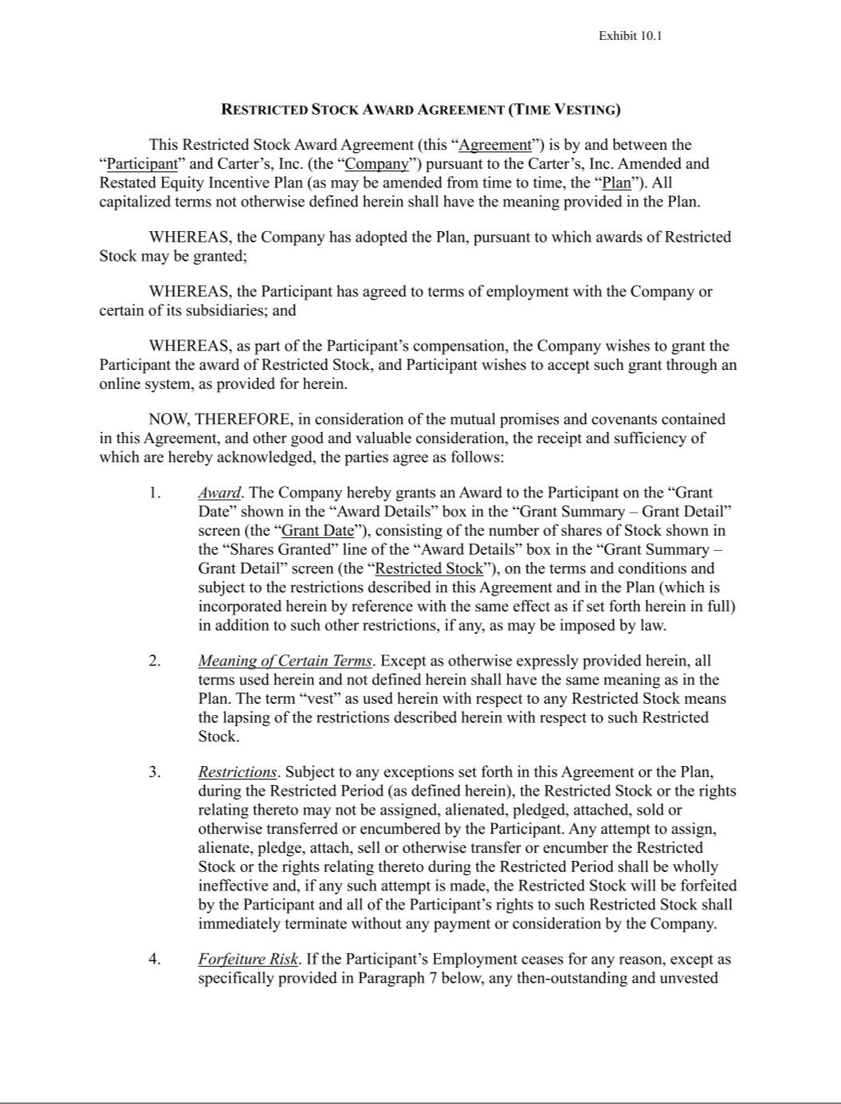

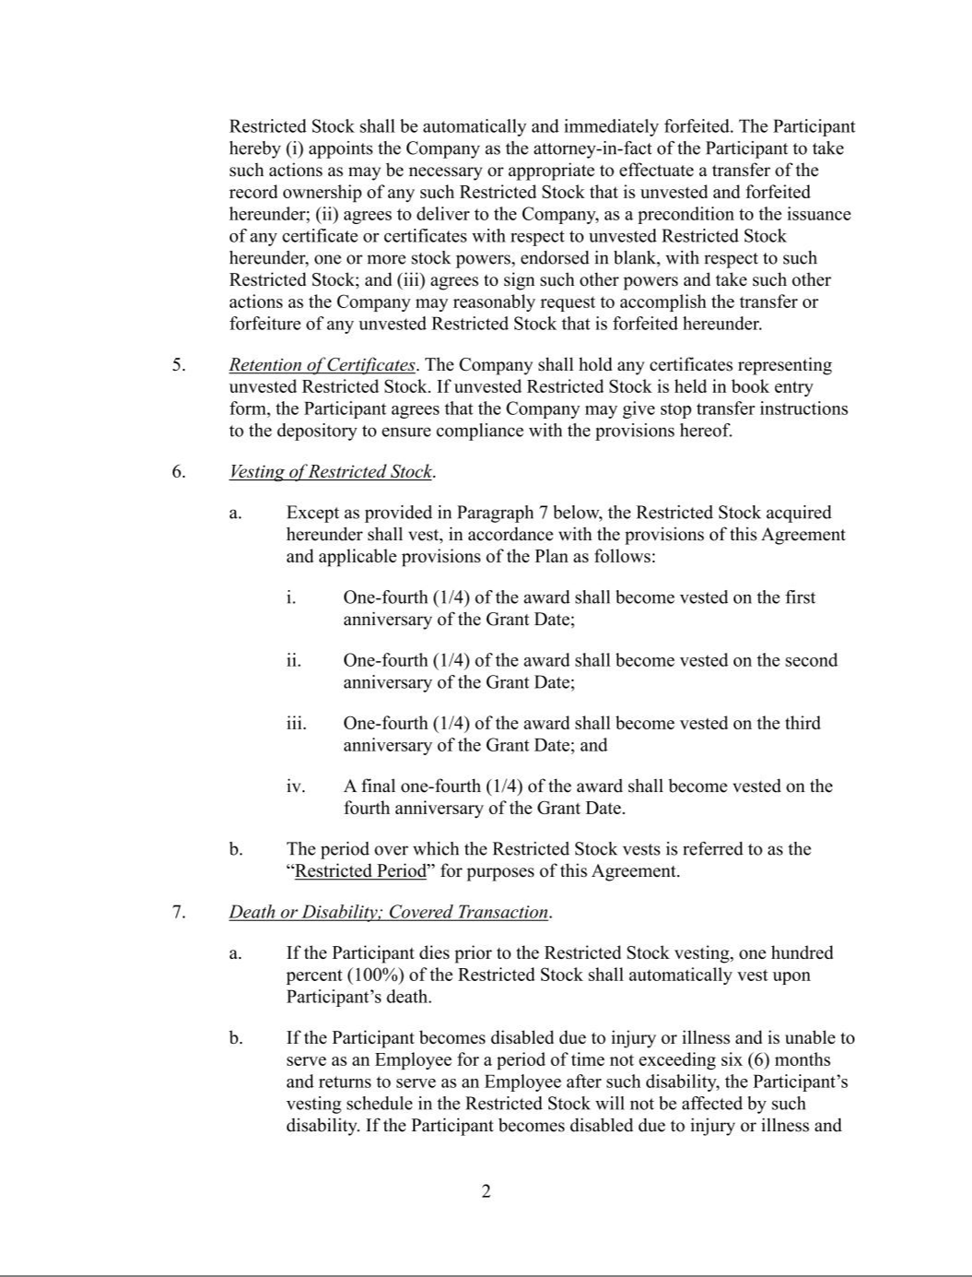

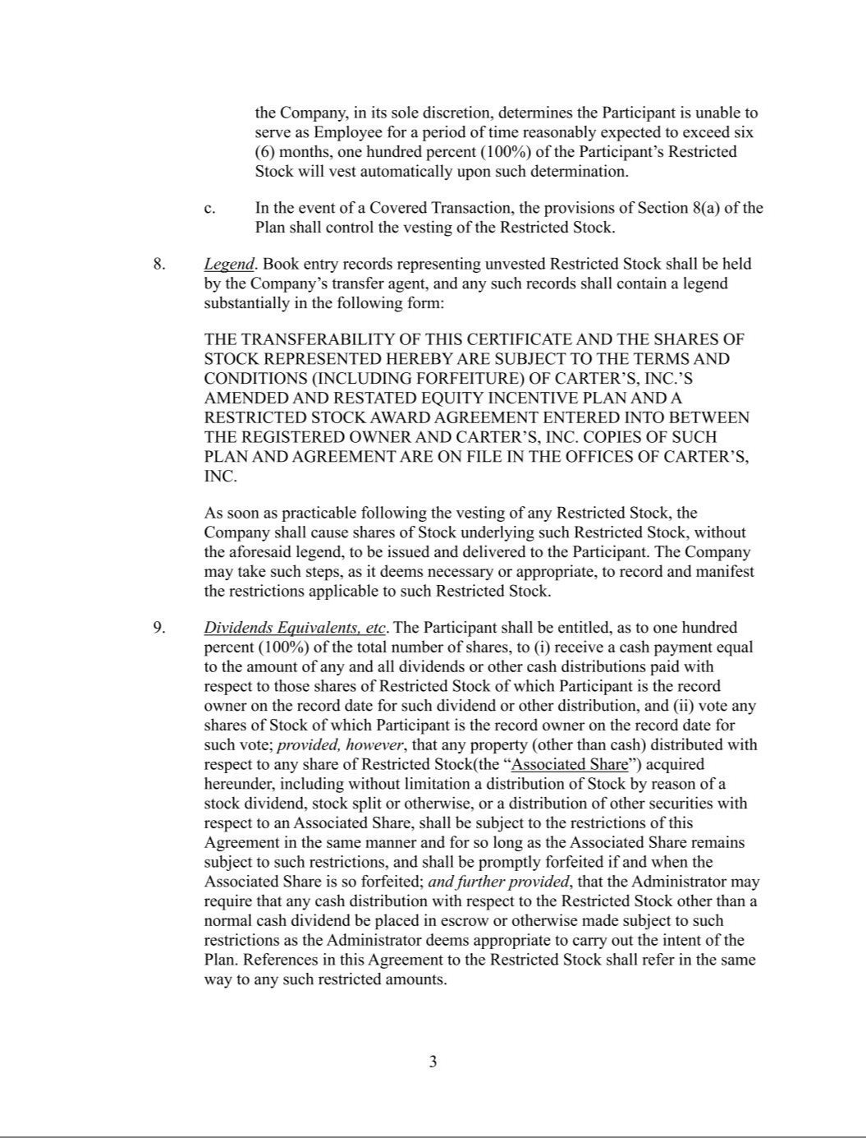

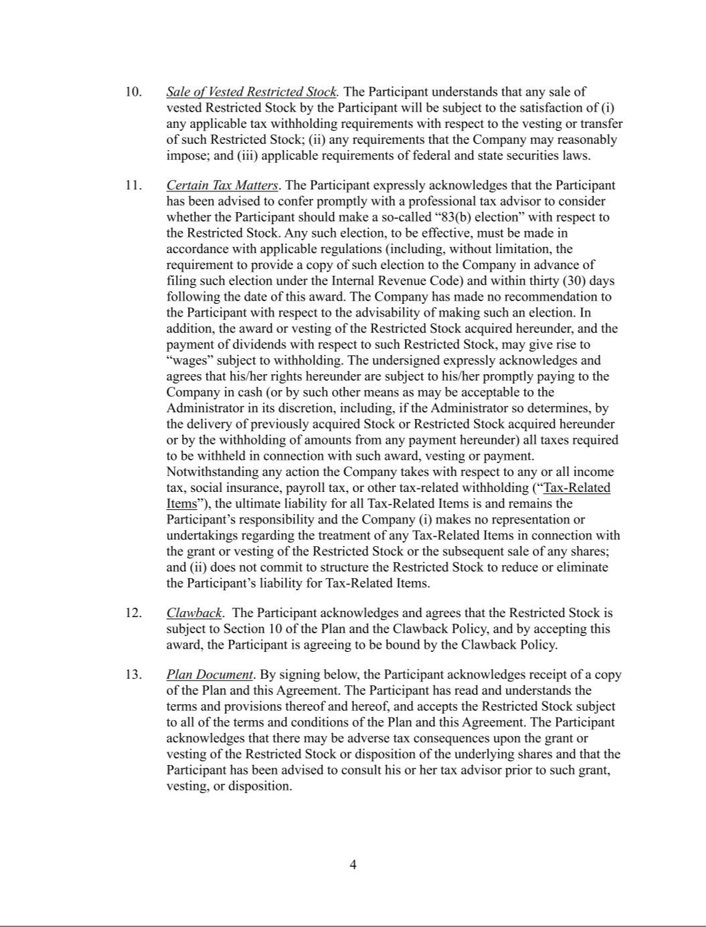

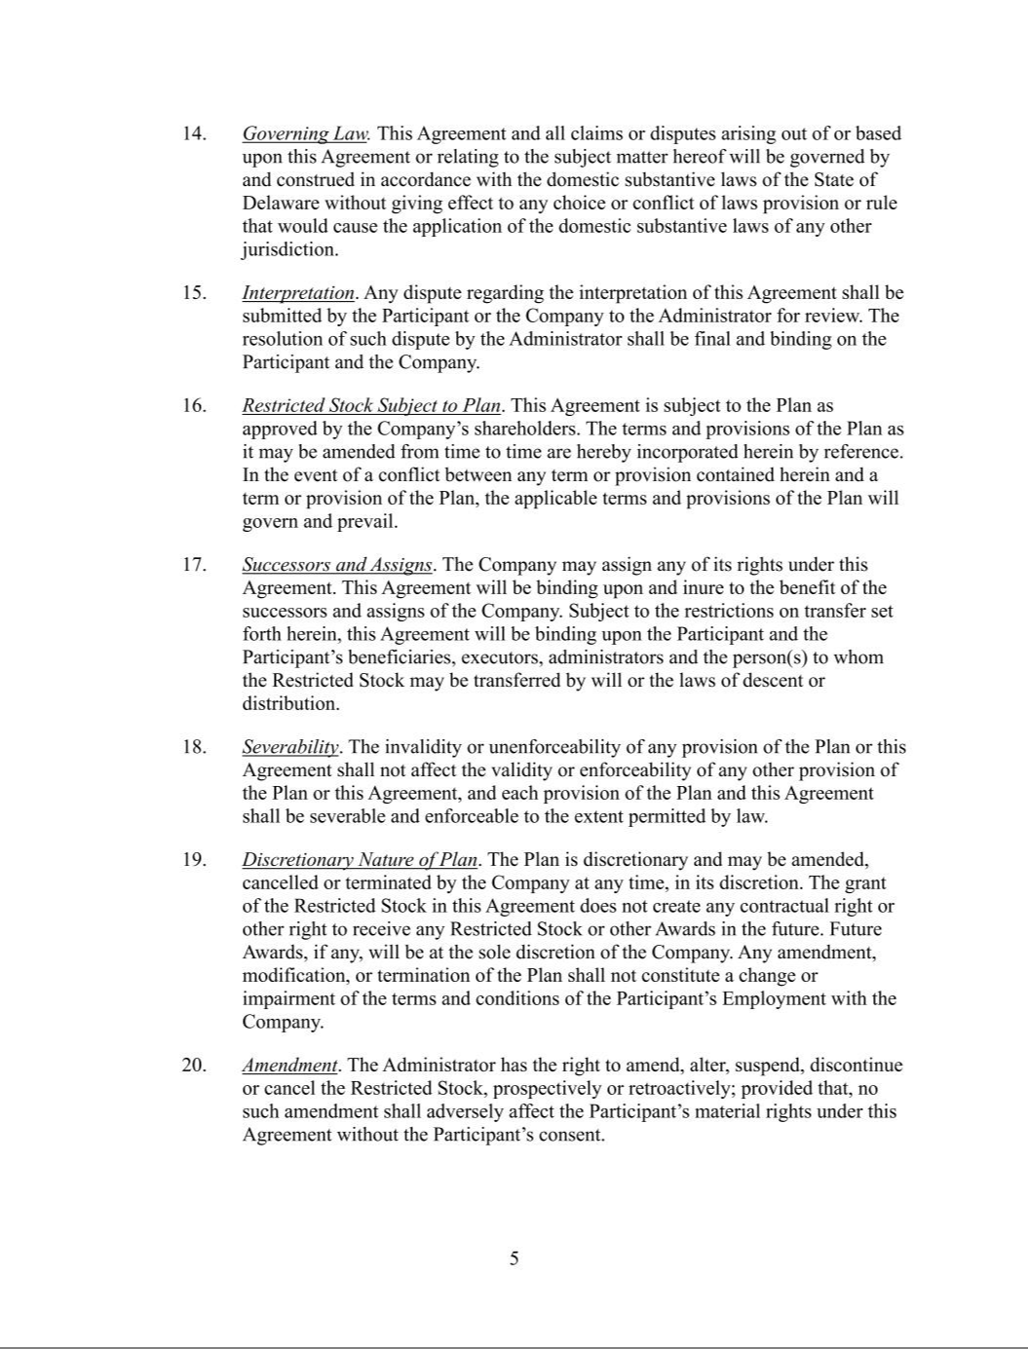

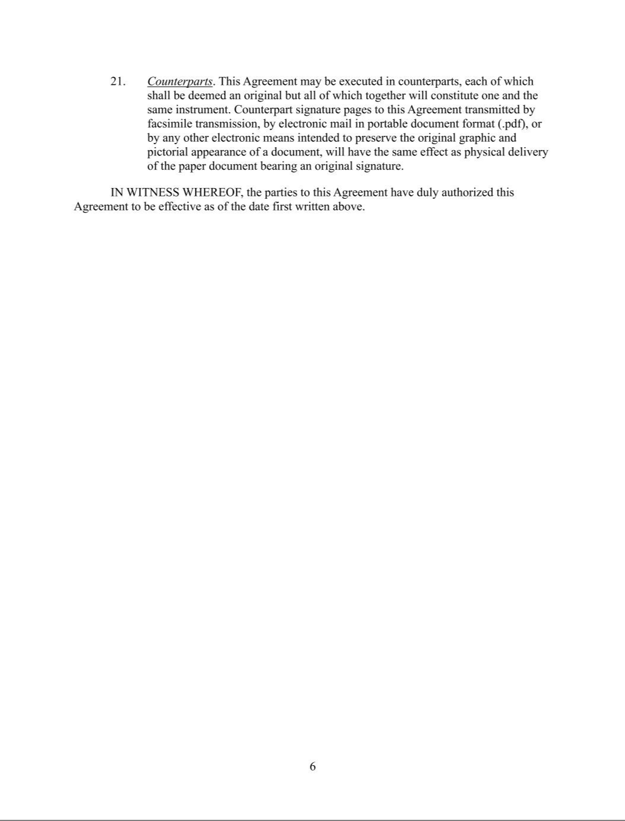

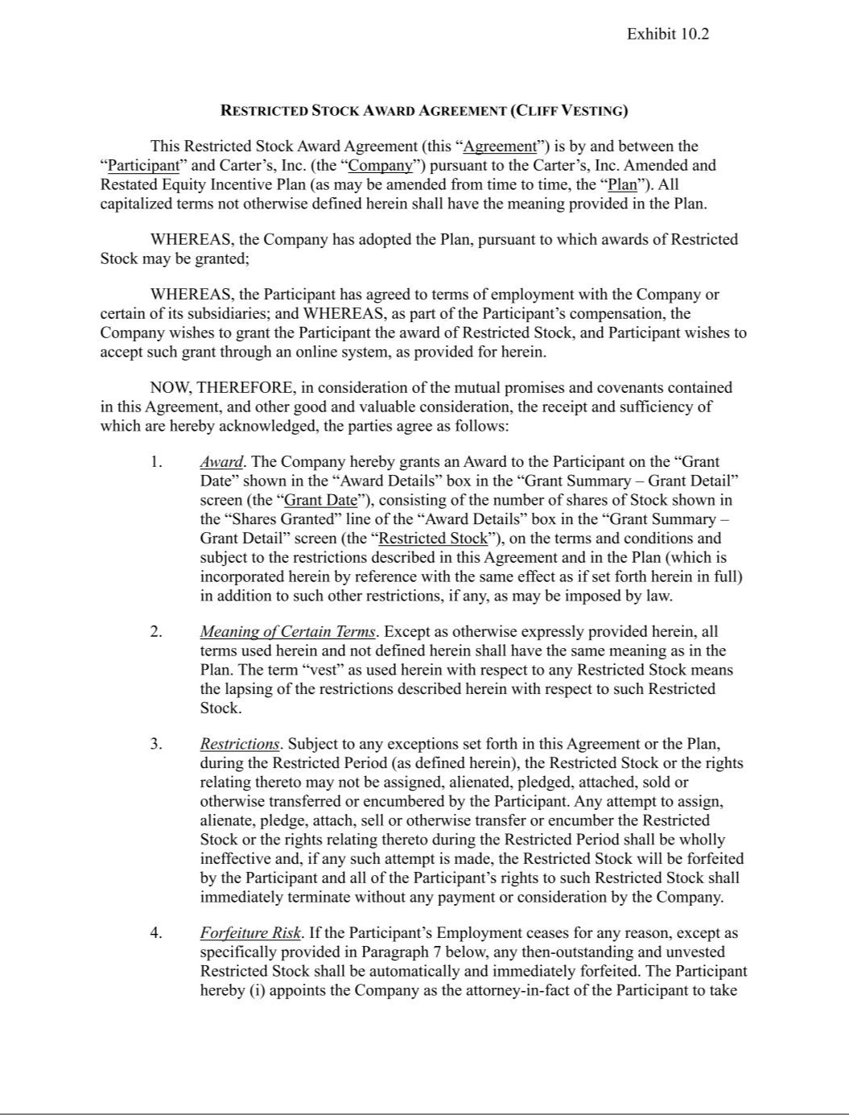

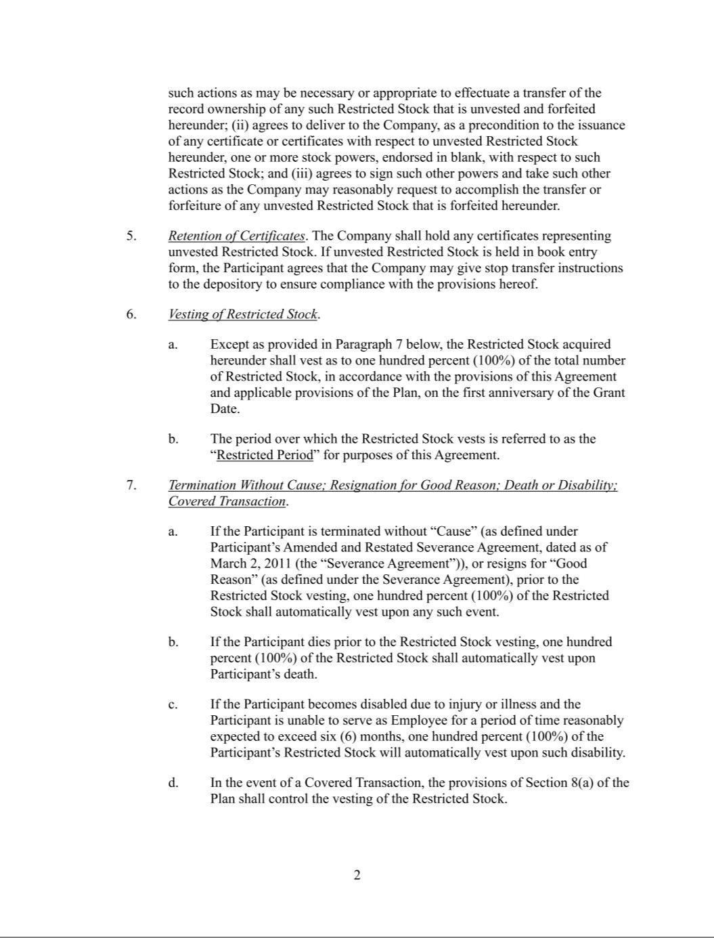

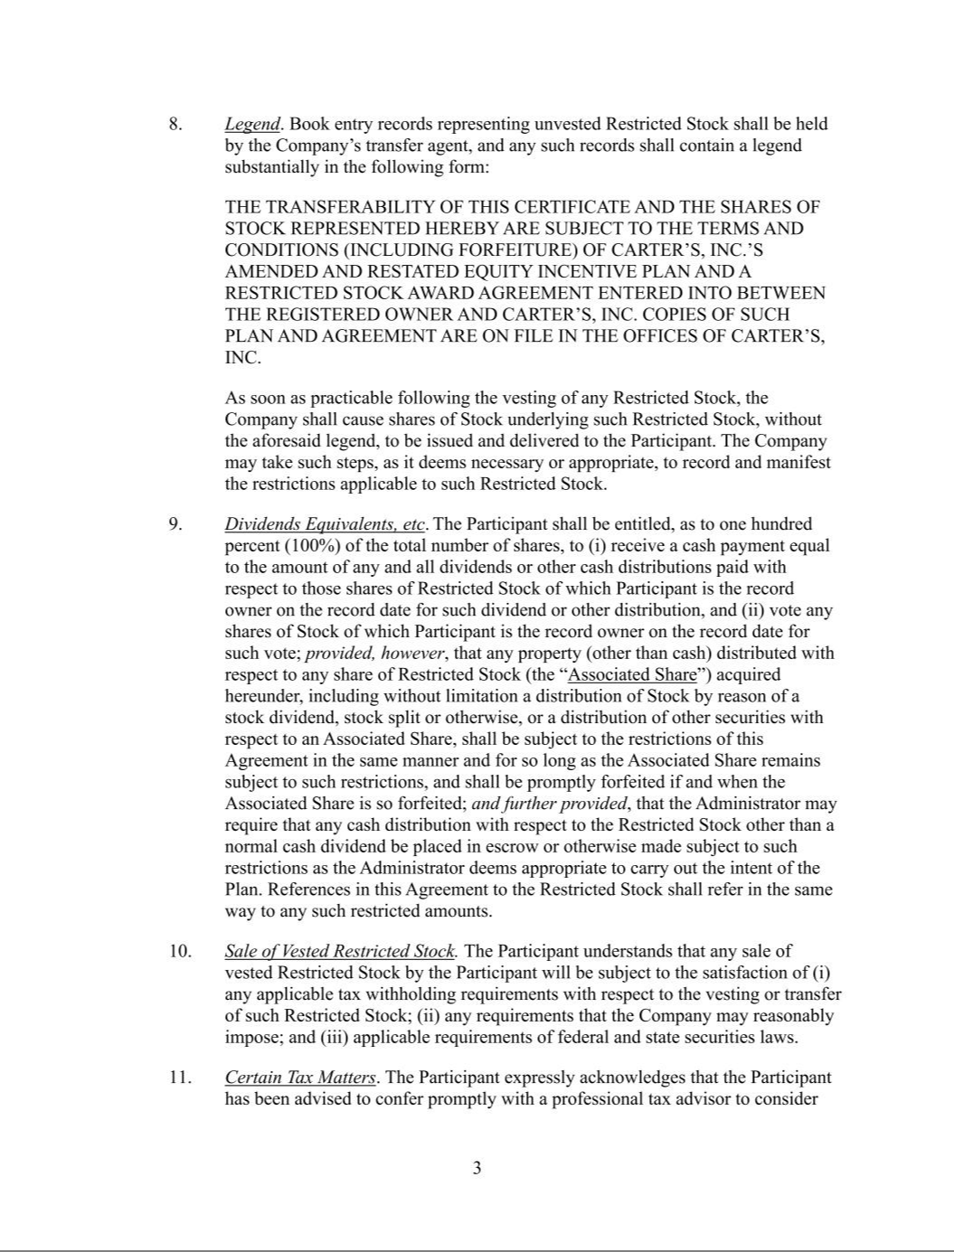

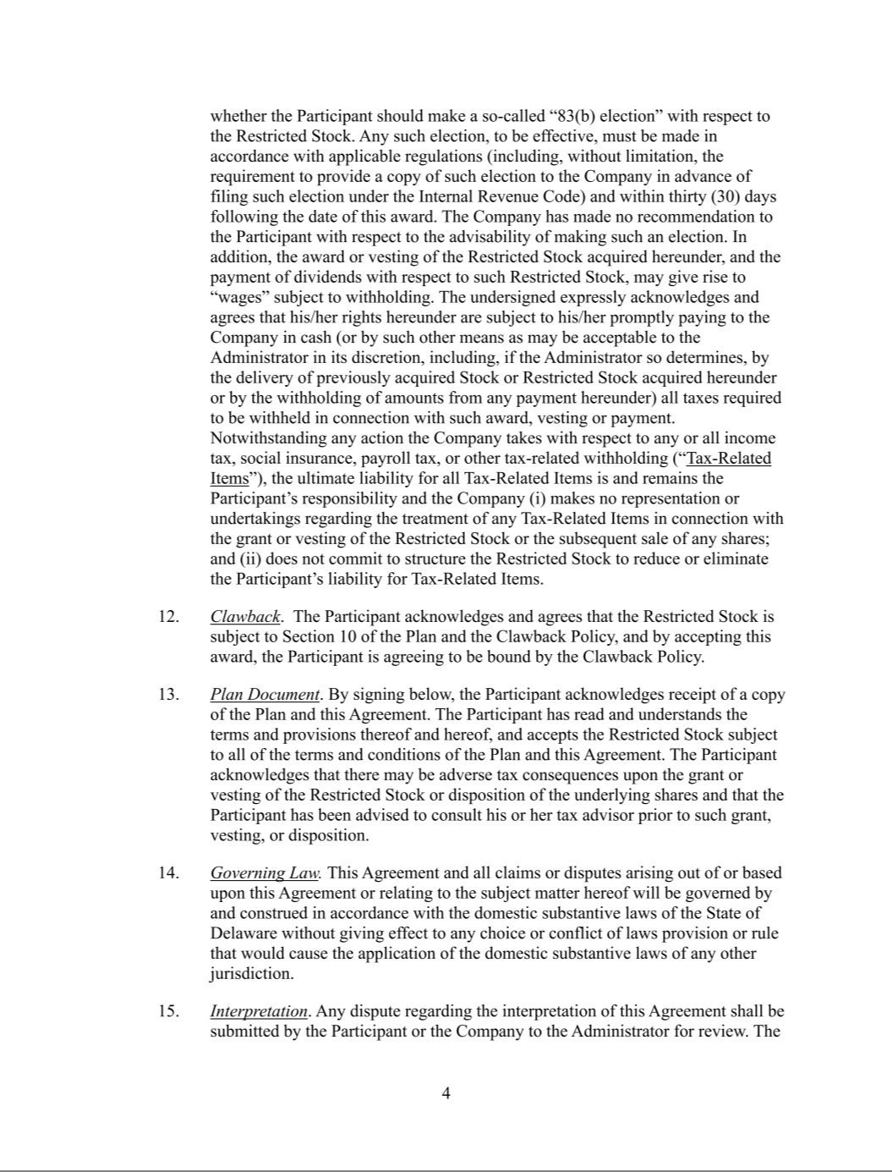

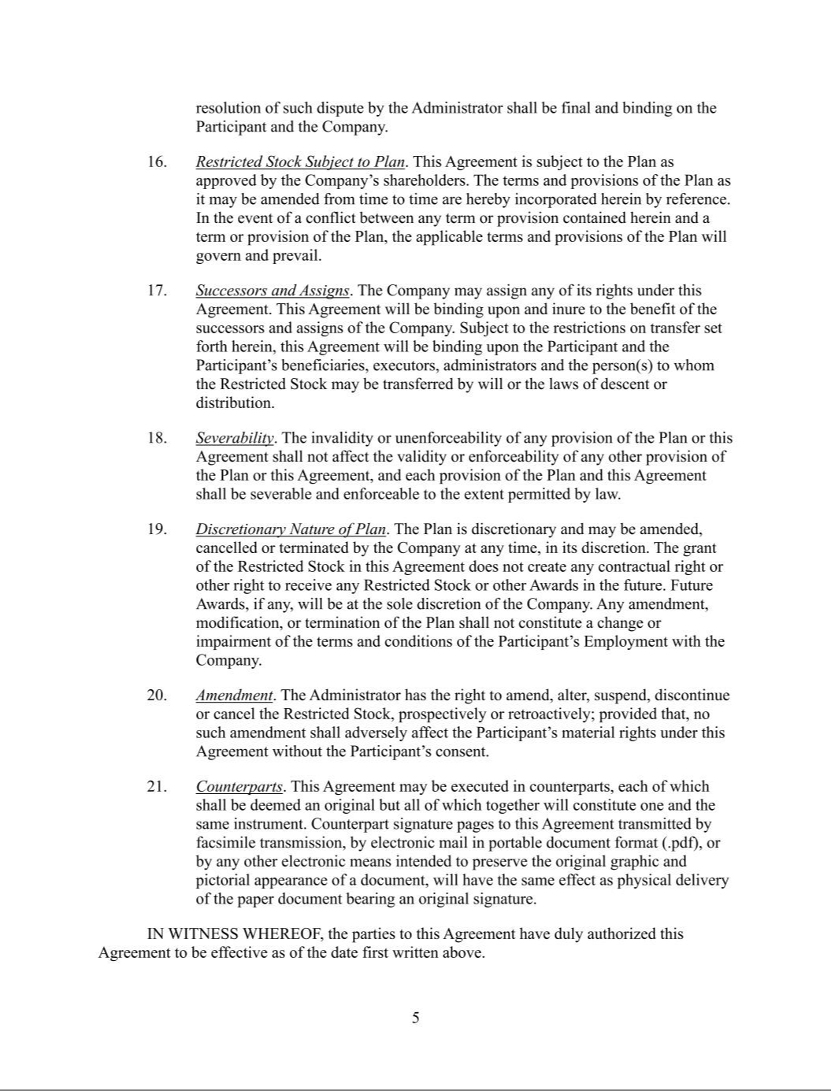

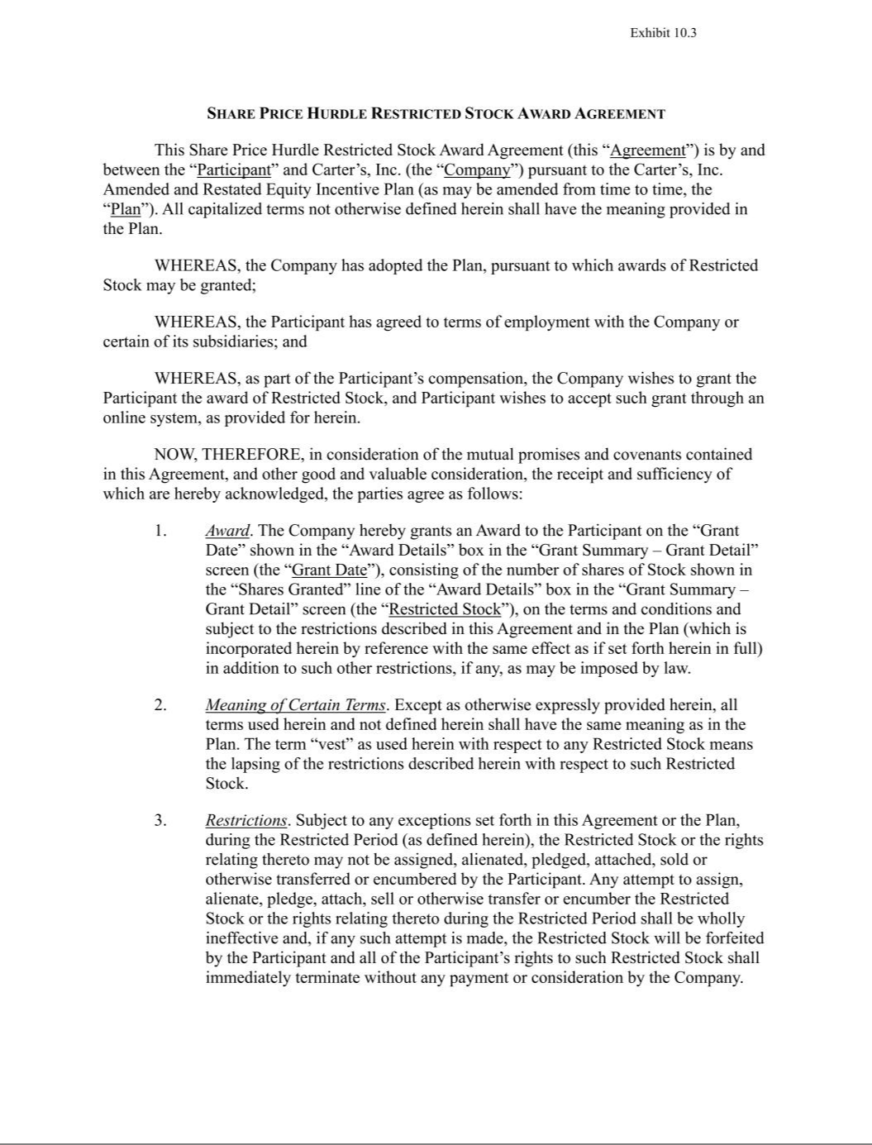

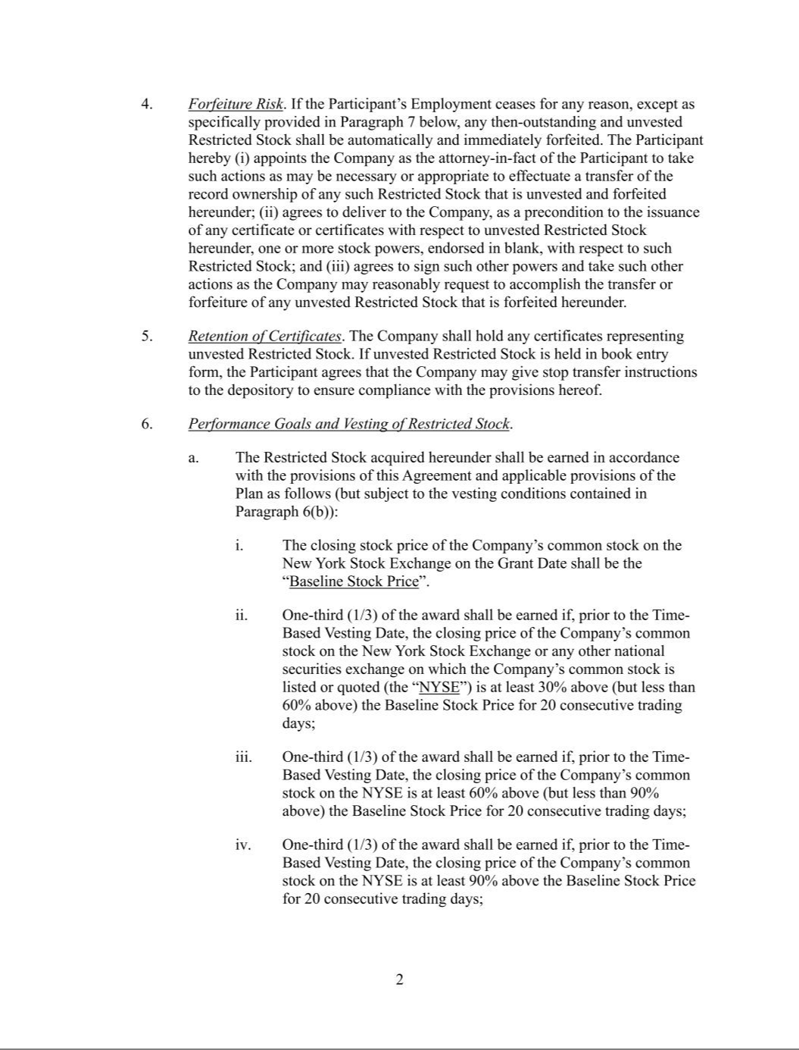

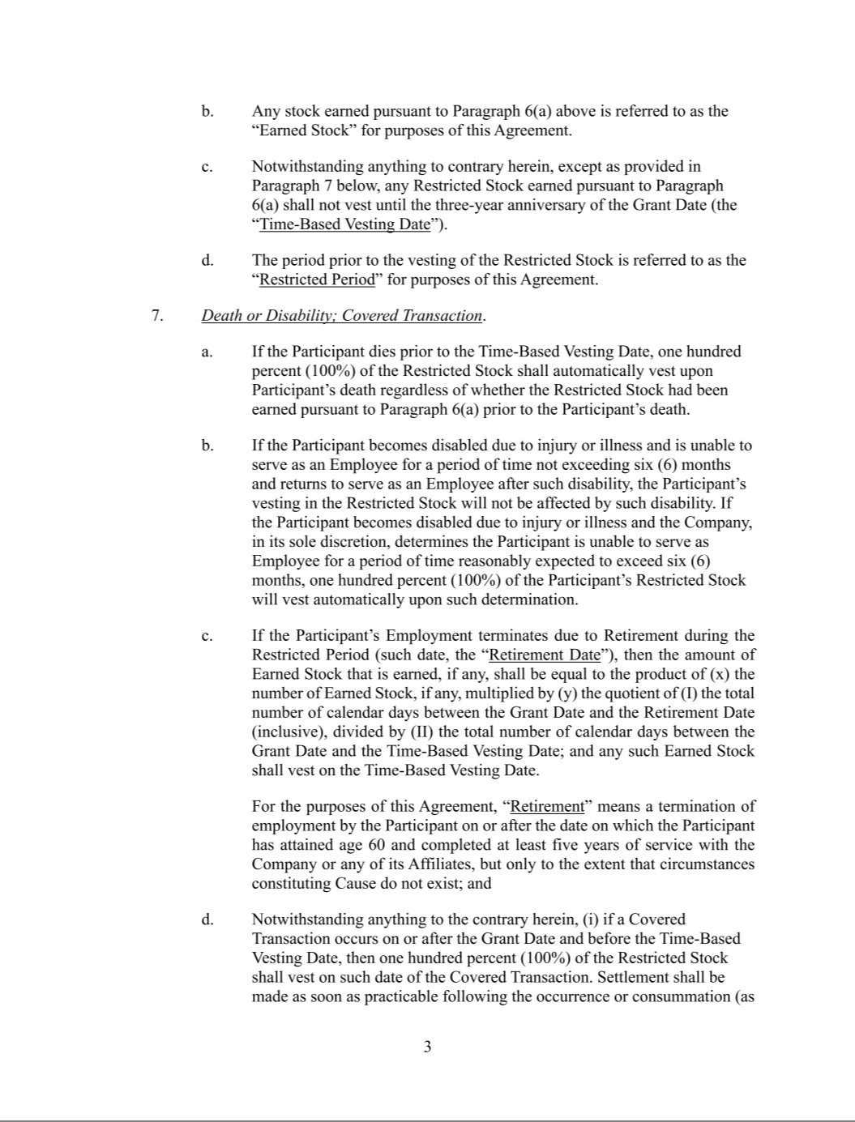

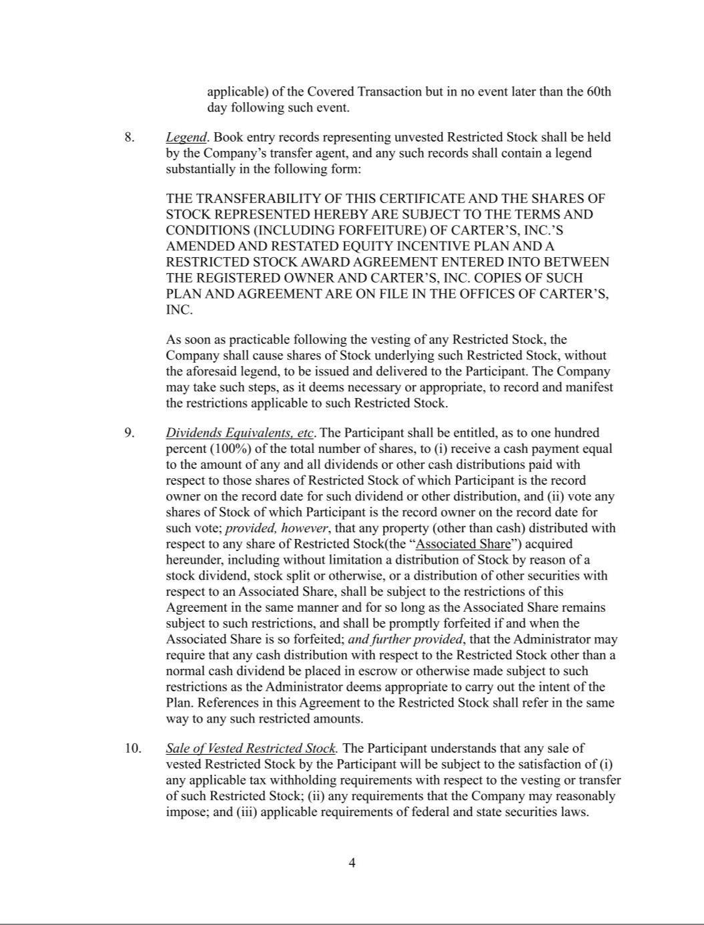

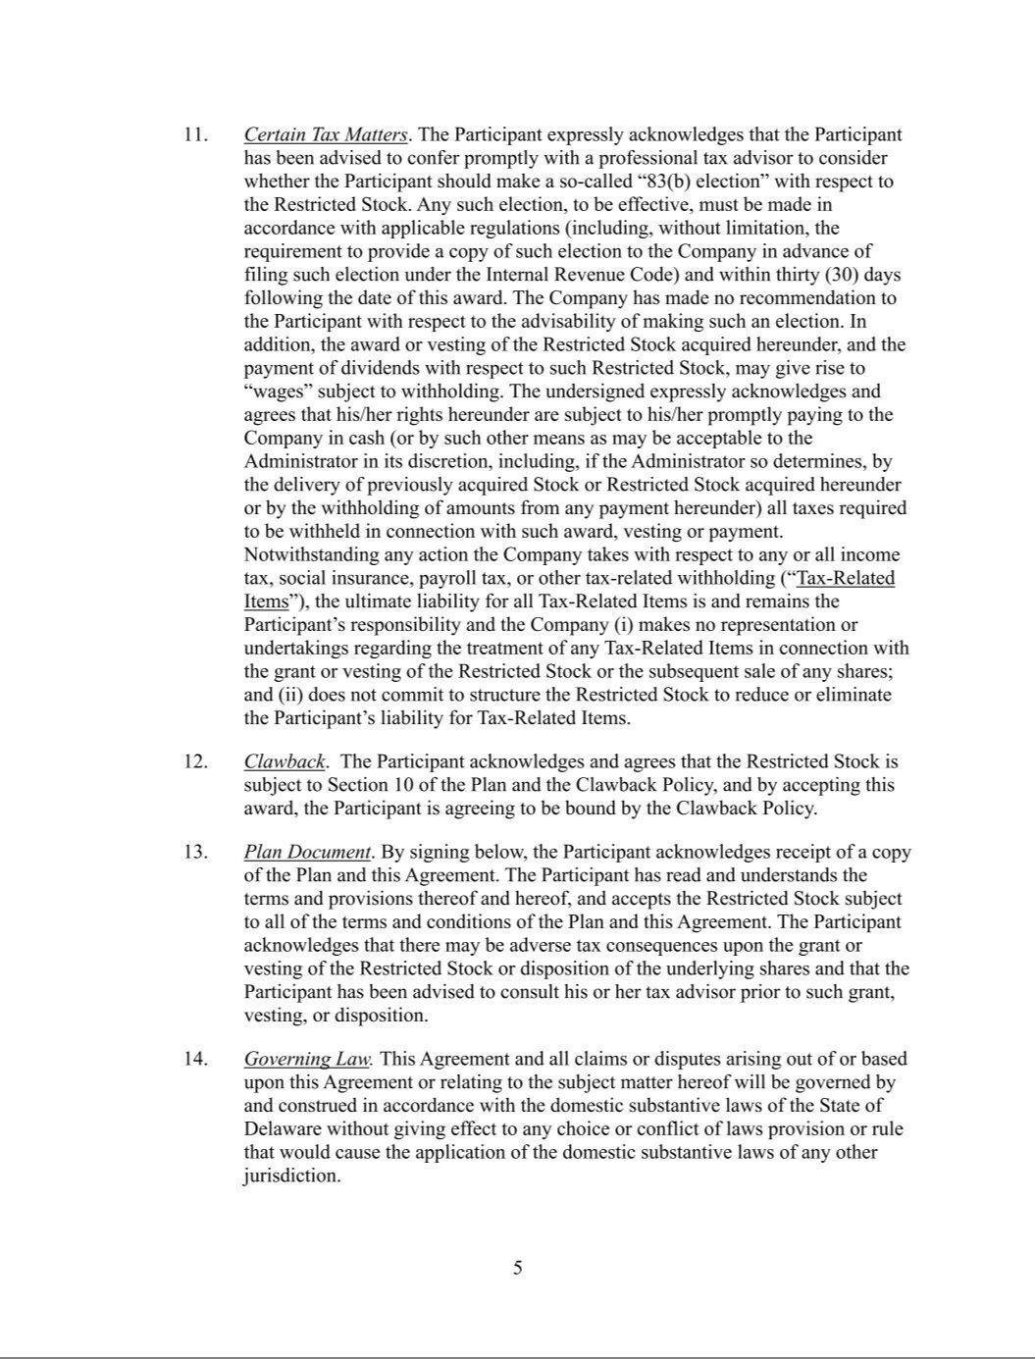

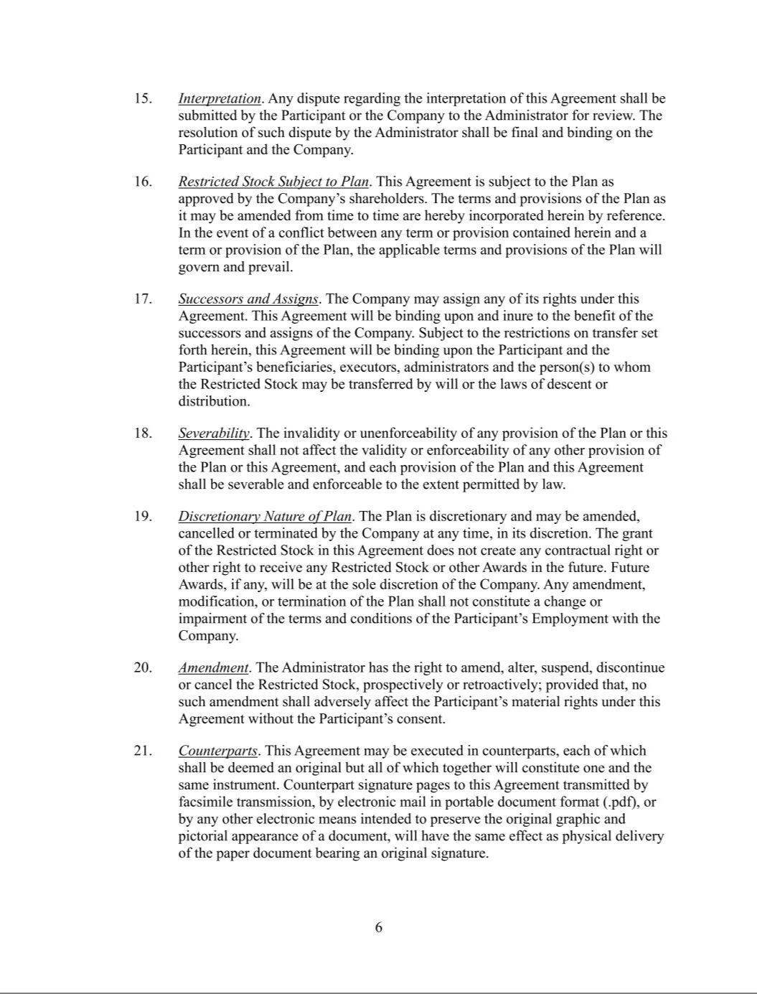



Exhibit 31.1

CERTIFICATION

I, Douglas C. Palladini, certify that:

- I have reviewed this quarterly report on Form 10-Q of Carter’s, Inc.;

- Based on my knowledge, this report does not contain any untrue statement of a material fact or omit to state a material fact necessary to make the statements made, in light of the circumstances under which such statements were made, not misleading with respect to the period covered by this report;

- Based on my knowledge, the financial statements, and other financial information included in this report, fairly present in all material respects the financial condition, results of operations and cash flows of the registrant as of, and for, the periods presented in this report;

- The registrant's other certifying officer and I are responsible for establishing and maintaining disclosure controls and procedures (as defined in Exchange Act Rules 13a-15(e) and 15d-15(e)) and internal control over financial reporting (as defined in Exchange Act Rules 13a-15(f) and 15d-15(f)) for the registrant and have:

  - Designed such disclosure controls and procedures, or caused such disclosure controls and procedures to be designed under our supervision, to ensure that material information relating to the registrant, including its consolidated subsidiaries, is made known to us by others within those entities, particularly during the period in which this report is being prepared;

  - Designed such internal control over financial reporting, or caused such internal control over financial reporting to be designed under our supervision, to provide reasonable assurance regarding the reliability of financial reporting and the preparation of financial statements for external purposes in accordance with generally accepted accounting principles;

  - Evaluated the effectiveness of the registrant’s disclosure controls and procedures and presented in this report our conclusions about the effectiveness of the disclosure controls and procedures, as of the end of the period covered by this report based on such evaluation; and

  - Disclosed in this report any change in the registrant’s internal control over financial reporting that occurred during the registrant’s most recent fiscal quarter (the registrant’s

fourth fiscal quarter in the case of an annual report) that has materially affected, or is reasonably likely to materially affect, the registrant’s internal control over financial reporting; and

- The registrant's other certifying officer and I have disclosed, based on our most recent evaluation of internal control over financial reporting, to the registrant's auditors and the audit committee of the registrant's board of directors (or persons performing the equivalent functions):

  - All significant deficiencies and material weaknesses in the design or operation of internal control over financial reporting which are reasonably likely to adversely affect the registrant's ability to record, process, summarize and report financial information; and

  - Any fraud, whether or not material, that involves management or other employees who have a significant role in the registrant's internal control over financial reporting.

April 25, 2025 /s/ DOUGLAS C. PALLADINI

Douglas C. Palladini

Chief Executive Officer & President

Exhibit 31.2

CERTIFICATION

I, Richard F. Westenberger, certify that:

- I have reviewed this quarterly report on Form 10-Q of Carter’s, Inc.;

- Based on my knowledge, this report does not contain any untrue statement of a material fact or omit to state a material fact necessary to make the statements made, in light of the circumstances under which such statements were made, not misleading with respect to the period covered by this report;

- Based on my knowledge, the financial statements, and other financial information included in this report, fairly present in all material respects the financial condition, results of operations and cash flows of the registrant as of, and for, the periods presented in this report;

- The registrant's other certifying officer and I are responsible for establishing and maintaining disclosure controls and procedures (as defined in Exchange Act Rules 13a-15(e) and 15d-15(e)) and internal control over financial reporting (as defined in Exchange Act Rules 13a-15(f) and 15d-15(f)) for the registrant and have:

  - Designed such disclosure controls and procedures, or caused such disclosure controls and procedures to be designed under our supervision, to ensure that material information relating to the registrant, including its consolidated subsidiaries, is made known to us by others within those entities, particularly during the period in which this report is being prepared;

  - Designed such internal control over financial reporting, or caused such internal control over financial reporting to be designed under our supervision, to provide reasonable assurance regarding the reliability of financial reporting and the preparation of financial statements for external purposes in accordance with generally accepted accounting principles;

  - Evaluated the effectiveness of the registrant’s disclosure controls and procedures and presented in this report our conclusions about the effectiveness of the disclosure controls and procedures, as of the end of the period covered by this report based on such evaluation; and

  - Disclosed in this report any change in the registrant’s internal control over financial reporting that occurred during the registrant’s most recent fiscal quarter (the registrant’s

fourth fiscal quarter in the case of an annual report) that has materially affected, or is reasonably likely to materially affect, the registrant’s internal control over financial reporting; and

- The registrant's other certifying officer and I have disclosed, based on our most recent evaluation of internal control over financial reporting, to the registrant's auditors and the audit committee of the registrant's board of directors (or persons performing the equivalent functions):

  - All significant deficiencies and material weaknesses in the design or operation of internal control over financial reporting which are reasonably likely to adversely affect the registrant's ability to record, process, summarize and report financial information; and

  - Any fraud, whether or not material, that involves management or other employees who have a significant role in the registrant's internal control over financial reporting.

April 25, 2025 /s/ RICHARD F. WESTENBERGER

Richard F. Westenberger

Senior Executive Vice President,

Chief Financial Officer & Chief Operating Officer

Exhibit 32

CERTIFICATION

Each of the undersigned in the capacity indicated hereby certifies that, to his knowledge, this Report on Form 10-Q for the fiscal quarter ended March 29, 2025 fully complies with the requirements of Section 13(a) or 15(d) of the Securities Exchange Act of 1934, and the information contained in this Report fairly presents, in all material respects, the financial condition and results of operations of Carter’s, Inc.

April 25, 2025 /s/ DOUGLAS C. PALLADINI

Douglas C. Palladini

Chief Executive Officer & President

April 25, 2025 /s/ RICHARD F. WESTENBERGER

Richard F. Westenberger

Senior Executive Vice President,

Chief Financial Officer & Chief Operating Officer

The foregoing certifications are being furnished solely pursuant to 18 U.S.C. § 1350 and are not being filed as part of the Report on Form 10-Q or as a separate disclosure document.

