UNITED STATES

SECURITIES AND EXCHANGE COMMISSION

Washington, D.C. 20549

FORM 10-Q

(Mark One)

- QUARTERLY REPORT PURSUANT TO SECTION 13 OR 15(d) OF THE SECURITIES EXCHANGE ACT OF 1934 For the quarterly period ended September 27, 2025

OR

- TRANSITION REPORT PURSUANT TO SECTION 13 OR 15(d) OF THE SECURITIES EXCHANGE ACT OF 1934 For the transition period from __________to __________

 | Commission file number: 001-31829
 |  | CARTER’S, INC.
 | (Exact name of registrant as specified in its charter)
Delaware |  |  |  | 13-3912933
(State or other jurisdiction of |  |  |  | (I.R.S. Employer Identification No.)
incorporation or organization)
 |  | Phipps Tower,
 |  | 3438 Peachtree Road NE, Suite 1800
 |  | Atlanta, Georgia 30326
 | (Address of principal executive offices, including zip code)
 | (678) 791-1000
 | (Registrant's telephone number, including area code)
Securities registered pursuant to Section 12(b) of the Act:
Title of each class |  | Trading Symbol(s) |  | Name of each exchange on which registered
Common stock, par value $0.01 per share |  | CRI |  | New York Stock Exchange
Series A Preferred Stock Purchase Rights |  | - |  | New York Stock Exchange

Indicate by check mark whether the registrant (1) has filed all reports required to be filed by Section 13 or 15(d) of the Securities Exchange Act of 1934 during the preceding 12 months (or for such shorter period that the registrant was required to file such reports), and (2) has been subject to such filing requirements for the past 90 days. Yes x No ☐

Indicate by check mark whether the registrant has submitted electronically every Interactive Data File required to be submitted pursuant to Rule 405 of Regulation S-T (§232.405 of this chapter) during the preceding 12 months (or for such shorter period that the registrant was required to submit such files). Yes x No ☐

Indicate by check mark whether the registrant is a large accelerated filer, an accelerated filer, a non-accelerated filer, a smaller reporting company, or an emerging growth company. See definition of “large accelerated filer,” “accelerated filer,” “smaller reporting company,” and “emerging growth company” in Rule 12b-2 of the Exchange Act.

Large accelerated filer x Accelerated filer ☐

Non-accelerated filer ☐ Smaller reporting company ☐

Emerging growth company ☐

If an emerging growth company, indicate by check mark if the registrant has elected not to use the extended transition period for complying with any new or revised financial accounting standards provided pursuant to Section 13(a) of the Exchange Act. ☐

Indicate by check mark whether the registrant is a shell company (as defined in Rule 12b-2 of the Exchange Act).Yes ☐ No x

As of October 22, 2025, there were 36,447,868 shares of the registrant’s common stock outstanding.

CARTER’S, INC.

INDEX

 | Part I. Financial Information |  |  |  |  |  |  |  |  |  |  |  |  |  |  |  |  |  |  |  | Page
 |  | Item 1 |  |  |  | Financial Statements
 |  |  |  |  |  | Unaudited Condensed Consolidated Balance Sheets as of September 27, 2025, December 28, 2024, and September 28, 2024 |  |  |  |  |  |  |  |  |  |  |  |  |  |  | 1
 |  |  |  |  |  | Unaudited Condensed Consolidated Statements of Operations for the fiscal quarter and three fiscal quarters ended September 27, 2025 and September 28, 2024 |  |  |  |  |  |  |  |  |  |  |  |  |  |  | 2
 |  |  |  |  |  | Unaudited Condensed Consolidated Statements of Comprehensive Income for the fiscal quarter and three fiscal quarters ended September 27, 2025 and |  |  |  |  |  |  |  |  |  |  |  |  |  |  | 3
 |  |  |  |  |  | September 28, 2024 |  |  |  |  |  |  |  |  |  |  |  |  |  |  | 3
 |  |  |  |  |  | Unaudited Condensed Consolidated Statements of Changes in Shareholders’ Equity for the fiscal quarters ended September 27, 2025, June 28, 2025, March 29, |  |  |  |  |  |  |  |  |  |  |  |  |  |  | 4
 |  |  |  |  |  | 2025, September 28, 2024, June 29, 2024, and March 30, 2024 |  |  |  |  |  |  |  |  |  |  |  |  |  |  | 4
 |  |  |  |  |  | Unaudited Condensed Consolidated Statements of Cash Flows for the three fiscal quarters ended September 27, 2025 and September 28, 2024 |  |  |  |  |  |  |  |  |  |  |  |  |  |  | 6
 |  |  |  |  |  | Notes to the Unaudited Condensed Consolidated Financial Statements |  |  |  |  |  |  |  |  |  |  |  |  |  |  | 7
 |  | Item 2 |  |  |  | Management’s Discussion and Analysis of Financial Condition and Results of Operations |  |  |  |  |  |  |  |  |  |  |  |  |  |  | 21
 |  | Item 3 |  |  |  | Quantitative and Qualitative Disclosures about Market Risk |  |  |  |  |  |  |  |  |  |  |  |  |  |  | 39
 |  | Item 4 |  |  |  | Controls and Procedures |  |  |  |  |  |  |  |  |  |  |  |  |  |  | 40
 | Part II. Other Information
 |  | Item 1 |  |  |  | Legal Proceedings |  |  |  |  |  |  |  |  |  |  |  |  |  |  | 41
 |  | Item 1A |  |  |  | Risk Factors |  |  |  |  |  |  |  |  |  |  |  |  |  |  | 41
 |  | Item 2 |  |  |  | Unregistered Sales of Equity Securities and Use of Proceeds |  |  |  |  |  |  |  |  |  |  |  |  |  |  | 42
 |  | Item 3 |  |  |  | Defaults upon Senior Securities |  |  |  |  |  |  |  |  |  |  |  |  |  |  | 42
 |  | Item 4 |  |  |  | Mine Safety Disclosures |  |  |  |  |  |  |  |  |  |  |  |  |  |  | 42
 |  | Item 5 |  |  |  | Other Information |  |  |  |  |  |  |  |  |  |  |  |  |  |  | 42
 |  | Item 6 |  |  |  | Exhibits |  |  |  |  |  |  |  |  |  |  |  |  |  |  | 43
 | Signatures |  |  |  |  |  |  |  |  |  |  |  |  |  |  |  |  |  |  |  | 44

PART I - FINANCIAL INFORMATION

ITEM 1. FINANCIAL STATEMENTS

CARTER’S, INC.

CONDENSED CONSOLIDATED BALANCE SHEETS

(dollars in thousands, except per share data)

(unaudited)

 |  | September 27, 2025 |  |  | December 28, 2024 |  |  | September 28, 2024
ASSETS
Current assets:
Cash and cash equivalents | $ | 184,190 |  | $ | 412,926 |  | $ | 175,536
Accounts receivable, net of allowance for credit losses of $12,026, $5,663, and $8,303, respectively |  | 237,866 |  |  | 194,834 |  |  | 247,013
Finished goods inventories, net of inventory reserves of $12,347, $8,257, and $17,135, respectively |  | 656,149 |  |  | 502,332 |  |  | 607,384
Prepaid expenses and other current assets |  | 55,576 |  |  | 32,580 |  |  | 41,577
Total current assets |  | 1,133,781 |  |  | 1,142,672 |  |  | 1,071,510
Property, plant, and equipment, net of accumulated depreciation of $599,467, $602,670, and $642,420,
respectively |  | 189,012 |  |  | 180,956 |  |  | 182,292
Operating lease assets |  | 611,569 |  |  | 577,133 |  |  | 560,246
Tradenames, net |  | 268,718 |  |  | 268,008 |  |  | 298,053
Goodwill |  | 208,351 |  |  | 206,875 |  |  | 209,384
Customer relationships, net |  | 20,993 |  |  | 23,543 |  |  | 24,440
Other assets |  | 37,015 |  |  | 33,980 |  |  | 32,460
Total assets | $ | 2,469,439 |  | $ | 2,433,167 |  | $ | 2,378,385
LIABILITIES AND SHAREHOLDERS’ EQUITY
Current liabilities:
Accounts payable | $ | 240,235 |  | $ | 248,200 |  | $ | 273,909
Current operating lease liabilities |  | 150,548 |  |  | 130,564 |  |  | 130,140
Other current liabilities |  | 110,907 |  |  | 130,052 |  |  | 80,059
Total current liabilities |  | 501,690 |  |  | 508,816 |  |  | 484,108
Long-term debt, net |  | 498,738 |  |  | 498,127 |  |  | 497,930
Deferred income taxes |  | 41,200 |  |  | 38,210 |  |  | 48,890
Long-term operating lease liabilities |  | 529,139 |  |  | 501,503 |  |  | 485,613
Other long-term liabilities |  | 34,030 |  |  | 31,949 |  |  | 32,504
Total liabilities | $ | 1,604,797 |  | $ | 1,578,605 |  | $ | 1,549,045
Commitments and contingencies - Note 16
Shareholders’ equity:
Preferred stock; par value $0.01 per share; 100,000 shares authorized; none issued or outstanding | $ | — |  | $ | — |  | $ | —
Common stock, voting; par value $0.01 per share; 150,000,000 shares authorized; 36,518,637, 36,041,995, and
36,038,814 shares issued and outstanding, respectively |  | 365 |  |  | 360 |  |  | 360
Additional paid-in capital |  | 18,029 |  |  | 3,856 |  |  | —
Accumulated other comprehensive loss |  | (28,107) |  |  | (43,678) |  |  | (32,361)
Retained earnings |  | 874,355 |  |  | 894,024 |  |  | 861,341
Total shareholders’ equity |  | 864,642 |  |  | 854,562 |  |  | 829,340
Total liabilities and shareholders’ equity | $ | 2,469,439 |  | $ | 2,433,167 |  | $ | 2,378,385

See accompanying notes to the unaudited condensed consolidated financial statements.

1

CARTER’S, INC.

CONDENSED CONSOLIDATED STATEMENTS OF OPERATIONS

(dollars in thousands, except per share data)

(unaudited)

 |  | Fiscal quarter ended |  |  |  |  |  | Three fiscal quarters ended
 |  | September 27, 2025 |  |  | September 28, 2024 |  |  | September 27, 2025 |  |  | September 28, 2024
Net sales | $ | 757,836 |  | $ | 758,464 |  | $ | 1,972,975 |  | $ | 1,984,390
Cost of goods sold |  | 416,208 |  |  | 402,450 |  |  | 1,058,497 |  |  | 1,030,249
Gross profit |  | 341,628 |  |  | 356,014 |  |  | 914,478 |  |  | 954,141
Royalty income, net |  | 5,428 |  |  | 5,740 |  |  | 14,008 |  |  | 14,959
Selling, general, and administrative expenses |  | 317,963 |  |  | 284,714 |  |  | 869,246 |  |  | 797,572
Operating income |  | 29,093 |  |  | 77,040 |  |  | 59,240 |  |  | 171,528
Interest expense |  | 7,173 |  |  | 7,381 |  |  | 22,849 |  |  | 23,156
Interest income |  | (2,573) |  |  | (2,370) |  |  | (10,007) |  |  | (8,644)
Other expense (income), net^{(*)} |  | 882 |  |  | 350 |  |  | (265) |  |  | 1,028
Pension plan settlement^{(*)} |  | 8,777 |  |  | 949 |  |  | 8,777 |  |  | 949
Income before income taxes |  | 14,834 |  |  | 70,730 |  |  | 37,886 |  |  | 155,039
Income tax provision |  | 3,241 |  |  | 12,410 |  |  | 10,308 |  |  | 31,047
Net income | $ | 11,593 |  | $ | 58,320 |  | $ | 27,578 |  | $ | 123,992
Basic net income per common share | $ | 0.32 |  | $ | 1.62 |  | $ | 0.75 |  | $ | 3.41
Diluted net income per common share | $ | 0.32 |  | $ | 1.62 |  | $ | 0.75 |  | $ | 3.41
Dividend declared and paid per common share | $ | 0.25 |  | $ | 0.80 |  | $ | 1.30 |  | $ | 2.40

- Pension plan settlement charges for the fiscal quarter and three fiscal quarters ended September 28, 2024 have been reclassified to the Pension plan settlement line item. These charges were previously included in Other expense (income), net.

See accompanying notes to the unaudited condensed consolidated financial statements.

2

CARTER’S, INC.

CONDENSED CONSOLIDATED STATEMENTS OF COMPREHENSIVE INCOME

(dollars in thousands)

(unaudited)

 |  | Fiscal quarter ended |  |  |  |  |  | Three fiscal quarters ended
 |  | September 27, 2025 |  |  | September 28, 2024 |  |  | September 27, 2025 |  |  | September 28, 2024
Net income | $ | 11,593 |  | $ | 58,320 |  | $ | 27,578 |  | $ | 123,992
Other comprehensive income (loss):
Reclassification related to pension plan settlement, net of tax of
$1,279 and $224 for the third quarter and first three quarters of |  | 4,117 |  |  | 725 |  |  | 4,117 |  |  | 725
fiscal 2025 and fiscal 2024, respectively |  | 4,117 |  |  | 725 |  |  | 4,117 |  |  | 725
Gain on OshKosh B’Gosh defined benefit plan, net of tax of $281
and $476 for the third quarter and first three quarters of fiscal 2025 |  | 905 |  |  | 1,539 |  |  | 905 |  |  | 1,539
and fiscal 2024, respectively |  | 905 |  |  | 1,539 |  |  | 905 |  |  | 1,539
Foreign currency translation adjustments |  | (312) |  |  | (1,811) |  |  | 10,549 |  |  | (10,710)
Total other comprehensive income (loss) |  | 4,710 |  |  | 453 |  |  | 15,571 |  |  | (8,446)
Comprehensive income | $ | 16,303 |  | $ | 58,773 |  | $ | 43,149 |  | $ | 115,546

See accompanying notes to the unaudited condensed consolidated financial statements.

3

CARTER’S, INC.

CONDENSED CONSOLIDATED STATEMENTS OF CHANGES IN SHAREHOLDERS’ EQUITY

(amounts in thousands, except share amounts)

(unaudited)

 |  |  |  |  |  |  | Additional |  |  | Accumulated other |  |  |  |  |  | Total
 | Common stock - |  |  | Common |  |  | paid-in |  |  | comprehensive |  |  | Retained |  |  | shareholders’
 | shares |  |  | stock - $ |  |  | capital |  |  | loss |  |  | earnings |  |  | equity
Balance at December 28, 2024 | 36,041,995 |  | $ | 360 |  | $ | 3,856 |  | $ | (43,678) |  | $ | 894,024 |  | $ | 854,562
Withholdings from vesting | (93,538) |  |  | (1) |  |  | (4,221) |  |  | — |  |  | — |  |  | (4,222)
of restricted stock | (93,538) |  |  | (1) |  |  | (4,221) |  |  |  |  |  |  |  |  | (4,222)
Restricted stock activity | 288,657 |  |  | 3 |  |  | (3) |  |  | — |  |  | — |  |  | —
Stock-based compensation expense | — |  |  | — |  |  | 9,753 |  |  | — |  |  | — |  |  | 9,753
Cash dividends declared and paid of $0.80 per common share | — |  |  | — |  |  | — |  |  | — |  |  | (28,999) |  |  | (28,999)
Comprehensive income | — |  |  | — |  |  | — |  |  | 612 |  |  | 15,539 |  |  | 16,151
Balance at March 29, 2025 | 36,237,114 |  | $ | 362 |  | $ | 9,385 |  | $ | (43,066) |  | $ | 880,564 |  | $ | 847,245
Withholdings from vesting | (3,233) |  |  | — |  |  | (110) |  |  | — |  |  | — |  |  | (110)
of restricted stock | (3,233) |  |  |  |  |  | (110) |  |  |  |  |  |  |  |  | (110)
Restricted stock activity | 233,190 |  |  | 3 |  |  | (3) |  |  | — |  |  | — |  |  | —
Stock-based compensation expense | — |  |  | — |  |  | 5,188 |  |  | — |  |  | — |  |  | 5,188
Cash dividends declared and paid of $0.25 per common share | — |  |  | — |  |  | — |  |  | — |  |  | (9,116) |  |  | (9,116)
Comprehensive income | — |  |  | — |  |  | — |  |  | 10,249 |  |  | 446 |  |  | 10,695
Balance at June 28, 2025 | 36,467,071 |  | $ | 365 |  | $ | 14,460 |  | $ | (32,817) |  | $ | 871,894 |  | $ | 853,902
Withholdings from vesting | (6,238) |  |  | — |  |  | (157) |  |  | — |  |  | — |  |  | (157)
of restricted stock | (6,238) |  |  |  |  |  | (157) |  |  |  |  |  |  |  |  | (157)
Restricted stock activity | 57,804 |  |  | — |  |  | — |  |  | — |  |  | — |  |  | —
Stock-based compensation expense | — |  |  | — |  |  | 3,726 |  |  | — |  |  | — |  |  | 3,726
Cash dividends declared and paid of $0.25 per common share | — |  |  | — |  |  | — |  |  | — |  |  | (9,132) |  |  | (9,132)
Comprehensive income | — |  |  | — |  |  | — |  |  | 4,710 |  |  | 11,593 |  |  | 16,303
Balance at September 27, 2025 | 36,518,637 |  | $ | 365 |  | $ | 18,029 |  | $ | (28,107) |  | $ | 874,355 |  | $ | 864,642

4

CARTER’S, INC.

CONDENSED CONSOLIDATED STATEMENTS OF CHANGES IN SHAREHOLDERS’ EQUITY (Continued)

(amounts in thousands, except share amounts)

(unaudited)

 | Common stock - |  |  | Common
 | shares |  |  | stock - $
Balance at December 30, 2023 | 36,551,221 |  | $ | 366 | $
Exercise of stock options | 4,408 |  |  | —
Withholdings from vesting | (90,922) |  |  | (1)
of restricted stock | (90,922) |  |  | (1)
Restricted stock activity | 243,120 |  |  | 2
Stock-based compensation expense | — |  |  | —
Repurchase of common stock | (107,795) |  |  | (1)
Cash dividends declared and paid of $0.80 per common share | — |  |  | —
Comprehensive income | — |  |  | —
Balance at March 30, 2024 | 36,600,032 |  | $ | 366 | $
Withholdings from vesting | (839) |  |  | —
of restricted stock | (839) |  |  | —
Restricted stock activity | 34,956 |  |  | 1
Stock-based compensation expense | — |  |  | —
Repurchase of common stock | (354,093) |  |  | (4)
Cash dividends declared and paid of $0.80 per common share | — |  |  | —
Comprehensive income | — |  |  | —
Other | — |  |  | —
Balance at June 29, 2024 | 36,280,056 |  | $ | 363 | $
Withholdings from vesting | (2,187) |  |  | —
of restricted stock | (2,187) |  |  | —
Restricted stock activity | 35,480 |  |  | —
Stock-based compensation expense | — |  |  | —
Repurchase of common stock | (274,535) |  |  | (3)
Cash dividends declared and paid of $0.80 per common share | — |  |  | —
Comprehensive income | — |  |  | —
Other | — |  |  | —
Balance at September 28, 2024 | 36,038,814 |  | $ | 360 | $

Additional |  | Accumulated other
paid-in |  | comprehensive
capital |  | loss
— | $ | (23,915) | $
367 |  | —
(5,535) |  | —
(2) |  | —
5,170 |  | —
— |  | —
— |  | —
— |  | (1,752)
— | $ | (25,667) | $
(58) |  | —
(1) |  | —
4,120 |  | —
(3,854) |  | —
— |  | —
— |  | (7,147)
(207) |  | —
— | $ | (32,814) | $
(133) |  | —
— |  | —
4,686 |  | —
(4,401) |  | —
— |  | —
— |  | 453
(152) |  | —
— | $ | (32,361) | $

Retained |  | Total
Retained |  | shareholders’
earnings |  | equity
868,799 | $ | 845,250
— |  | 367
(1,842) |  | (7,378)
— |  | —
— |  | 5,170
(8,998) |  | (8,999)
(29,338) |  | (29,338)
38,033 |  | 36,281
866,654 | $ | 841,353
— |  | (58)
— |  | —
— |  | 4,120
(20,920) |  | (24,778)
(29,172) |  | (29,172)
27,639 |  | 20,492
— |  | (207)
844,201 | $ | 811,750
— |  | (133)
— |  | —
— |  | 4,686
(12,345) |  | (16,749)
(28,835) |  | (28,835)
58,320 |  | 58,773
— |  | (152)
861,341 | $ | 829,340

See accompanying notes to the unaudited condensed consolidated financial statements.

5

CARTER’S, INC.

CONDENSED CONSOLIDATED STATEMENTS OF CASH FLOWS

(dollars in thousands)

(unaudited)

 |  | Three fiscal quarters ended
 |  | September 27, 2025 |  |  | September 28, 2024
Cash flows from operating activities:
Net income | $ | 27,578 |  | $ | 123,992
Adjustments to reconcile net income to net cash (used in) provided by operating activities:
Depreciation of property, plant, and equipment |  | 37,797 |  |  | 40,893
Amortization of intangible assets |  | 2,781 |  |  | 2,778
Provision for excess and obsolete inventory, net |  | 3,912 |  |  | 8,348
Loss on disposal of property, plant and equipment |  | 21 |  |  | 235
Amortization of debt issuance costs |  | 1,253 |  |  | 1,218
Stock-based compensation expense |  | 18,667 |  |  | 13,976
Unrealized foreign currency exchange (gain) loss, net |  | (393) |  |  | 307
Provision for credit losses |  | 6,864 |  |  | 3,689
Unrealized gain on investments |  | (1,477) |  |  | (1,678)
Pension plan settlement |  | 8,777 |  |  | 949
Deferred income taxes expense |  | 879 |  |  | 6,416
Effect of changes in operating assets and liabilities:
Accounts receivable |  | (48,893) |  |  | (68,035)
Finished goods inventories |  | (153,621) |  |  | (83,268)
Prepaid expenses and other assets |  | (25,509) |  |  | (12,376)
Accounts payable and other liabilities |  | (14,946) |  |  | (26,125)
Net cash (used in) provided by operating activities | $ | (136,310) |  | $ | 11,319
Cash flows from investing activities:
Capital expenditures | $ | (42,662) |  | $ | (39,637)
Net cash used in investing activities | $ | (42,662) |  | $ | (39,637)
Cash flows from financing activities:
Dividends paid | $ | (47,247) |  | $ | (87,345)
Repurchases of common stock |  | — |  |  | (50,526)
Withholdings from vesting of restricted stock |  | (4,489) |  |  | (7,569)
Proceeds from exercises of stock options |  | — |  |  | 367
Other |  | (370) |  |  | —
Net cash used in financing activities | $ | (52,106) |  | $ | (145,073)
Net effect of exchange rate changes on cash and cash equivalents |  | 2,342 |  |  | (2,286)
Net decrease in cash and cash equivalents | $ | (228,736) |  | $ | (175,677)
Cash and cash equivalents, beginning of period |  | 412,926 |  |  | 351,213
Cash and cash equivalents, end of period | $ | 184,190 |  | $ | 175,536

See accompanying notes to the unaudited condensed consolidated financial statements.

6

CARTER’S, INC.

NOTES TO CONDENSED CONSOLIDATED FINANCIAL STATEMENTS

(unaudited)

NOTE 1 – THE COMPANY

Carter’s, Inc. and its wholly owned subsidiaries (collectively, the “Company”) design, source, and market branded childrenswear under the Carter’s, OshKosh B’gosh (or “OshKosh”), Skip Hop, Child of Mine, Just One You, Simple Joys, Little Planet, Otter Avenue, and other brands. The Company’s products are sourced through contractual arrangements with manufacturers worldwide for sale in the Company’s retail stores, eCommerce sites, and mobile app, which offer the Company’s brand name merchandise and other licensed products manufactured by other companies. The Company also distributes its products to wholesale customers, which include leading department stores, national chains, and specialty retailers domestically and internationally.

Our trademarks that are referred to in this Quarterly Report on Form 10-Q, including Carter’s, OshKosh B’gosh, OshKosh, Skip Hop, Child of Mine, Just One You, Simple Joys, Little Planet, Otter Avenue, PurelySoft, and Carter’s Rewards, many of which are registered in the United States and in over 100 other countries and territories, are each the property of one or more subsidiaries of Carter’s, Inc.

NOTE 2 – BASIS OF PRESENTATION, RECENT ACCOUNTING PRONOUNCEMENTS, AND OTHER

The accompanying unaudited condensed consolidated financial statements of the Company have been prepared in accordance with accounting principles generally accepted in the United States (“U.S. GAAP”) for interim financial information and the rules and regulations of the U.S. Securities and Exchange Commission (the “SEC”). All intercompany transactions and balances have been eliminated in consolidation.

In the opinion of management, the accompanying unaudited condensed consolidated financial statements contain all normal and recurring adjustments necessary to state fairly the condensed consolidated financial condition, results of operations, comprehensive income, statement of shareholders’ equity, and cash flows of the Company for the interim periods presented. Except as otherwise disclosed, all such adjustments consist only of those of a normal recurring nature. Operating results for the fiscal quarter ended September 27, 2025 are not necessarily indicative of the results that may be expected for the current fiscal year ending January 3, 2026.

The preparation of these unaudited condensed consolidated financial statements in conformity with U.S. GAAP requires management to make estimates and assumptions that affect the reported amounts of assets and liabilities and disclosures of contingent assets and liabilities at the date of the financial statements, and the reported amounts of revenues and expenses during the reporting periods. Actual results could differ from those estimates.

The accompanying condensed consolidated balance sheet as of December 28, 2024 was derived from the Company’s audited consolidated financial statements included in its most recently filed Annual Report on Form 10-K. Certain information and footnote disclosure normally included in financial statements prepared in accordance with U.S. GAAP have been condensed or omitted pursuant to the rules and regulations of the SEC and the instructions to Form 10-Q.

The Company operates on a 52 or 53 week fiscal calendar. Fiscal 2025 will end on January 3, 2026 and includes 53 weeks. Fiscal 2024 ended on December 28, 2024 and included 52 weeks. The fiscal quarters ended September 27, 2025 and September 28, 2024 each included 13 weeks.

Accounting Policies

The accounting policies the Company follows are set forth in its most recently filed Annual Report on Form 10-K. There have been no material changes to these accounting policies.

Goodwill and Tradename Assets

During the second quarter of fiscal 2025, the Company identified a triggering event related to the new tariffs enacted by the Trump Administration and the resulting unfavorable impact on the Company’s financial forecasts, as well as a sustained decrease in the Company’s stock price since the last impairment test conducted in the fourth quarter of fiscal 2024. As a result, the Company performed a quantitative impairment test on the goodwill ascribed to each of the Company’s reporting units and on the value of its indefinite-lived intangible tradename assets.

7

NOTES TO CONDENSED CONSOLIDATED FINANCIAL STATEMENTS (continued)

Additionally, during the third quarter of fiscal 2025, the Company identified a triggering event related to the sustained decrease in the Company’s stock price since the last impairment test conducted in the second quarter of fiscal 2025. As a result, the Company performed a quantitative impairment test on the goodwill ascribed to each of the Company’s reporting units and on the value of its indefinite-lived intangible tradename assets.

Goodwill

The goodwill impairment assessments for each reporting unit were performed in accordance with ASC 350, “Intangibles--Goodwill and Other” (“ASC 350”) and compares the carrying value of each reporting unit to its fair value. Consistent with prior practice, the Company uses a 50% weighting of the income approach and a 50% weighting of the market approach to determine the fair value of a reporting unit. The assumptions used in these approaches include revenue growth and profitability, terminal growth rates, discount rates, market multiples, and a control premium. Discount rates are dependent upon interest rates and the cost of capital at a point in time. These assumptions are consistent with those we believe hypothetical marketplace participants would use. An impairment is recorded for any excess carrying value above the fair value of the reporting unit, not to exceed the carrying value of goodwill.

Based on these assessments, there were no impairments to the value of goodwill in the second quarter or third quarter of fiscal 2025. The assessment performed in the third quarter of fiscal 2025 indicated that the fair value of assets exceeded its carrying value for the U.S. Wholesale reporting unit by over 100%. The assessment indicated that the fair value of assets for the U.S. Retail, Canada, and Other International reporting units exceeded its carrying values by approximately 4%, 7%, and 4%, respectively.

Tradename Assets

The indefinite-lived tradename asset assessments were performed in accordance with ASC 350 and were determined using the relief-from-royalty valuation method, which examines the hypothetical cost savings that accrue as a result of not having to license the tradename from another owner. The relief-from-royalty valuation method involves two steps: (1) estimation of reasonable royalty rates for the tradename assets and (2) the application of these royalty rates to a forecasted net revenue stream and discounting the resulting cash flows to determine a fair value. If the carrying amount exceeds the fair value of the tradename, an impairment charge is recognized in the amount of the excess.

Based on these assessments, there were no impairments to the value of our indefinite-lived tradename assets in the second quarter or third quarter of fiscal 2025. Related Party Transaction
In August 2025, the Company appointed Emily D. Evert to its executive leadership team as Chief Strategy Officer. Prior to joining the Company, Emily was a managing director and partner at The Boston Consulting Group, Inc. (“BCG”).

The Company engaged BCG to provide general consulting services in fiscal 2024 and to support operating model improvement initiatives in fiscal 2025. The aggregate fees paid to BCG were approximately $13.6 million in the first three quarters of fiscal 2025 and $1.7 million in the first three quarters of fiscal 2024. As of September 27, 2025, December 28, 2024, and September 28, 2024, outstanding payables to BCG under these engagements were $0.5 million, $0.1 million, and $0.1 million, respectively.

These arrangements were entered into with BCG prior to Ms. Evert’s joining the Company and the engagements with BCG were entered into on terms Management believes to be consistent with those negotiated in an arm’s-length transaction with an unrelated third party.

Shareholder Right’s Plan

On September 22, 2025, the Board of Directors (the “Board”) of the Company adopted a limited duration shareholder rights agreement (the “Rights Agreement”) in response to the rapid accumulation of a significant amount of the common stock of the Company by a third party. The agreement is intended to reduce the likelihood that any entity, person or group is able to gain control of the Company through open market accumulation without paying all stockholders an appropriate control premium or providing the Board sufficient opportunity to make informed judgments and take actions that are in the best interests of all shareholders. Pursuant to the agreement, the Company issued, by means of a “dividend”, one preferred share purchase right (a “Right”) for each outstanding share of the Company’s common stock to shareholders of record on the close of business on October 3, 2025. Initially, these Rights are not exercisable and trade with, and are represented by, the shares of the Company’s common stock. The Rights Agreement will expire on September 21, 2026, or earlier, as provided in the Right’s Agreement.

8

NOTES TO CONDENSED CONSOLIDATED FINANCIAL STATEMENTS (continued)

Under the Rights Agreement, if a person or group (each, an “acquiring person”) acquires beneficial ownership of 15% (or 20% in the case of investors eligible to file Schedule 13Gs) or more of the outstanding shares of the Company’s common stock in a transaction not approved by the Board, the Board, at its option, may exchange each Right (other than Rights owned by the acquiring person that will become void and will not be exercisable) in whole or in part, at an exchange ratio of one share of the Company’s common stock, or one ten-thousandth of a share of Series A Junior Participating Preferred Stock (the “Preferred Stock”) (or of a share of a class or series of the Company’s preferred stock having equivalent rights, preferences and privileges), per outstanding right, subject to adjustment.

Adoption of the Rights Plan did not have an impact on the Company’s condensed consolidated financial statements, including basic and diluted earnings per share. Additional information is included in the Company’s current report on Form 8-K filed September 24, 2025, which is not incorporated herein by reference.

Recent Accounting Pronouncements

Income Taxes - Improvements to Income Tax Disclosures (ASU 2023-09)

In December 2023, the FASB issued ASU No. 2023-09, Income Taxes - Improvements to Income Tax Disclosures. This new guidance requires consistent categories and greater disaggregation of information in the rate reconciliation and greater disaggregation of income taxes paid by jurisdiction. ASU 2023-09 is effective for fiscal years beginning after December 15, 2024. Early adoption is permitted. The Company is currently evaluating the impact of this amendment on its consolidated financial statements but does not expect the effect of the adoption of ASU 2023-09 to be material.

Disaggregation of Income Statement Expenses (ASU 2024-03)

In November 2024, the FASB issued ASU No. 2024-03, Disaggregation of Income Statement Expenses. This new guidance is intended to increase transparency and comparability of financial statements by requiring disclosure of significant expense components for certain expenses on the face of the consolidated statement of operations. The ASU is effective for fiscal years beginning after December 15, 2026 and for interim periods within fiscal years beginning after December 15, 2027, with early adoption permitted. The Company is currently evaluating the impact that this standard will on its consolidated financial statements but does not expect the effect of the adoption of ASU 2024-03 to be material.

NOTE 3 - REVENUE RECOGNITION

The Company’s revenues are earned from contracts or arrangements with retail and wholesale customers and licensees. Contracts include written agreements, as well as arrangements that are implied by customary practices or law.

Disaggregation of Revenue

The Company sells its products directly to consumers (“direct-to-consumer”) and to other retail companies and partners that subsequently sell the products directly to their own retail customers (“wholesale channel”). The Company also earns royalties from certain of its licensees. Disaggregated revenues from these sources for the fiscal periods indicated were as follows:

 |  |  |  |  |  |  | Fiscal quarter ended September 27, 2025
(dollars in thousands) |  | U.S. Retail |  |  |  |  | U.S. Wholesale |  |  |  | International |  |  |  | Total
Direct-to-consumer | $ | 362,307 |  |  |  | $ |  | — |  | $ | 70,209 |  |  | $ | 432,516
Wholesale channel |  |  |  | — |  |  | 283,805 |  |  |  | 41,515 |  |  |  | 325,320
 | $ | 362,307 |  |  |  | $ | 283,805 |  |  | $ | 111,724 |  |  | $ | 757,836
Royalty income, net | $ | 2,434 |  |  |  | $ | 2,239 |  |  | $ | 755 |  |  | $ | 5,428

 |  |  |  |  |  |  | Three fiscal quarters ended September 27, 2025
(dollars in thousands) |  | U.S. Retail |  |  |  |  | U.S. Wholesale |  |  |  |  | International |  |  |  |  | Total
Direct-to-consumer | $ | 956,288 |  |  |  | $ |  |  | — |  | $ | 184,651 |  |  |  | $ | 1,140,939
Wholesale channel |  |  |  | — |  |  | 726,899 |  |  |  |  | 105,137 |  |  |  |  | 832,036
 | $ | 956,288 |  |  |  | $ | 726,899 |  |  |  | $ | 289,788 |  |  |  | $ | 1,972,975
Royalty income, net | $ | 4,359 |  |  |  | $ | 7,680 |  |  |  | $ | 1,969 |  |  |  | $ | 14,008

9

NOTES TO CONDENSED CONSOLIDATED FINANCIAL STATEMENTS (continued)

 |  |  |  |  |  |  |  |  |  |  |  |  |  | Fiscal quarter ended September 28, 2024
 |  | (dollars in thousands) |  |  | U.S. Retail |  |  |  |  |  |  |  | U.S. Wholesale |  |  |  |  |  |  |  |  |  |  |  | International |  |  |  |  |  |  |  |  |  |  | Total
 |  | Direct-to-consumer |  | $ | 352,987 |  |  |  |  |  | $ |  |  |  |  |  |  | — |  |  |  | $ | 67,172 |  |  |  |  |  |  |  |  |  |  | $ | 420,159
 |  | Wholesale channel |  |  |  |  | — |  |  |  |  |  |  |  |  | 298,980 |  |  |  |  |  |  | 39,325 |  |  |  |  |  |  |  |  |  |  |  | 338,305
 |  |  |  | $ | 352,987 |  |  |  |  |  | $ |  |  |  |  | 298,980 |  |  |  |  |  | $ | 106,497 |  |  |  |  |  |  |  |  |  |  | $ | 758,464
 |  | Royalty income, net |  | $ | 2,539 |  |  |  | $ |  |  |  |  |  |  | 2,884 |  |  |  | $ |  |  |  |  |  |  |  | 317 |  |  |  | $ |  |  | 5,740
 |  |  |  |  |  |  |  |  |  |  |  | Three fiscal quarters ended September 28, 2024
 |  | (dollars in thousands) |  |  | U.S. Retail |  |  |  |  |  |  |  | U.S. Wholesale |  |  |  |  |  |  |  |  |  | International |  |  |  |  |  |  |  |  |  |  |  |  | Total
 |  | Direct-to-consumer |  | $ | 950,877 |  |  |  |  | $ |  |  |  |  |  |  |  | — |  |  | $ |  | 176,583 |  |  |  |  |  |  |  |  |  | $ |  | 1,127,460
 |  | Wholesale channel |  |  |  |  | — |  |  |  |  |  |  |  |  | 756,022 |  |  |  |  |  |  | 100,908 |  |  |  |  |  |  |  |  |  |  |  | 856,930
 |  |  |  | $ | 950,877 |  |  |  |  | $ |  |  |  |  |  | 756,022 |  |  |  |  | $ |  | 277,491 |  |  |  |  |  |  |  |  |  | $ |  | 1,984,390
 |  | Royalty income, net |  | $ | 4,581 |  |  |  | $ |  |  |  |  |  |  | 8,727 |  |  |  | $ |  |  |  |  |  |  |  | 1,651 |  |  |  | $ |  |  | 14,959
Accounts Receivable from Customers and Licensees
The components of Accounts receivable, net were as follows:
 | (dollars in thousands) |  |  |  |  |  | September 27, 2025 |  |  |  |  |  |  |  |  |  |  | December 28, 2024 |  |  |  |  |  |  |  |  |  |  |  |  |  |  |  |  | September 28, 2024
 | Trade receivables from wholesale customers, net |  |  |  |  | $ |  |  |  |  |  | 239,417 |  |  |  | $ |  |  |  |  |  |  | 187,715 |  |  |  |  |  |  | $ |  |  |  |  | 243,085
 | Royalties receivable |  |  |  |  |  |  |  |  |  |  | 4,960 |  |  |  |  |  |  |  |  |  |  | 3,728 |  |  |  |  |  |  |  |  |  |  |  | 5,237
 | Other receivables⁽¹⁾ |  |  |  |  |  |  |  |  |  |  | 8,957 |  |  |  |  |  |  |  |  |  |  | 13,444 |  |  |  |  |  |  |  |  |  |  |  | 12,030
 | Total gross receivables |  |  |  |  | $ |  |  |  |  |  | 253,334 |  |  |  | $ |  |  |  |  |  |  | 204,887 |  |  |  |  |  |  | $ |  |  |  |  | 260,352
 | Less: Wholesale accounts receivable reserves⁽²⁾⁽³⁾ |  |  |  |  |  |  |  |  |  |  | (15,468) |  |  |  |  |  |  |  |  |  |  | (10,053) |  |  |  |  |  |  |  |  |  |  |  | (13,339)
 | Accounts receivable, net |  |  |  |  | $ |  |  |  |  |  | 237,866 |  |  |  | $ |  |  |  |  |  |  | 194,834 |  |  |  |  |  |  | $ |  |  |  |  | 247,013

- Includes receivables related to tax recoveries, shipping volume rebates, healthcare-related rebates, amounts due from third-party gift card program partners, and recoveries related to provisional anti-dumping duties in Mexico.

- Includes allowance for chargebacks of $3.4 million, $4.4 million, and $5.0 million for the periods ended September 27, 2025, December 28, 2024, and September 28, 2024, respectively.

- Includes allowance for credit losses of $12.0 million, $5.7 million, and $8.3 million for the periods ended September 27, 2025, December 28, 2024, and September 28, 2024, respectively.

Contract Assets and Liabilities

The Company’s contract assets are not material.

10

NOTES TO CONDENSED CONSOLIDATED FINANCIAL STATEMENTS (continued)

Contract Liabilities

The Company recognizes a contract liability when it has received consideration from a customer and has a future obligation to transfer goods to the customer. Total contract liabilities consisted of the following amounts:

(dollars in thousands) |  | September 27, 2025 |  |  | December 28, 2024 |  |  | September 28, 2024
Contract liabilities - current:
Unredeemed gift cards⁽¹⁾ | $ | 25,318 |  | $ | 25,043 |  | $ | 24,638
Unredeemed customer loyalty rewards |  | 2,232 |  |  | 2,552 |  |  | 2,362
Carter’s credit card - upfront bonus⁽²⁾ |  | 179 |  |  | 714 |  |  | 714
Total contract liabilities - current⁽³⁾ | $ | 27,729 |  | $ | 28,309 |  | $ | 27,714
Contract liabilities - non-current⁽⁴⁾ | $ | — |  | $ | — |  | $ | 179
Total contract liabilities | $ | 27,729 |  | $ | 28,309 |  | $ | 27,893

- During the third quarters of fiscal 2025 and fiscal 2024, the Company recognized revenue of $1.3 million and $1.4 million related to the gift card liability balance that existed at June 28, 2025 and June 29, 2024, respectively. Additionally, during the first three quarters of fiscal 2025 and fiscal 2024, the Company recognized revenue of $6.8 million and $7.1 million related to the gift card liability balance that existed at December 28, 2024 and December 30, 2023, respectively.

- The Company received an upfront signing bonus from a third-party financial institution, which will be recognized as revenue on a straight-line basis over the term of the agreement. The amount as of September 27, 2025 reflects the current portion of this bonus and will be recognized as revenue through the end of fiscal 2025. The amounts as of December 28, 2024 and September 28, 2024 reflected the current portion of this bonus and were recognized as revenue over the subsequent twelve months.

- Included with Other current liabilities on the Company’s condensed consolidated balance sheets.

- This amount reflects the non-current portion of the Carter’s credit card signing bonus and is included within Other long-term liabilities on the Company’s condensed consolidated balance sheets.

NOTE 4 – OTHER CURRENT LIABILITIES

Other current liabilities at the end of any comparable period were as follows:

(dollars in thousands) |  | September 27, 2025 |  |  | December 28, 2024 |  |  | September 28, 2024
Unredeemed gift cards | $ | 25,318 |  | $ | 25,043 |  | $ | 24,638
Accrued employee benefits |  | 17,180 |  |  | 20,824 |  |  | 14,995
Accrued bonuses and incentive compensation⁽¹⁾ |  | 13,851 |  |  | 2,757 |  |  | 2,866
Accrued taxes |  | 10,671 |  |  | 14,455 |  |  | 10,512
Income taxes payable |  | 7,286 |  |  | 13,820 |  |  | 1,099
Accrued salaries and wages |  | 6,203 |  |  | 12,345 |  |  | 5,999
Other⁽²⁾ |  | 30,398 |  |  | 40,808 |  |  | 19,950
Other current liabilities | $ | 110,907 |  | $ | 130,052 |  | $ | 80,059

- Increase as of September 27, 2025 relates to a higher projected attainment of annual incentive objectives relative to the prior periods.

- Includes accruals for severance and other termination benefits, freight, and interest on long-term debt.

NOTE 5 – SUPPLY CHAIN FINANCE PROGRAM

We have established a voluntary supply chain finance (“SCF”) program through participating financial institutions. This SCF program enables participating suppliers to accelerate payments for receivables due from the Company by selling them directly to the participating financial institutions at their discretion. As of September 27, 2025, the SCF program has a $70.0 million revolving capacity. We are not a party to the agreements between the participating financial institutions and the suppliers in connection with the SCF program. Payment terms for most of our suppliers are 60 days, regardless of participation in the SCF program. The Company does not provide any guarantees under the SCF program.

The Company’s liability related to amounts payable to the participating financial institution for suppliers who voluntarily participate in the SCF program are included in Accounts payable on our condensed consolidated balance sheets. As of September 27, 2025, December 28, 2024, and September 28, 2024, amounts under the SCF program included in Accounts payable were $24.5 million, $19.0 million, and $14.3 million, respectively. Payments made in connection with the SCF program, like payments of other accounts payable, are reflected as a reduction to our operating cash flow.

11

NOTES TO CONDENSED CONSOLIDATED FINANCIAL STATEMENTS (continued)

NOTE 6 – LONG-TERM DEBT

Long-term debt consisted of the following:

(dollars in thousands) |  | September 27, 2025 |  |  | December 28, 2024 |  |  | September 28, 2024
$500 million 5.625% senior notes due March 15, 2027 | $ | 500,000 |  | $ | 500,000 |  | $ | 500,000
Less unamortized issuance-related costs for senior notes |  | (1,262) |  |  | (1,873) |  |  | (2,070)
Senior notes, net | $ | 498,738 |  | $ | 498,127 |  | $ | 497,930
Secured revolving credit facility |  | — |  |  | — |  |  | —
Long-term debt, net | $ | 498,738 |  | $ | 498,127 |  | $ | 497,930

Secured Revolving Credit Facility

As of September 27, 2025, December 28, 2024, and September 28, 2024, the Company had no outstanding borrowings under its secured revolving credit facility, exclusive of $6.9 million, $4.7 million, and $5.7 million of outstanding letters of credit, respectively.

As of September 27, 2025, December 28, 2024, and September 28, 2024, there was $843.1 million, $845.3 million, and $844.3 million available for future borrowing. Any outstanding borrowings under the Company’s secured revolving credit facility are classified as non-current liabilities on the Company’s condensed consolidated balance sheets due to the contractual repayment terms under the credit facility. However, these repayment terms also allow us to repay some or all of the outstanding borrowings at any time.

Terms of the Secured Revolving Credit Facility

The Company’s secured revolving credit facility provides for an aggregate credit line of $850 million which includes a $750 million U.S. dollar facility and a $100 million multicurrency facility. The credit facility matures in April 2027. The facility contains covenants that restrict the Company’s ability to, among other things: (i) create or incur liens, debt, guarantees or other investments, (ii) engage in mergers and consolidations, (iii) pay dividends or other distributions to, and redemptions and repurchases from, equity holders, (iv) prepay, redeem or repurchase subordinated or junior debt, (v) amend organizational documents, and (vi) engage in certain transactions with affiliates.

The Company’s secured revolving credit facility provides for a leverage-based pricing grid which determines an interest rate for borrowings, calculated as the applicable floating benchmark rate plus a credit spread adjustment, if any, plus an amount ranging from 1.125% to 1.625%, based on leverage. As of September 27, 2025, the borrowing rate for an adjusted term Secured Overnight Financing Rate (“SOFR”) loan would have been 5.39%, which includes a leverage-based adjustment of 1.125%.

As of September 27, 2025, the Company was in compliance with its financial and other covenants under the secured revolving credit facility.

In October 2025, the Company’s wholly-owned subsidiaries, The William Carter Company and The Genuine Canadian Corp., obtained commitments for a new five-year asset-based revolving credit facility with initial borrowing commitments of no less than $750 million, subject to the borrowing base under the new facility. Additionally, the Company is evaluating opportunities to refinance our $500.0 million principal amount of senior notes outstanding that mature on March 15, 2027.

NOTE 7 – COMMON STOCK

Open Market Share Repurchases

The Company repurchased and retired shares in open market transactions in the following amounts for the fiscal periods indicated:

 | Fiscal quarter ended |  |  |  |  |  |  | Three fiscal quarters ended
 | September 27, 2025 |  |  |  | September 28, 2024 |  |  | September 27, 2025 |  |  | September 28, 2024
Number of shares repurchased⁽¹⁾ |  | — |  |  | 274,535 |  |  | — |  |  | 736,423
Aggregate cost of shares repurchased (dollars in thousands)⁽²⁾ | $ | — |  | $ | 16,749 |  | $ | — |  | $ | 50,526
Average price per share⁽²⁾ | $ | — |  | $ | 61.01 |  | $ | — |  | $ | 68.61

- Share repurchases were made in compliance with all applicable rules and regulations and in accordance with the share repurchase authorizations.

- The aggregate cost of share repurchases and average price paid per share exclude excise tax on share repurchases.

12

NOTES TO CONDENSED CONSOLIDATED FINANCIAL STATEMENTS (continued)

The total aggregate remaining capacity under outstanding repurchase authorizations as of September 27, 2025 was $599.0 million, based on settled repurchase transactions. The share repurchase authorizations have no expiration date.

Future repurchases may occur from time to time in the open market, in privately negotiated transactions, or otherwise. The timing and amount of any repurchases will be at the discretion of the Company subject to restrictions under the Company’s secured revolving credit facility, market conditions, stock price, other investment priorities, and other factors.

Dividends

In the first, second, and third quarters of fiscal 2025, the Board of Directors declared, and the Company paid, a cash dividend per common share of $0.80, $0.25, and $0.25, respectively (for an aggregate cash dividend per common share of $1.30 for the first three quarters of fiscal 2025). Additionally, in each of the first three quarters of fiscal 2024, the Board of Directors declared, and the Company paid, a cash dividend per common share of $0.80 (for an aggregate cash dividend per common share of $2.40 for the first three quarters of fiscal 2024). The Board of Directors will evaluate future dividend declarations based on a number of factors, including restrictions under the Company’s secured revolving credit facility, business conditions, the Company’s financial performance, and other considerations.

Provisions in the Company’s secured revolving credit facility could have the effect of restricting the Company’s ability to pay cash dividends on, or make future repurchases of, its common stock, as further described in Note 6, Long-term Debt, to the condensed consolidated financial statements.

NOTE 8 – STOCK-BASED COMPENSATION

The Company recorded stock-based compensation expense as follows:

 | Fiscal quarter ended |  |  |  |  |  |  | Three fiscal quarters ended
(dollars in thousands) | September 27, 2025 |  |  | September 28, 2024 |  |  |  | September 27, 2025 |  |  | September 28, 2024
Restricted stock:
Time-based awards⁽¹⁾ | $ | 2,919 |  | $ | 4,005 |  | $ | 15,260 |  | $ | 12,437
Performance-based awards⁽²⁾ |  | 694 |  |  | 444 |  |  | 1,125 |  |  | (605)
Market-based awards |  | 113 |  |  | 237 |  |  | 682 |  |  | 544
Stock awards |  | — |  |  | — |  |  | 1,600 |  |  | 1,600
Total | $ | 3,726 |  | $ | 4,686 |  | $ | 18,667 |  | $ | 13,976

- Increase in the first three quarters of fiscal 2025 was primarily due to the accelerated vesting of outstanding time-based restricted stock awards related to the retirement of our former CEO in the first quarter of fiscal 2025.

- During the first three quarters of fiscal 2024, the achievement of performance target estimates related to certain performance-based grants were revised resulting in a reversal of previously recognized stock-based compensation expense.

The Company recognizes compensation cost ratably over the applicable performance periods based on the estimated probability of achievement of its performance targets at the end of each period.

On April 3, 2025, the Company granted the following awards to Douglas C. Palladini in connection with his appointment as CEO and President of the Company and a member of the Board of Directors: 98,400 shares of time-based restricted stock awards and 98,400 shares of market-based restricted stock awards. The number of shares granted was based on the closing price of the Company’s stock on the grant date, which was $35.57, with the time-based restricted stock awards having a grant-date fair value of $35.57 per share and the market-based restricted stock awards having a grant-date fair value of $10.67 per share. A Monte-Carlo simulation was utilized to determine the grant-date fair value of the market-based restricted stock awards.

The market-based restricted stock awards issued to Mr. Palladini are eligible to be earned upon achieving share price hurdles for 20 consecutive trading days over a three-year period, starting on the award grant date. The share price hurdles were set based on growth rates of 30%, 60%, and 90% above the closing stock price on grant date, which was $35.57. One-third of the award will be earned upon achievement of each of the applicable share price hurdles, but no earned shares will vest until the end of the three-year period, subject to Mr. Palladini’s continued employment through the end of the three-year period.

13

NOTES TO CONDENSED CONSOLIDATED FINANCIAL STATEMENTS (continued)

NOTE 9 – ACCUMULATED OTHER COMPREHENSIVE LOSS

The components of Accumulated other comprehensive loss consisted of the following:

(dollars in thousands) |  | September 27, 2025 |  |  | December 28, 2024 |  |  | September 28, 2024
Cumulative foreign currency translation adjustments | $ | (29,173) |  | $ | (39,722) |  | $ | (28,943)
Pension and post-retirement obligations^{(*)} |  | 1,066 |  |  | (3,956) |  |  | (3,418)
Total accumulated other comprehensive loss | $ | (28,107) |  | $ | (43,678) |  | $ | (32,361)

- Net of income taxes of $0.3 million, $1.2 million, and $1.1 million for the periods ended September 27, 2025, December 28, 2024, and September 28, 2024, respectively.

Pension Plan Settlements

During the third quarter of fiscal 2025, the Company substantially completed the process of settling its pension obligations under the frozen OshKosh B’Gosh, Inc. Pension Plan (the “pension plan”). In August 2025, the pension plan used existing pension plan assets to purchase non-participating annuity contracts from an insurance company and to make single-sum payments to certain plan participants, thereby settling its existing pension benefit obligations. The Company expects to distribute surplus plan assets to plan participants in fiscal 2026 in accordance with the terms of the plan and regulatory requirements.

As a result of the settlement, the Company remeasured the funded status of the pension plan as of August 31, 2025. In the third quarter and first three quarters of fiscal 2025, a gain on pension obligations of $0.9 million (net of income taxes of $0.3 million) was recognized in Accumulated other comprehensive (loss) income related to this remeasurement. Additionally, in the third quarter and first three quarters of fiscal 2025, $4.1 million of deferred losses on pension obligations (net of income taxes of $1.3 million) were reclassified from Accumulated other comprehensive loss to Pension plan settlement within the condensed consolidated statement of operations in connection with the settlement of the pension plan. Refer to Note 13, Employee Benefit Plans, to the condensed consolidated financial statements.

In the third quarter of fiscal 2024 the Company made single-sum payments to certain participants in the pension plan, thereby reducing its pension benefit obligations. As a result of the single-sum payout, the Company remeasured the funded status of the pension plan as of August 31, 2024. In the third quarter and first three quarters of fiscal 2024, a gain on pension obligations of $1.5 million (net of income taxes of $0.5 million) was recognized in Accumulated other comprehensive (loss) income related to this remeasurement. Additionally, in the third quarter and first three quarters of fiscal 2024, $0.7 million of deferred losses on pension obligations (net of income taxes of $0.2 million) were reclassified from Accumulated other comprehensive loss to Pension plan settlement within the condensed consolidated statement of operations related to the partial settlement of the pension plan.

NOTE 10 – FAIR VALUE MEASUREMENTS

Investments

In support of The William Carter Company Deferred Compensation Plan (the “Plan”), the Company invests comparable amounts in marketable securities, principally equity-based mutual funds, to approximate the participant’s investment return on employee deferrals of compensation. All of the marketable securities are included in Other assets on the Company’s condensed consolidated balance sheets, and their aggregate fair values were $21.0 million, $19.5 million, and $19.0 million at September 27, 2025, December 28, 2024, and September 28, 2024, respectively. These investments are classified as Level 1 within the fair value hierarchy. The change in the aggregate fair values of marketable securities is due to the net activity of gains and losses and any contributions and distributions during the period. Gains on the investments in marketable securities were $1.0 million and $1.5 million for the third quarter and the first three quarters of fiscal 2025, respectively. Gains on the investments in marketable securities were $0.6 million and $1.7 million for the third quarter and the first three quarters of fiscal 2024, respectively. These amounts are included in Other (income) expense, net on the Company’s condensed consolidated statement of operations.

During the third quarter of fiscal 2025, the Board of Directors approved the termination of the Plan, effective as of September 30, 2025 (the “Termination Date”). In connection with the termination, all participants will receive a single lump-sum distribution of their account balances on a final payment date, expected to occur in the third quarter of fiscal 2026. Until the final payment date, the Plan will continue to operate in the ordinary course. This includes maintaining investment allocations and processing scheduled distributions; however, all employee contributions ceased as of the Termination Date. See Note 13, Employee Benefit Plans for additional information.

14

NOTES TO CONDENSED CONSOLIDATED FINANCIAL STATEMENTS (continued)

Borrowings

As of September 27, 2025, the Company had no outstanding borrowings under its secured revolving credit facility.

The fair value of the Company’s senior notes was $500.2 million, $494.4 million, and $498.1 million at September 27, 2025, December 28, 2024, and September 28, 2024, respectively. The fair value of these senior notes with a notional value and carrying value (gross of debt issuance costs) of $500.0 million was estimated using a quoted price as provided in the secondary market, which considers the Company’s credit risk and market related conditions, and is therefore within Level 2 of the fair value hierarchy.

Goodwill, Intangible Assets, and Long-Lived Tangible Assets

Some assets are not measured at fair value on a recurring basis but are subject to fair value adjustments only in certain circumstances. These assets can include goodwill, indefinite-lived intangible assets, and long-lived tangible assets that have been reduced to fair value when impaired. Assets that are written down to fair value when impaired are not subsequently adjusted to fair value unless further impairment occurs.

In the fourth quarter of fiscal 2024, the Company recorded a non-cash pre-tax impairment charge of $30.0 million to reduce the carrying value of the indefinite-lived OshKosh tradename asset to $40.0 million. The impairment charge was driven by decreased actual and projected sales and profitability for our OshKosh brand.

During the second quarter of fiscal 2025, the Company identified a triggering event related to the new tariffs enacted by the Trump Administration and the resulting unfavorable impact on the Company’s financial forecasts, as well as a sustained decrease in the Company’s stock price since the last impairment test conducted in the fourth quarter of fiscal 2024. As a result, the Company performed a quantitative impairment test on the goodwill ascribed to each of the Company’s reporting units and on the value of its indefinite-lived intangible tradename assets.

Additionally, during the third quarter of fiscal 2025, the Company identified a triggering event related to the sustained decrease in the Company’s stock price since the last impairment test conducted in the second quarter of fiscal 2025. As a result, the Company performed a quantitative impairment test on the goodwill ascribed to each of the Company’s reporting units and on the value of its indefinite-lived intangible tradename assets.

The goodwill impairment assessments for each reporting unit was performed in accordance with ASC 350 and compares the carrying value of each reporting unit to its fair value. Consistent with prior practice, the Company uses a 50% weighting of the income approach and a 50% weighting of the market approach to determine the fair value of a reporting unit. The assumptions used in these approaches include revenue growth and profitability, terminal growth rates, discount rates, market multiples, and a control premium. Discount rates are dependent upon interest rates and the cost of capital at a point in time. These assumptions are consistent with those we believe hypothetical marketplace participants would use. An impairment is recorded for any excess carrying value above the fair value of the reporting unit, not to exceed the carrying value of goodwill.

Based on these assessments, there were no impairments to the value of goodwill in the second quarter or third quarter of fiscal 2025. The assessment performed in the third quarter of fiscal 2025 indicated that the fair value of assets exceeded its carrying value for the U.S. Wholesale reporting unit by over 100%. The assessment indicated that the fair value of assets for the U.S. Retail, Canada, and Other International reporting units exceeded its carrying values by approximately 4%, 7%, and 4%, respectively.

The indefinite-lived tradename asset assessments were performed in accordance with ASC 350 and were determined using the relief-from-royalty valuation method, which examines the hypothetical cost savings that accrue as a result of not having to license the tradename from another owner. The relief-from-royalty valuation method involves two steps: (1) estimation of reasonable royalty rates for the tradename assets and (2) the application of these royalty rates to a forecasted net revenue stream and discounting the resulting cash flows to determine a fair value. If the carrying amount exceeds the fair value of the tradename, an impairment charge is recognized in the amount of the excess.

Based on these assessments, there were no impairments to the value of our indefinite-lived tradename assets in the second quarter or third quarter of fiscal 2025.

15

NOTES TO CONDENSED CONSOLIDATED FINANCIAL STATEMENTS (continued)

NOTE 11 – INCOME TAXES

The Company’s income tax provision and effective tax rates for the fiscal periods indicated were as follows:

 |  | Fiscal quarter ended |  |  |  |  | Three fiscal quarters ended
(dollars in thousands) |  | September 27, 2025 |  | September 28, 2024 |  |  | September 27, 2025 |  | September 28, 2024
Income tax provision | $ | 3,241 | $ | 12,410 |  | $ | 10,308 | $ | 31,047
Effective income tax rate |  | 21.8 % |  | 17.5 % |  |  | 27.2 % |  | 20.0 %

The Company’s effective income tax rate was 21.8% for the third fiscal quarter ended September 27, 2025, compared to 17.5% for the third fiscal quarter ended September 28, 2024. The Company’s effective income tax rate was 27.2% for the first three fiscal quarters ended September 27, 2025, compared to 20.0% for the first three fiscal quarters ended September 28, 2024. The increase in the effective tax rate was driven by lower income before income taxes in period, incremental nondeductible officers’ compensation, and Hong Kong’s implementation of the Pillar Two global minimum tax legislation. This was partially offset by a lower proportion of income generated in the United States, where the tax rate is higher relative to some of our international jurisdictions.

As of September 27, 2025, the Company had gross unrecognized income tax benefits of $7.9 million, of which $5.6 million, if ultimately recognized, may affect the Company’s effective income tax rate in the periods settled. The Company has recorded tax positions for which the ultimate deductibility is more likely than not, but for which there is uncertainty about the timing of such deductions.

On July 4, 2025, the U.S. government enacted the One Big Beautiful Bill Act of 2025 (“OBBB”), which includes, among other provisions, changes to the U.S. corporate income tax system such as the immediate expensing of qualifying research and development costs and the permanent extension of certain provisions of the Tax Cuts and Jobs Act. Based on the Company’s current evaluation of the legislation, the Company does not expect these tax law changes to have a material impact on the Company’s consolidated financial statements. The Company will continue to assess the potential impacts of OBBB as additional regulatory guidance becomes available.

16

NOTES TO CONDENSED CONSOLIDATED FINANCIAL STATEMENTS (continued)

NOTE 12 – EARNINGS PER SHARE

The following is a reconciliation of basic common shares outstanding to diluted common and common equivalent shares outstanding:

Weighted-average number of common and common equivalent shares outstanding:

Basic number of common shares outstanding Dilutive effect of equity awards
Diluted number of common and common equivalent shares outstanding

Fiscal quarter ended |  |  |  | Three fiscal quarters ended
September 27, 2025 |  | September 28, 2024 |  | September 27, 2025 |  | September 28, 2024
35,443,712 |  | 35,301,131 |  | 35,388,596 |  | 35,616,875
146 |  | 619 |  | 348 |  | 1,325
35,443,858 |  | 35,301,750 |  | 35,388,944 |  | 35,618,200

 | Earnings per share:
 | (dollars in thousands, except per share data)
 | Basic net income per common share:
 | Net income |  | $ | 11,593 |  | $ | 58,320 |  | $ | 27,578 |  | $ | 123,992
 | Income allocated to participating securities |  |  | (305) |  |  | (1,210) |  |  | (1,118) |  |  | (2,401)
 | Net income available to common shareholders |  | $ | 11,288 |  | $ | 57,110 |  | $ | 26,460 |  | $ | 121,591
 | Basic net income per common share |  | $ | 0.32 |  | $ | 1.62 |  | $ | 0.75 |  | $ | 3.41
 | Diluted net income per common share:
 | Net income |  | $ | 11,593 |  | $ | 58,320 |  | $ | 27,578 |  | $ | 123,992
 | Income allocated to participating securities |  |  | (305) |  |  | (1,210) |  |  | (1,118) |  |  | (2,401)
 | Net income available to common shareholders |  | $ | 11,288 |  | $ | 57,110 |  | $ | 26,460 |  | $ | 121,591
 | Diluted net income per common share |  | $ | 0.32 |  | $ | 1.62 |  | $ | 0.75 |  | $ | 3.41
 | Anti-dilutive awards excluded from diluted earnings per share |  |  | 201,909 |  |  | 408,799 |  |  | 289,835 |  |  | 428,325
 | computation^{(*)} |  |  | 201,909 |  |  | 408,799 |  |  | 289,835 |  |  | 428,325

- The volume of anti-dilutive awards is, in part, due to the related unamortized compensation costs.

NOTE 13 – EMPLOYEE BENEFIT PLANS

OshKosh B’Gosh Pension Plan

In fiscal 2024, the Board of Directors authorized the termination of the pension plan, with an effective date of November 30, 2024, through lump sum distributions and the purchase of annuity contracts. During the third quarter of fiscal 2025, the Company substantially completed the process of settling its pension obligations under the pension plan. In August 2025, the pension plan used existing pension plan assets to purchase non-participating annuity contracts from an insurance company and to make single-sum payments to certain plan participants, thereby settling its existing pension benefit obligations. The Company expects to distribute surplus plan assets to plan participants in fiscal 2026 in accordance with the terms of the plan and regulatory requirements.

These settlement transactions had no cash impact on the Company but did result in a non-cash pre-tax pension settlement charge of $8.8 million in the third quarter of fiscal 2025, recorded within Pension plan settlement on the Company’s condensed consolidated statement of operations. The charge reflects the recognition of $5.4 million of deferred losses associated with its pension obligations, which were released from Accumulated other comprehensive income, and a $3.4 million charge related to the recognition of prior service cost for the surplus plan assets to be distributed to plan participants in fiscal 2026.

During the third quarter of fiscal 2024, the pension plan made lump sum payments to certain participants, thereby reducing its pension benefit obligations. The transaction had no cash impact on the Company but did result in a non-cash pre-tax partial

17

NOTES TO CONDENSED CONSOLIDATED FINANCIAL STATEMENTS (continued)

pension settlement charge of $0.9 million, which is included in Pension plan settlement on the Company’s condensed consolidated statement of operations.

Funded Status

As a result of the pension plan settlements, the Company remeasured the funded status of its pension plan as of August 31, 2025 and August 31, 2024. Presented below is the reconciliation of changes in the projected benefit obligation and plan assets as a result of this remeasurement and pension plan settlements:

 |  | For the period ended
(dollars in thousands) |  | August 31, 2025 |  |  | August 31, 2024
Change in projected benefit obligation:
Projected benefit obligation at beginning of year | $ | 43,077 |  | $ | 54,785
Interest cost |  | 1,519 |  |  | 1,684
Actuarial gain |  | (1,010) |  |  | (2,345)
Benefits paid |  | (2,059) |  |  | (1,981)
Settlements |  | (41,527) |  |  | (6,887)
Amendment to distribute excess assets to participants |  | 3,381 |  |  | —
Projected benefit obligation at end of period | $ | 3,381 |  | $ | 45,256
Change in plan assets:
Fair value of plan assets at beginning of year | $ | 45,549 |  | $ | 55,959
Actual return on plan assets |  | 1,418 |  |  | 1,064
Benefits paid |  | (2,059) |  |  | (1,981)
Settlements |  | (41,527) |  |  | (6,887)
Fair value of plan assets at end of period | $ | 3,381 |  | $ | 48,155
Funded status | $ | — |  | $ | 2,899

The accumulated benefit obligation was equal to the projected benefit obligation as of August 31, 2025 and August 31, 2024 because the plan was frozen. The funded status asset is included in Other assets in the Company’s condensed consolidated balance sheets.

Net periodic pension cost of $0.3 million was recognized in the first three quarters of fiscal 2025, exclusive of the $8.8 million non-cash pre-tax pension settlement charge described above. Assumptions
The discount rate for determining the benefit obligation as of August 31, 2025 and August 31, 2024 was 0.00% and 5.00%, respectively. The assumption for net periodic pension cost in the first three quarters of fiscal 2025 includes a discount rate of 5.50% through August 31, 2025 and 0.00% thereafter. The assumption for net periodic pension cost in the first three quarters of fiscal 2024 includes a discount rate of 4.75% through August 31, 2024 and 5.00% thereafter. The expected rate of return on plan assets in the first three quarters of fiscal 2025 was 5.50% through August 31, 2025 and 0.00% thereafter. The expected rate of return on plan assets in the first three quarters of fiscal 2024 was 4.75% through August 31, 2024 and 5.00% thereafter.

The fair value of plan assets was $3.4 million and $48.2 million as of August 31, 2025 and August 31, 2024, respectively. Plan assets as of August 31, 2024 were invested in fixed income securities, which include funds holding corporate bonds of companies from diverse industries and U.S. Treasuries.

Deferred Compensation Plan

During the third quarter of fiscal 2025, the Board of Directors approved the termination of The William Carter Company Deferred Compensation Plan (the “Plan”), effective as of September 30, 2025 (the “Termination Date”). In connection with the termination, all participants will receive a single lump-sum distribution of their account balances on a final payment date, expected to occur in the third quarter of fiscal 2026. Until the final payment date, the Plan will continue to operate in the ordinary course. This includes maintaining investment allocations and processing scheduled distributions; however, all employee contributions ceased as of the Termination Date.

18

NOTES TO CONDENSED CONSOLIDATED FINANCIAL STATEMENTS (continued)

The Plan permitted eligible employees to defer salary and incentive compensation in accordance with the Internal Revenue Code. Participant deferrals earn investment returns based on a select number of investment options, including equity, debt, and real estate mutual funds. Deferred compensation plan liabilities are recognized in Other long term liabilities on the Company’s condensed consolidated balance sheets. Changes in the balance, excluding those related to contributions or payments, are included in Other expense (income), net on the Company’s condensed consolidated statement of operations. The Company invests comparable amounts in marketable securities to approximate the participants’ return on selected investment options.

NOTE 14 – ORGANIZATIONAL RESTRUCTURING

In the third quarter of fiscal 2025, the Company initiated an organizational restructuring of our offices-based workforce to right-size its cost structure and improve future profitability. The Company currently estimates it will incur approximately $10.0 million to $11.0 million in organizational restructuring charges through the end of fiscal 2025 in connection with this initiative.

Substantially all of these charges are related to severance and other termination benefits and are recorded within Selling, general and administrative expenses. Severance and other termination benefits are expected to be paid out primarily in the first two quarters of fiscal 2026, and therefore the accrual is included in Other current liabilities in the Company’s condensed consolidated balance sheets. The activity in the organizational restructuring accrual was as follows:

(dollars in thousands) |  | Severance and other termination
(dollars in thousands) |  | benefits
Balance at June 28, 2025 | $ | —
Charges |  | 6,117
Cash payments |  | —
Balance at September 27, 2025 | $ | 6,117

NOTE 15 – SEGMENT INFORMATION

The Company has three operating and reportable segments: U.S. Retail, U.S. Wholesale, and International. The U.S. Retail segment consists of revenue primarily from sales of products in the United States through our retail stores, eCommerce websites, and mobile app. Similarly, the U.S. Wholesale segment consists of revenue primarily from sales in the United States of products to our wholesale partners. The International segment consists of revenue primarily from sales of products outside the United States, largely through our retail stores and eCommerce websites in Canada and Mexico, and sales to our international wholesale customers and licensees. The Company sells similar products in each of its three segments.

The Company’s chief operating decision maker is the Chief Executive Officer. The chief operating decision maker evaluates the operating performance of the segments based upon each segment’s net sales and segment operating income. Segment operating income includes net sales, royalty income, and related cost of goods sold and selling, general, and administrative expenses attributable to each segment. Segment operating income excludes unallocated corporate expenses as well as specific charges that are not directly attributable to segment operations, including restructuring costs, operating model improvement costs, leadership transition costs, and impairment charges related to goodwill and indefinite-lived intangible assets.

In fiscal 2024, the Company changed its measure of segment profitability to segment operating income, which excludes the charges mentioned above, and which were included in our previous measure of segment profitability, to better align with management’s assessment of segment performance and to provide better insights into segment performance. Prior period segment operating income for the third quarter and three fiscal quarters ended September 28, 2024 have been recast to conform to the current presentation. The Company does not evaluate performance or allocate resources based on segment asset data, and therefore total segments assets are not presented.

Certain costs, including incentive compensation for certain employees, and various other general corporate costs that are not specifically allocable to segments, are included in unallocated corporate expenses below.

19

NOTES TO CONDENSED CONSOLIDATED FINANCIAL STATEMENTS (continued)

Segment Performance

The table below presents certain segment information for our reportable segments for the periods indicated:

 |  |  |  |  | Fiscal quarter ended September 27, 2025
(dollars in thousands) |  | U.S. Retail |  |  | U.S. Wholesale |  |  | International |  |  | Total
Net sales | $ | 362,307 |  | $ | 283,805 |  | $ | 111,724 |  | $ | 757,836
Cost of goods sold |  | 152,721 |  |  | 205,441 |  |  | 58,046 |  |  | 416,208
Selling expenses⁽¹⁾ |  | 130,217 |  |  | 2,245 |  |  | 27,930 |  |  | 160,392
Distribution expenses⁽²⁾ |  | 28,819 |  |  | 16,681 |  |  | 7,370 |  |  | 52,870
Other segment items⁽³⁾ |  | 40,574 |  |  | 15,440 |  |  | 9,206 |  |  | 65,220
Segment operating income | $ | 9,976 |  | $ | 43,998 |  | $ | 9,172 |  | $ | 63,146

- Selling expenses include the costs of operating our retail stores and eCommerce channels, as well as wholesale sales management costs.

- Distribution expenses include payments to third-party shippers and handling costs to process product through our distribution facilities, including eCommerce fulfillment costs, and delivery to our wholesale customers and to our retail stores.

- Other segment items include royalty income and overhead costs that are attributable to our reportable segments and include allocated accounting, finance, human resources, and information technology expenses, occupancy costs, and other benefit and compensation programs, including performance-based compensation.

 |  |  |  |  | Three fiscal quarters ended September 27, 2025
(dollars in thousands) |  | U.S. Retail |  |  | U.S. Wholesale |  |  | International |  |  | Total
Net sales | $ | 956,288 |  | $ | 726,899 |  | $ | 289,788 |  | $ | 1,972,975
Cost of goods sold |  | 389,864 |  |  | 514,117 |  |  | 154,516 |  |  | 1,058,497
Selling expenses |  | 378,985 |  |  | 7,054 |  |  | 78,411 |  |  | 464,450
Distribution expenses |  | 66,279 |  |  | 47,092 |  |  | 18,508 |  |  | 131,879
Other segment items |  | 105,108 |  |  | 32,267 |  |  | 25,789 |  |  | 163,164
Segment operating income | $ | 16,052 |  | $ | 126,369 |  | $ | 12,564 |  | $ | 154,985

 |  |  |  |  | Fiscal quarter ended September 28, 2024
(dollars in thousands) |  | U.S. Retail |  |  | U.S. Wholesale |  |  | International |  |  | Total
Net sales | $ | 352,987 |  | $ | 298,980 |  | $ | 106,497 |  | $ | 758,464
Cost of goods sold |  | 140,708 |  |  | 205,938 |  |  | 55,804 |  |  | 402,450
Selling expenses |  | 125,576 |  |  | 2,035 |  |  | 24,938 |  |  | 152,549
Distribution expenses |  | 26,282 |  |  | 18,142 |  |  | 6,962 |  |  | 51,386
Other segment items |  | 33,112 |  |  | 9,738 |  |  | 8,556 |  |  | 51,406
Segment operating income | $ | 27,309 |  | $ | 63,127 |  | $ | 10,237 |  | $ | 100,673

 |  |  |  |  | Three fiscal quarters ended September 28, 2024
(dollars in thousands) |  | U.S. Retail |  |  | U.S. Wholesale |  |  | International |  |  | Total
Net sales | $ | 950,877 |  | $ | 756,022 |  | $ | 277,491 |  | $ | 1,984,390
Cost of goods sold |  | 371,124 |  |  | 517,681 |  |  | 141,444 |  |  | 1,030,249
Selling expenses |  | 354,843 |  |  | 7,373 |  |  | 75,766 |  |  | 437,982
Distribution expenses |  | 64,640 |  |  | 46,438 |  |  | 17,685 |  |  | 128,763
Other segment items |  | 100,589 |  |  | 21,868 |  |  | 24,615 |  |  | 147,072
Segment operating income | $ | 59,681 |  | $ | 162,662 |  | $ | 17,981 |  | $ | 240,324

20

NOTES TO CONDENSED CONSOLIDATED FINANCIAL STATEMENTS (continued)

 |  | Fiscal quarter ended |  |  |  |  |  | Three fiscal quarters ended
 |  | September 27, 2025 |  |  | September 28, 2024 |  |  | September 27, 2025 |  |  | September 28, 2024
Total segment operating income | $ | 63,146 |  | $ | 100,673 |  | $ | 154,985 |  | $ | 240,324
Items not included in segment operating income:
Unallocated corporate expenses⁽¹⁾ |  | (23,767) |  |  | (23,633) |  |  | (68,465) |  |  | (68,796)
Operating model improvement costs⁽²⁾ |  | (3,669) |  |  | — |  |  | (13,469) |  |  | —
Leadership transition costs⁽³⁾ |  | (500) |  |  | — |  |  | (7,694) |  |  | —
Organizational restructuring⁽⁴⁾ |  | (6,117) |  |  | — |  |  | (6,117) |  |  | —
Consolidated operating income | $ | 29,093 |  | $ | 77,040 |  | $ | 59,240 |  | $ | 171,528
Interest expense |  | 7,173 |  |  | 7,381 |  |  | 22,849 |  |  | 23,156
Interest income |  | (2,573) |  |  | (2,370) |  |  | (10,007) |  |  | (8,644)
Other expense (income), net⁽⁵⁾ |  | 882 |  |  | 350 |  |  | (265) |  |  | 1,028
Pension plan settlement⁽⁵⁾ |  | 8,777 |  |  | 949 |  |  | 8,777 |  |  | 949
Income before income taxes | $ | 14,834 |  | $ | 70,730 |  | $ | 37,886 |  | $ | 155,039

- Unallocated corporate expenses include corporate overhead expenses that are not directly attributable to one of our reportable segments and include unallocated accounting, finance, legal, human resources, and information technology expenses, occupancy costs for our corporate headquarters, and other benefit and compensation programs, including performance-based compensation.

- Primarily related to third-party consulting costs to support operating model improvement costs.

- Related to costs associated with the transition of our former CEO, including accelerated vesting of outstanding time-based restricted stock awards pursuant to a retirement agreement approved by the Board of Directors, executive recruiting costs, and other related costs.
- Related to charges for severance and other termination benefits as a result of organizational restructuring. Refer to Note 14, Organizational Restructuring for more information.

- Pension plan settlement charges for the fiscal quarter and three fiscal quarters ended September 28, 2024 have been reclassified to the Pension plan settlement line item. These charges were previously included in Other expense (income), net.

Additional Data by Segment

The tables below present additional information for our reportable segments for the periods presented:

Depreciation and amortization expense

 |  | Fiscal quarter ended |  |  |  |  |  | Three fiscal quarters ended
 |  | September 27, 2025 |  |  | September 28, 2024 |  |  | September 27, 2025 |  |  | September 28, 2024
U.S. Wholesale | $ | 2,182 |  | $ | 2,170 |  | $ | 6,541 |  | $ | 6,588
U.S. Retail |  | 8,667 |  |  | 8,883 |  |  | 25,426 |  |  | 26,749
International |  | 2,472 |  |  | 2,836 |  |  | 7,266 |  |  | 8,663
Unallocated corporate |  | 445 |  |  | 538 |  |  | 1,345 |  |  | 1,671
Total | $ | 13,766 |  | $ | 14,427 |  | $ | 40,578 |  | $ | 43,671

NOTE 16 – COMMITMENTS AND CONTINGENCIES

The Company is subject to various claims and pending or threatened lawsuits in the normal course of business. The Company is not currently a party to any legal proceedings that it believes would have a material adverse impact on its financial position, results of operations, or cash flows.

The Company’s contractual obligations and commitments include obligations associated with leases, the secured revolving credit agreement, senior notes, and employee benefit plans.

ITEM 2. MANAGEMENT’S DISCUSSION AND ANALYSIS OF FINANCIAL CONDITION AND

RESULTS OF OPERATIONS

FORWARD-LOOKING STATEMENTS

Statements in this Quarterly Report on Form 10-Q that are not historical fact and use predictive words such as “estimates”, “outlook”, “guidance”, “expect”, “believe”, “intend”, “designed”, “target”, “plans”, “may”, “will”, “are confident” and similar words are forward-looking statements (as such term is defined in the Private Securities Litigation Reform Act of 1995). These forward-looking statements and related assumptions involve risks and uncertainties that could cause actual results and outcomes

21

ITEM 2. MANAGEMENT'S DISCUSSION AND ANALYSIS OF FINANCIAL CONDITION AND RESULTS OF OPERATIONS (Continued)

to differ materially from any forward-looking statements or views expressed in this Form 10-Q. These risks and uncertainties include, but are not limited to, those disclosed in Part II, Item 1A. “Risk Factors” of the Company’s Quarterly Report on Form 10-Q for the fiscal quarter ended September 27, 2025 and Part I, Item 1A. “Risk Factors” of the Company’s Annual Report on Form 10-K for the fiscal year ended December 28, 2024, and otherwise in our reports and filings with the Securities and Exchange Commission, as well as the following factors: changes in global economic and financial conditions, and the resulting impact on consumer confidence and consumer spending, as well as other changes in consumer discretionary spending habits; risks related to public health crises; risks related to the organizational restructuring plan, including, but not limited to, our ability to achieve the expected savings from the plan and to fully implement the plan; risks related to consumer tastes and preferences, as well as fashion trends; the failure to protect our intellectual property; the diminished value of our brands, potentially as a result of negative publicity or unsuccessful branding and marketing efforts; delays, product recalls, or loss of revenue due to a failure to meet our quality standards; risks related to uncertainty regarding the future of international trade agreements and the United States’ position on international trade, as well as significant political, trade, and regulatory developments and other circumstances beyond our control; increased competition in the marketplace; financial difficulties for one or more of our major customers; identification of locations and negotiation of appropriate lease terms for our retail stores; distinct risks facing our eCommerce business; failure to forecast demand for our products and our failure to manage our inventory; increased margin pressures, including increased cost of materials and labor and our inability to successfully increase prices to offset these increased costs; continued inflationary pressures with respect to labor and raw materials and global supply chain constraints that have, and could continue, to affect freight, transit, and other costs; fluctuations in foreign currency exchange rates; unseasonable or extreme weather conditions; risks associated with corporate responsibility issues; our foreign sourcing arrangements; a relatively small number of vendors supply a significant amount of our products; disruptions in our supply chain, including increased transportation and freight costs; our ability to effectively source and manage inventory; problems with our Braselton, Georgia distribution facility; pending and threatened lawsuits; a breach of our information technology systems and the loss of personal data or a failure to implement new information technology systems successfully; unsuccessful expansion into international markets; failure to comply with various laws and regulations; failure to properly manage strategic initiatives; retention of key individuals; acquisition and integration of other brands and businesses; failure to achieve sales growth plans and profitability objectives to support the carrying value of our intangible assets; our continued ability to meet obligations related to our debt; our ability to close our new asset based lending facility within the timeframe we previously disclosed; changes in our tax obligations, including additional customs, duties or tariffs; our continued ability to declare and pay a dividend; volatility in the market price of our common stock; and the cost or effort required for our shareholders to bring certain claims or actions against us, as a result of our designation of the Court of Chancery of the State of Delaware as the sole and exclusive forum for certain types of actions and proceedings. Except for any ongoing obligations to disclose material information as required by federal securities laws, the Company does not undertake any obligation to publicly update or revise any forward-looking statements, whether as a result of new information, future events, or otherwise. The inclusion of any statement in this Quarterly Report on Form 10-Q does not constitute an admission by the Company or any other person that the events or circumstances described in such statement are material.

OVERVIEW

We are North America’s largest and most-enduring apparel company exclusively for babies and young children. Our core brands are Carter’s and OshKosh B’gosh (or “OshKosh”), iconic and among the sector’s most trusted names. Our exclusive Carter’s brands are developed for Walmart, Target, and Amazon. Our emerging brands include Little Planet, crafted with organic fabrics and sustainable materials, Otter Avenue, a toddler-focused apparel brand, and Skip Hop, baby essentials from tubs to toys.

Established in 1865, our Carter’s brand is recognized and trusted by consumers for high-quality apparel and accessories for children in sizes newborn to 14.

Established in 1895, OshKosh is a well-known brand, trusted by consumers for high-quality apparel and accessories for children in sizes newborn to 14, with a focus on playclothes for toddlers and young children. We acquired OshKosh in 2005.

Established in 2003, the Skip Hop brand rethinks, reenergizes, and reimagines durable necessities to create higher value, superior quality, and award-winning products for parents, babies, and toddlers. We acquired Skip Hop in 2017.

Launched in 2021, the Little Planet brand focuses on sustainable clothing through the sourcing of mostly organic cotton as certified under the Global Organic Textile Standard (“GOTS”), a global textile processing standard for organic fibers. This brand includes a wide assortment of baby and toddler apparel, accessories, and sleepwear.

22

ITEM 2. MANAGEMENT'S DISCUSSION AND ANALYSIS OF FINANCIAL CONDITION AND RESULTS OF OPERATIONS (Continued)

Launched in July 2025, Otter Avenue is a toddler brand that focuses on functionality designed to encourage independence, while combining fun, sophistication, and fashion-forward styles. This brand includes a curated assortment of toddler apparel and accessories.

Additionally, Child of Mine, an exclusive Carter’s brand, is sold at Walmart, Just One You, an exclusive Carter’s brand, is sold at Target, and Simple Joys, an exclusive Carter’s brand, is available on Amazon.

Our purpose is to embrace the wonder of childhood and uplift those shaping the future. We believe our brands are complementary to one another in product offering and aesthetic. Each brand is uniquely positioned in the marketplace and offers great value to families with young children. Our multichannel, global business model, which includes retail stores, eCommerce, mobile app, and wholesale distribution channels, as well as omni-channel capabilities in the United States and Canada, enables us to reach a broad range of consumers around the world. As of September 27, 2025, our channels included 1,065 company-operated retail stores in North America, eCommerce websites, approximately 19,500 wholesale locations in North America, as well as our international wholesale accounts and licensees who operate in over 1,100 locations outside of North America in over 90 countries.

The following is a discussion of our results of operations and current financial condition. This should be read in conjunction with the unaudited condensed consolidated financial statements and related notes included in this Form 10-Q and audited consolidated financial statements and related notes included in our Annual Report on Form 10-K for the 2024 fiscal year ended December 28, 2024.

Fiscal Periods

The Company operates on a 52 or 53 week fiscal calendar. Fiscal 2025 will end on January 3, 2026 and includes 53 weeks. Fiscal 2024 ended on December 28, 2024 and included 52 weeks. The fiscal quarters ended September 27, 2025 and September 28, 2024 each included 13 weeks.

Segments

We have three operating and reportable segments: U.S. Retail, U.S. Wholesale, and International. Our U.S. Retail segment consists of revenue primarily from sales of products in the United States through our retail stores, eCommerce websites, and mobile app. Similarly, our U.S. Wholesale segment consists of revenue primarily from sales in the United States of products to our wholesale customers. Our International segment consists of revenue primarily from sales of products outside the United States, largely through our retail stores and eCommerce websites in Canada and Mexico, and sales to our international wholesale customers and licensees. The Company sells similar products in each of its three segments.

In fiscal 2024, the Company changed its measure of segment profitability to segment operating income. Segment operating income includes net sales, royalty income, and related cost of goods sold and selling, general, and administrative (“SG&A”) expenses attributable to each segment. Segment operating income excludes unallocated corporate expenses as well as specific charges that are not directly attributable to segment operations, including restructuring costs, operating model improvement costs, leadership transition costs, and impairment charges related to goodwill and indefinite-lived intangible assets, which were included in our previous measure of segment profitability. This change has no impact on our consolidated operating income. Management believes this updated presentation more accurately reflects how the business is managed and provides better insight into segment performance. Prior period segment operating income for the fiscal quarter and three fiscal quarters ended September 28, 2024 have been recast to conform to the current presentation.

Gross Profit and Gross Margin

Gross profit is calculated as consolidated net sales less cost of goods sold. Gross margin is calculated as gross profit divided by consolidated net sales. Cost of goods sold includes expenses related to the merchandising, design, and procurement of product, including inbound freight, purchasing, receiving, and inspection costs. Also included in costs of goods sold are the costs of shipping eCommerce product to end consumers. Retail store occupancy costs, distribution expenses, and generally all other expenses other than interest and income taxes are included in SG&A expenses. Distribution expenses that are included in SG&A primarily consist of payments to third-party shippers and handling costs to process product through our distribution facilities, including eCommerce fulfillment costs, and delivery to our wholesale customers and to our retail stores. Our gross profit and gross margin may not be comparable to other entities that define their metrics differently.

Comparable Sales Metrics

We present comparable sales metrics because we consider them an important supplemental measure of our U.S. Retail and International performance, and the Company uses such information to assess the performance of the U.S. Retail and

23

ITEM 2. MANAGEMENT'S DISCUSSION AND ANALYSIS OF FINANCIAL CONDITION AND RESULTS OF OPERATIONS (Continued)

International segments. Additionally, we believe they are frequently used by securities analysts, investors, and other interested parties in the evaluation of our business.

Our comparable sales metrics include sales for all stores and eCommerce sites, including the mobile app, that were open and operated by us during the comparable fiscal period, including stand-alone format stores that converted to multi-branded format stores and certain remodeled or relocated stores. A store or site becomes comparable following 13 consecutive full fiscal months of operations. If a store relocates within the same center with no business interruption or material change in square footage, the sales of such store will continue to be included in the comparable store metrics. If a store relocates to another center more than five miles away, or there is a material change in square footage, such store is treated as a new store. Stores that are closed during the relevant fiscal period are included in the comparable store sales metrics up to the last full fiscal month of operations.

The method of calculating sales metrics varies across the retail industry. As a result, our comparable sales metrics may not be comparable to those of other retailers.

Recent Developments

Organizational Restructuring

In the third quarter of fiscal 2025, we initiated an organizational restructuring of our offices-based workforce to right-size our cost structure and improve future profitability. The plan is expected to reduce offices-based roles by approximately 15% and to generate approximately $35 million in annual savings beginning in fiscal 2026 primarily related to reduced compensation and employee benefit costs.

As a result, we recorded $6.1 million in severance and other termination benefits during the third quarter of fiscal 2025. We expect to record an additional $4.0 million to $5.0 million in severance and other termination benefits in the fourth quarter of fiscal 2025. We expect to pay substantially all of these costs in the first two quarters of fiscal 2026. Refer to Note 14, Organizational Restructuring in the condensed consolidated financial statements for additional information.

Operating Model Improvement

Throughout the second half of fiscal 2024 and continuing into fiscal 2025, with the assistance of external industry experts, we conducted a comprehensive assessment of our business with the goal of identifying long-term growth opportunities and to scope the strategies and investments needed to realize them in the coming years.

This review highlighted many strengths, including our brand assets, significant awareness and equity with consumers, and the unique reach of our multi-channel business model. It also identified several opportunities to improve the focus and appeal of our product offerings, enabling us to capture new customer segments and market share going forward.

Based on learnings from the review, we are pursuing enhancements to our operating model, which include improving our product and brand development processes to be faster, nimbler, and more responsive to changing consumer preferences. We believe this operating model work is very foundational to improving our capabilities and will better position us for future growth.

Operating model improvement costs, primarily related to third-party consulting fees, were $3.7 million and $13.5 million for the fiscal quarter and three fiscal quarters ended September 27, 2025, respectively. These costs were included in SG&A expenses in our condensed consolidated statement of operations. We anticipate incurring additional costs of approximately $1 million to $2 million for the remainder of fiscal 2025.

Dividend Update

In each of the second and third quarters of fiscal 2025, the Board of Directors declared, and the Company paid, a cash dividend per common share of $0.25, which represented a 69% reduction when compared to the cash dividend per common share paid of $0.80 in the first quarter of fiscal 2025. The action was taken to realign our dividend with our current level of profitability, especially against the backdrop of a challenging market environment and the significantly higher product costs the Company will incur as the result of the incremental tariffs on products imported into the United States.

Leadership Transition

On March 26, 2025, the Company announced the appointment of Douglas C. Palladini as Chief Executive Officer and President and a member of the Board of Directors, effective April 3, 2025. Mr. Palladini brings extensive leadership and brand-building

24

ITEM 2. MANAGEMENT’S DISCUSSION AND ANALYSIS OF FINANCIAL CONDITION AND RESULTS OF OPERATIONS (Continued)

experience to the role and succeeded Richard F. Westenberger, then serving as Interim Chief Executive Officer. Mr. Westenberger continues to serve as our Chief Financial Officer & Chief Operating Officer.

Known or Anticipated Trends

Trade Policy

Following its inauguration in January 2025, the second Trump Administration has made numerous announcements and taken action to increase tariffs assessed on products imported into the United States, which introduced heightened uncertainty across the global economy. Given that we source all of our apparel and other products from a global network of third-party suppliers—primarily located in Asia—any new or increased tariffs, quotas, embargoes, or other trade barriers have the potential to adversely affect our supply chain, cost structure, margins, and competitiveness. Additionally, retaliatory actions taken by impacted countries could further disrupt global trade and create additional inflationary pressures in raw materials and logistics. We estimate that Vietnam, Cambodia, Bangladesh, and India will collectively represent approximately 75%, and China less than 3%, of our product sourcing spend in fiscal 2025. In fiscal 2024, 60% of the fabric used in the manufacture of our products was sourced from China; however, the fibers used to produce that fabric were sourced from outside of China.

While these recently announced tariffs did not have a material impact on the Company’s financial results during the first three quarters of fiscal 2025, we expect incremental tariffs related to imports from Vietnam, Cambodia, Bangladesh, India, and other countries to have a net unfavorable impact to our pre-tax income of approximately $25 million to $35 million in the fourth quarter of fiscal 2025. On an annualized basis, the Company estimates gross incremental costs of approximately $200 million to $250 million related to these incremental tariffs. While the Company expects pressure on gross margin in fiscal 2026, the Company is pursuing actions to mitigate the impact, which include, but are not limited to, changes to our product assortments, cost sharing with our vendor partners, changes to the mix of production by country, and raising prices to end consumers and our wholesale customers. These actions that we take may not fully offset the impact of tariffs and, as a result, our revenues, gross margins, and overall financial performance may be materially harmed.

Refer to the risk factor under the heading “Risk Factors” in Part II, Item 1A of this Quarterly Report on Form 10-Q and the risk factors disclosed under the heading, “Risk Factors” in our most recently filed Annual Report on Form 10-K for further information on risks related to the uncertainty of future global trade relations.

Business Strategies and Outlook

Notwithstanding the factors described above, we remain focused on returning to consistent, profitable growth, recapturing market share, and creating long‑term shareholder value through initiatives designed to (i) stabilize business performance, (ii) increase near‑term productivity, and (iii) invest to enable long‑term growth.

Stabilize Business Performance

We have prioritized stabilizing business performance in response to recent market challenges, including declining birth rates, inflationary pressures, evolving consumer preferences and the imposition of incremental tariffs. Initiatives to stabilize our business performance include revisions to our product assortments, investing in marketing to drive demand, implementing pricing strategies to reinforce our value proposition for consumers, and pursuing actions to mitigate the impact of incremental tariffs, which include, but are not limited to, changes to our product assortments, cost sharing with our vendor partners, changes to the mix of production by country, and raising prices to end consumers and our wholesale customers. We are already seeing improved trends in U.S. Retail as a result of these initiatives, achieving two consecutive quarters of positive comparable net sales, a second consecutive quarter of year-over-year growth in customer count, and continued strength in our core baby assortment.

Increase Near-Term Productivity

In order to position the Company for consistent profitable growth, we have implemented a comprehensive productivity agenda that includes the following:

- Store portfolio optimization - We have identified opportunities to rationalize our store portfolio by closing approximately 150 low-margin stores primarily at lease expiration in North America during fiscal years 2025 through 2028. We currently expect to close approximately 100 stores across fiscal 2025 and fiscal 2026. The 150 stores collectively represent approximately $110 million in annual net sales. We expect these actions, assuming anticipated sales transfer to nearby company-operated stores and our eCommerce channel and the elimination of fixed store expenses, to favorably impact our profitability. Additionally, we are suspending new store openings in the U.S. under our current store model. These actions allow us to focus on improving the productivity of our existing retail store fleet and to advance our fleet segmentation strategy to create more differentiated consumer experiences.

25

ITEM 2. MANAGEMENT’S DISCUSSION AND ANALYSIS OF FINANCIAL CONDITION AND RESULTS OF OPERATIONS (Continued)

- Organizational restructuring - In the third quarter of fiscal 2025, we initiated an organizational restructuring of our offices-based workforce to right-size our cost structure and improve future profitability. The plan is expected to reduce offices-based roles by approximately 15% by the end of the second quarter of fiscal 2026 and to generate approximately $35 million in annual savings beginning in fiscal 2026.

- Reduction in discretionary spending - We are targeting approximately $10 million of reductions in discretionary spending, deferring non-critical expenditures where possible.

- Process efficiency - Our operating model improvement initiative has shortened our product development calendar by approximately three months, improved responsiveness to changing consumer and market trends, and reduced assortment over-development. In addition, we are rationalizing our product choices by approximately 20-30% to create a more unified, global product assortment across all of our brands.

Invest to Enable Long-term Growth

We are investing in foundational investments to drive long-term growth:

- Marketing and demand creation - We are increasing marketing spend to drive traffic and strengthen consumer loyalty, while continuously measuring our return on these investments.

- Store format testing - Although we are pausing further expansion of our current U.S. store model, we plan to invest in new store-type testing, in-store experiences, and real estate strategy development as we seek greater productivity from our retail store fleet.

- Infrastructure and Technology - We continue to invest in modernizing our distribution network and enhancing technology capabilities. These initiatives include upgrading equipment and systems, digitizing aspects of our product design and development process, migrating certain applications to cloud-based platforms, and consolidating systems and platforms.

Third Fiscal Quarter 2025 Financial Highlights

Unless otherwise stated, comparisons are to the third quarter of fiscal 2024:

- Consolidated net sales decreased $0.6 million, or 0.1%, to $757.8 million.

  - U.S. Retail sales increased $9.3 million, driven by higher average selling prices per unit. U.S. Retail comparable net sales increased 2.0%, a second consecutive quarter of positive comparable net sales.

  - U.S. Wholesale sales decreased $15.2 million, driven largely by lower sales of our Simple Joys brand.

  - International sales increased $5.2 million, primarily driven by growth in Mexico and higher average selling prices per unit.

- Consolidated gross profit decreased $14.4 million, or 4.0%, to $341.6 million, and consolidated gross margin decreased 180 basis points (“bps”) to 45.1%, primarily due to higher average cost per unit sold driven by incremental tariffs and investments in product make.

- Consolidated SG&A expenses increased $33.2 million, or 11.7%, to $318.0 million. SG&A as a percentage of consolidated net sales (“SG&A rate”) increased 450 bps to 42.0%, driven by factors that include costs related to organizational restructuring, operating model improvements and leadership transition, investments in new and remodeled retail stores, and increased performance-based compensation.

- Consolidated operating income decreased $47.9 million, or 62.2%, to $29.1 million and adjusted consolidated operating income, a non-GAAP financial measure, decreased $37.7 million, or 48.9%, to $39.4 million. Operating margin decreased 640 bps to 3.8%, and adjusted operating margin decreased 500 bps to 5.2%, driven by the factors discussed in detail below.

- Consolidated net income decreased $46.7 million, or 80.1%, to $11.6 million, driven by the factors discussed in detail below, including a pre-tax, non-cash pension settlement charge of $8.8 million.

- Diluted net income per common share decreased $1.30, or 80.2%, to $0.32, and adjusted diluted net income per common share decreased $0.90, or 54.9%, to $0.74.

- During the first three quarters of fiscal 2025, we opened 19 stores and closed 15 stores in the United States.

- As a result of our strong financial position and available liquidity, we returned $9.1 million in cash dividends to our shareholders in the third quarter of fiscal 2025.

26

ITEM 2. MANAGEMENT’S DISCUSSION AND ANALYSIS OF FINANCIAL CONDITION AND RESULTS OF OPERATIONS (Continued)

RESULTS OF OPERATIONS

THIRD FISCAL QUARTER ENDED SEPTEMBER 27, 2025 COMPARED TO THIRD FISCAL QUARTER ENDED SEPTEMBER 28, 2024

The following table summarizes our results of operations.

 |  | Fiscal quarter ended
(dollars in thousands, except per share data) |  | September 27, 2025 |  |  | September 28, 2024 |  |  | $ Change |  | % / bps Change
Consolidated net sales | $ | 757,836 |  | $ | 758,464 |  | $ | (628) |  | (0.1)%
Cost of goods sold |  | 416,208 |  |  | 402,450 |  |  | 13,758 |  | 3.4 %
Gross profit |  | 341,628 |  |  | 356,014 |  |  | (14,386) |  | (4.0)%
Gross profit as % of consolidated net sales |  | 45.1 % |  |  | 46.9 % |  |  |  |  | (180) bps
Royalty income, net |  | 5,428 |  |  | 5,740 |  |  | (312) |  | (5.4)%
Royalty income as % of consolidated net sales |  | 0.7 % |  |  | 0.8 % |  |  |  |  | (10) bps
Selling, general, and administrative expenses |  | 317,963 |  |  | 284,714 |  |  | 33,249 |  | 11.7 %
SG&A expenses as % of consolidated net sales |  | 42.0 % |  |  | 37.5 % |  |  |  |  | 450 bps
Operating income |  | 29,093 |  |  | 77,040 |  |  | (47,947) |  | (62.2)%
Operating income as % of consolidated net sales |  | 3.8 % |  |  | 10.2 % |  |  |  |  | (640) bps
Interest expense |  | 7,173 |  |  | 7,381 |  |  | (208) |  | (2.8)%
Interest income |  | (2,573) |  |  | (2,370) |  |  | 203 |  | 8.6 %
Other expense (income), net⁽¹⁾ |  | 882 |  |  | 350 |  |  | 532 |  | nm
Pension plan settlement⁽¹⁾ |  | 8,777 |  |  | 949 |  |  | 7,828 |  | nm
Income before income taxes |  | 14,834 |  |  | 70,730 |  |  | (55,896) |  | (79.0)%
Income tax provision |  | 3,241 |  |  | 12,410 |  |  | (9,169) |  | (73.9)%
Effective tax rate⁽²⁾ |  | 21.8 % |  |  | 17.5 % |  |  |  |  | 430 bps
Net income | $ | 11,593 |  | $ | 58,320 |  | $ | (46,727) |  | (80.1)%
Basic net income per common share | $ | 0.32 |  | $ | 1.62 |  | $ | (1.30) |  | (80.2)%
Diluted net income per common share | $ | 0.32 |  | $ | 1.62 |  | $ | (1.30) |  | (80.2)%
Dividend declared and paid per common share | $ | 0.25 |  | $ | 0.80 |  | $ | (0.55) |  | (68.8)%

- Pension plan settlement charge for the fiscal quarter ended September 28, 2024 has been reclassified to the Pension plan settlement line item. This charge was previously included in Other expense (income).

- Effective tax rate is calculated by dividing the provision for income taxes by income before income taxes.

Note: Results may not be additive due to rounding. If applicable, percentage changes that are not considered meaningful are denoted with “nm”.

Consolidated Net Sales

Consolidated net sales decreased $0.6 million, or 0.1%, to $757.8 million. The decrease in net sales was driven by lower demand in U.S. Wholesale, offset by growth in our U.S. Retail and International segments.

Average selling prices per unit increased by a low-single digit percentage and units sold decreased by a low-single digit percentage. Changes in foreign currency exchange rates used for translation had an unfavorable effect on our consolidated net sales of $0.2 million.

Gross Profit and Gross Margin

Consolidated gross profit decreased $14.4 million, or 4.0%, to $341.6 million and consolidated gross margin decreased 180 bps to 45.1%. The decrease in consolidated gross profit and gross margin was primarily due to a high-single digit percentage increase in average cost per unit sold driven by incremental tariffs and investments in product make, partially offset by higher average selling prices per unit. Incremental tariffs unfavorably impacted product costs by approximately $20 million.

Selling, General, and Administrative Expenses

Consolidated SG&A expenses increased $33.2 million, or 11.7%, to $318.0 million and increased as a percentage of consolidated net sales by 450 bps to 42.0%. The increase in SG&A rate was driven by costs related to organizational restructuring, operating model improvements, and leadership transition, as well as continued investments in new and remodeled retail stores and higher performance-based compensation expense and marketing expense.

27

ITEM 2. MANAGEMENT’S DISCUSSION AND ANALYSIS OF FINANCIAL CONDITION AND RESULTS OF OPERATIONS (Continued)

Operating Income

Consolidated operating income decreased $47.9 million, or 62.2%, to $29.1 million and decreased as a percentage of net sales by 640 bps to 3.8%, primarily due to the factors previously discussed.

Other Expense (Income), Net

Consolidated other expense increased $0.5 million to $0.9 million, driven by unfavorable changes in foreign currency exchange rates during the period.

Pension Plan Settlement

During the third quarter of fiscal 2025 and fiscal 2024, the Company recognized non-cash pension settlement charges of $8.8 million and $0.9 million, respectively, which were related to the settlement of obligations under the frozen OshKosh B’Gosh Pension Plan.

Income Taxes

Consolidated income tax provision decreased $9.2 million, or 73.9%, to $3.2 million and the effective tax rate increased 430 bps to 21.8%. The increase in the effective tax rate is driven by the lower level of income before income taxes in the third quarter of fiscal 2025, incremental nondeductible officers’ compensation, and Hong Kong’s implementation of the Pillar Two global minimum tax legislation. This was partially offset by a lower proportion of income generated in the United States, where the tax rate is higher relative to some of our international jurisdictions, compared to the third quarter of fiscal 2024.

Net Income

Consolidated net income decreased $46.7 million, or 80.1%, to $11.6 million, primarily due to the factors previously discussed.

28

ITEM 2. MANAGEMENT’S DISCUSSION AND ANALYSIS OF FINANCIAL CONDITION AND RESULTS OF OPERATIONS (Continued)

Results by Segment - Third Quarter of Fiscal 2025 compared to Third Quarter of Fiscal 2024

The following table summarizes net sales by segment and segment operating income for the third quarter of fiscal 2025 and the third quarter of fiscal 2024:

 |  |  |  | Fiscal quarter ended
(dollars in thousands) |  | September 27, 2025 |  | % of consolidated net |  |  | September 28, 2024 |  | % of consolidated net |  |  | $ Change |  | % Change
(dollars in thousands) |  |  |  | sales |  |  |  |  | sales |  |  | $ Change |  | % Change
Net sales:
U.S. Retail | $ | 362,307 |  | 47.8 % |  | $ | 352,987 |  | 46.5 % |  | $ | 9,320 | 2.6 %
U.S. Wholesale |  | 283,805 |  | 37.4 % |  |  | 298,980 |  | 39.5 % |  |  | (15,175) | (5.1)%
International |  | 111,724 |  | 14.8 % |  |  | 106,497 |  | 14.0 % |  |  | 5,227 | 4.9 %
Consolidated net sales | $ | 757,836 |  | 100.0 % |  | $ | 758,464 |  | 100.0 % |  | $ | (628) | (0.1)%

Segment operating income⁽¹⁾: |  |  |  | Segment operating |  |  |  |  | Segment operating
Segment operating income⁽¹⁾: |  |  |  | margin |  |  |  |  | margin
U.S. Retail | $ | 9,976 |  | 2.8 % |  | $ | 27,309 |  | 7.7 % |  | $ | (17,333) | (63.5)%
U.S. Wholesale |  | 43,998 |  | 15.5 % |  |  | 63,127 |  | 21.1 % |  |  | (19,129) | (30.3)%
International |  | 9,172 |  | 8.2 % |  |  | 10,237 |  | 9.6 % |  |  | (1,065) | (10.4)%
Total segment operating income | $ | 63,146 |  | 8.3 % |  | $ | 100,673 |  | 13.3 % |  | $ | (37,527) | (37.3)%

Items not included in segment operating income: |  |  |  | Consolidated operating |  |  |  |  | Consolidated operating
Items not included in segment operating income: |  |  |  | margin |  |  |  |  | margin
Unallocated corporate expenses | $ | (23,767) |  | n/a |  | $ | (23,633) |  | n/a |  | $ | 134 | 0.6 %
Operating model improvement costs⁽²⁾ |  | (3,669) |  | n/a |  |  | — |  | n/a |  |  | n/a | n/a
Leadership transition costs⁽³⁾ |  | (500) |  | n/a |  |  | — |  | n/a |  |  | n/a | n/a
Organizational restructuring⁽⁴⁾ |  | (6,117) |  | n/a |  |  | — |  | n/a |  |  | n/a | n/a
Consolidated operating income | $ | 29,093 |  | 3.8 % |  | $ | 77,040 |  | 10.2 % |  | $ | (47,947) | (62.2)%

- Segment operating income for the fiscal quarter ended September 28, 2024 has been recast to conform to the current presentation.

- Primarily related to third-party consulting costs to support operating model improvements.

- Related to costs associated with the transition of our former CEO, including executive recruiting costs, and other related costs.

- Related to charges for severance and other termination benefits as a result of a organizational restructuring.

U.S. Retail

U.S. Retail segment net sales increased $9.3 million, or 2.6%, to $362.3 million. The increase in net sales was driven by a mid-single digit percentage increase in average selling prices per unit, growth in our core baby assortment, and a strong Labor Day performance, resulting in a second consecutive quarter of positive comparable net sales. Other contributing factors to the increase include sales contribution of our new retail stores. These factors were partially offset by a low-single digit percentage decrease in units sold and lower traffic in both retail stores and eCommerce.

Comparable net sales, including retail store and eCommerce, increased 2.0% primarily driven by the factors mentioned above. As of September 27, 2025, we operated 808 retail stores in the U.S.

compared to 804 as of December 28, 2024, and 795 as of September 28, 2024.

U.S. Retail segment operating income decreased $17.3 million, or 63.5%, to $10.0 million, primarily due to a decrease in gross profit of $2.7 million and an increase in SG&A expenses of $14.5 million. Segment operating margin decreased 490 bps to 2.8%, primarily driven by a 230 bps decrease in gross margin and a 270 bps increase in SG&A rate. The decrease in gross margin was driven by a low-teens percentage increase in average cost per unit sold as a result of incremental tariffs and investments in product make, partially offset by increased average selling prices per unit. The increase in SG&A rate was driven by continued investments in new and remodeled retail stores, higher performance-based compensation expense, increased marketing spend, and higher distribution and transportation costs.

29

ITEM 2. MANAGEMENT’S DISCUSSION AND ANALYSIS OF FINANCIAL CONDITION AND RESULTS OF OPERATIONS (Continued)

U.S. Wholesale

U.S. Wholesale segment net sales decreased $15.2 million, or 5.1%, to $283.8 million, driven by decreased sales of our Simple Joys brand primarily due to changes in business model that reduced visibility, traffic, and demand for the brand. Other factors include lower replenishment and unfavorable timing of customer shipments, offset by increased demand for our other exclusive Carter’s brands. We expect for reduced demand for Simple Joys to continue into fiscal 2026, which could unfavorably impact net sales and operating income in the U.S. Wholesale segment. Units sold decreased by a mid-single digit percentage. Average selling prices per unit were comparable to the third quarter of fiscal 2024.

U.S. Wholesale segment operating income decreased $19.1 million, or 30.3%, to $44.0 million, primarily due to a decrease in gross profit of $14.7 million and an increase in SG&A expenses of $3.8 million. Segment operating margin decreased 560 bps to 15.5%, driven by a 350 bps decrease in gross margin and a 190 bps increase in SG&A rate. The decrease in gross margin was driven by a mid-single digit percentage increase in average cost per unit sold as a result of incremental tariffs and investments in product make, partially offset by customer mix. The increase in the SG&A rate was driven by fixed cost deleverage on decreased net sales, higher bad debt expense, and increased performance-based compensation expense, partially offset by decreased distribution costs on lower volumes shipped.

International

International segment net sales increased $5.2 million, or 4.9%, to $111.7 million, driven by a 30.9% increase in net sales in Mexico due to the contribution of new retail stores, higher traffic, and increased wholesale shipments. Other contributing factors to the increase in net sales include a mid-single digit percentage increase in average selling prices per unit and increased shipments to our international wholesale partners. These factors were partially offset by unfavorable timing of wholesale customer shipments in Canada.

Canadian comparable net sales, including retail stores and eCommerce, decreased 1.5%, driven by decreased units sold, partially offset by increased average selling prices per unit. The decrease in units sold was primarily related to reduced availability of clearance inventory following a strong sell-through in the first half of fiscal 2025. Changes in foreign currency exchange rates used for translation had a $0.2 million unfavorable effect on International segment net sales.

As of September 27, 2025, we operated 192 stores and 65 stores in Canada and Mexico, respectively. As of December 28, 2024, we operated 191 and 62 stores in Canada and Mexico, respectively.

As of September 28, 2024, we operated 188 and 56 stores in Canada and Mexico, respectively.

International segment operating income decreased $1.1 million, or 10.4%, to $9.2 million, primarily due to an increase in SG&A expenses of $4.5 million, partially offset by an increase in gross profit of $3.0 million and an increase in royalty income of $0.4 million. Segment operating margin decreased 140 bps to 8.2%, driven by a 220 bps increase in the SG&A rate, partially offset by a 40 bps increase in gross margin and a 40 bps increase in royalty income. The increase in gross margin was driven by higher average selling prices per unit and product mix, partially offset by higher average cost per unit sold. Average cost per unit sold increased by a mid-single digit percentage, reflecting the impact of incremental tariffs in Mexico and product mix. The increase in the SG&A rate was driven by increased performance-based compensation expense, retail store rent, and retail store employee costs, partially offset by decreased bad debt expense and fixed cost leverage on increased net sales.

Unallocated Corporate Expenses

Unallocated corporate expenses include corporate overhead expenses that are not directly attributable to one of our business segments and include unallocated accounting, finance, legal, human resources, and information technology expenses, occupancy costs for our corporate headquarters, and other benefit and compensation programs, including performance-based compensation.

Unallocated corporate expenses increased $0.1 million, or 0.6%, to $23.8 million. Unallocated corporate expenses were 3.1% of net sales, comparable to the third quarter of fiscal 2024, reflecting higher severance, relocation, and recruiting costs and increased performance-based compensation expense, offset by lower consulting costs.

30

ITEM 2. MANAGEMENT’S DISCUSSION AND ANALYSIS OF FINANCIAL CONDITION AND RESULTS OF OPERATIONS (Continued)

THREE FISCAL QUARTERS ENDED SEPTEMBER 27, 2025 COMPARED TO THREE FISCAL QUARTERS ENDED SEPTEMBER 28, 2024 The following table summarizes our results of operations.

 |  | Three fiscal quarters ended
(dollars in thousands, except per share data) |  | September 27, 2025 |  |  | September 28, 2024 |  |  | $ Change |  | % / bps Change
Consolidated net sales | $ | 1,972,975 |  | $ | 1,984,390 |  | $ | (11,415) |  | (0.6)%
Cost of goods sold |  | 1,058,497 |  |  | 1,030,249 |  |  | 28,248 |  | 2.7 %
Gross profit |  | 914,478 |  |  | 954,141 |  |  | (39,663) |  | (4.2)%
Gross profit as % of consolidated net sales |  | 46.4 % |  |  | 48.1 % |  |  |  |  | (170) bps
Royalty income, net |  | 14,008 |  |  | 14,959 |  |  | (951) |  | (6.4)%
Royalty income, net as % of consolidated net sales |  | 0.7 % |  |  | 0.8 % |  |  |  |  | (10) bps
Selling, general, and administrative expenses |  | 869,246 |  |  | 797,572 |  |  | 71,674 |  | 9.0 %
SG&A expenses as % of consolidated net sales |  | 44.1 % |  |  | 40.2 % |  |  |  |  | 390 bps
Operating income |  | 59,240 |  |  | 171,528 |  |  | (112,288) |  | (65.5)%
Operating income as % of consolidated net sales |  | 3.0 % |  |  | 8.6 % |  |  |  |  | (560) bps
Interest expense |  | 22,849 |  |  | 23,156 |  |  | (307) |  | (1.3)%
Interest income |  | (10,007) |  |  | (8,644) |  |  | (1,363) |  | 15.8 %
Other (income) expense, net⁽¹⁾ |  | (265) |  |  | 1,028 |  |  | (1,293) |  | nm
Pension plan settlement⁽¹⁾ |  | 8,777 |  |  | 949 |  |  | 7,828 |  | nm
Income before income taxes |  | 37,886 |  |  | 155,039 |  |  | (117,153) |  | (75.6)%
Income tax provision |  | 10,308 |  |  | 31,047 |  |  | (20,739) |  | (66.8)%
Effective tax rate⁽²⁾ |  | 27.2 % |  |  | 20.0 % |  |  |  |  | 720 bps
Net income | $ | 27,578 |  | $ | 123,992 |  | $ | (96,414) |  | (77.8)%
Basic net income per common share | $ | 0.75 |  | $ | 3.41 |  | $ | (2.66) |  | (78.0)%
Diluted net income per common share | $ | 0.75 |  | $ | 3.41 |  | $ | (2.66) |  | (78.0)%
Dividend declared and paid per common share | $ | 1.30 |  | $ | 2.40 |  | $ | (1.10) |  | (45.8)%

- Pension plan settlement charge for the three fiscal quarters ended September 28, 2024 has been reclassified to the Pension plan settlement line item. This charge was previously included in Other expense (income).

- Effective tax rate is calculated by dividing the provision for income taxes by income before income taxes.

Note: Results may not be additive due to rounding. Percentage changes that are not considered meaningful are denoted with “nm”.

Consolidated Net Sales

Consolidated net sales decreased $11.4 million, or 0.6%, to $1.97 billion. The decrease in net sales was driven by lower sales of our Simple Joys brand, lower replenishment and demand with department stores, and the unfavorable impact of foreign currency exchange rates due to a stronger U.S. dollar compared to the first three quarters of fiscal 2024. These factors were partially offset by growth in our International segment and increased sales to off-price wholesale channel customers.

Average selling prices per unit decreased by a low-single digit percentage reflecting selected investments in pricing in the first half of fiscal 2025, partially offset by pricing actions in the third quarter of fiscal 2025 in response to incremental tariffs. Units sold increased by a low-single digit percentage. Changes in foreign currency exchange rates used for translation had an unfavorable effect on our consolidated net sales of $9.7 million.

Gross Profit and Gross Margin

Consolidated gross profit decreased $39.7 million, or 4.2%, to $914.5 million and consolidated gross margin decreased 170 bps to 46.4%. The decrease in consolidated gross profit and gross margin was driven by decreased net sales, higher average cost per unit sold, and increased sales to off-price wholesale channel customers, partially offset by channel mix and decreased inventory provisions driven by improved utilization of excess inventory. Average cost per unit sold increased by a low-single digit percentage driven by incremental tariffs and investments in product make.

31

ITEM 2. MANAGEMENT’S DISCUSSION AND ANALYSIS OF FINANCIAL CONDITION AND RESULTS OF OPERATIONS (Continued)

Selling, General, and Administrative Expenses

Consolidated SG&A expenses increased $71.7 million, or 9.0%, to $869.2 million and increased as a percentage of consolidated net sales by 390 bps to 44.1%. This increase in SG&A rate was driven by fixed cost deleverage on decreased sales, costs related to operating model improvements and leadership transition, organizational restructuring, higher performance-based compensation expense, and investments in new and remodeled retail stores. Performance-based compensation expense as a percentage of net sales increased 60 bps, due to a higher projected attainment of annual incentive objectives relative to the prior period.

Operating Income

Consolidated operating income decreased $112.3 million, or 65.5%, to $59.2 million and decreased as a percentage of net sales by 560 bps to 3.0%, primarily due to the factors previously discussed.

Interest Income

Consolidated interest income increased $1.4 million to $10.0 million, due to increased cash balances during the period and interest recognized on federal tax refunds.

Other (Income) Expense, Net

Consolidated other income was $0.3 million in the first three quarters of fiscal 2025 compared to consolidated other expense of $1.0 million in the first three quarters of fiscal 2024. The change was driven by favorable changes in foreign currency exchange rates during the period.

Pension Plan Settlement

During the first three quarters of fiscal 2025 and fiscal 2024, the Company recognized non-cash pension settlement charges of $8.8 million and $0.9 million, respectively, which were related to the settlement of pension obligations under the frozen OshKosh B’Gosh Pension Plan.

Income Taxes

Consolidated income tax provision decreased $20.7 million, or 66.8%, to $10.3 million and the effective tax rate increased 720 bps to 27.2%. The increase in the effective tax rate was driven by lower income before income taxes in the first three quarters of fiscal 2025, incremental nondeductible officers’ compensation, and Hong Kong’s implementation of the Pillar Two global minimum tax legislation. This was partially offset by a lower proportion of income generated in the United States, where the tax rate is higher relative to some of our international jurisdictions, compared to the first three quarters of fiscal 2024.

Net Income

Consolidated net income decreased $96.4 million, or 77.8%, to $27.6 million, primarily due to the factors previously discussed.

32

ITEM 2. MANAGEMENT’S DISCUSSION AND ANALYSIS OF FINANCIAL CONDITION AND RESULTS OF OPERATIONS (Continued)

Results by Segment - First Three Quarters of Fiscal 2025 compared to First Three Quarters of Fiscal 2024

The following table summarizes net sales and segment operating income, by segment, for the first three quarters of fiscal 2025 and fiscal 2024:

 |  |  |  | Three fiscal quarters ended
(dollars in thousands) |  | September 27, 2025 |  | % of consolidated net |  |  | September 28, 2024 |  | % of consolidated net |  |  | $ Change |  | % Change
(dollars in thousands) |  |  |  | sales |  |  |  |  | sales |  |  | $ Change |  | % Change
Net sales:
U.S. Retail | $ | 956,288 |  | 48.5 % |  | $ | 950,877 |  | 47.9 % |  | $ | 5,411 | 0.6 %
U.S. Wholesale |  | 726,899 |  | 36.8 % |  |  | 756,022 |  | 38.1 % |  |  | (29,123) | (3.9)%
International |  | 289,788 |  | 14.7 % |  |  | 277,491 |  | 14.0 % |  |  | 12,297 | 4.4 %
Consolidated net sales | $ | 1,972,975 |  | 100.0 % |  | $ | 1,984,390 |  | 100.0 % |  | $ | (11,415) | (0.6)%

Segment operating income⁽¹⁾: |  |  |  | Segment operating |  |  |  |  | Segment operating
Segment operating income⁽¹⁾: |  |  |  | margin |  |  |  |  | margin
U.S. Retail | $ | 16,052 |  | 1.7 % |  | $ | 59,681 |  | 6.3 % |  | $ | (43,629) | (73.1)%
U.S. Wholesale |  | 126,369 |  | 17.4 % |  |  | 162,662 |  | 21.5 % |  |  | (36,293) | (22.3)%
International |  | 12,564 |  | 4.3 % |  |  | 17,981 |  | 6.5 % |  |  | (5,417) | (30.1)%
Total segment operating income | $ | 154,985 |  | 7.9 % |  | $ | 240,324 |  | 12.1 % |  | $ | (85,339) | (35.5)%

Items not included in segment operating income: |  |  |  | Consolidated operating |  |  |  |  | Consolidated operating
Items not included in segment operating income: |  |  |  | margin |  |  |  |  | margin
Unallocated corporate expenses | $ | (68,465) |  | n/a |  | $ | (68,796) |  | n/a |  | $ | (331) | (0.5)%
Operating model improvement costs⁽²⁾ |  | (13,469) |  | n/a |  |  | — |  | n/a |  |  | n/a | n/a
Leadership transition costs⁽³⁾ |  | (7,694) |  | n/a |  |  | — |  | n/a |  |  | n/a | n/a
Organizational restructuring⁽⁴⁾ |  | (6,117) |  | n/a |  |  | — |  | n/a |  |  | n/a | n/a
Consolidated operating income | $ | 59,240 |  | 3.0 % |  | $ | 171,528 |  | 8.6 % |  | $ | (112,288) | (65.5)%

- Segment operating income for the three fiscal quarters ended September 28, 2024 have been recast to conform to the current presentation.

- Primarily related to third-party consulting costs to support operating model improvements.

- Related to costs associated with the transition of our former CEO, including accelerated vesting of outstanding time-based restricted stock awards pursuant to a retirement agreement approved by the Board of Directors, executive recruiting costs, and other related costs.

- Related to charges for severance and other termination benefits as a result of organizational restructuring.

U.S. Retail

U.S. Retail segment net sales increased $5.4 million, or 0.6%, to $956.3 million. The increase in net sales was driven by sales contribution of our new retail stores, growth in our core baby assortment, and increased units per transaction in both our stores and eCommerce channels. These factors were partially offset by decreased traffic in our retail stores, lower demand for our kid-sized assortment, and lower average selling prices per unit. Average selling prices per unit decreased by a low-single digit percentage, reflecting product mix and selected investments in pricing in the first half of fiscal 2025, partially offset by pricing actions in the third quarter of fiscal 2025 in response to incremental tariffs. Units sold increased by a low-single digit percentage. Comparable net sales, including retail store and eCommerce, decreased 0.3%, driven by lower traffic and lower average selling prices per unit.

U.S. Retail segment operating income decreased $43.6 million, or 73.1%, to $16.1 million, primarily due to a decrease in gross profit of $13.3 million and an increase in SG&A expenses of $30.1 million. Segment operating margin decreased 460 bps to 1.7%, driven by a 180 bps decrease in gross margin and a 280 bps increase in the SG&A rate. The decrease in gross margin was driven by decreased average selling prices per unit, a mid-single digit percentage increase in average cost per unit sold driven by incremental tariffs and investments in product make, and product mix. The increase in the SG&A rate was driven by investments in new and remodeled retail stores, increased performance-based compensation expense, and higher distribution and transportation costs.

U.S. Wholesale

U.S. Wholesale segment net sales decreased $29.1 million, or 3.9%, to $726.9 million, driven by decreased sales of our Simple Joys brand primarily due to changes in business model that reduced visibility, traffic, and demand for brand. Other factors

33

ITEM 2. MANAGEMENT’S DISCUSSION AND ANALYSIS OF FINANCIAL CONDITION AND RESULTS OF OPERATIONS (Continued)

include lower replenishment and demand with department stores and decreased average selling prices per unit, which were offset by increased demand with our other exclusive Carter’s brands, higher sales to our off-price wholesale channel customers, and increased demand for our Skip Hop brand. Average selling prices per unit decreased by a low-single digit percentage driven by customer mix. Units sold decreased by a low-single digit percentage.

U.S. Wholesale segment operating income decreased $36.3 million, or 22.3%, to $126.4 million, primarily due to a decrease in gross profit of $25.6 million and an increase in SG&A expenses of $9.7 million. Segment operating margin decreased 410 bps to 17.4%. The drivers of the decrease in operating margin were a 220 bps decrease in gross margin and a 170 bps increase in SG&A rate. The decrease in gross margin was driven by decreased average selling prices per unit sold, a low-single digit percentage increase in average cost per unit sold, and customer mix, partially offset by decreased inventory provisions driven by improved utilization of excess inventory. Average cost per unit sold increased as a result of incremental tariffs, and investments in product make, partially offset by product mix. The increase in the SG&A rate was driven by increased bad debt expense, higher distribution and performance-based compensation costs, and fixed cost deleverage on decreased sales.

International

International segment net sales increased $12.3 million, or 4.4%, to $289.8 million, driven by improved demand with our international wholesale partners, and growth in Mexico and Canada. Growth in Mexico was driven by the contribution of new retail stores and higher traffic. Canadian comparable net sales, including retail stores and eCommerce, increased 2.5% driven by an increase in traffic and units sold. International segment units sold increased by a mid-single digit percentage.

These factors were partially offset by decreased average selling prices per unit. Average selling prices per unit decreased by a low-single digit percentage, driven by the unfavorable impact of foreign currency exchange rates and product mix. Changes in foreign currency exchange rates used for translation had a $9.7 million unfavorable effect on International segment net sales.

International segment operating income decreased $5.4 million, or 30.1%, to $12.6 million, primarily due to a decrease in gross profit of $0.8 million and an increase in SG&A expenses of $5.0 million. Segment operating margin decreased 220 bps to 4.3%, driven by a 230 bps decrease in gross margin, partially offset by a 10 bps decrease in the SG&A rate. The decrease in gross margin was due to decreased average selling prices per unit and increased average cost per unit sold. Average cost per unit sold increased by a mid-single digit percentage due to product mix. The decrease in the SG&A rate was driven by fixed cost leverage on increased net sales, partially offset by increased performance-based compensation and higher retail store rent and retail store employee costs.

Unallocated Corporate Expenses

Unallocated corporate expenses decreased $0.3 million, or 0.5%, to $68.5 million. Unallocated corporate expenses were 3.5% of net sales, comparable to the first three quarters of fiscal 2024.

RECONCILIATION OF NON-GAAP FINANCIAL MEASURES TO GAAP MEASURES

We have provided non-GAAP adjusted operating income, income taxes, net income, and diluted net income per common share measures, which exclude certain items presented below. We believe that this information provides a meaningful comparison of our results and affords investors a view of what management considers to be our core performance, and we also, from time to time, use some of these non-GAAP measures, such as adjusted operating income, as performance metrics in awards under our annual and long-term incentive compensation plans. These measures are not in accordance with, or an alternative to, generally accepted accounting principles in the U.S. (GAAP). The most comparable GAAP measures are operating income, income tax provision, net income, and diluted net income per common share, respectively. Adjusted operating income, income taxes, net income, and diluted net income per common share should not be considered in isolation or as a substitute for analysis of our results as reported in accordance with GAAP. Other companies may calculate adjusted operating income, income taxes, net income, and diluted net income per common share differently than we do, limiting the usefulness of the measure for comparisons with other companies.

34

ITEM 2. MANAGEMENT’S DISCUSSION AND ANALYSIS OF FINANCIAL CONDITION AND RESULTS OF OPERATIONS (Continued)

 |  |  |  |  |  |  |  |  |  |  |  |  |  | Fiscal quarter ended
 |  |  |  | September 27, 2025 |  |  |  |  |  |  |  |  |  |  |  |  |  |  |  | September 28, 2024
(dollars in millions, except |  | Operating |  |  |  |  |  |  |  |  |  |  |  | Diluted Net |  |  |  |  |  |  |  |  | Income |  |  |  |  |  | Diluted Net
(dollars in millions, except |  | Operating |  | % Net Sales |  | Income Taxes |  |  |  | Net Income |  |  |  | Income per |  |  | Operating Income |  |  | % Net Sales |  |  |  |  | Net Income |  |  |  | Income per
earnings per share) |  | Income |  |  |  |  |  |  |  |  |  |  | Common Share |  |  |  |  |  |  |  |  |  | Taxes |  |  |  |  | Common Share
As reported (GAAP) | $ | 29.1 |  | 3.8 % |  | $ | 3.2 |  |  | $ | 11.6 |  | $ | 0.32 |  |  | $ | 77.0 |  | 10.2 % |  | $ | 12.4 |  | $ | 58.3 |  | $ | 1.62
Organizational |  | 6.1 |  |  |  |  | 1.5 |  |  |  | 4.6 |  |  | 0.13 |  |  |  | — |  |  |  |  | — |  |  | — |  |  | —
restructuring⁽¹⁾ |  | 6.1 |  |  |  |  | 1.5 |  |  |  | 4.6 |  |  | 0.13 |  |  |  | — |  |  |  |  |  |  |  |  |  |  | —
Operating model |  | 3.7 |  |  |  |  | 0.9 |  |  |  | 2.8 |  |  | 0.08 |  |  |  | — |  |  |  |  | — |  |  | — |  |  | —
improvement costs⁽²⁾ |  | 3.7 |  |  |  |  | 0.9 |  |  |  | 2.8 |  |  | 0.08 |  |  |  | — |  |  |  |  |  |  |  |  |  |  | —
Leadership transition costs⁽³⁾ |  | 0.5 |  |  |  |  | 0.1 |  |  |  | 0.4 |  |  | 0.01 |  |  |  | — |  |  |  |  | — |  |  | — |  |  | —
Pension plan settlement⁽⁴⁾ |  | — |  |  |  |  | 2.1 |  |  |  | 6.7 |  |  | 0.18 |  |  |  | — |  |  |  |  | 0.2 |  |  | 0.7 |  |  | 0.02
Deferred compensation plan |  | — |  |  |  |  | (0.8) |  |  |  | 0.8 |  |  | 0.02 |  |  |  | — |  |  |  |  | — |  |  | — |  |  | —
termination⁽⁵⁾ |  | — |  |  |  |  | (0.8) |  |  |  | 0.8 |  |  | 0.02 |  |  |  | — |  |  |  |  |  |  |  |  |  |  | —
As adjusted | $ | 39.4 | 5.2 % |  |  | $ | 7.1 |  |  | $ | 26.8 |  | $ | 0.74 |  |  | $ | 77.0 | 10.2 % |  |  | $ | 12.6 |  | $ | 59.0 |  | $ | 1.64

- Related to charges for severance and other termination benefits as a result of organizational restructuring.

- Primarily related to third-party consulting costs to support operating model improvements.

- Related to costs associated with the transition of our former CEO, including executive recruiting costs, and other related costs.

- Related to non-cash charges as a result of pension plan settlements.

- Related to the incremental income tax impact resulting from the announced termination of the Company’s deferred compensation plan. Note: Results may not be additive due to rounding.

 |  |  |  |  |  |  |  |  |  |  |  |  | Three fiscal quarters ended
 |  |  |  | September 27, 2025 |  |  |  |  |  |  |  |  |  |  |  |  |  |  | September 28, 2024
(dollars in millions, except |  | Operating |  |  |  |  |  |  |  |  |  |  | Diluted Net |  |  |  |  |  |  |  |  |  |  |  |  |  |  | Diluted Net
(dollars in millions, except |  | Operating |  | % Net Sales |  | Income Taxes |  |  | Net Income |  |  |  | Income per |  |  | Operating Income |  |  | % Net Sales |  | Income Taxes |  |  | Net Income |  |  |  | Income per
earnings per share) |  | Income |  |  |  |  |  |  |  |  |  | Common Share |  |  |  |  |  |  |  |  |  |  |  |  |  |  | Common Share
As reported (GAAP) | $ | 59.2 |  | 3.0 % |  | $ | 10.3 |  | $ | 27.6 |  | $ | 0.75 |  |  | $ | 171.5 |  | 8.6 % |  | $ | 31.0 |  | $ | 124.0 |  | $ | 3.41
Operating model |  | 13.5 |  |  |  |  | 3.2 |  |  | 10.2 |  |  | 0.29 |  |  |  | — |  |  |  |  | — |  |  | — |  |  | —
improvement costs⁽¹⁾ |  | 13.5 |  |  |  |  | 3.2 |  |  | 10.2 |  |  | 0.29 |  |  |  | — |  |  |  |  |  |  |  |  |  |  | —
Leadership transition costs⁽²⁾ |  | 7.7 |  |  |  |  | 0.7 |  |  | 7.0 |  |  | 0.19 |  |  |  | — |  |  |  |  | — |  |  | — |  |  | —
Organizational |  | 6.1 |  |  |  |  | 1.5 |  |  | 4.6 |  |  | 0.13 |  |  |  | — |  |  |  |  | — |  |  | — |  |  | —
restructuring⁽³⁾ |  | 6.1 |  |  |  |  | 1.5 |  |  | 4.6 |  |  | 0.13 |  |  |  | — |  |  |  |  |  |  |  |  |  |  | —
Pension plan settlement⁽⁴⁾ |  | — |  |  |  |  | 2.1 |  |  | 6.7 |  |  | 0.19 |  |  |  | — |  |  |  |  | 0.2 |  |  | 0.7 |  |  | 0.02
Deferred compensation plan |  | — |  |  |  |  | (0.8) |  |  | 0.8 |  |  | 0.02 |  |  |  | — |  |  |  |  | — |  |  | — |  |  | —
termination⁽⁵⁾ |  | — |  |  |  |  | (0.8) |  |  | 0.8 |  |  | 0.02 |  |  |  | — |  |  |  |  |  |  |  |  |  |  | —
As adjusted | $ | 86.5 | 4.4 % |  |  | $ | 17.0 |  | $ | 56.9 |  | $ | 1.57 |  |  | $ | 171.5 | 8.6 % |  |  | $ | 31.3 |  | $ | 124.7 |  | $ | 3.43

- Primarily related to third-party consulting costs to support operating model improvements.

- Related to costs associated with the transition of our former CEO, including accelerated vesting of outstanding time-based restricted stock awards pursuant to a retirement agreement approved by the Board of Directors, executive recruiting costs, and other related costs.

- Related to charges for severance and other termination benefits as a result of organizational restructuring.

- Related to non-cash charges as a result of pension plan settlement.

- Related to the incremental income tax impact resulting from the announced termination of the Company’s deferred compensation plan.

Note: Results may not be additive due to rounding.

35

ITEM 2. MANAGEMENT’S DISCUSSION AND ANALYSIS OF FINANCIAL CONDITION AND RESULTS OF OPERATIONS (Continued)

LIQUIDITY AND CAPITAL RESOURCES

Our ongoing cash needs are primarily for working capital (consisting primarily of inventory), capital expenditures, employee compensation, interest on debt, the return of capital to our shareholders, and other general corporate purposes. We expect that our primary sources of liquidity will be cash and cash equivalents on hand, cash flow from operations, and available borrowing capacity under our secured revolving credit facility. We believe that our sources of liquidity are sufficient to meet our cash requirements for at least the next twelve months. However, these sources of liquidity may be affected by events described in “Forward-Looking Statements” section of this Form 10-Q, including, but not limited to, our risk factors discussed under the heading “Risk Factors” in Part II, Item 1A. of this Quarterly Report on Form 10-Q, the risk factors discussed under the heading “Risk Factors” in our most recently filed Annual Report on Form 10-K, and in other reports filed with the Securities and Exchange Commission from time to time.

As discussed under the heading “Known or Anticipated Trends” in this Quarterly Report on Form 10-Q, the impacts of new tariffs or trade restrictions will have an adverse impact on our cost structure and could have an adverse impact on our supply chain, which may impact our working capital needs in the near term. We are pursuing actions to mitigate the impact, but we expect some volatility in cash flows in near term. However, we believe that our sources of liquidity, including the available borrowing capacity under our secured revolving credit facility, will be sufficient to manage these recent developments.

As of September 27, 2025, we had $184.2 million of cash and cash equivalents held at major financial institutions, including $52.2 million held at financial institutions located outside of the United States. We maintain cash deposits with major financial institutions that exceed the insurance coverage limits provided by the Federal Deposit Insurance Corporation in the United States and by similar insurers for deposits located outside the United States. To mitigate this risk, we utilize a policy of allocating cash deposits among major financial institutions that have been evaluated by us and third-party rating agencies as having acceptable risk profiles.

Balance Sheet

Net accounts receivable at September 27, 2025 were $237.9 million compared to $247.0 million at September 28, 2024 and $194.8 million at December 28, 2024. The decrease of $9.1 million, or

3.7%, at September 27, 2025 compared to September 28, 2024 primarily reflects the timing of wholesale customer shipments. Due to the seasonal nature of our operations, the net accounts receivable balance at September 27, 2025 is not comparable to the net accounts receivable balance at December 28, 2024.

Inventories at September 27, 2025 were $656.1 million compared to $607.4 million at September 28, 2024 and $502.3 million at December 28, 2024. The increase of $48.8 million, or 8.0%, at September 27, 2025 compared to September 28, 2024 was driven by $34.0 million of incremental tariffs imposed on products imported into the United States and investments in product make. Days of supply were comparable to September 28, 2024. Due to the seasonal nature of our operations, the inventory balance at September 27, 2025 is not comparable to the inventories balance at December 28, 2024.

Operating lease assets at September 27, 2025 were $611.6 million compared to $560.2 million at September 28, 2024 and $577.1 million at December 28, 2024. The increase of $51.3 million or 9.2%, at September 27, 2025 compared to September 28, 2024 was driven by the renewal of one of our distribution centers in Georgia, the commencement of a new corporate office lease in New York following the expiration of the prior lease, and investments in our retail store fleet.

Cash Flow

Net Cash (Used in) Provided by Operating Activities

Net cash used in operating activities was $136.3 million for the first three quarters of fiscal 2025 compared to net cash provided by operating activities of $11.3 million in the first three quarters of fiscal 2024. Our cash flow provided by operating activities is driven by net income and changes in our working capital. The change in net cash from operating activities was primarily driven by decreased net income and increased inventory purchases driven by incremental tariffs imposed on products imported into the U.S.

Net Cash Used in Investing Activities

Net cash used in investing activities was $42.7 million for the first three quarters of fiscal 2025 compared to $39.6 million in the first three quarters of fiscal 2024. The increase in net cash used in investing activities was driven by increased capital expenditures. Capital expenditures in the first three quarters of fiscal 2025 was driven by U.S. and international retail store openings and remodels and investments in our distribution facilities.

36

ITEM 2. MANAGEMENT’S DISCUSSION AND ANALYSIS OF FINANCIAL CONDITION AND RESULTS OF OPERATIONS (Continued)

We plan to invest $60.0 million in capital expenditures in fiscal 2025, which primarily relates to U.S. and international retail store openings and remodels, investments in our distribution facilities, and strategic information technology initiatives.

Net Cash Used in Financing Activities

Net cash used in financing activities was $52.1 million in the first three quarters of fiscal 2025 compared to $145.1 million in the first three quarters of fiscal 2024. This change in cash flow from financing activities was primarily driven by open market repurchases of common stock in the first three quarters of fiscal 2024 that did not reoccur in the first three quarters of fiscal 2025 and a decrease in cash dividends distributed to shareholders.

Share Repurchases

The Company did not repurchase and retire shares in open market transactions in the first three quarters of fiscal 2025. In the first three quarters of fiscal 2024, we repurchased and retired 736,423 shares in open market transactions for $50.5 million, at an average price of $68.61 per share.

The total remaining capacity under outstanding repurchase authorizations as of September 27, 2025 was $599.0 million, based on settled repurchase transactions. The share repurchase authorizations have no expiration dates.

Future repurchases may occur from time to time in the open market, in privately negotiated transactions, or otherwise. The timing and amount of any repurchases will be at the discretion of the Company subject to restrictions under the Company’s secured revolving credit facility and considerations given to market conditions, stock price, other investment priorities, and other factors.

Dividends

In the first, second, and third quarters of fiscal 2025, the Board of Directors declared, and the Company paid, a cash dividend per common share of $0.80, $0.25, and $0.25, respectively (for an aggregate cash dividend per common share of $1.30 for the first three quarters of fiscal 2025). Additionally, in each of the first three quarters of fiscal 2024, the Board of Directors declared, and the Company paid, a cash dividend per common share of $0.80 (for an aggregate cash dividend per common share of $2.40 for the first three quarters of fiscal 2024). Our Board of Directors will evaluate future dividend declarations based on a number of factors, including restrictions under the Company’s secured revolving credit facility, business conditions, the Company’s financial performance, and other considerations.

Provisions in our secured revolving credit facility could have the effect of restricting our ability to pay cash dividends on, or make future repurchases of, our common stock, as further described in Note 6, Long-term Debt, to the condensed consolidated financial statements.

Financing Activities

Secured Revolving Credit Facility

As of September 27, 2025, December 28, 2024, and September 28, 2024, the Company had no outstanding borrowings under its secured revolving credit facility, exclusive of $6.9 million, $4.7 million, and $5.7 million of outstanding letters of credit, respectively. There were no borrowings in the first three quarters of fiscal 2025 or fiscal 2024.

As of September 27, 2025, December 28, 2024, and September 28, 2024, there was $843.1 million, $845.3 million, and $844.3 million available for future borrowing, respectively. All outstanding borrowings under our secured revolving credit facility are classified as non-current liabilities on our condensed consolidated balance sheets due to contractual repayment terms under the credit facility. However, these repayment terms also allow us to repay some or all of the outstanding borrowings at any time.

Our secured revolving credit facility provides for a leverage-based pricing grid which determines an interest rate for borrowings, calculated as the applicable floating benchmark rate plus a credit spread adjustment, if any, plus an amount ranging from 1.125% to 1.625%, based on leverage. As of September 27, 2025, the borrowing rate for an adjusted term Secured Overnight Financing Rate (“SOFR”) loan would have been 5.39%, which includes a leverage-based adjustment of 1.125%.

As of September 27, 2025, the Company was in compliance with its financial and other covenants under the secured revolving credit facility.

In October 2025, the Company’s wholly-owned subsidiaries, The William Carter Company and The Genuine Canadian Corp., obtained commitments for a new five-year asset-based revolving credit facility with initial borrowing commitments of no less than $750 million, subject to the borrowing base under the new facility.

37

ITEM 2. MANAGEMENT’S DISCUSSION AND ANALYSIS OF FINANCIAL CONDITION AND RESULTS OF OPERATIONS (Continued)

Senior Notes

As of September 27, 2025, the Company had $500.0 million principal amount of senior notes outstanding, bearing interest at a rate of 5.625% per annum, and maturing on March 15, 2027. On our condensed consolidated balance sheets, the $500.0 million of outstanding senior notes as of September 27, 2025 is reported net of $1.3 million of unamortized issuance-related debt costs. We are evaluating opportunities to refinance our $500.0 million principal amount of senior notes outstanding that mature on March 15, 2027.

Seasonality

We experience seasonal fluctuations in our sales and profitability due to the timing of certain holidays and key retail shopping periods, which generally has resulted in lower sales and gross profit in the first half of our fiscal year versus the second half of the fiscal year. Accordingly, our results of operations during the first half of the year may not be indicative of the results we expect for the full year.

CRITICAL ACCOUNTING POLICIES AND ESTIMATES

Our discussion and analysis of our financial condition and results of operations are based upon our condensed consolidated financial statements, which have been prepared in accordance with accounting principles generally accepted in the United States of America. The preparation of these financial statements requires us to make estimates and judgments that affect the reported amounts of assets, liabilities, revenues, expenses, and related disclosure of contingent assets and liabilities. We base our estimates on historical experience and on various other assumptions that we believe are reasonable under the circumstances, the results of which form the basis for making judgments about the carrying values of assets and liabilities that are not readily apparent from other sources. Actual results may differ from these estimates under different assumptions or conditions.

Our critical accounting policies and estimates are described under the heading “Critical Accounting Policies and Estimates” in Item 7 of our most recent Annual Report on Form 10-K for the 2024 fiscal year ended December 28, 2024. Our critical accounting policies and estimates are those policies that require management’s most difficult and subjective judgments and may result in the need to make estimates about the effect of matters that are inherently uncertain. Our critical accounting policies and estimates include: revenue recognition and accounts receivable allowance, inventory, goodwill and other indefinite-lived intangible assets, accrued expenses, loss contingencies, accounting for income taxes, foreign currency, employee benefit plans, and stock-based compensation arrangements. There have been no material changes in these critical accounting policies and estimates from those described in our most recent Annual Report on Form 10-K.

Goodwill and Indefinite-lived Intangible Assets

During the second quarter of fiscal 2025, the Company identified a triggering event related to the new tariffs enacted by the Trump Administration and the resulting unfavorable impact on the Company’s financial forecasts, as well as a sustained decrease in the Company’s stock price since the last impairment test conducted in the fourth quarter of fiscal 2024. As a result, the Company performed a quantitative impairment test on the goodwill ascribed to each of the Company’s reporting units and on the value of its indefinite-lived intangible tradename assets. Based on these assessments, there were no impairments to the value of goodwill or to our indefinite-lived tradename assets in the second quarter of fiscal 2025

Additionally, during the third quarter of fiscal 2025, the Company identified a triggering event related to the sustained decrease in the Company’s stock price since the last impairment test conducted in the second quarter of fiscal 2025. As a result, the Company performed a quantitative impairment test on the goodwill ascribed to each of the Company’s reporting units and on the value of its indefinite-lived intangible tradename assets.

The assumptions used in the quantitative impairment test of the goodwill of our reporting units include revenue growth and profitability, terminal growth rates, discount rates, market multiples, and a control premium. The assumptions used in the quantitative impairment test of our indefinite-lived intangible tradename assets include revenue growth and profitability, terminal growth rates, discount rates, and royalty rates.

The assessment indicated that the fair value of assets for the U.S. Wholesale reporting unit exceeded its carrying value by over 100%. Additionally, the fair value of our indefinite-lived tradename assets exceeded the carrying values by at least 25%.

The assessment indicated that the fair value of assets for the U.S. Retail, Canada, and Other International reporting units exceeded its carrying values by approximately 4%, 7%, and 4%, respectively. Sensitivity tests on the Canada reporting unit showed that a 100 bps increase in the discount rate, 50 bps decrease in the long-term revenue growth rate, a 250 bps decrease in revenue growth rates, or a 50 bps decrease in operating margins would not change the conclusion and would not result in an impairment charge.

38

ITEM 2. MANAGEMENT’S DISCUSSION AND ANALYSIS OF FINANCIAL CONDITION AND RESULTS OF OPERATIONS (Continued)

Sensitivity tests on the U.S. Retail reporting unit showed that a 50 bps decrease in the long-term revenue growth rate would not change the conclusion and would not result in an impairment charge. However, a 250 bps decrease in the revenue growth rates, a 100 bps increase in the discount rate, or a 50 bps decrease in operating margins would indicate goodwill impairment charges of approximately $20 million, $30 million, and $50 million ascribed to the U.S. Retail reporting unit, respectively.

Sensitivity tests on the Other International reporting unit showed that a 50 bps decrease in the long-term growth rate would not change the conclusion and would not result in an impairment charge. However, a 100 bps increase in the discount rate, a 250 bps decrease in the revenue growth rates, or a 50 bps decrease in operating margins would indicate goodwill impairment charges of approximately $8 million, $3 million, and $3 million ascribed to the Other International reporting unit, respectively.

The degree of uncertainty associated with the assumptions used in our impairment tests is elevated in the current macroeconomic environment due to evolving trade policies. The Company continues to monitor these macroeconomic conditions, including the potential impacts from new tariffs or trade restrictions, which could adversely affect the financial performance of our reporting units and indefinite-lived intangible tradename assets. Should these conditions lead to a significant decline in projected financial results, there could be impairment charges to these assets mentioned above, to the goodwill ascribed to our other reporting units, or to our other indefinite-lived intangible tradename assets.

ITEM 3. QUANTITATIVE AND QUALITATIVE DISCLOSURES ABOUT MARKET RISK

Currency and Interest Rate Risks

In the operation of our business, we have market risk exposures including those related to foreign currency risk and interest rates. These risks, and our strategies to manage our exposure to them, are discussed below.

Currency Risk

We contract for production with third parties, primarily in Asia. While these contracts are stated in U.S. dollars, there can be no assurance that the cost for the future production of our products will not be affected by exchange rate fluctuations between the U.S. dollar and the local currencies of these contractors. Due to the number of currencies involved, we cannot quantify the potential impact that future currency fluctuations may have on our results of operations in future periods.

The financial statements of our foreign subsidiaries that are denominated in functional currencies other than the U.S. dollar are translated into U.S. dollars using period-end exchange rates for assets and liabilities and weighted-average exchange rates for revenues and expenses. The resulting translation adjustments are recorded as a component of Accumulated other comprehensive income (loss) in our condensed consolidated balance sheets.

Our foreign subsidiaries typically record sales denominated in currencies other than the U.S. dollar, which are then translated into U.S. dollars using weighted-average exchange rates. The changes in foreign currency exchange rates used for translation in the third quarter of fiscal 2025, compared to the third quarter of fiscal 2024, had a $0.2 million unfavorable effect on our consolidated net sales. Changes in foreign currency exchange rates used for translation in the first three quarters of fiscal 2025, compared to the first three quarters of fiscal 2024, had a $9.7 million unfavorable effect on our consolidated net sales.

Fluctuations in exchange rates between the U.S. dollar and other currencies may affect our results of operations, financial position, and cash flows. Transactions by our foreign subsidiaries may be denominated in a currency other than the entity’s functional currency. Foreign currency transaction gains and losses also include the impact of intercompany loans with foreign subsidiaries that are marked to market. In our condensed consolidated statement of operations, these gains and losses are recorded within Other (income) expense, net. Foreign currency transaction gains and losses related to intercompany loans with foreign subsidiaries that are of a long-term nature are accounted for as translation adjustments and are included in Accumulated other comprehensive income (loss) in our condensed consolidated balance sheets.

Interest Rate Risk

Our operating results are subject to risk from interest rate fluctuations on our secured revolving credit facility, which carries variable interest rates. As of September 27, 2025, there were no variable rate borrowings outstanding under the secured revolving credit facility. As a result, the impact of a hypothetical 100 bps increase in the effective interest rate would not result in a material amount of additional interest expense over a 12-month period.

Other Risks

We enter into various purchase order commitments with our suppliers. We generally can cancel these arrangements, although in some instances we may be subject to a termination charge reflecting a percentage of work performed prior to cancellation.

39

ITEM 4. CONTROLS AND PROCEDURES

Evaluation of Disclosure Controls and Procedures

Our Principal Executive Officer and Principal Financial Officer have evaluated the effectiveness of the design and operation of our disclosure controls and procedures (as defined under Rules 13a-15(e) and 15d-15(e) promulgated under the Securities Exchange Act of 1934, as amended) as of the end of the period covered by this Quarterly Report on Form 10-Q. Based upon that evaluation, our Principal Executive Officer and Principal Financial Officer have concluded that our disclosure controls and procedures are effective as of September 27, 2025.

Changes in Internal Control over Financial Reporting

The Principal Executive Officer and Principal Financial Officer also conducted an evaluation of the Company’s internal control over financial reporting (“Internal Control”) to determine whether any changes in Internal Control occurred during the fiscal quarter ended September 27, 2025 that have materially affected, or which are reasonably likely to materially affect, Internal Control.

There were no changes in the Company’s Internal Control that materially affected, or were likely to materially affect, such control over financial reporting during the fiscal quarter ended September 27, 2025.

40

PART II - OTHER INFORMATION

ITEM 1. LEGAL PROCEEDINGS

The Company is subject to various claims and pending or threatened lawsuits in the normal course of our business. The Company is not currently a party to any legal proceedings that it believes would have a material adverse effect on its financial position, results of operations, or cash flows.

ITEM 1A. RISK FACTORS

Except as noted below, there have been no material changes to the risk factors described in our Form 10-K for the 2024 fiscal year ended December 28, 2024.

We may not fully realize the expected benefits of our restructuring plans or other operating or cost-saving initiatives, which may negatively impact our profitability.

We have recently announced a restructuring plan designed to more closely align our financial resources against the critical priorities of our business and rebalance our cost base to further improve future profitability. We have also implemented several changes to our operating model and continue to refine our operating model in response to business and market conditions. We may not achieve the operational improvements and efficiencies that we targeted in our restructuring plans and operating model changes, which could adversely impact our results of operations and financial condition. Implementing any restructuring plan or operating model change presents significant potential risks including, among others, higher than anticipated implementation costs, management distraction from ongoing business activities, failure to maintain adequate controls and procedures while executing our restructuring plans and operating model changes, damage to our reputation and brand image and workforce attrition beyond planned reductions. If we fail to achieve targeted operating improvements and/or cost reductions, our profitability and results of operations could be negatively impacted, which may be dilutive to our earnings in the short term.

We face risks related to the uncertainty regarding the future of international trade agreements and the United States’ position on international trade. Significant political, trade, regulatory developments, and other circumstances beyond our control, are expected to have a material impact on our business, financial condition, and results of operations if we are unable to successfully implement various mitigating actions.

We sell products outside the United States through our multichannel global business model, and we rely on a network of global suppliers, primarily located in Asia. We estimate that Vietnam, Cambodia, Bangladesh, and India will collectively represent approximately 75%, and China less than 3%, of our product sourcing spend in fiscal 2025. In addition, 60% of the fabric that was used in the manufacture of our products in fiscal 2024 was sourced from China. As a result of the tariffs announced on April 2, 2025 by the Trump Administration, we are anticipating increased supply chain challenges, cost volatility, and consumer and economic uncertainty due to rapid changes in global trade policies. We continue to analyze the impact of these tariffs on our business and actions we can take to minimize their impact. We expect these new tariffs to have a material impact on our business and results of operations in fiscal year 2025 and in the longer term if we are unable to successfully implement various mitigating actions noted below.

Uncertainty regarding policies of the Trump Administration with respect to the future of trade partnerships and relations, including as a result of the tariffs announced on April 2, 2025 and additional tariffs that may be announced or implemented in the future, are expected to impact our market share, revenue and gross margins and reduce our competitiveness in countries that will be affected by those policies. In addition, these developments may also negatively impact the carrying value of our reporting units and our indefinite-lived tradename assets.

As a result of the tariffs announced on April 2, 2025 or additional tariffs or other restrictions, quotas, embargoes, or safeguards that are placed on goods imported into the United States, or any related counter-measures that are taken by other countries, we expect to take actions which may include, but not be limited to, changes to our product assortments, cost sharing with our vendor partners, changes to the mix of production by country, and raising prices to end consumers and our wholesale customers. The actions that we take may not fully offset the impact of tariffs and, as a result, our market share, revenue, gross margins, and results of operations may be materially harmed.

41

ITEM 2. UNREGISTERED SALES OF EQUITY SECURITIES AND USE OF PROCEEDS

Share Repurchases

The following table provides information about share repurchases during the third quarter of fiscal 2025:

Period

June 29, 2025 through July 26, 2025

July 27, 2025 through August 23, 2025

August 24, 2025 through September 27, 2025

Total

Total number of shares
purchased⁽¹⁾ |  | Average price paid per share
— |  | $ | —
6,238 | $ |  | 25.21
— | $ |  | —
6,238

Total number of shares |  | Approximate dollar value of
purchased as part of publicly |  |  | shares that may yet be
announced plans or |  | purchased under the plans or
programs⁽²⁾ |  |  | programs⁽³⁾
— |  | $ | 598,966,271
— | $ |  | 598,966,271
— | $ |  | 598,966,271
—

- All the shares purchased represent shares of our common stock surrendered by our employees to satisfy required tax withholding upon the vesting of restricted stock awards between July 27, 2025 and August 23, 2025.

- The Company did not repurchase shares in open market transactions during the third quarter of fiscal 2025. Refer to the open market repurchases as disclosed in Note 7, Common Stock, to our accompanying unaudited condensed consolidated financial statements included in Part I. Item 1 of this Quarterly Report on Form 10-Q.
- Under share repurchase authorizations approved by our Board of Directors. The share repurchase authorizations have no expiration date.

ITEM 3. DEFAULTS UPON SENIOR SECURITIES

N/A

ITEM 4. MINE SAFETY DISCLOSURES

N/A

ITEM 5. OTHER INFORMATION

Securities Trading Plans of Directors and Executive Officers

During the fiscal quarter ended September 27, 2025, none of the Company’s directors or officers, as defined in Section 16 of the Exchange Act adopted or terminated any contract, instruction or written plan for the purchase or sale of Company securities that was intended to satisfy the affirmative defense conditions of Rule 10b5-1(c) or any “non-Rule 10b5-1 trading arrangement” as defined under Item 408(a) of Regulation S-K.

42

ITEM 6. EXHIBITS

 |  |  |  |  |  |  |  |  |  |  |  |  |  |  |  |  |  | Incorporated by Reference
Exhibit Number |  |  |  |  |  |  | Exhibit Description |  |  |  |  |  |  |  |  | Form |  | Exhibit |  | Filing Date |  | Filed Herewith
 |  |  |  |  |  |  |  |  |  |  |  |  |  |  |  |  |  | Number |  |  |  | Filed Herewith
3.1 |  |  | Amended and Restated Certificate of Incorporation of Carter’s, Inc. |  |  |  |  |  |  |  |  |  |  |  |  | 8-K |  | 3.1 |  | May 23, 2017
3.2 |  |  | Amended and Restated By-Laws of Carter’s, Inc. |  |  |  |  |  |  |  |  |  |  |  |  | 8-K |  | 3.1 |  | August 18, 2023
3.3 |  |  | Certificate of Designation of the Series A Junior Participating Preferred Stock of the Company, |  |  |  |  |  |  |  |  |  |  |  |  | 8-A |  | 3.1 |  | September 24, 2025
 |  |  | dated September 24, 2025
4.1 |  |  | Stockholder Rights Agreement, dated as of September 22, 2025, by and between the Company and |  |  |  |  |  |  |  |  |  |  |  |  | 8-A |  | 4.1 |  | September 24, 2025
 |  |  | Equiniti Trust Company, LLC, as rights agent (which includes the Form of Rights Certificate as
 |  |  | Exhibit B thereto)
10.1 |  |  | Separation Agreement effective September 3, 2025, between The William Carter Company and |  |  |  |  |  |  |  |  |  |  |  |  |  |  |  |  |  |  | X
 |  |  | Kendra D. Krugman
31.1 |  |  | Rule 13a-15(e)/15d-15(e) and 13a-15(f)/15d-15(f) Certification. |  |  |  |  |  |  |  |  |  |  |  |  |  |  |  |  |  |  | X
31.2 |  |  | Rule 13a-15(e)/15d-15(e) and 13a-15(f)/15d-15(f) Certification. |  |  |  |  |  |  |  |  |  |  |  |  |  |  |  |  |  |  | X
32 |  |  | Section 1350 Certification. |  |  |  |  |  |  |  |  |  |  |  |  |  |  |  |  |  |  | X
101.INS |  |  | XBRL Instance Document - the instant document does not appear in the Interactive Data File |  |  |  |  |  |  |  |  |  |  |  |  |  |  |  |  |  |  | X
 |  |  | because its XBRL tags are embedded within the Inline XBRL document
101.SCH |  |  | XBRL Taxonomy Extension Schema Document |  |  |  |  |  |  |  |  |  |  |  |  |  |  |  |  |  |  | X
101.CAL |  |  | XBRL Taxonomy Extension Calculation Linkbase Document |  |  |  |  |  |  |  |  |  |  |  |  |  |  |  |  |  |  | X
101.DEF |  |  | XBRL Taxonomy Extension Definition Linkbase Document |  |  |  |  |  |  |  |  |  |  |  |  |  |  |  |  |  |  | X
101.LAB |  |  | XBRL Taxonomy Extension Label Linkbase Document |  |  |  |  |  |  |  |  |  |  |  |  |  |  |  |  |  |  | X
101.PRE |  |  | XBRL Taxonomy Extension Presentation Linkbase Document |  |  |  |  |  |  |  |  |  |  |  |  |  |  |  |  |  |  | X
104 |  |  | The cover page from this Current Report on Form 10-Q formatted as Inline XBRL |  |  |  |  |  |  |  |  |  |  |  |  |  |  |  |  |  |  | X

43

SIGNATURES

Pursuant to the requirements of the Securities Exchange Act of 1934, the registrant has duly caused this report to be signed on its behalf by the undersigned, thereunto duly authorized.

CARTER’S, INC.

October 27, 2025 /s/ DOUGLAS C. PALLADINI

Douglas C. Palladini

Chief Executive Officer & President

(Principal Executive Officer)

October 27, 2025 /s/ RICHARD F. WESTENBERGER

Richard F. Westenberger

Chief Financial Officer & Chief Operating Officer

(Principal Financial & Accounting Officer)

44

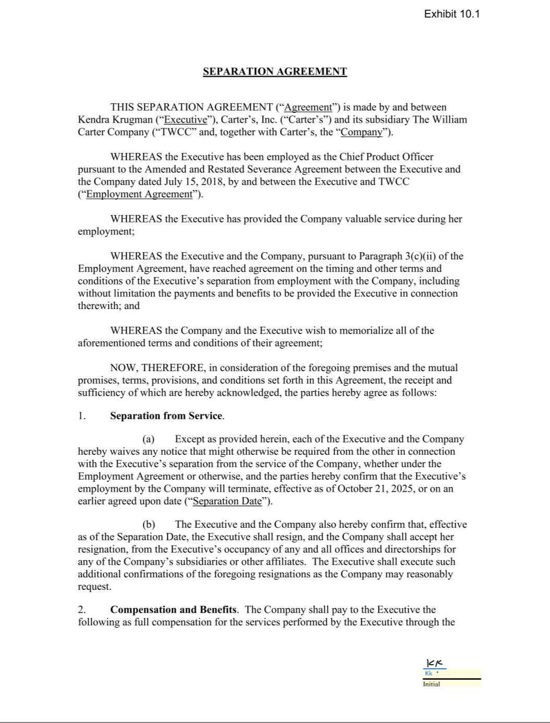

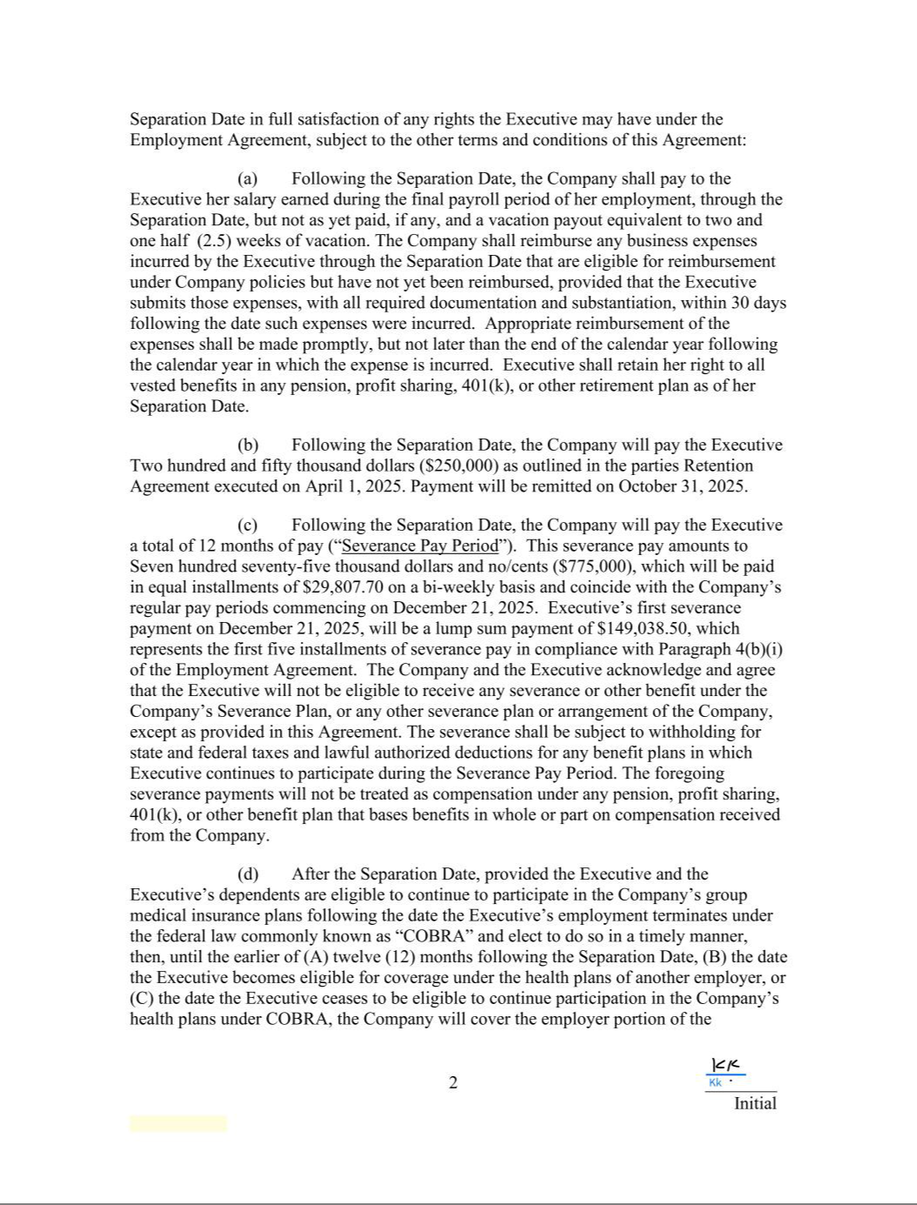

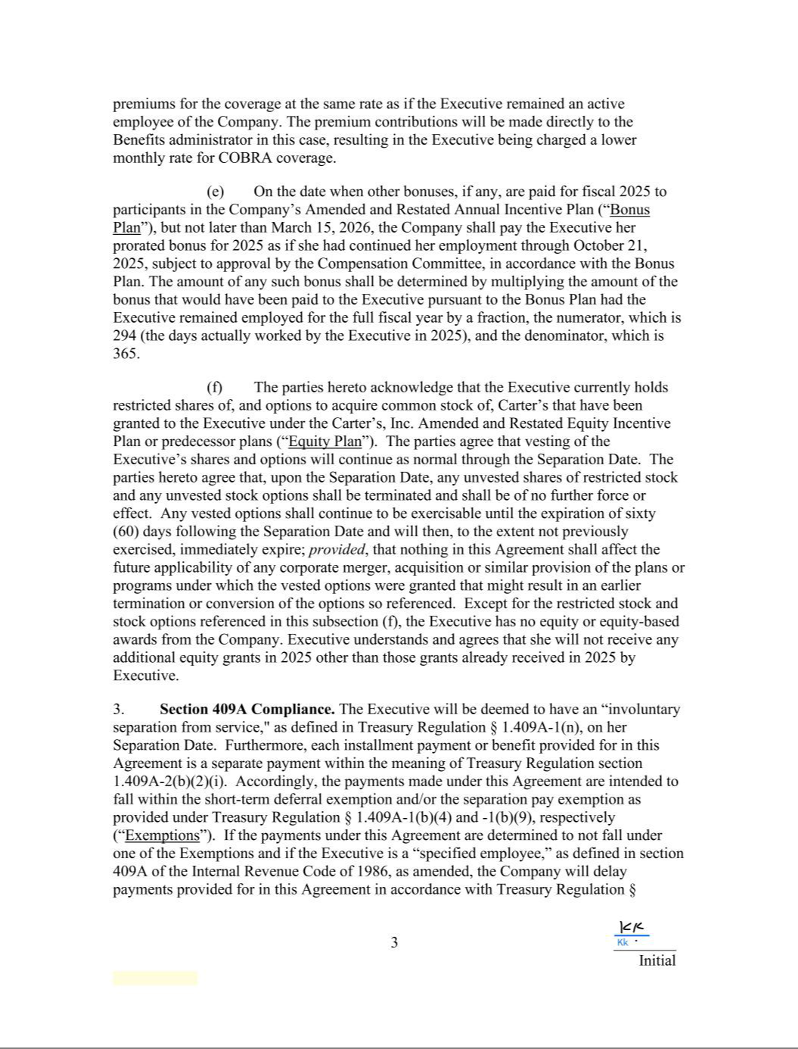

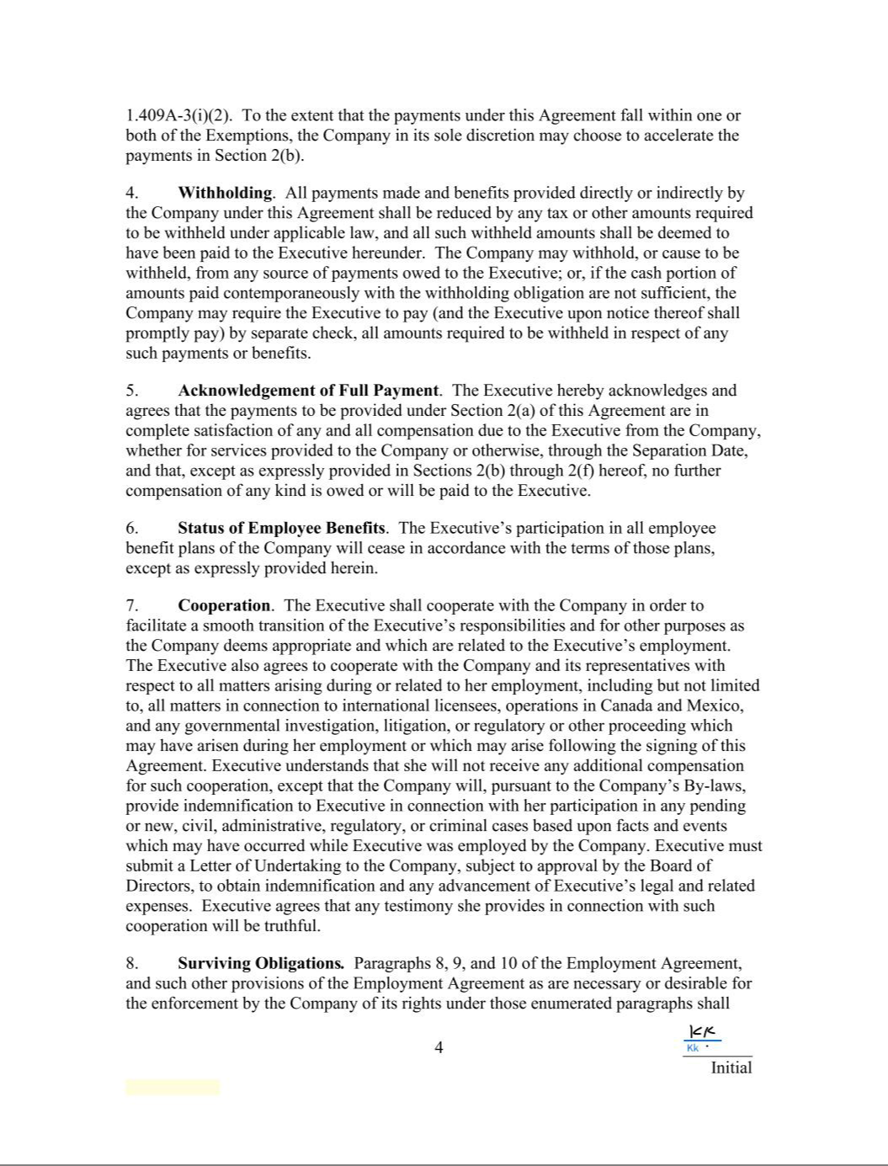

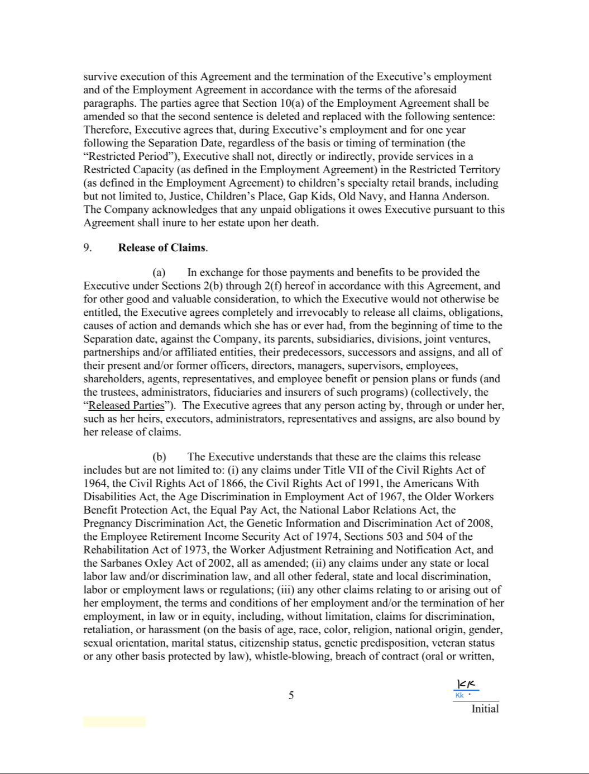

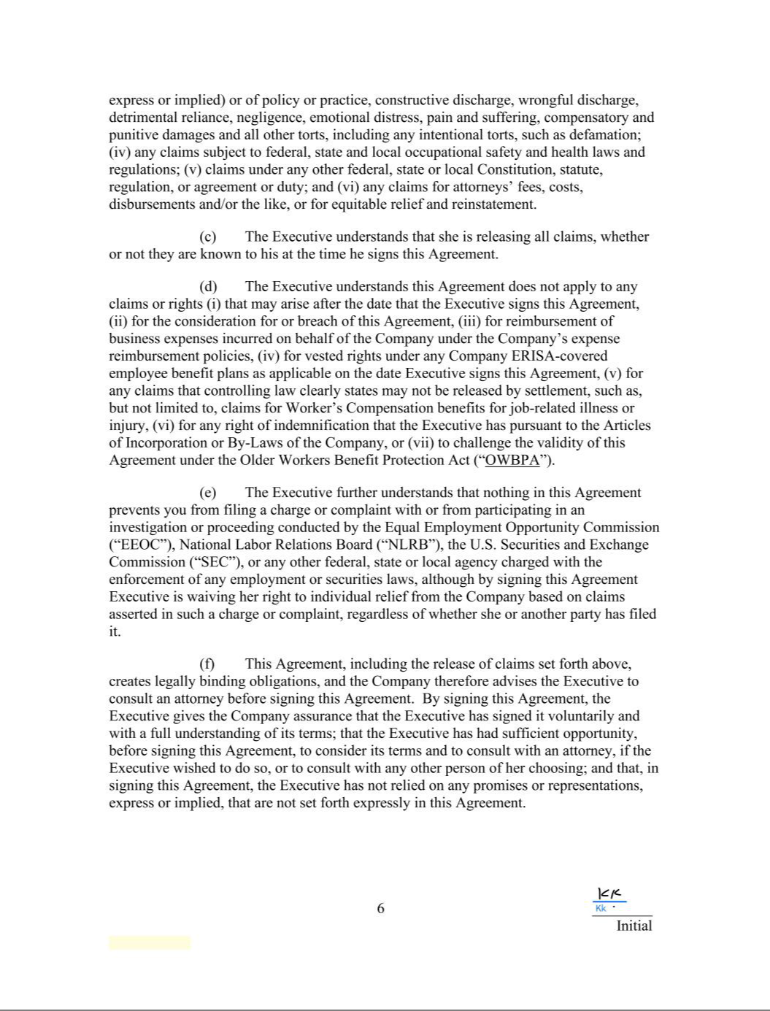

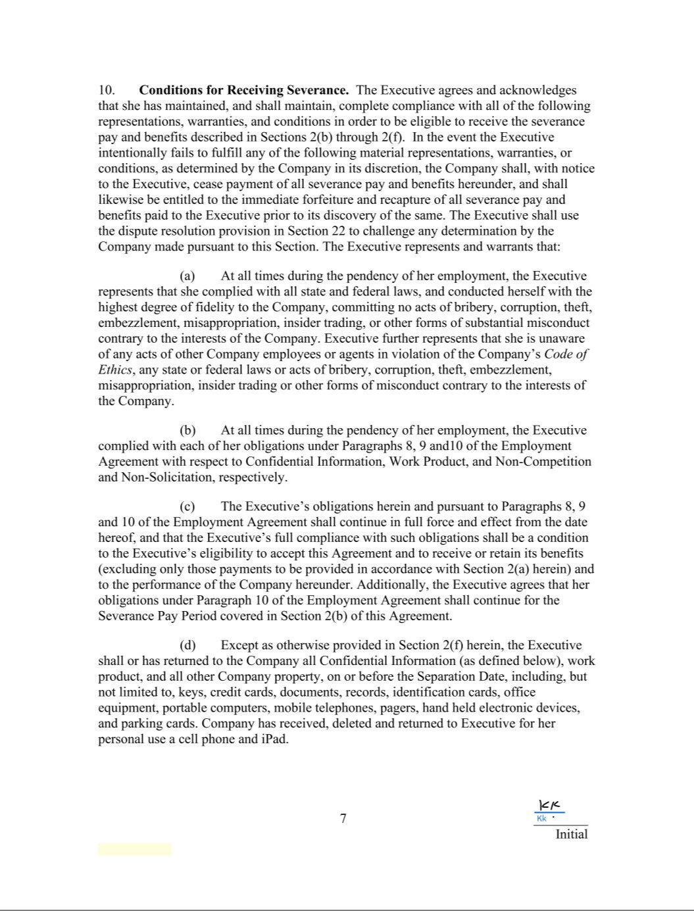

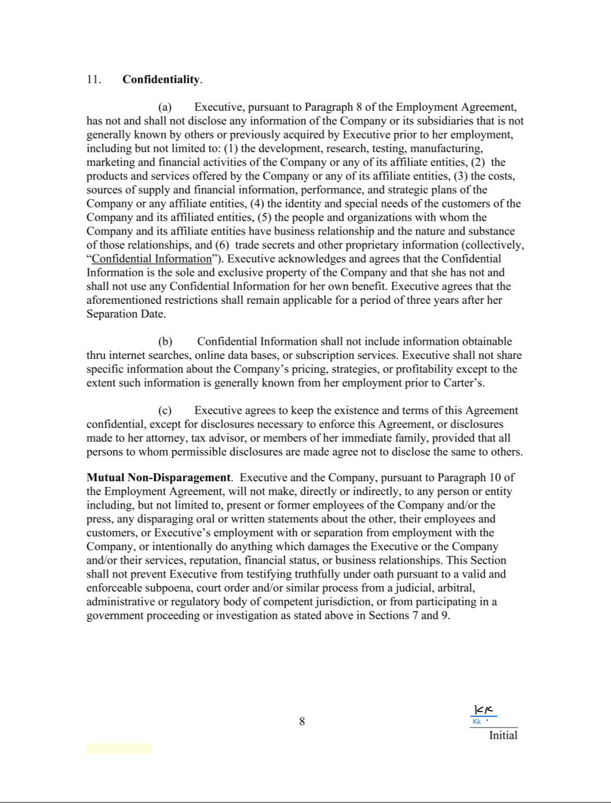

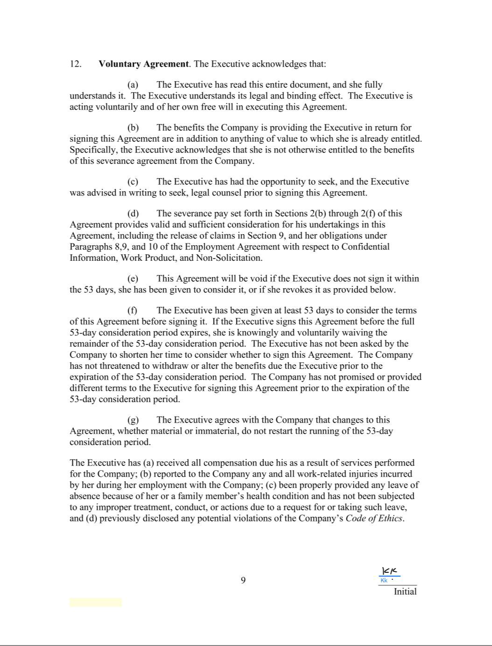

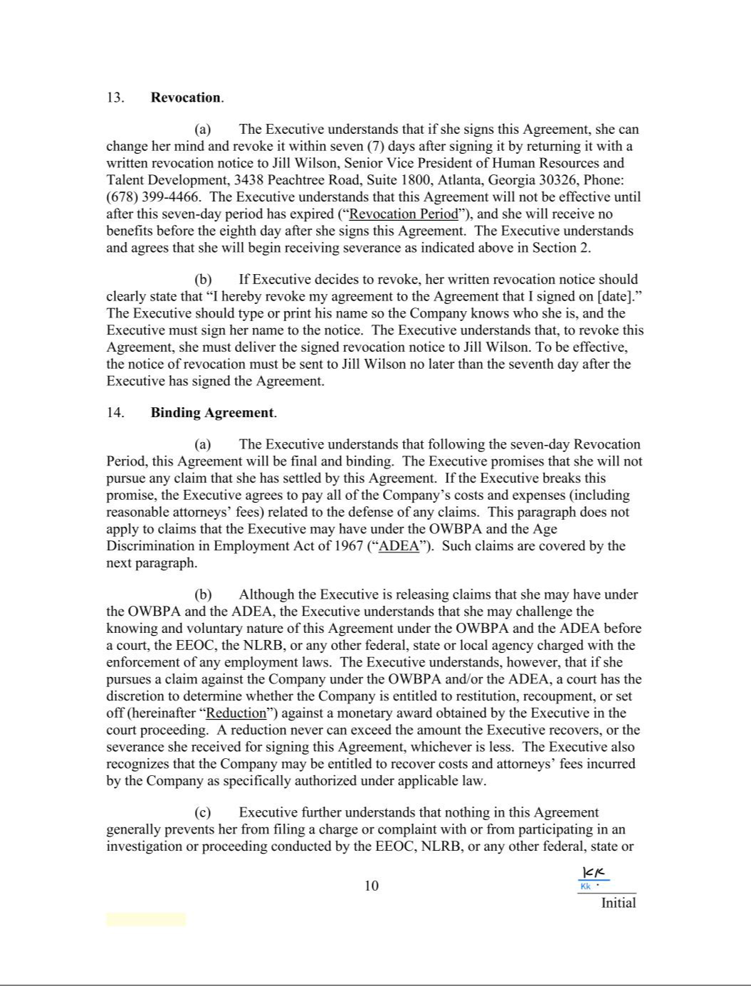

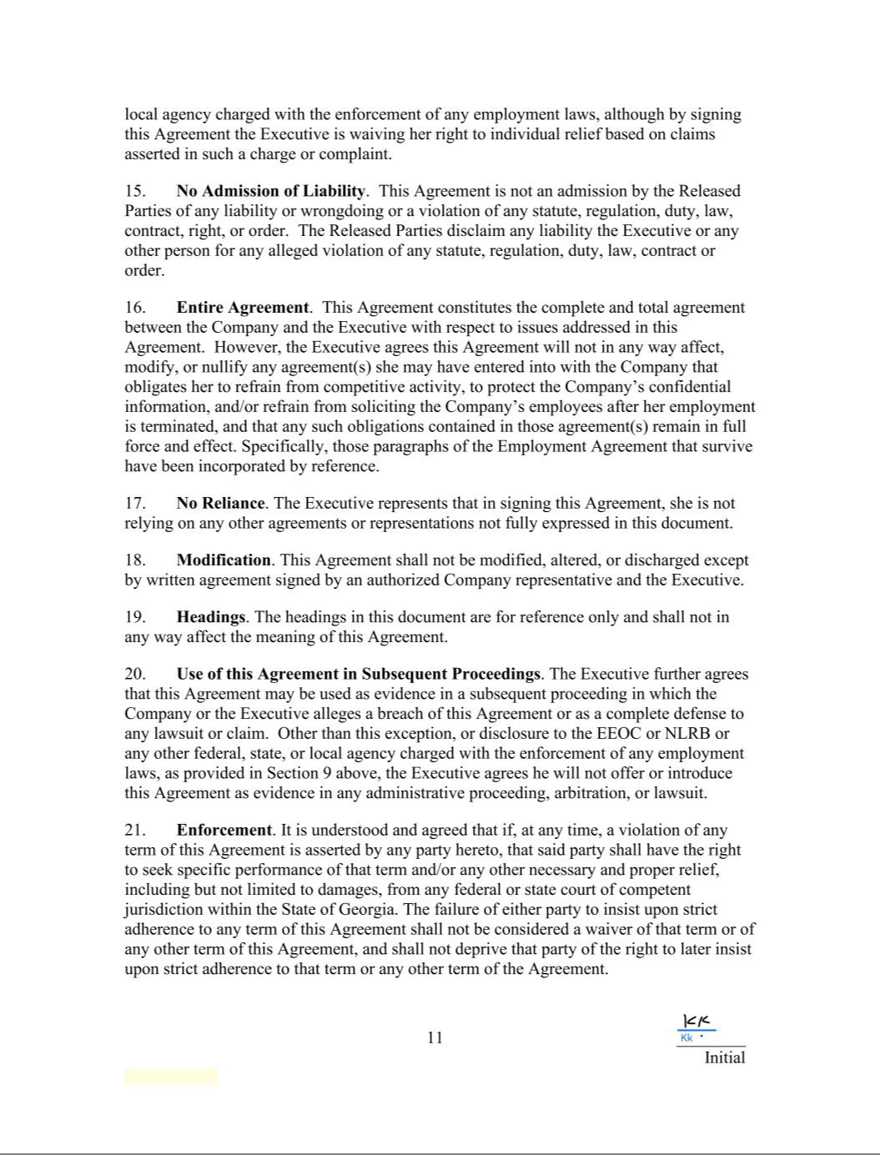

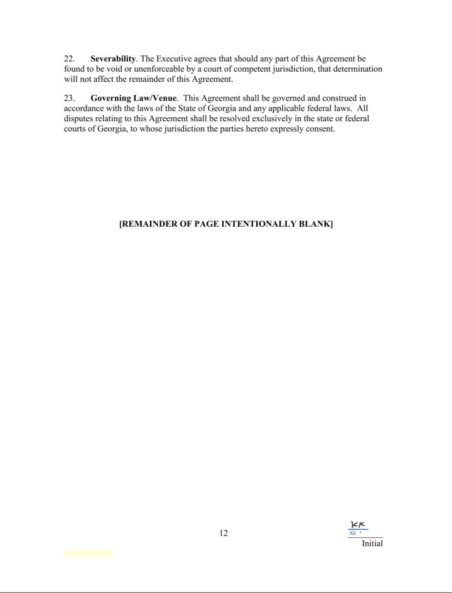

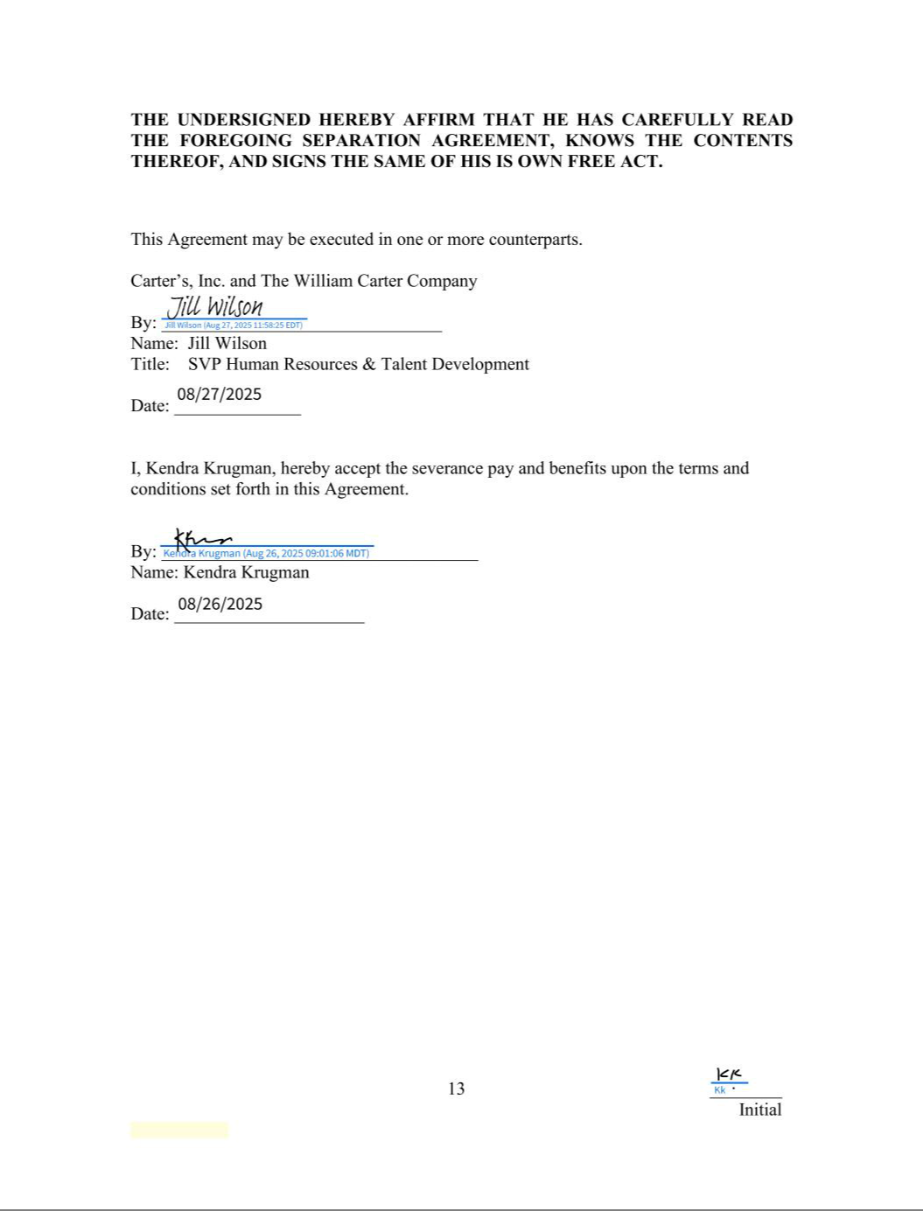

Exhibit 31.1

CERTIFICATION

I, Douglas C. Palladini, certify that:

- I have reviewed this quarterly report on Form 10-Q of Carter’s, Inc.;

- Based on my knowledge, this report does not contain any untrue statement of a material fact or omit to state a material fact necessary to make the statements made, in light of the circumstances under which such statements were made, not misleading with respect to the period covered by this report;

- Based on my knowledge, the financial statements, and other financial information included in this report, fairly present in all material respects the financial condition, results of operations and cash flows of the registrant as of, and for, the periods presented in this report;

- The registrant's other certifying officer and I are responsible for establishing and maintaining disclosure controls and procedures (as defined in Exchange Act Rules 13a-15(e) and 15d-15(e)) and internal control over financial reporting (as defined in Exchange Act Rules 13a-15(f) and 15d-15(f)) for the registrant and have:

  - Designed such disclosure controls and procedures, or caused such disclosure controls and procedures to be designed under our supervision, to ensure that material information relating to the registrant, including its consolidated subsidiaries, is made known to us by others within those entities, particularly during the period in which this report is being prepared;

  - Designed such internal control over financial reporting, or caused such internal control over financial reporting to be designed under our supervision, to provide reasonable assurance regarding the reliability of financial reporting and the preparation of financial statements for external purposes in accordance with generally accepted accounting principles;

  - Evaluated the effectiveness of the registrant’s disclosure controls and procedures and presented in this report our conclusions about the effectiveness of the disclosure controls and procedures, as of the end of the period covered by this report based on such evaluation; and

  - Disclosed in this report any change in the registrant’s internal control over financial reporting that occurred during the registrant’s most recent fiscal quarter (the registrant’s

fourth fiscal quarter in the case of an annual report) that has materially affected, or is reasonably likely to materially affect, the registrant’s internal control over financial reporting; and

- The registrant's other certifying officer and I have disclosed, based on our most recent evaluation of internal control over financial reporting, to the registrant's auditors and the audit committee of the registrant's board of directors (or persons performing the equivalent functions):

  - All significant deficiencies and material weaknesses in the design or operation of internal control over financial reporting which are reasonably likely to adversely affect the registrant's ability to record, process, summarize and report financial information; and

  - Any fraud, whether or not material, that involves management or other employees who have a significant role in the registrant's internal control over financial reporting.

October 27, 2025 /s/ DOUGLAS C. PALLADINI

Douglas C. Palladini

Chief Executive Officer & President

Exhibit 31.2

CERTIFICATION

I, Richard F. Westenberger, certify that:

- I have reviewed this quarterly report on Form 10-Q of Carter’s, Inc.;

- Based on my knowledge, this report does not contain any untrue statement of a material fact or omit to state a material fact necessary to make the statements made, in light of the circumstances under which such statements were made, not misleading with respect to the period covered by this report;

- Based on my knowledge, the financial statements, and other financial information included in this report, fairly present in all material respects the financial condition, results of operations and cash flows of the registrant as of, and for, the periods presented in this report;

- The registrant's other certifying officer and I are responsible for establishing and maintaining disclosure controls and procedures (as defined in Exchange Act Rules 13a-15(e) and 15d-15(e)) and internal control over financial reporting (as defined in Exchange Act Rules 13a-15(f) and 15d-15(f)) for the registrant and have:

  - Designed such disclosure controls and procedures, or caused such disclosure controls and procedures to be designed under our supervision, to ensure that material information relating to the registrant, including its consolidated subsidiaries, is made known to us by others within those entities, particularly during the period in which this report is being prepared;

  - Designed such internal control over financial reporting, or caused such internal control over financial reporting to be designed under our supervision, to provide reasonable assurance regarding the reliability of financial reporting and the preparation of financial statements for external purposes in accordance with generally accepted accounting principles;

  - Evaluated the effectiveness of the registrant’s disclosure controls and procedures and presented in this report our conclusions about the effectiveness of the disclosure controls and procedures, as of the end of the period covered by this report based on such evaluation; and

  - Disclosed in this report any change in the registrant’s internal control over financial reporting that occurred during the registrant’s most recent fiscal quarter (the registrant’s

fourth fiscal quarter in the case of an annual report) that has materially affected, or is reasonably likely to materially affect, the registrant’s internal control over financial reporting; and

- The registrant's other certifying officer and I have disclosed, based on our most recent evaluation of internal control over financial reporting, to the registrant's auditors and the audit committee of the registrant's board of directors (or persons performing the equivalent functions):

  - All significant deficiencies and material weaknesses in the design or operation of internal control over financial reporting which are reasonably likely to adversely affect the registrant's ability to record, process, summarize and report financial information; and

  - Any fraud, whether or not material, that involves management or other employees who have a significant role in the registrant's internal control over financial reporting.

October 27, 2025 /s/ RICHARD F. WESTENBERGER

Richard F. Westenberger

Chief Financial Officer & Chief Operating Officer

Exhibit 32

CERTIFICATION

Each of the undersigned in the capacity indicated hereby certifies that, to his knowledge, this Report on Form 10-Q for the fiscal quarter ended September 27, 2025 fully complies with the requirements of Section 13(a) or 15(d) of the Securities Exchange Act of 1934, and the information contained in this Report fairly presents, in all material respects, the financial condition and results of operations of Carter’s, Inc.

October 27, 2025 /s/ DOUGLAS C. PALLADINI

Douglas C. Palladini

Chief Executive Officer & President

October 27, 2025 /s/ RICHARD F. WESTENBERGER

Richard F. Westenberger

Chief Financial Officer & Chief Operating Officer

The foregoing certifications are being furnished solely pursuant to 18 U.S.C. § 1350 and are not being filed as part of the Report on Form 10-Q or as a separate disclosure document.

